Executive Summary

In this project, we are working for a manufacturer of optical fiber and we want to minimize one of the most important factor that is optical signal attenuation. Factors affecting the fiber drawing process are Fiber draw speed (ranges from 20-30 m/s), Furnace temperature (ranges from 1800-20000 C), Draw Tension (ranges from 0.5 to 1 N), and Germanium Concentration (ranges from 0.01 to 0.05), Fiber design (1 or 2), Draw tower (1 or 2), Raw Material Supplier (1 or 2), Coating type (1 or 2).

# Introduction

# Optical Fiber Drawing Process:

A solid optical fiber glass preform is transferred to a vertical fiber drawing system. Machines that make up a typical vertical drawing system can be two stories high and are able to produce continuous fibers up to 300 kilometers (186 miles) long. This system consists of a furnace to melt the end of the preform, sensors to monitor the diameter of the fiber being pulled from the preform, and coating devices to apply protective layers over the outer cladding. The preform first passes through a furnace, where it is heated to about 3600 degrees Fahrenheit (about 2000 degrees Celsius). Next, a drop of molten glass called a "gob" forms at the end of the preform, much like a droplet of water that collects at the bottom of a leaky faucet. The gob then falls away, and the single optical fiber inside is drawn out of the preform through compression on the preform from a feed mechanism at the top of the draw tower and tension provided from a take-up mechanism at the bottom of the draw tower.

# The goal of the analysis was to identify any significant factors and their interactions that have effect on attenuation from the list of above identified factors, to build a model to predict attenuation from the significant factors, and generate a list of optimal settings based on that model to minimize the attenuation. The budget provided for the experimental runs was $50000, which cost $1000/run and we could perform 16 experimental runs/day.

# For our first experimental design we created a 2(8-4) fractional factorial design of resolution IV and the simulated data was obtained. Based on the analysis of the first experimental run, we were able to identify significant factors and their interactions. We were able to identify aliased two factor interactions and in our follow up design we used fold over design to de-alias those. Detailed designs are explained below.

# Experimental Design:

# Iteration 1:

# The first iteration of the experimental design is a 2(8-4) resolution IV design where the factors are

# A=Fiber Draw Speed

# B=Temperature

# C=Tension

# D=Ge Concentration

# E=Design

# F=Tower

# G=Supplier

# F=Coating Type

# 

# Design Generator

# A, B, C, D, E=BCD, F=ACD, G=ABD, H=ABC.

# The defining relation of the design is as follows:

# I=BCDE=ACDF=ABDG=ABCH=ABEF=ACGE=BCFG=DEFG=ADEH=BDFH=CDGH=CEFH=BEGH=AFGH=ABCDEFGH

# 

# As you can see above the second order aliases are

# AB=EF=CH=DG

# AC=BH=DF=EG

# AD=BG=CF=EH

# AE=BF=CG=DH

# AF=BE=CD=GH

# AG=BD=CE=FH

# AH=BC=DE=FG

# 

# Here you can see that there is no correlation among the individual factors.

# 

Here the design efficient is 100% and the other optimization tools of G efficiency and A efficiency also display 100% and the variability seen is 39.6%

Design 2:

After analyzing the first design based on the observation and results we performed a full fold-over on factor A resulting in 32 runs which makes it a 2(8-3) fractional factorial design.

Design Generators

A, B, C, D, E, F=ABC, G=ABD, H=BCDE

The Defining Relations are

I=ABCF=ABDG=CDFG=BCDEH=ADEFH=ACEGH=BCFGH

The Aliases are

# AB= Null

# EF=CH=DG

# AC= Null

# BH=DF=EG

# AD= Null

# BG=CF=EH

# AE= Null

# BF=CG=DH

# AF= Null

# BE=CD=GH

# AG= Null

# BD=CE=FH

# AH= Null

# BC=DE=FG

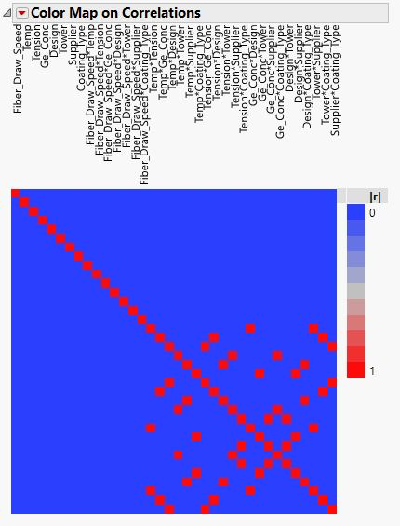

Here you can see that there is no correlation among the individual factors and some two factor interactions are aliased.

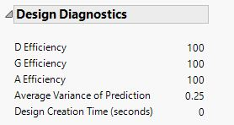 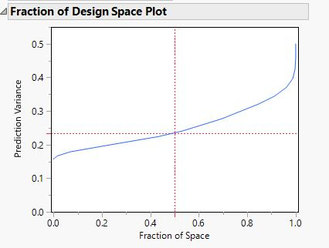

In the design diagnostics here the optimization tools of D, E, A efficiency are same as that of the first design that is 100% and the variation has reduced from 39% to 25%