

**DESIGN OF EXPERIMENT – MINIMIZE ATTENUATION IN FIBER PROCESS**



**By Supervised by**

**Jimit Shah (200318691) Dr. Dan Harris**

**Sai Shashank (200320973)**

**Shounak Deo (200321421)**

**Sushrut Ghotankar (200266022)**

**Yuvaraj Vivekanandan (200252347)**

Contents

Executive Summary 3

Introduction 3

Optical Fiber Drawing Process 3

Experimental Design 4

Iteration 1 4

Iteration 2 6

Analysis and Design 7

Prediction Expression 1 9

Prediction Expression 2 11

Conclusion 11

# Executive Summary

In our design of minimizing the attenuation, we have considered 4 factors (at their optimal setting) and 3 interaction terms.

1. Germanium Concentration – 0.01
2. Furnace temperature - 2200 C
3. Tension - 1 N
4. Design - 2
5. Interaction between Temperature and Tension
6. Interaction between Temperature and Germanium Concentration
7. Interaction between Temperature and Design

Clearly the Tension and Temperature are inversely proportional to response – attenuation. Let us see in detail the effect of each factor and their interactions in the model.

# Introduction

In this project, we are working for a manufacturer of optical fiber and we want to minimize one of the most important factors - optical signal attenuation. The main factors affecting the fiber drawing process are:

**Process Parameters:**

Fiber draw speed (ranges from 20-30 m/s)

Furnace temperature (ranges from 1800-20000 C)

Draw Tension (ranges from 0.5 to 1 N)

Germanium Concentration (ranges from 0.01 to 0.05)

**Design Parameters:**

Fiber design (1 or 2)

Draw tower (1 or 2)

Raw Material Supplier (1 or 2)

Coating type (1 or 2)

Since we have a total of 8 factors, it will take 28 = 256 runs to clearly estimate the significant effect of each factor and their interaction terms. The cost of conducting this experiment is 1000$/run which makes it infeasible to run all the experiments. Hence, we are designing a model that would minimize the desired attenuation with minimum number of experiments runs.

The focus of this experiment is to identify the factors that are significant and the operating range of these factors to control the attenuation.

In this process, we have used a resolution IV design and full fold-over to screen the main factors and their two factor interactions. From the first process, we did a screening process to choose the factors that are significant and, in our fold-over analysis, we de-aliased one factor (Fiber draw speed) and its interaction terms to confirm the screening we got in first design.

# Optical Fiber Drawing Process

A solid optical fiber glass preform is transferred to a vertical fiber drawing system. Machines that make up a typical vertical drawing system can be two stories high and are able to produce continuous fibers up to 300 kilometres (186 miles) long. This system consists of a furnace to melt the end of the preform, sensors to monitor the diameter of the fiber being pulled from the preform, and coating devices to apply protective layers over the outer cladding. The preform first passes through a furnace, where it is heated to about 3600 degrees Fahrenheit (about 2000 degrees Celsius). Next, a drop of molten glass called a "gob" forms at the end of the preform, much like a droplet of water that collects at the bottom of a leaky faucet. The gob then falls away, and the single optical fiber inside is drawn out of the preform through compression on the preform from a feed mechanism at the top of the draw tower and tension provided from a take-up mechanism at the bottom of the draw tower.

The goal of the analysis was to identify any significant factors and their interactions that have effect on attenuation from the list of above identified factors, to build a model to predict attenuation from the significant factors, and generate a list of optimal settings based on that model to minimize the attenuation.

# Experimental Design

## Iteration 1

The first iteration of the experimental design is a 2(8-4) resolution IV design where the factors are

A=Fiber Draw Speed

B=Temperature

C=Tension

D=Ge Concentration

E=Design

F=Tower

G=Supplier

H=Coating Type

Design Generator:

A, B, C, D, E=BCD, F=ACD, G=ABD, H=ABC.

The defining relation of the design is as follows:

I=BCDE=ACDF=ABDG=ABCH=ABEF=ACGE=BCFG=DEFG=ADEH=BDFH=CDGH=CEFH=BEGH=AFGH=ABCDEFGH

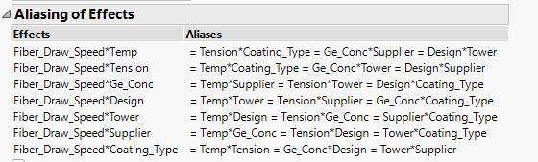

As you can see above the second order aliases are

AB=EF=CH=DG

AC=BH=DF=EG

AD=BG=CF=EH

AE=BF=CG=DH

AF=BE=CD=GH

AG=BD=CE=FH

AH=BC=DE=FG

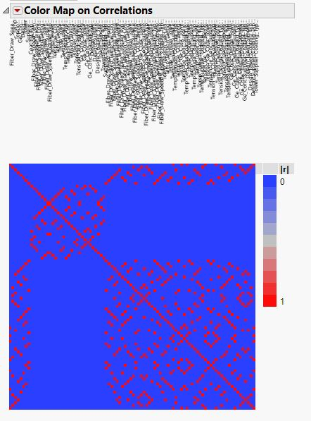

Here you can see that there is no correlation among the individual factors.

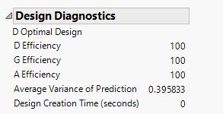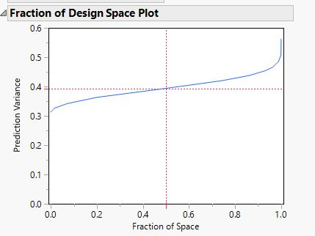

Here the design efficient is 100% and the other optimization tools of G efficiency and A efficiency also display 100% and the variability seen is 39.6%

## Iteration 2

After analyzing the first design based on the observation and results, we performed a full fold-over on factor A resulting in 32 runs which makes it a 2(8-3) fractional factorial design.

Design Generators

A, B, C, D, E, F=ABC, G=ABD, H=BCDE

The Defining Relations are

I=ABCF=ABDG=CDFG=BCDEH=ADEFH=ACEGH=BCFGH

The Aliases are

AB= Null

EF=CH=DG

AC= Null

BH=DF=EG

AD= Null

BG=CF=EH

AE= Null

BF=CG=DH

AF= Null

BE=CD=GH

AG= Null

BD=CE=FH

AH= Null

BC=DE=FG

Here you can see that there is no correlation among the individual factors and some two factor interactions are aliased.

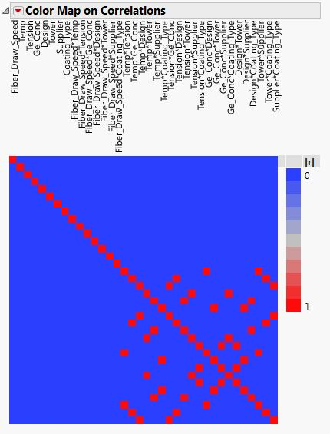

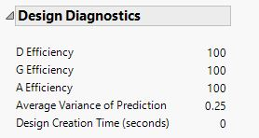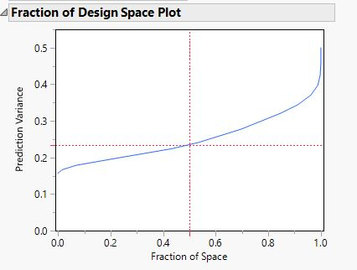

In the design diagnostics here the optimization tools of D, E and A efficiency are same as that of the first design that is 100% and the variation has reduced from 39% to 25%

# Analysis and Design

In our analysis, we are going with the assumptions that all the third order interactions and above are negligible in the process as they are contributing less to the model. Hence are we focused on finding the main factors along with their second order interactions.

In our initial run of 16 runs, we started the diagnosis with screening the design with most important factors. The half normal plot of the screening process is shown below:

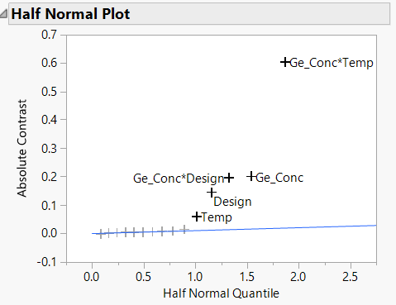

The half normal plot shows that thee are 3 significant factors with 2 of their interactions being significant.

Significant factors:

1. Germanium concentration.
2. Temperature of furnace.
3. Design.
4. Interaction between Germanium concentration and Design.
5. Interaction between Germanium concentration and Temperature.

Based on the above set of significant factors, we reduce the model with just factors and their interactions.

The normality of the model is validated using residual plots and predicted plots. Both the plots look clear without any ambiguity.

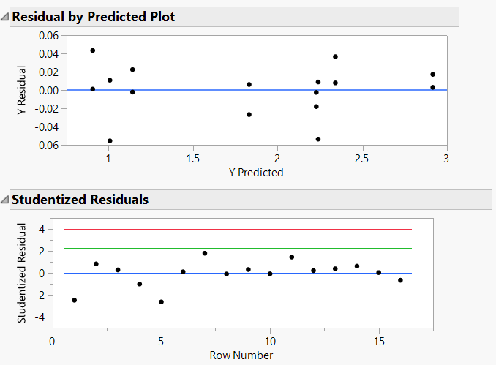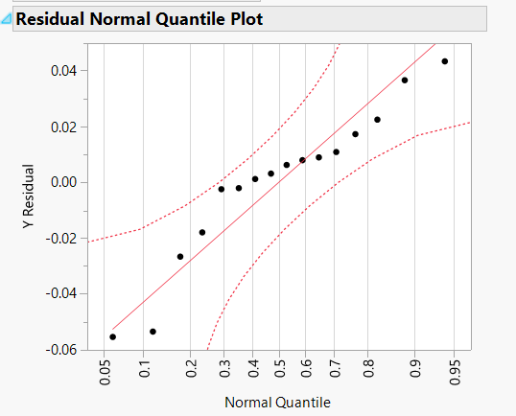

## Prediction Expression 1

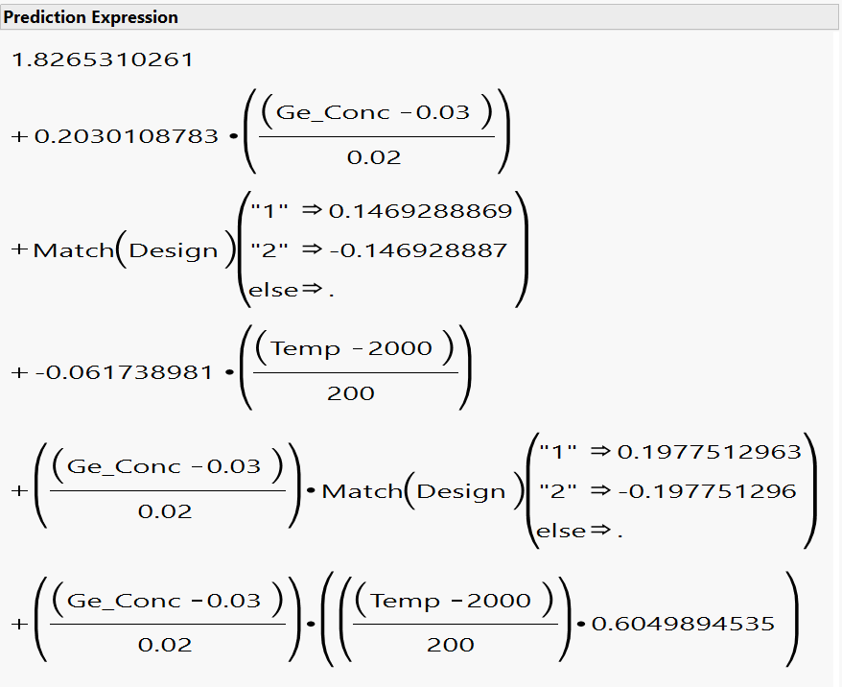

Clearly this model gives the main effects that are affecting the process. Germanium concentration, Temperature and Design. The problem is that we have our second order interactions aliased with one another. The interactions could be of any of the other aliases as well.

In order to remove aliasing of one of the factors – Fiber draw speed, we decided to do a complete fold-over on the factor Fiber draw speed.

In this model, we separated all the interactions made from fiber draw speed we started the analysis with normality validation.

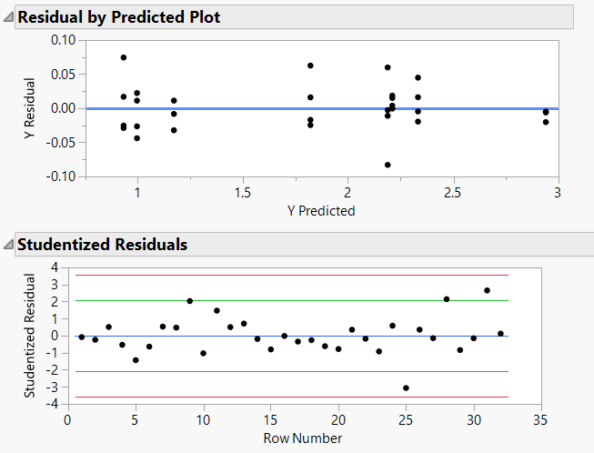 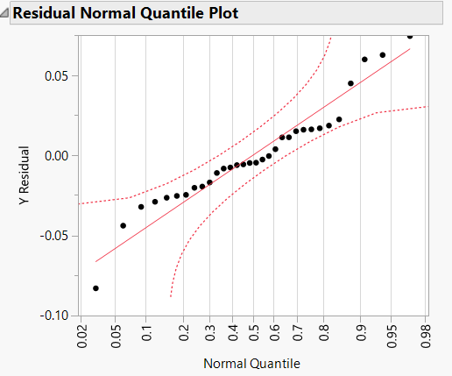

In the residual by Predicted Plot, there are couple of clusters we can notice. The values are aligning to 1 or 2 which could indicate that the responses depend on categorical factor like design. Both the plots indicate that there is no non-linearity or skewness. The plots look normal.

Conitnuing our analysis, we found out that none of the interations made out of Fiber draw speed are significant. Hence we can remove the interations made out of fiber draw speed.

The model build with Fiber draw speed is given below:

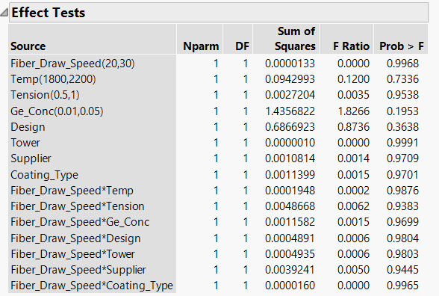

Clearly we can eliminate the factor Fiber draw speed from the analysis. Going forward, we built the model with 3 main factors we found with model 1, and their interations.

The model is analysed with R2 and ANOVA method to check the performance.

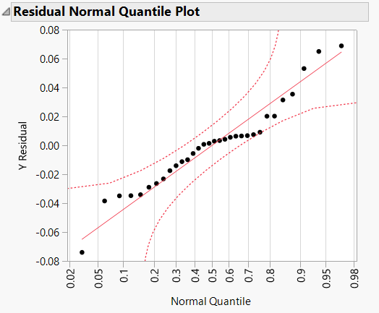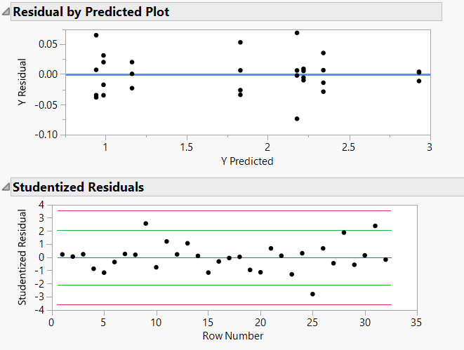

Here as we predicted, the 4 main factors and their interactions are signifcant with a R2 value of .99 and F-ratio of 1774.68. Even though the second order intration aliasing is present in this design, it is more likely for the main factor interations to have an impact in the process than the rest of the factors.

## Prediction Expression 2

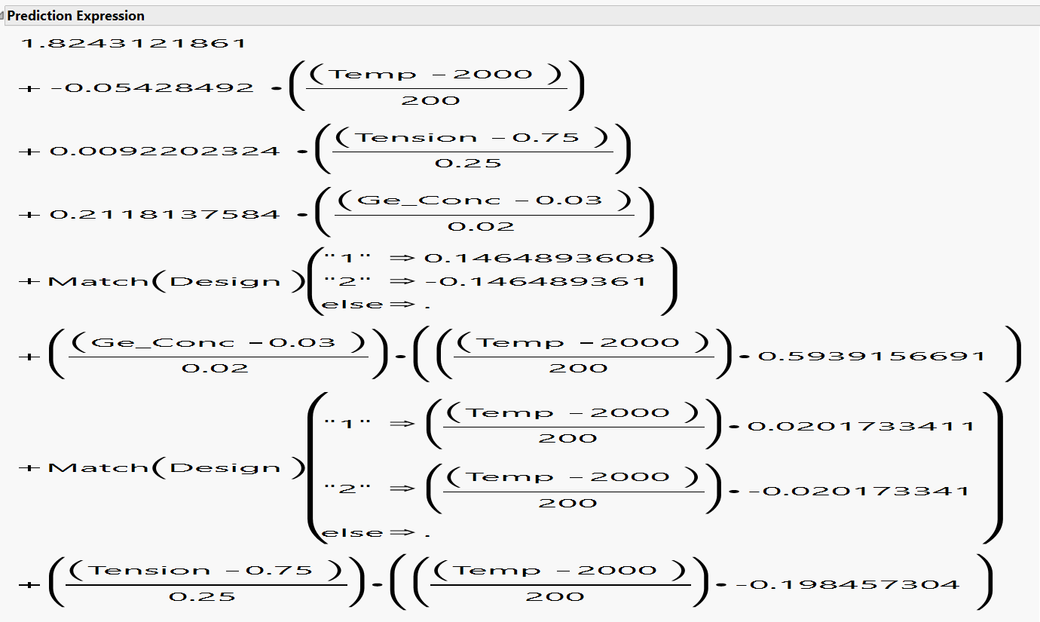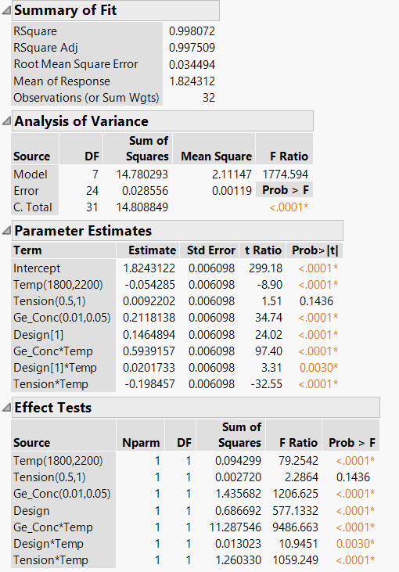

We can find the values for maximum desirability, that is minimum attenuation, using prediction profiler:

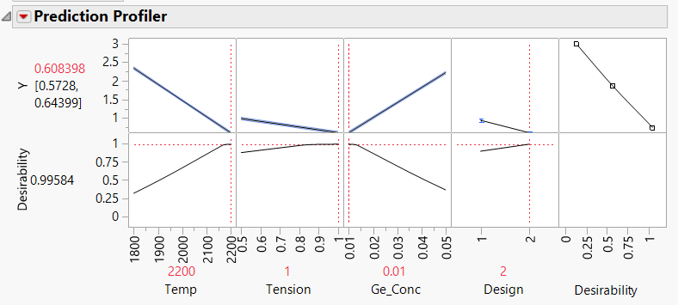

# Conclusion

In order to reduce the response, attenuation, we can find the optimum settings of these factors using cube plots.

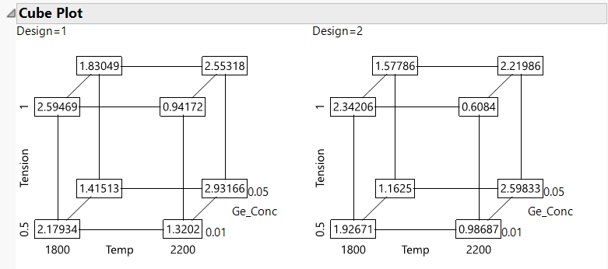

From the cube plot, in order to minimize attenuation, we must have the following setting for 4 main factors:

Germanium concentration - .01

Design – 2

Temperature – 2200 C

Tension – 1 N

Clearly, we had limited number of runs and our model had a variation of 25% in the final response. Hence if we could run more runs, we could one more fold-over on Germanium concentration in order to reduce the variation and increase model accuracy. Moreover, in order to get accurate settings on continuous factors like Temperature, Tension and Germanium concentration, we could add center points to validate our model with response surface methods. It would lead us to find the global minima of the model.