SunQuarTeX Example - Jupyter Notebook
Subtitle Here
sun123zxy
2023-02-14
Abstract
This is an abstract.

Title
This is a sample Jupyter Notebook using SunQuarTeX.
Below is an example of a Python code cell:
import numpy as np
import matplotlib.pyplot as plt
r = np.arange(0, 2, 0.01)
theta = 2 * np.pi * r
fig, ax = plt.subplots(
subplot_kw = {'projection': 'polar'}
)
fig.patch.set_alpha(0)
ax.patch.set_alpha(0)
ax.plot(theta, r)
ax.set_rticks([0.5, 1, 1.5, 2])
ax.grid(True)
plt.show()
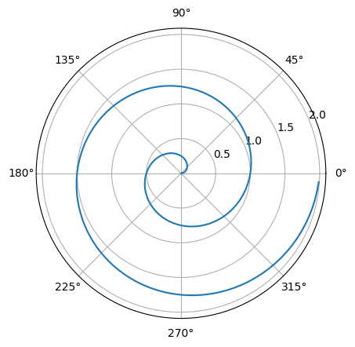
Figure 1: A line plot on a polar axis
Quarto’s specific Markdown feature still works in Jupyter Notebook. For example:
Theorem 1 (This) is a theorem.

