Relative efficiency =
2018
Mass(GeV) | HLT | Quality Control | Energy Cut | F51 | dE/dx Significance
1000 | 0.10 | 0.64 | 0.13 | 0.60 | 1
2000 | 0.10 | 0.52 | 0.10 | 0.58 | 1
3000 | 0.11 | 0.59 | 0.09 | 0.70 | 1

Cut flow table: the number of events after the following cuts.
2018
CutFlow Mass | 1000GeV | 2000GeV | 3000GeV
HLT | 1045 | 1288 | 1342
HLT+QualityCuts | 567 | 665 | 658
HLT+Quality+Energy | 70 | 69 | 53
HLT+Quality+Energy+F51 | 42 | 40 | 37
HLT+Quality+Energy+F51+dEdXSig | 42 | 40 | 37

2018 NO TRG
CutFlow Mass | 1000GeV | 2000GeV | 3000GeV
All Events | 15000 | 15000 | 15000
QualityCuts | 6286 | 6420 | 6469
Quality+Energy | 522 | 495 | 351
Quality+Energy+F51 | 435 | 399 | 343
Quality+Energy+F51+dEdXSig | 435 | 398 | 341

N-1 Cut table: the no. of events after the all cuts except the mentioned cut in the left colume.

2018
N-1Cut Mass | 1000GeV | 2000GeV | 3000GeV
No HLT | 435 | 398 | 341
No QualityCuts | 66 | 77 | 63
No EnergyCut | 317 | 404 | 391
No F51 Cut | 70 | 69 | 53
No dEdXSig Cut | 42 | 40 | 37

Signal Efficiency =

2018
 | 1000GeV | 2000GeV | 3000GeV
No HLT pass | 0.029 | 0.027 | 0.023
HLT pass | 0.003 | 0.003 | 0.002

先放cut flow 和n-2 cut：有HLT pass的cut結果
在放signal efficiency
最後放第一章 說明通過HLT之後的效率變低，主因是HLT相對效率很低

2017

Relative efficiency =
2017
Mass(GeV) | HLT | Quality Control | Energy Cut | F51 | dE/dx Significance
1000 | 0.09 | 0.59 | 0.11 | 0.56 | 1
2000 | 0.14 | 0.60 | 0.15 | 0.65 | 1
3000 | 0.08 | 0.55 | 0.08 | 0.52 | 1

Cut flow table: the number of events after the following cuts.
2017
CutFlow Mass | 1000GeV | 2000GeV | 3000GeV
HLT | 1096 | 1406 | 1356
HLT+QualityCuts | 567 | 716 | 631
HLT+Quality+Energy | 63 | 95 | 53
HLT+Quality+Energy+F51 | 35 | 62 | 27
HLT+Quality+Energy+F51+dEdXSig | 35 | 62 | 27

2017 NO TRG
CutFlow Mass | 1000GeV | 2000GeV | 3000GeV
All Events | 15000 | 15000 | 15000
QualityCuts | 6178 | 6390 | 6434
Quality+Energy | 494 | 537 | 418
Quality+Energy+F51 | 408 | 431 | 332
Quality+Energy+F51+dEdXSig | 408 | 430 | 332

N-1 Cut table: the no. of events after the all cuts except the mentioned cut in the left colume.
2017
N-1Cut Mass | 1000GeV | 2000GeV | 3000GeV
No HLT | 408 | 430 | 332
No QualityCuts | 59 | 104 | 49
No EnergyCut | 306 | 406 | 370
No F51 Cut | 63 | 95 | 52
No dEdXSig Cut | 35 | 62 | 27

Signal Efficiency =
2017
 | 1000GeV | 2000GeV | 3000GeV
No HLT pass | 0.027 | 0.029 | 0.022
HLT pass | 0.002 | 0.004 | 0.002

////////////////////////////////////////E55///////////////////////////////////////////////////////////////////////////////////

2018 CutFlow table
CutFlow Mass | 1000GeV(E55 order) | 1000GeV(original)
HLT | 1045 | 1045
HLT+QualityCuts | 475 | 567
HLT+Quality+Energy | 468 | 70
HLT+Quality+Energy+F51 | 257 | 42
HLT+Quality+Energy+F51+dEdXSig | 248 | 42

2018 Relative Efficiency
Mass(GeV) | HLT | Quality Control | Energy Cut | F51 | dE/dx Significance
1000(e55 order) | 0.08 | 0.59 | 0.98 | 0.55 | 0.96
1000(original) | 0.10 | 0.64 | 0.13 | 0.60 | 1

2018 Signal Efficiency
 | 1000GeV(e55 order) | 1000GeV(original)
No HLT pass | 0.209 | 0.029
HLT pass | 0.017 | 0.003

2018 CutFlow table
CutFlow Mass | 1000GeV(New) | 1000GeV(original)
HLT | 1045 | 1045
HLT+QualityCuts | 893 | 567
HLT+Quality+Energy | 729 | 70
HLT+Quality+Energy+F51 | 488 | 42
HLT+Quality+Energy+F51+dEdXSig | 473 | 42
Energy cut lose % | 18 % | 88 %

Mass(GeV) | 1000(new) | 1000(orginal)
HLT | 0.10 | 0.10
Quality Control | 0.64 | 0.64
Energy Cut | 0.83 | 0.13
F51 | 0.67 | 0.60
dEdx Significance | 0.97 | 1

2018 Signal Efficiency
Mass(GeV) | 1000(new) | 1000(original)
No HLT pass | 0.321 | 0.029
HLT pass | 0.031 | 0.003

2018 CutFlow table
Mass(GeV)  CutFlow | 1000 | 1000  (old) | 2000 | 2000  (old) | 3000 | 3000  (old)
HLT | 1045 | 1045 | 1288 | 1288 | 1342 | 1342
HLT+QualityCuts | 893 | 567 | 1085 | 665 | 1134 | 658
HLT+Quality+Energy | 729 | 70 | 843 | 69 | 842 | 53
HLT+Quality+Energy+F51 | 488 | 42 | 562 | 40 | 523 | 37
HLT+Quality+Energy+F51+dEdXSig | 473 | 42 | 553 | 40 | 503 | 37
Energy cut lose % | 18 % | 88% | 22% | 90% | 26% | 92%

2018 Relative Efficiency
Mass(GeV) | 1000 | 1000  (old) | 2000 | 2000  (old) | 3000 | 3000  (old)
HLT | 0.10 | 0.10 | 0.10 | 0.10 | 0.10 | 0.11
Quality Control | 0.64 | 0.64 | 0.61 | 0.52 | 0.57 | 0.59
Energy Cut | 0.83 | 0.13 | 0.84 | 0.10 | 0.84 | 0.09
F51 | 0.67 | 0.60 | 0.68 | 0.58 | 0.64 | 0.70
dEdx Significance | 0.97 | 1.00 | 0.98 | 1.00 | 0.96 | 1.00

2018 Signal Efficiency
Mass(GeV) | 1000 | 1000  (Old) | 2000 | 2000  (Old) | 3000 | 3000  (Old)
No HLT pass | 0.321 | 0.029 | 0.356 | 0.027 | 0.352 | 0.023
HLT pass | 0.031 | 0.003 | 0.037 | 0.003 | 0.034 | 0.002

2017 CutFlow table
Mass(GeV)  CutFlow | 1000 | 1000  (old) | 2000 | 2000  (old) | 3000 | 3000  (old)
HLT | 1096 | 1096 | 1406 | 1406 | 1356 | 1356
HLT+QualityCuts | 926 | 567 | 1174 | 716 | 1105 | 631
HLT+Quality+Energy | 760 | 63 | 936 | 95 | 829 | 53
HLT+Quality+Energy+F51 | 490 | 35 | 599 | 62 | 495 | 27
HLT+Quality+Energy+F51+dEdXSig | 475 | 35 | 586 | 62 | 478 | 27
Energy cut lose % | 18 % | 89% | 20% | 87% | 25% | 92%

2017 Relative Efficiency
Mass(GeV) | 1000 | 1000  (old) | 2000 | 2000  (old) | 3000 | 3000  (old)
HLT | 0.10 | 0.09 | 0.11 | 0.14 | 0.09 | 0.08
Quality Control | 0.64 | 0.59 | 0.59 | 0.60 | 0.55 | 0.55
Energy Cut | 0.82 | 0.11 | 0.83 | 0.15 | 0.83 | 0.08
F51 | 0.65 | 0.56 | 0.64 | 0.65 | 0.62 | 0.52
dEdx Significance | 0.97 | 1.00 | 0.98 | 1.00 | 0.97 | 1.00

2017 Signal Efficiency
Mass(GeV) | 1000 | 1000  (old) | 2000 | 2000  (old) | 3000 | 3000  (old)
No HLT pass | 0.319 | 0.027 | 0.351 | 0.029 | 0.351 | 0.022
HLT pass | 0.032 | 0.002 | 0.039 | 0.004 | 0.032 | 0.002

2017
no. of Monopole | 1000 | 1000  (TRG) | 2000 | 2000  (TRG) | 3000 | 3000  (TRG)
1 | 3936 | 424 | 4285 | 519 | 4377 | 424
2 | 836 | 50 | 974 | 67 | 889 | 54
3 | 9 | 1 | 3 | 0 | 0 | 0

2018
no. of Monopole | 1000 | 1000  (TRG) | 2000 | 2000  (TRG) | 3000 | 3000  (TRG)
1 | 3900 | 412 | 4344 | 481 | 4405 | 445
2 | 911 | 60 | 1000 | 72 | 877 | 58
3 | 12 | 1 | 1 | 0 | 0 | 0

12/9 new static
e55->pt

2018 CutFlow table
Mass(GeV)  CutFlow | 1000  (e55) | 1000  (pT) | 2000  (e55) | 2000  (pT) | 3000  (e55) | 3000  (pT)
HLT | 1045 | 1045 | 1288 | 1288 | 1342 | 1342
HLT+QualityCuts | 893 | 893 | 1085 | 1085 | 1134 | 1134
HLT+Quality+Energy | 729 | 700 | 843 | 809 | 842 | 815
HLT+Quality+Energy+F51 | 488 | 450 | 562 | 531 | 523 | 505
HLT+Quality+Energy+F51+dEdXSig | 473 | 436 | 553 | 523 | 503 | 486

Mass(GeV)  CutFlow | 1000  (e55) | 1000  (pT) | 2000  (e55) | 2000  (pT) | 3000  (e55) | 3000  (pT)
 | 14977 | 14977 | 14976 | 14976 | 14992 | 14992
QualityCuts | 10923 | 10923 | 11165 | 11165 | 11450 | 11450
Quality+Energy | 5775 | 4513 | 6534 | 5523 | 6676 | 5732
Quality+Energy+F51 | 4935 | 3849 | 5481 | 4678 | 5462 | 4747
Quality+Energy+F51+dEdXSig | 4923 | 3765 | 5345 | 4565 | 5282 | 4601

2018 Relative Efficiency
Mass(GeV) | 1000  (e55) | 1000  (pT) | 2000  (e55) | 2000  (pT) | 3000  (e55) | 3000  (pT)
HLT | 0.10 | 0.12 | 0.10 | 0.11 | 0.10 | 0.11
Quality Control | 0.64 | 0.64 | 0.61 | 0.61 | 0.57 | 0.58
Energy Cut | 0.83 | 0.76 | 0.84 | 0.79 | 0.84 | 0.81
F51 | 0.67 | 0.64 | 0.68 | 0.67 | 0.64 | 0.64
dEdx Significance | 0.97 | 0.96 | 0.98 | 0.98 | 0.96 | 0.96

2018 Signal Efficiency
Mass(GeV) | 1000  (e55) | 1000  (pT) | 2000  (e55) | 2000  (pT) | 3000  (e55) | 3000  (pT)
No HLT pass | 0.321 | 0.251 | 0.356 | 0.304 | 0.352 | 0.307
HLT pass | 0.031 | 0.029 | 0.037 | 0.035 | 0.034 | 0.032

2017 CutFlow table
Mass(GeV)  CutFlow | 1000  (E55) | 1000  (pT) | 2000  (e55) | 2000  (pT) | 3000  (e55) | 3000  (pT)
HLT | 1096 | 1096 | 1406 | 1406 | 1356 | 1356
HLT+QualityCuts | 926 | 926 | 1174 | 1174 | 1105 | 1105
HLT+Quality+Energy | 760 | 687 | 936 | 879 | 829 | 789
HLT+Quality+Energy+F51 | 490 | 434 | 599 | 552 | 495 | 465
HLT+Quality+Energy+F51+dEdXSig | 475 | 421 | 586 | 538 | 478 | 449

2017 CutFlow table
Mass(GeV)  CutFlow | 1000  (E55) | 1000  (pT) | 2000  (e55) | 2000  (pT) | 3000  (e55) | 3000  (pT)
No TRG, No CUTS | 14982 | 14982 | 14984 | 14984 | 14986 | 14986
QualityCuts | 10955 | 10955 | 11122 | 11122 | 11447 | 11447
Quality+Energy | 5713 | 4353 | 6415 | 5440 | 6673 | 5693
Quality+Energy+F51 | 4885 | 3731 | 5391 | 4604 | 5440 | 4700
Quality+Energy+F51+dEdXSig | 4781 | 3649 | 5262 | 4510 | 5266 | 4566

Relative efficiency =
2017 Relative Efficiency
Mass(GeV) | 1000  (e55) | 1000  (pT) | 2000  (e55) | 2000  (pT) | 3000  (e55) | 3000  (pT)
HLT | 0.10 | 0.12 | 0.11 | 0.12 | 0.09 | 0.10
Quality Control | 0.64 | 0.63 | 0.59 | 0.59 | 0.55 | 0.54
Energy Cut | 0.82 | 0.72 | 0.83 | 0.77 | 0.83 | 0.77
F51 | 0.65 | 0.63 | 0.64 | 0.63 | 0.62 | 0.61
dEdx Significance | 0.97 | 0.97 | 0.98 | 0.97 | 0.97 | 0.96
Signal Efficiency =

2017 Signal Efficiency
Mass(GeV) | 1000  (e55) | 1000  (pT) | 2000  (e55) | 2000  (pT) | 3000  (e55) | 3000  (old)
No HLT pass | 0.319 | 0.243 | 0.351 | 0.301 | 0.351 | 0.304
HLT pass | 0.032 | 0.028 | 0.039 | 0.036 | 0.032 | 0.030

2017
no. of Monopole | 1000 | 1000  (TRG) | 2000 | 2000  (TRG) | 3000 | 3000  (TRG)
1 | 2936 | 379 | 3633 | 481 | 3798 | 429
2 | 706 | 41 | 874 | 57 | 803 | 57
3 | 7 | 1 | 3 | 0 | 0 | 0

2018
no. of Monopole | 1000 | 1000  (TRG) | 2000 | 2000  (TRG) | 3000 | 3000  (TRG)
1 | 2986 | 389 | 3666 | 456 | 3748 | 399
2 | 768 | 46 | 898 | 67 | 818 | 50
3 | 11 | 1 | 1 | 0 | 0 | 0

Relative efficiency =

Signal Efficiency =

Trigger Efficiency =

trg efficiency 這樣算可以ㄇ

 | avg prescale  (2017) | Trigger efficiency | trg / total evt
Photon175 | X | 0.123 | 0.08728
PFMET170_NotCleaned | ~4 | 0.362 | 0.29549
PFMET170_NoiseCleaned | 4.6 | 0.322 | 0.2692
PFMET170_JetIdCleaned | 4.6 | 0.323 | 0.26928
PFMET170_BeamHaloCleaned | 5.5 | 0.361 | 0.29401
PFMET170_HBHECleaned | X | 0.361 | 0.2952
PFMET170_HBHE_BeamHaloCleaned | 1.6 | 0.360 | 0.29372
OR (Photon175||PFMET170_HBHECleaned) |  | 0.381 | 0.31385
NoTRG |  | 1

Cut Flow table (Total event: 100,000)

 | TRG | TRG  +Quality | TRG  +Quality  +Ptz(200) | TRG  +Quality  +Pt(200)  +f51 | TRG  +Quality  +Pt(200)  +f51  +dEdxSig
Photon175 | 8787 | 7240 | 5408 | 3587 | 3516
PFMET170_NotCleaned | 29549 | 23379 | 12979 | 10545 | 10346
PFMET170_NoiseCleaned | 26920 | 21466 | 11705 | 9382 | 9214
PFMET170_JetIdCleaned | 26928 | 21471 | 11710 | 9387 | 9219
PFMET170_BeamHaloCleaned | 29401 | 23279 | 12935 | 10509 | 10311
PFMET170_HBHECleaned | 29520 | 23359 | 12960 | 10528 | 10329
PFMET170_HBHE_BeamHaloCleaned | 29372 | 23259 | 12916 | 10492 | 10294
OR (Photon175||PFMET170_NotCleaned) | 31414 | 24879 | 14007 | 11041 | 10830
NoTRG | 99812 | 69345 | 33435 | 29008 | 28576

說明使用MET的理由 : 因為monopole與detector反應的能量異常高，可能成為造成missing energy
eff結果和舊的比較: 175
有沒有可能漏掉什麼？例如MET真的可能殺掉一些monopole?
有無trg 最後cut完數字應該要接近才對？
為什麼當初要放棄MET? 找met刪掉spike的資料

 | Photon175 | PFMET170  _NotCleaned | PFMET170  _NoiseCleaned | OR | NoTRG
No TRG | 28542 | 28542 | 28542 | 29542 | 28576
No Quality | 5500 | 15446 | 13766 | 16248 | 40467
No Pt | 4660 | 15550 | 14028 | 16324 | 49011
No f51 | 5279 | 12635 | 11389 | 13642 | 32869
No dEdxSig | 3571 | 10517 | 9351 | 11011 | 29008

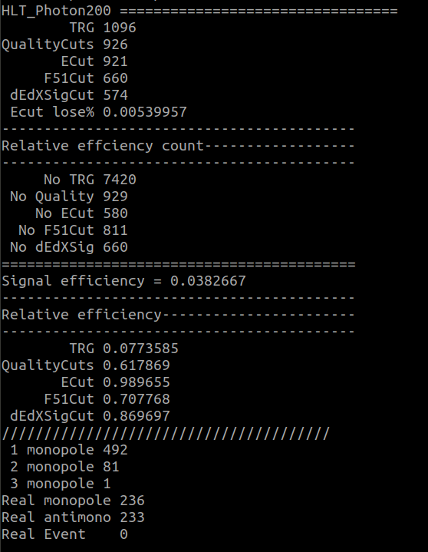
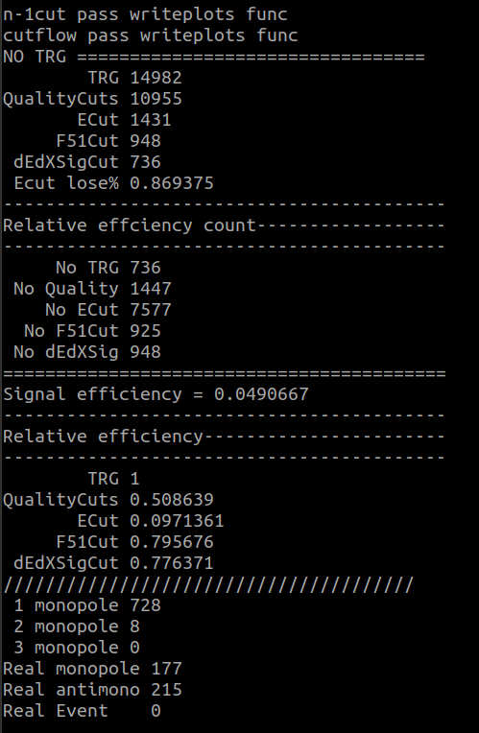

左邊是故意關掉pT cut 200看+HLT 結果為574
右邊是開pT cut 200 看no HLT 結果為736,

