How to test the functionality?

**Store Admin Functions -**

Step 1- Select the account (from which you published the contract or default account) from meta-mask as shown below:

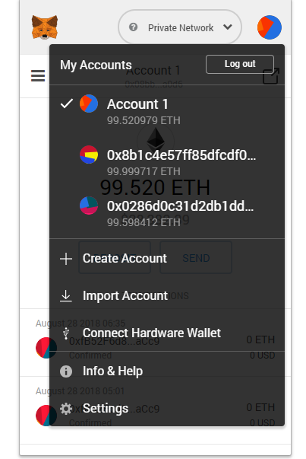

Step 2 – Open <http://localhost:3004/> and you will see that the default index.html is loaded and it invokes the contract to check if it’s an admin account, and welcomes the user.

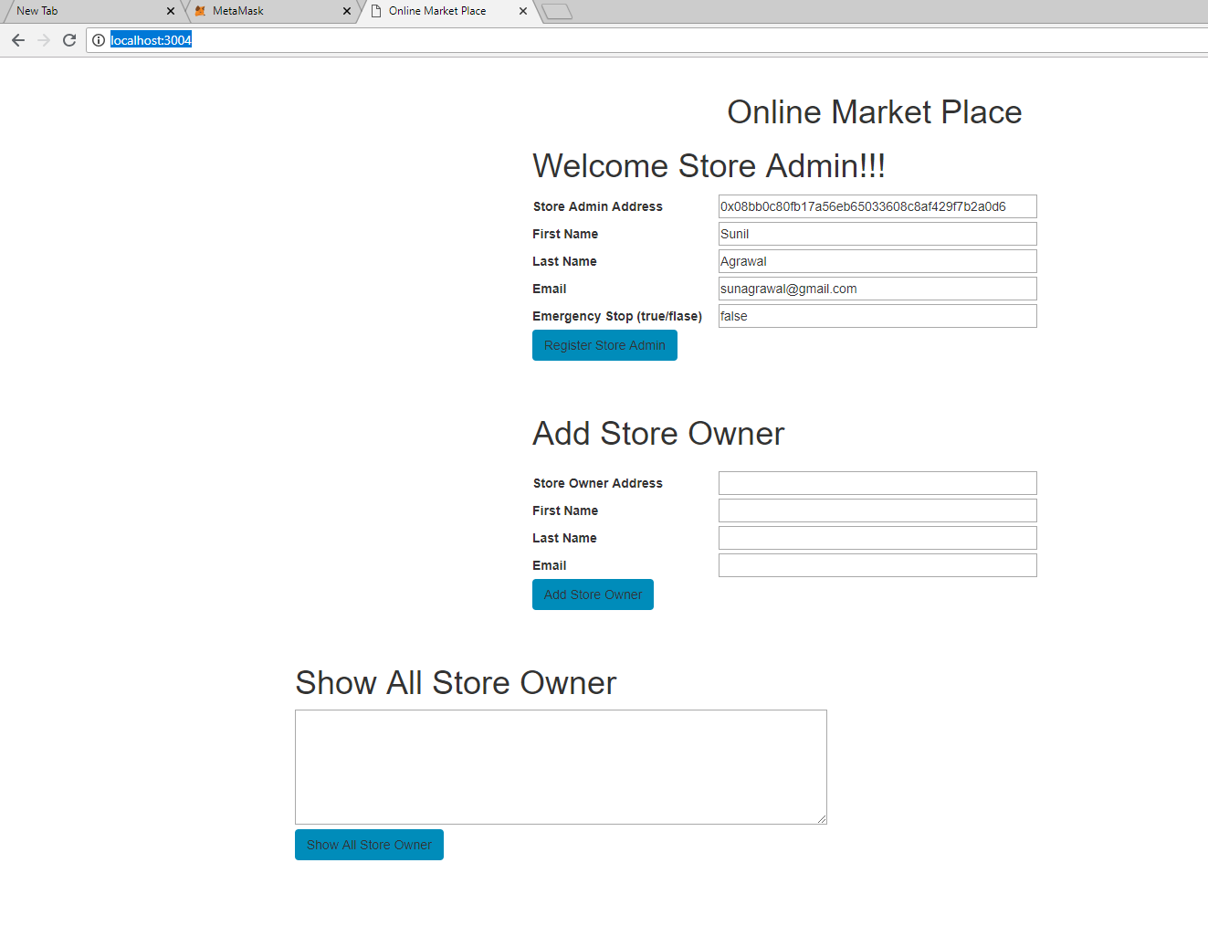

Step 3 – You can change the First Name, Last Name, Email and Emergency Stop attributes and hit Register Store Admin. Wait for few second till you get the block mined and then if you refresh the page, you will see the changes reflected like below –

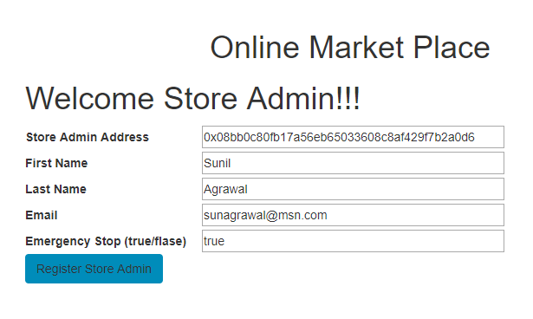

Step 4 – Now you as Store Admin, can create Store Owners (see below). Note here you need to pick any additional account address as Store Owner address and hit add button –

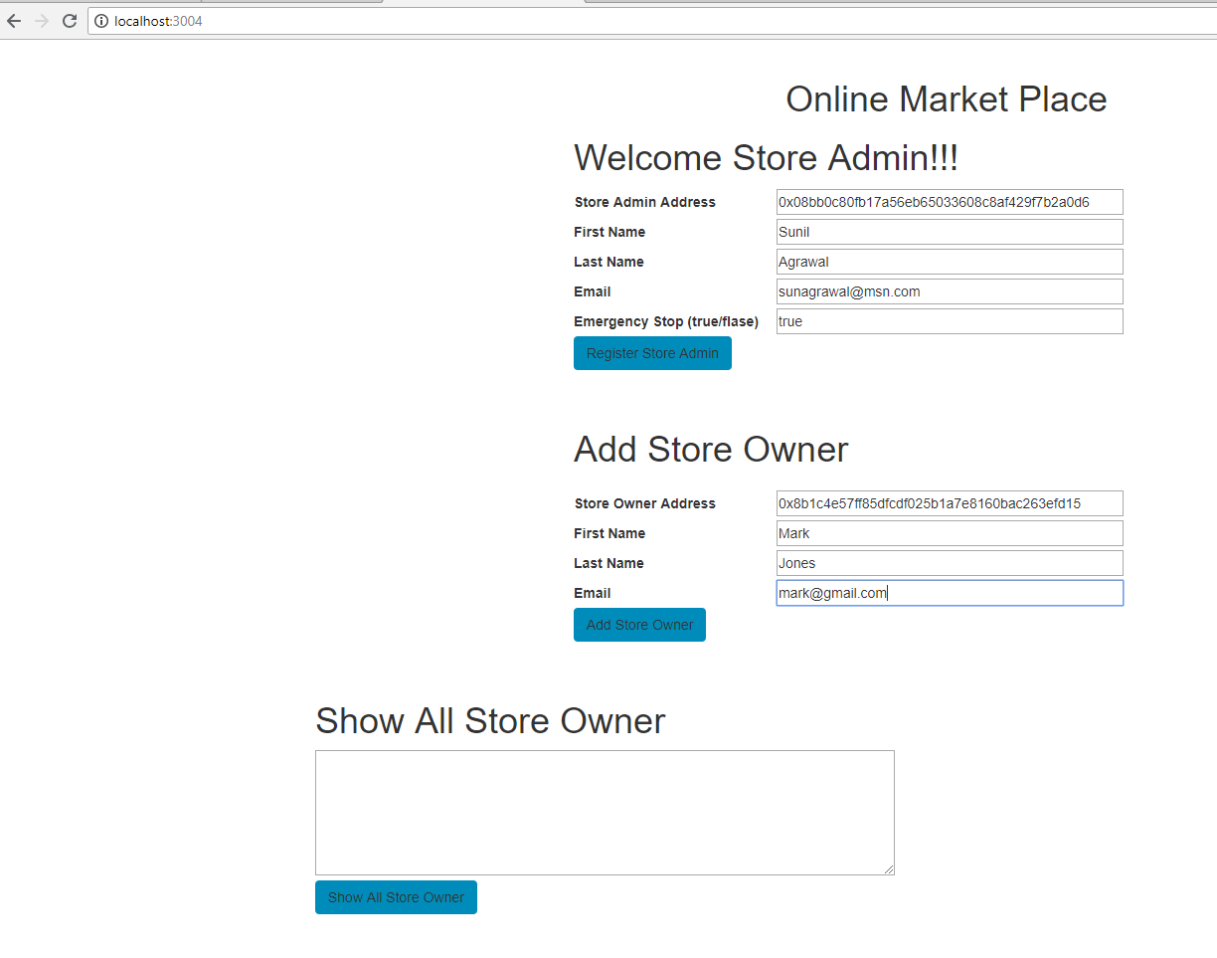

Once you hit “Add Store Owner” button you will see the following –

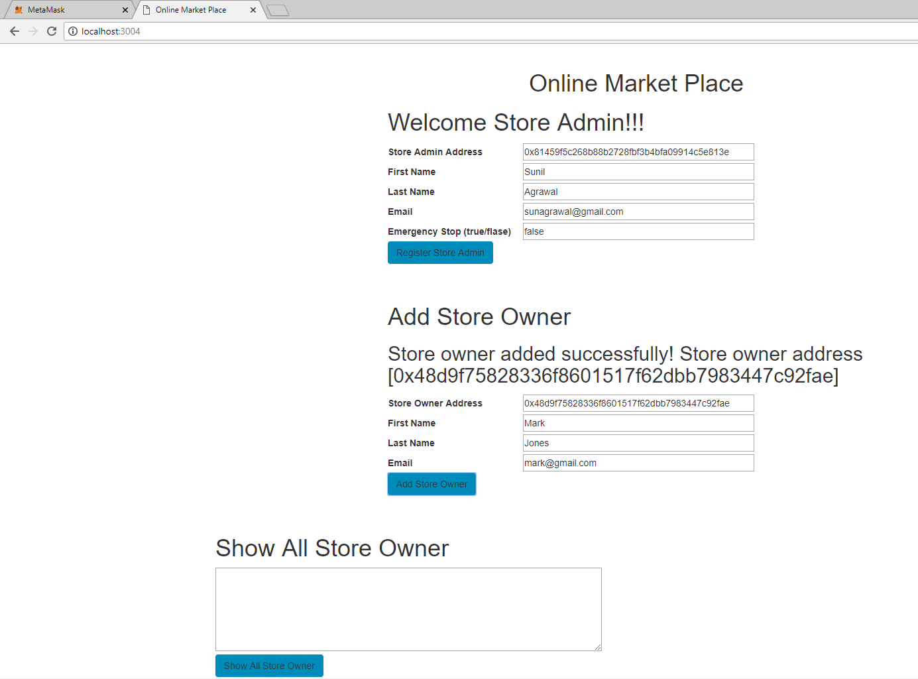

Step 5 – Now once you have added store owner. You can check all the store owners by clicking the button “Show All Store Owner”

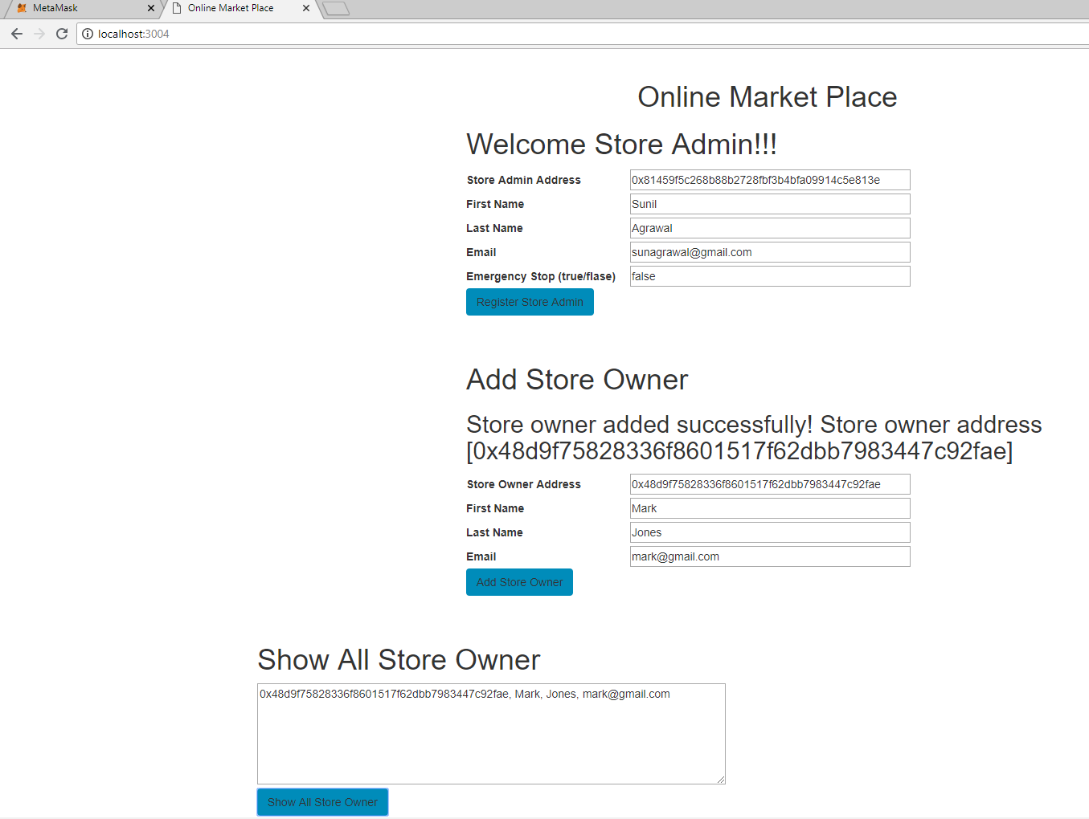

Note here you can see the recently added store owner in the list.

**Store Owner Functionality**

**Step 1- Change the address in meta-mask to Store Owner address (instead of the Store Admin Address) as shown below –**

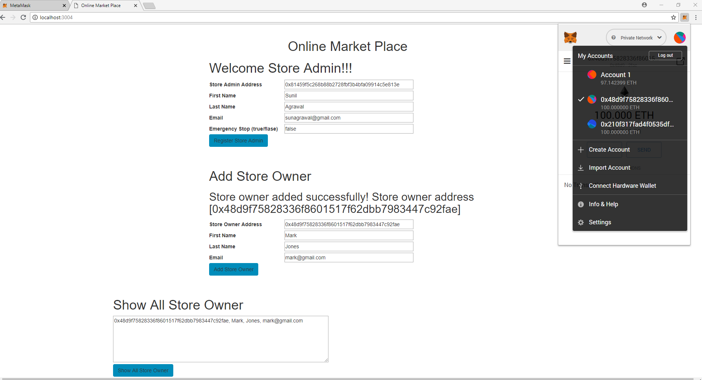

**Step 2 – Once you have select the store owners address, on the browser window hit refresh and you will see the page automatically detects it’s an Store Owner and show the Welcome message as shown below –**

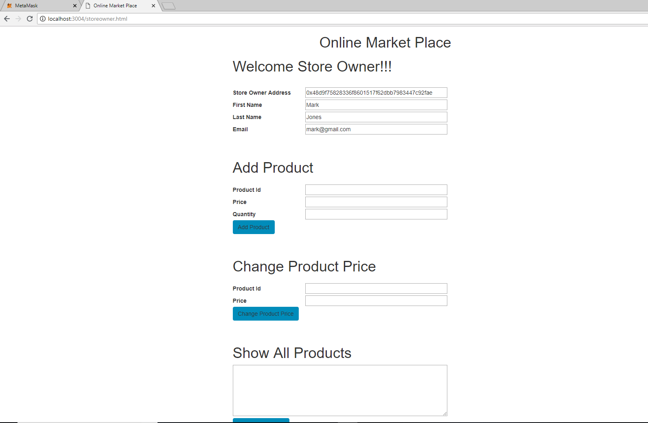

**Step 3 – Now you can add product by entering the Product Id, Price and Quantity as shown below –**

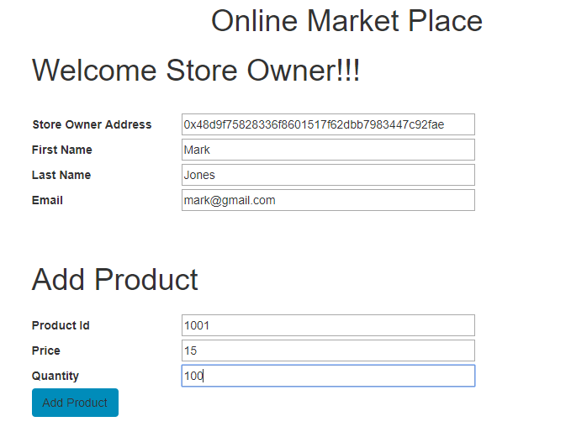

**And hit “Add Product” button. Once you finish this step you can go to “Show All Products” button and see all the products added in the list as shown below –**

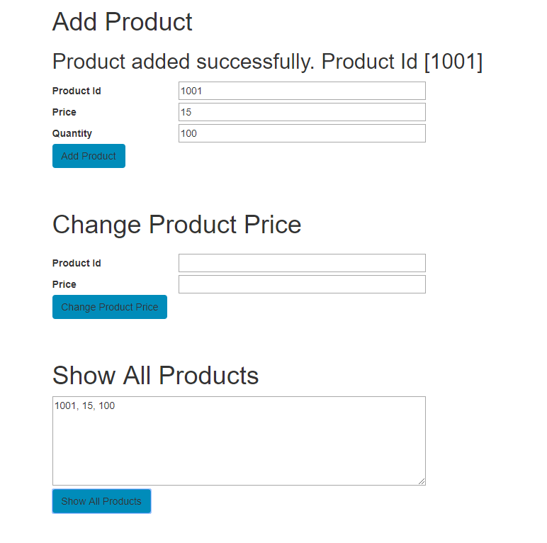

Step 4 – You can try other functions like Change Product Price, Remove Product and Get Store Balance.

Note here, Store Balance will show any balance the store accumulated from all the different sales across the products listed.

Also note that the Remove Product functionality is not very efficient and often complains about gas low error, so you might need to bump up the gas limit and price to test this functionality.

**Buyers Function-**

Finally you can select the third account from Meta-Mask that’s neither a Store Admin or Store Owner as shown below –

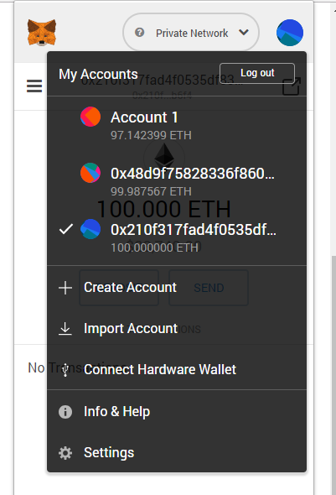

Now hit refresh again and you will notice it recognize that it’s not an admin or owners account, so the buyer page gets loaded, where the buyer can do the transaction as shown below –

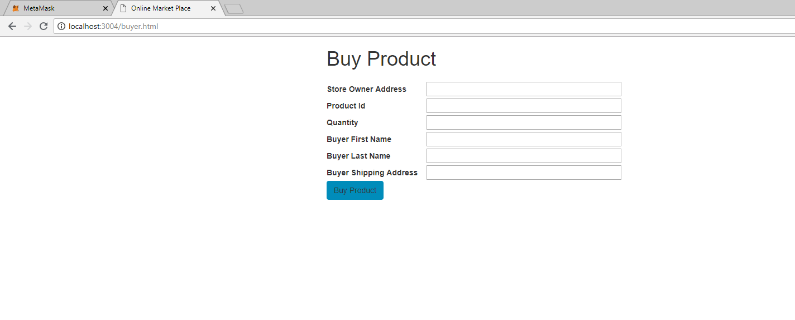

Note here, you have to manually type the Store Owner address, Product Id and Quantity along with the buyer information like first name, last name and shipping address.

Once you provide the required information and hit “Buy Product”, the transaction must go through. Remember you have to send the money which should be >= product price * quantity + Gas fees for your transaction to be successfully completed.

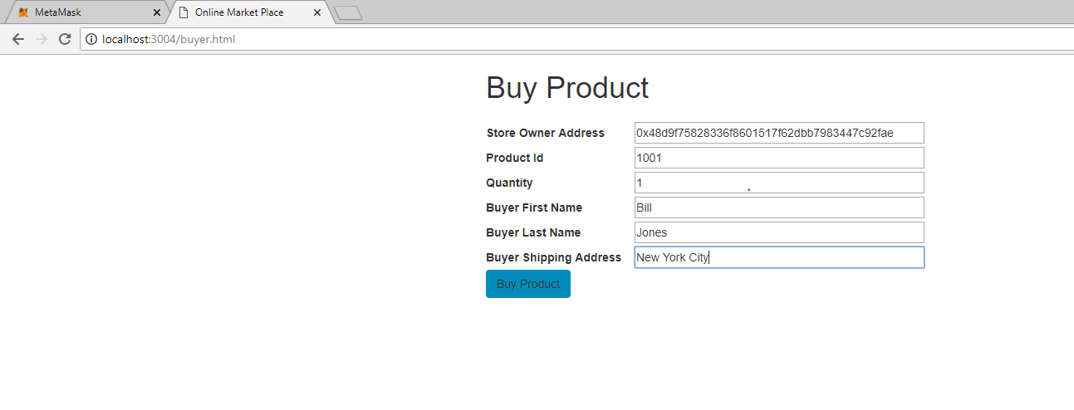

Hope this helps!