PBJ-2 Practical Assignment
Lab 1: End-to-End Loan Approval Automation
Camunda 8 · BPMN · DMN · Spring Boot Job Worker · REST Connector
Name: ______________________________
Register No.: ________________________
Date: 31 October 2026

1. Objective
Build an end-to-end loan approval workflow on Camunda 8 that combines BPMN orchestration, a DMN decision table, an external Java/Spring Boot job worker, a REST Connector to a credit-assessment API, process variables, a human review task in Tasklist, and monitoring and incident recovery in Operate. All applicant data is synthetic.

2. Environment and Tools
Component | Version / details
Camunda 8 Run (c8run) | 8.8.32, local: Zeebe, Operate, Tasklist, Connectors runtime 8.8.15
Camunda Desktop Modeler | 5.49.0, target platform Camunda 8.8
Java / Spring Boot | OpenJDK 21, Spring Boot 3.5.16, camunda-spring-boot-starter 8.8.32
IDE / build | IntelliJ IDEA, Maven
Mock credit API | Spring REST controller in the same app, port 8090
Operate / Tasklist | http://localhost:8080/operate and /tasklist (demo / demo)

3. Architecture
The solution has two runtime parts on one machine:
- Camunda 8 Run executes the process (Zeebe), evaluates the DMN, runs the REST Connector, serves the Tasklist form and records history for Operate.
- Spring Boot application (port 8090) hosts the validate-applicant job worker and the mock credit-bureau endpoint GET /api/credit-score/{applicantId}.
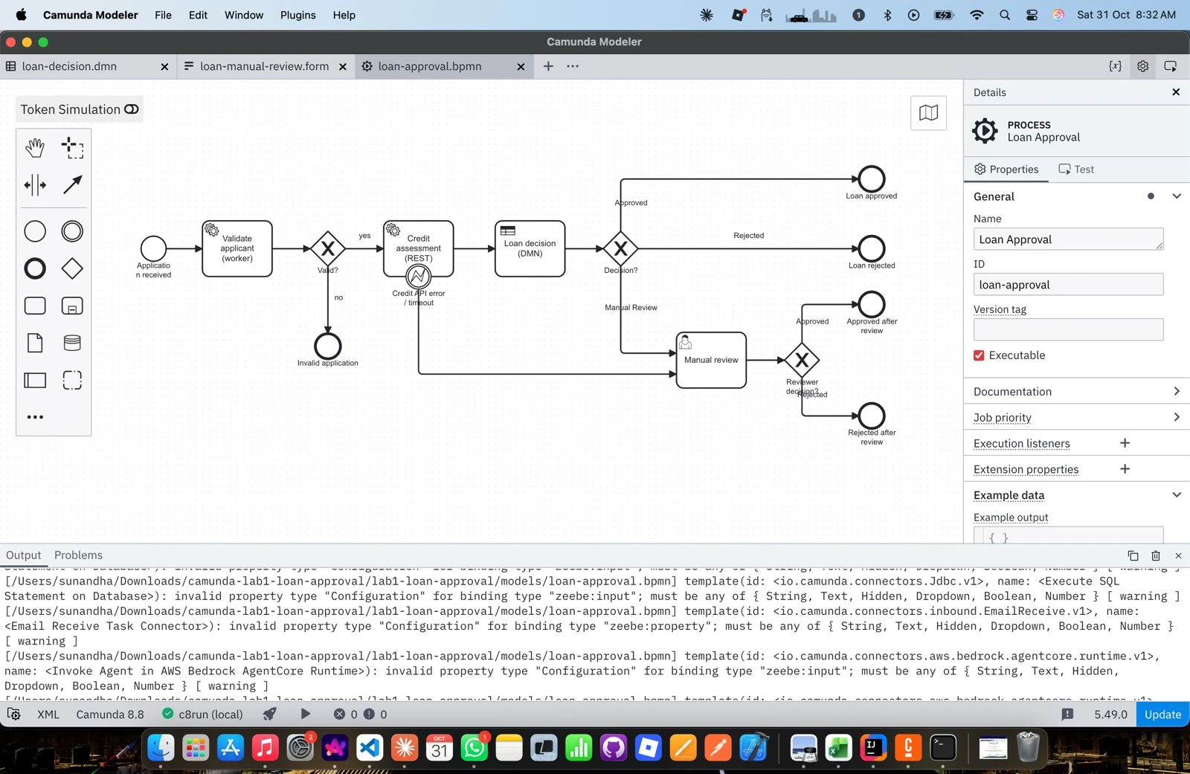
Figure 1: Loan Approval BPMN process in Camunda Desktop Modeler (process id loan-approval)
Execution flow: Application received → Validate applicant (Java worker) → Valid? gateway → Credit assessment (REST Connector) → Loan decision (DMN) → Decision? gateway → Loan approved / Loan rejected / Manual review. If the credit API returns an error or times out, an error boundary event routes the case straight to Manual review. After review, the Reviewer decision? gateway ends the instance at Approved after review or Rejected after review. Invalid applications end at Invalid application.

4. Implementation

4.1 BPMN process
Element | Type | Configuration
Validate applicant | Service task | Job type validate-applicant, 3 retries (Java worker)
Valid? | Exclusive gateway | =valid = true / =valid = false
Credit assessment | Service task (REST Connector) | Type io.camunda:http-json:1, GET mock API, 5 s read timeout
Credit API error / timeout | Error boundary event | Error code CREDIT_API_ERROR; output mapping exposes creditApiError
Loan decision | Business rule task | Calls DMN loan-decision, result variable decision
Decision? | Exclusive gateway | Routes on decision = Approved / Rejected / Manual Review
Manual review | User task (Camunda user task) | Assignee demo, linked form loan-manual-review
Reviewer decision? | Exclusive gateway | Routes on reviewDecision = Approved / Rejected

4.2 DMN decision table
Decision loan-decision, hit policy FIRST (rules are checked top to bottom; the first match wins). Inputs: creditScore, paymentToIncomeRatio, loanAmount. Output: decision (string).
Rule | creditScore | paymentToIncomeRatio | loanAmount | decision
R1 | < 550 | – | – | Rejected
R2 | – | > 0.5 | – | Rejected
R3 | >= 700 | <= 0.35 | <= 50000 | Approved
R4 | – | – | – | Manual Review

These are simplified educational rules. paymentToIncomeRatio = (loanAmount / loanTermMonths) / monthlyIncome; interest is ignored. Sample evaluations from the test runs:
Applicant | creditScore | ratio | Rule hit | decision
A-100 | 780 | 0.09 | R3 | Approved
A-200 | 480 | 0.16 | R1 | Rejected
A-300 | 640 | 0.13 | R4 | Manual Review
A-600 (after fix) | 760 | 0.10 | R3 | Approved

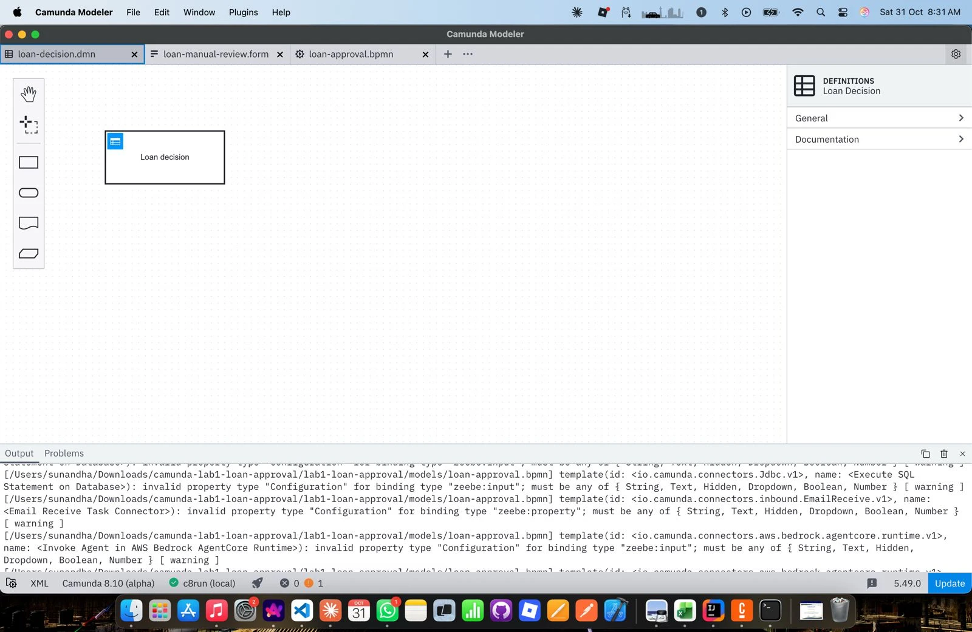
Figure 2: DMN decision requirements diagram (loan-decision) in Desktop Modeler

4.3 Spring Boot job worker
ValidateApplicantWorker is annotated with @JobWorker(type = "validate-applicant"). It reads the applicant variables, validates them, and returns new process variables (the job is auto-completed).
- Business validation (returns valid = false plus validationErrors): applicantId and applicantName required, age 18–75, loanAmount 1–500000, loanTermMonths 6–360, monthlyIncome > 0.
- Derived values when valid: monthlyInstallment and paymentToIncomeRatio.
- Technical failure (for the incident test): if monthlyIncome is missing, the worker throws IllegalStateException. The job fails, the 3 retries are used up and Zeebe raises a JOB_NO_RETRIES incident.
@JobWorker(type = "validate-applicant")
public Map<String, Object> validate(@Variable String applicantId, @Variable String applicantName,
@Variable Integer age, @Variable Double loanAmount,
@Variable Double monthlyIncome, @Variable Integer loanTermMonths) {
if (monthlyIncome == null) throw new IllegalStateException("monthlyIncome is missing ...");
...
return Map.of("valid", true, "monthlyInstallment", installment,
"paymentToIncomeRatio", round(installment / monthlyIncome), ...);
}
Configuration (application.properties): server.port=8090, camunda.client.grpc-address=http://localhost:26500, camunda.client.rest-address=http://localhost:8080. Three JUnit tests cover the approve, invalid and missing-income paths (mvn test: 3 passed).

4.4 REST Connector and mock credit API
Setting | Value
Method / auth | GET, no authentication
URL | ="http://localhost:8090/api/credit-score/" + applicantId
Timeouts | connection 20 s, read 5 s
Result expression | ={creditScore: response.body.creditScore, creditReference: response.body.reference}
Error expression | =if error != null then bpmnError("CREDIT_API_ERROR", error.message, {creditApiError: {code: error.code, message: error.message}}) else null

Mock behaviour: A-100 → 780, A-200 → 480, A-300 → 640, A-600 → 760, any other ID → 650. IDs starting with ERR return HTTP 503; IDs starting with SLOW respond after 10 s, which exceeds the 5 s timeout.
GET http://localhost:8090/api/credit-score/A-100
200 {"applicantId":"A-100","creditScore":780,"reference":"CB-A-100"}

GET http://localhost:8090/api/credit-score/ERR-400
503 {"error":"Credit bureau unavailable"}
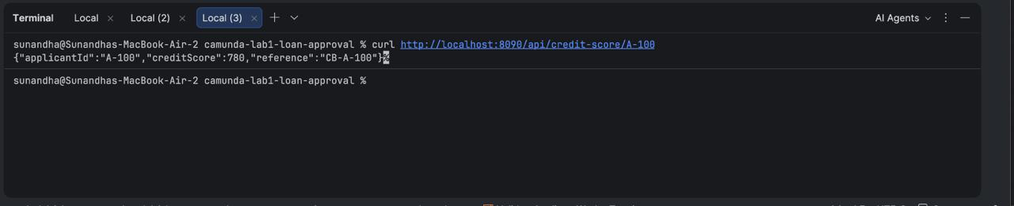
Figure 3: Mock credit-assessment API called from the terminal

4.5 Manual review task (Tasklist)
The Manual review user task uses the linked form loan-manual-review. It shows a summary of the application (applicant, amount, income, ratio, credit score, DMN decision and any credit API error) and collects reviewDecision (Approve / Reject, required) and an optional reviewComment.

4.6 Process variables
Variable | Type | Set by | Purpose
applicantId | String | Start | Synthetic reference; also used in the API URL
applicantName | String | Start | Display name
age | Number | Start | Eligibility check (18–75)
loanAmount | Number | Start | Requested amount; DMN input
monthlyIncome | Number | Start | Affordability; missing value triggers the incident test
loanTermMonths | Number | Start | Loan term (6–360)
valid | Boolean | Worker | Drives the Valid? gateway
validationErrors | List | Worker | Reasons an application is invalid
monthlyInstallment | Number | Worker | loanAmount / loanTermMonths
paymentToIncomeRatio | Number | Worker | DMN input
creditScore | Number | REST Connector | DMN input
creditReference | String | REST Connector | Credit bureau reference
creditApiError | String | Error boundary event | HTTP code / message shown to the reviewer
decision | String | DMN | Approved / Rejected / Manual Review
reviewDecision | String | Tasklist form | Reviewer's Approved / Rejected
reviewComment | String | Tasklist form | Reviewer's note

5. Deployment and Execution
The DMN, the form and the BPMN were deployed to the local cluster from Desktop Modeler (target c8run (local)). The Spring Boot app was started with mvn spring-boot:run, and one instance per scenario was started through the Orchestration Cluster REST API:
curl -u demo:demo -H "Content-Type: application/json" \
-X POST http://localhost:8080/v2/process-instances -d @test-data/1-approved.json
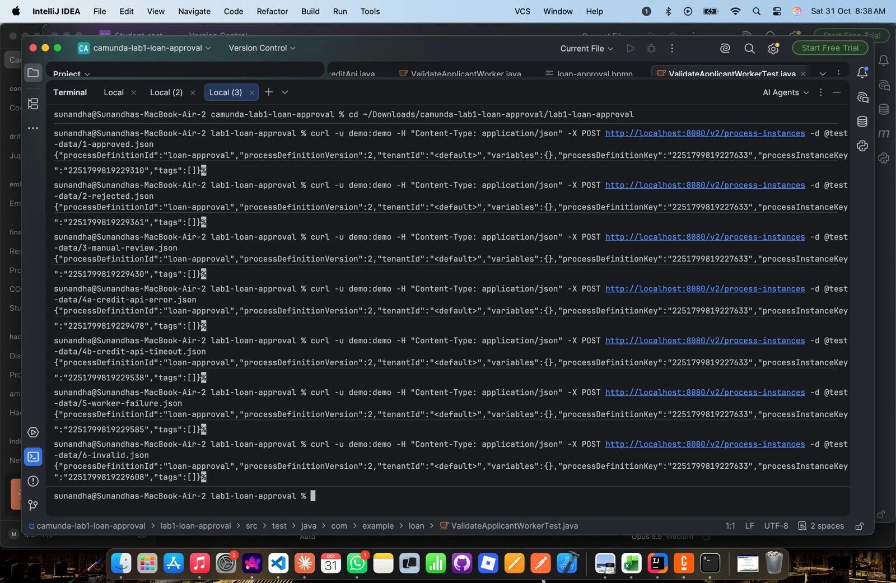
Figure 4: Starting the seven scenario instances (process version 2)
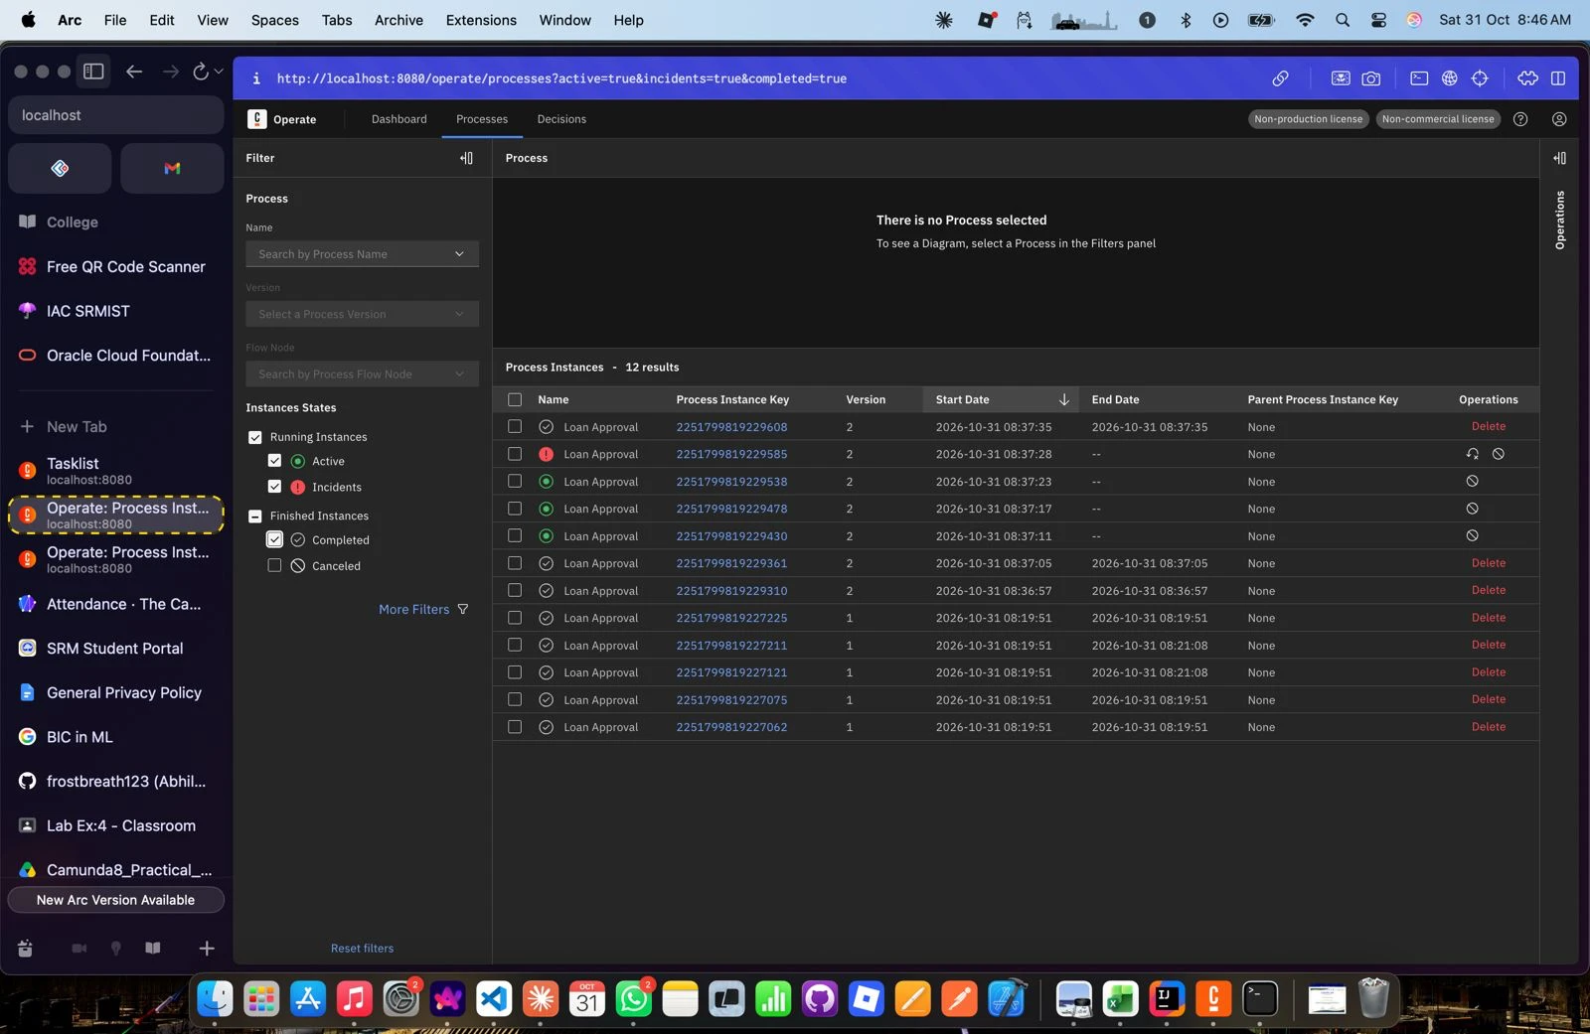
Figure 5: Operate: instance list with active, incident and completed instances

6. Test Results
All seven scenarios behaved as expected.
# | Scenario | Instance (ver.) | Actual outcome | Status
1 | Meets approval criteria (A-100) | …229310 (v2) | Score 780, ratio 0.09, R3 → Loan approved | Pass
2 | Fails eligibility (A-200) | …229361 (v2) | Score 480, R1 → Loan rejected | Pass
3 | Needs manual review (A-300) | …233882 (v3) | Score 640, R4 → Tasklist → Approved after review | Pass
4a | Credit API error (ERR-400) | …234146 (v3) | HTTP 503 → boundary event → Tasklist → Rejected after review | Pass
4b | Credit API timeout (SLOW-500) | …233559 (v3) | 408 timeout → boundary event → Tasklist → Approved after review | Pass
5 | Worker failure + recovery (A-600) | …229585 (v2) | Incident → monthlyIncome added → Retry → Loan approved | Pass
6 | Invalid input (A-700, age 16) | …229608 (v2) | valid = false → Invalid application | Pass

6.1 Scenario 1: Approved
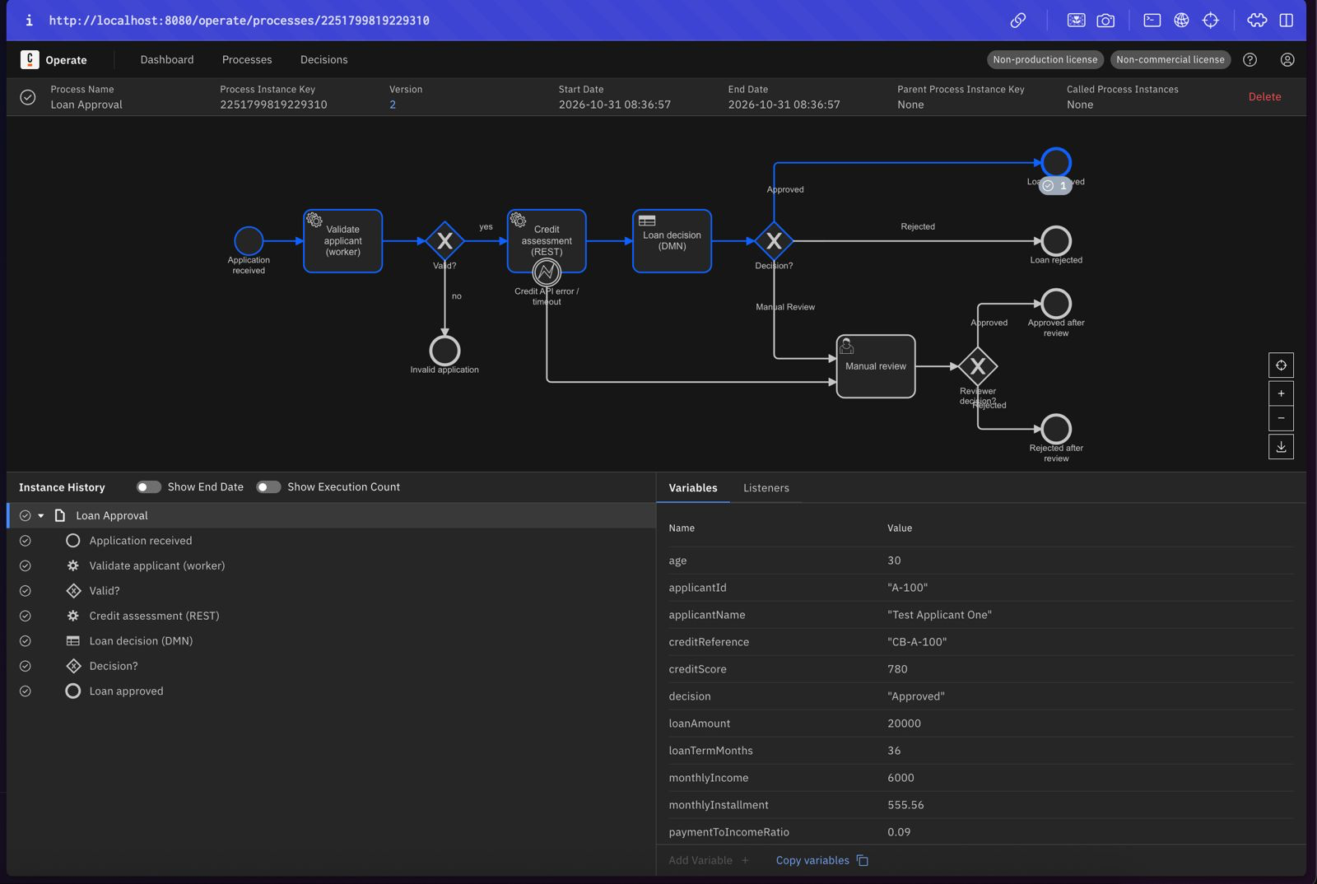
Figure 6: Scenario 1 (A-100): path to Loan approved, decision = "Approved"

6.2 Scenario 2: Rejected
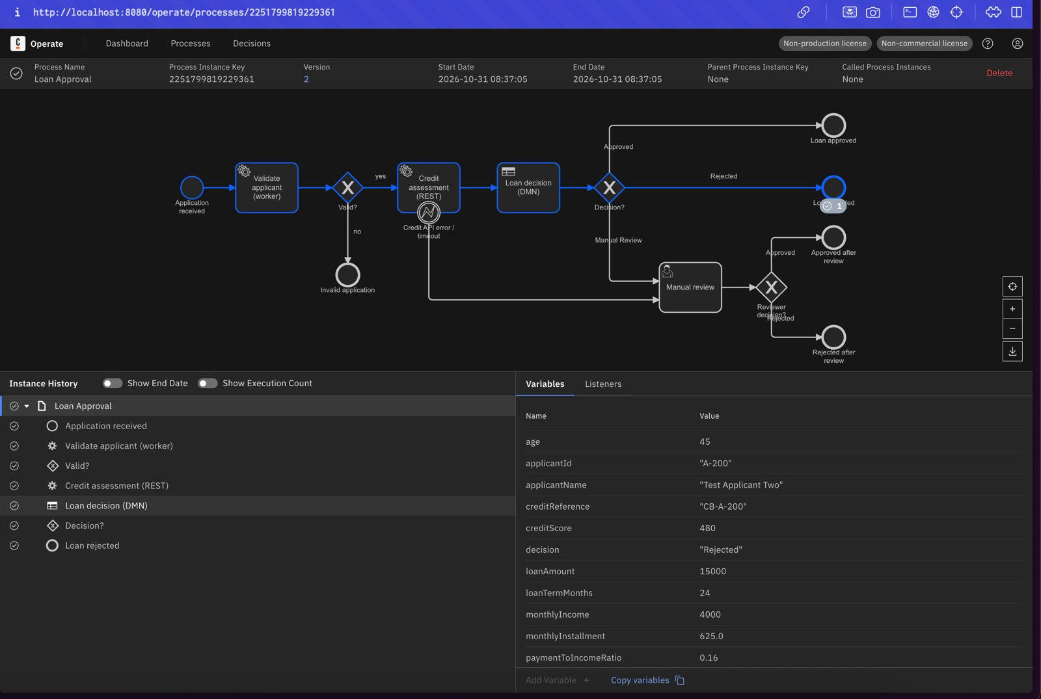
Figure 7: Scenario 2 (A-200): creditScore 480 → Loan rejected

6.3 Scenario 3: Manual review
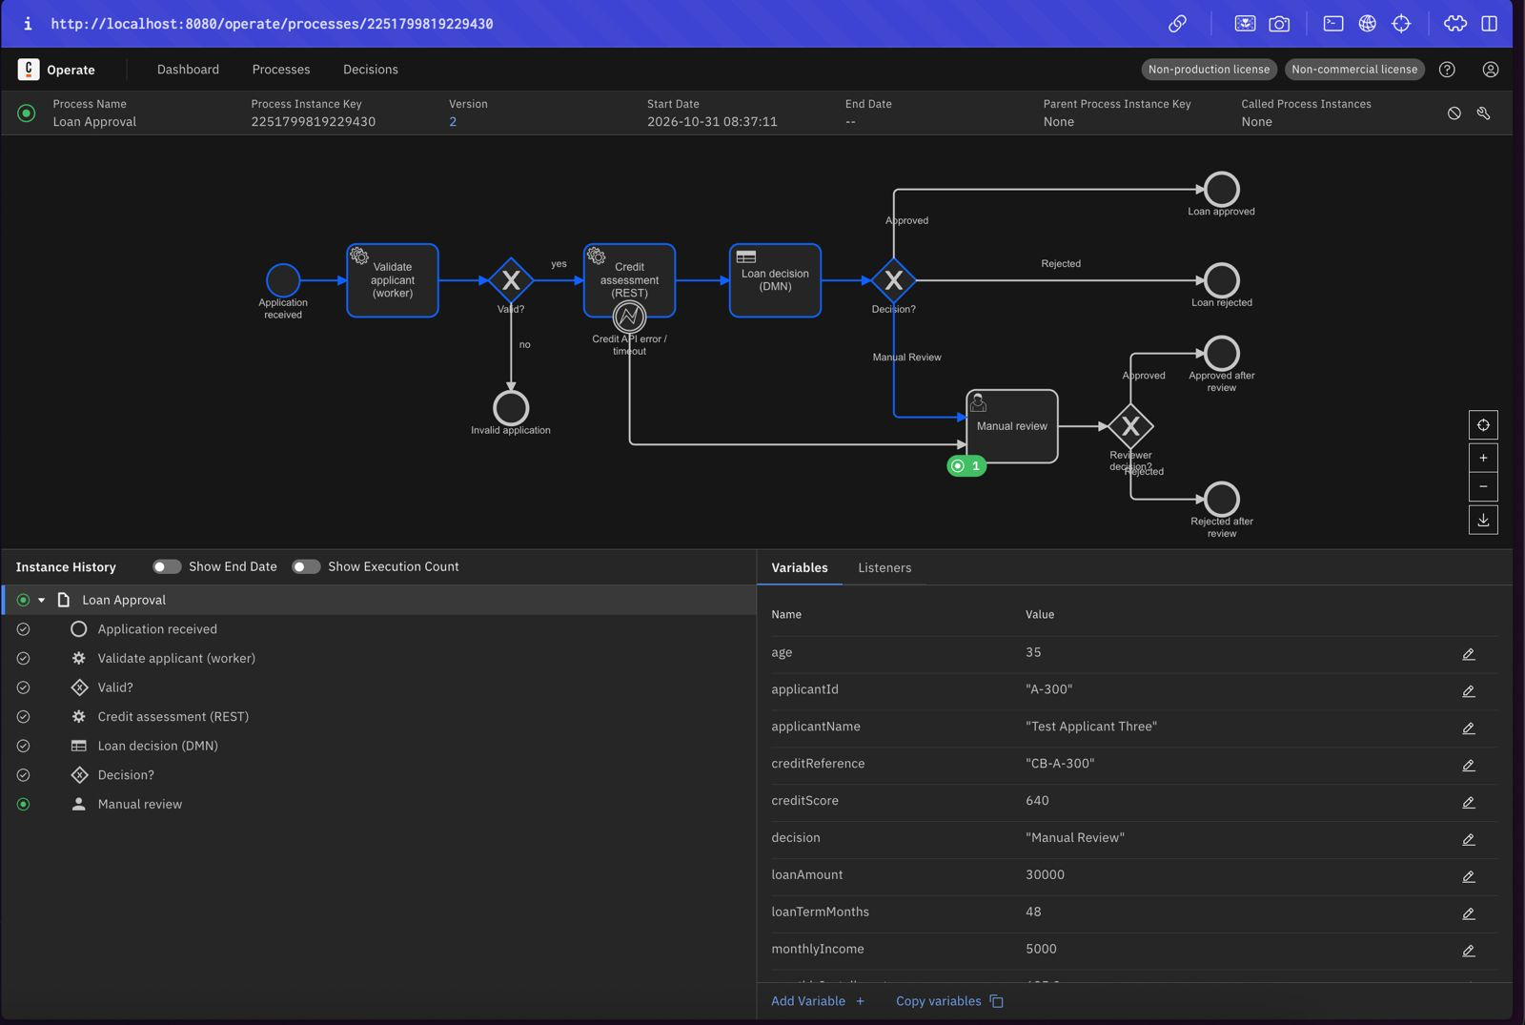
Figure 8: Scenario 3 (A-300): DMN returns Manual Review; instance waits at the user task
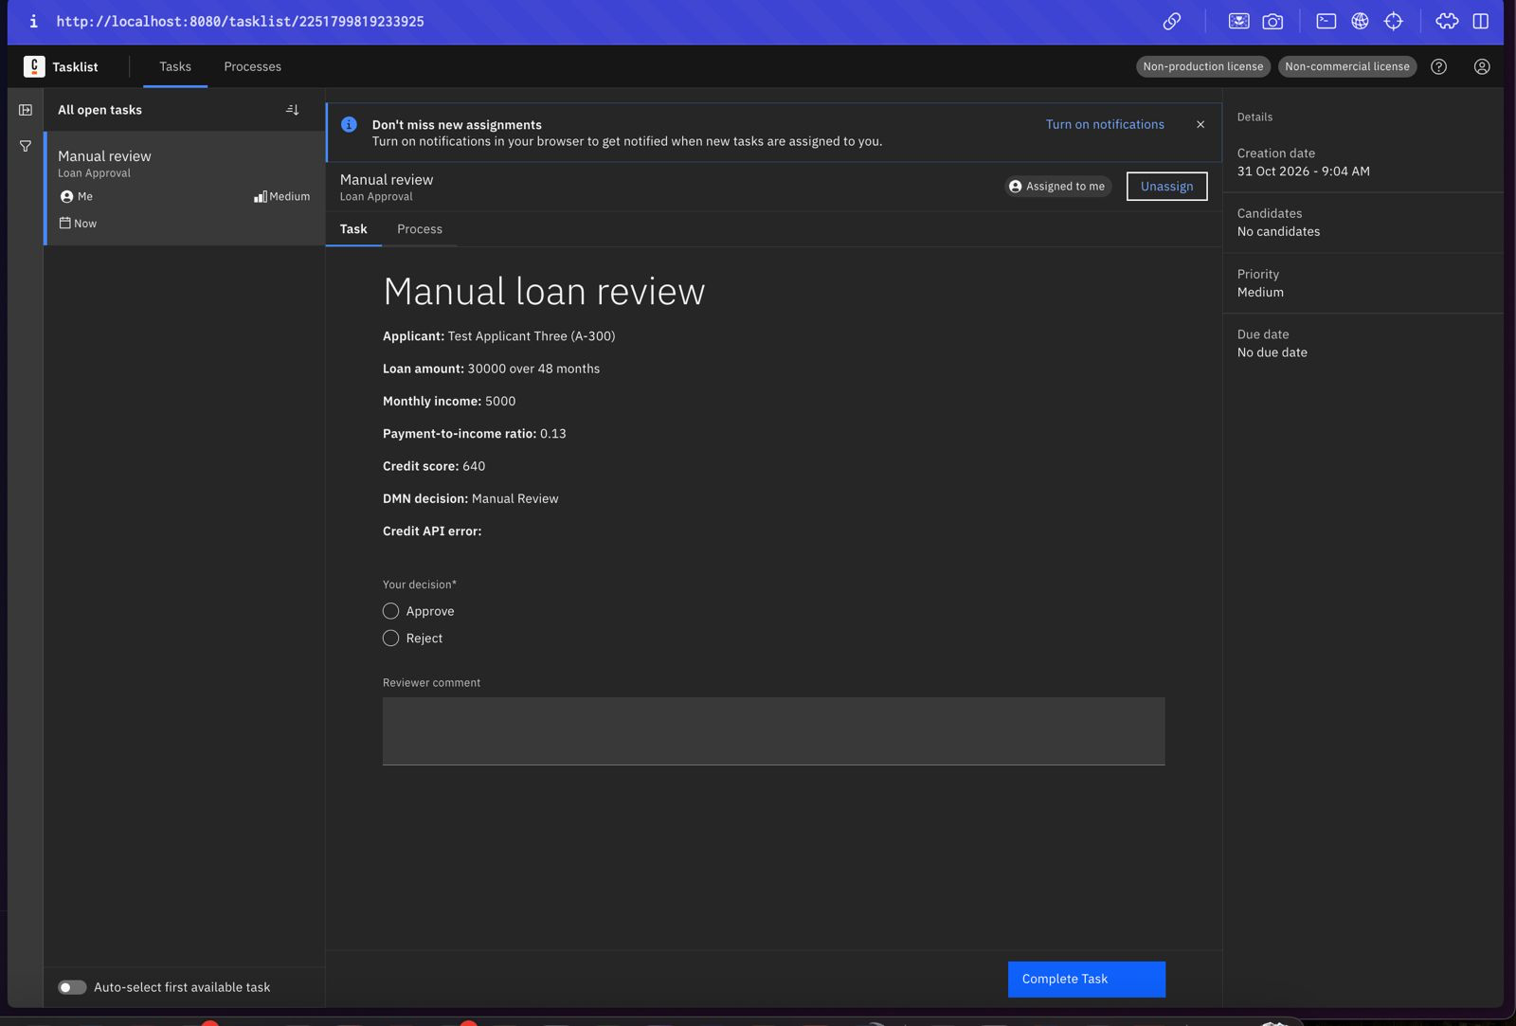
Figure 9: Scenario 3: review form in Tasklist (credit score 640, DMN decision Manual Review)
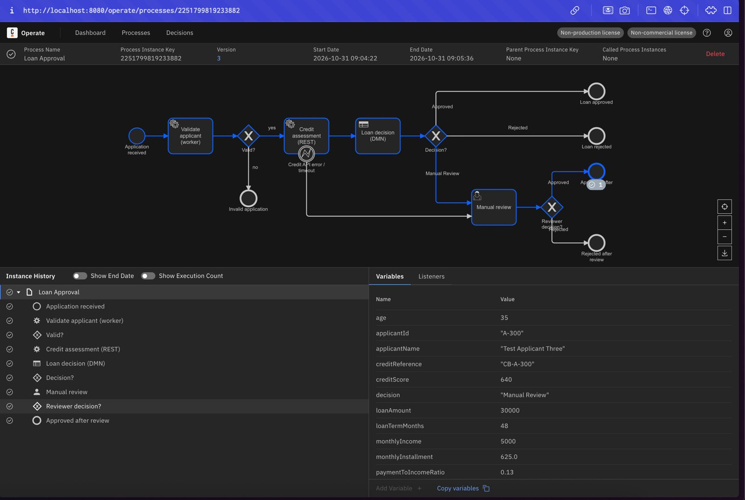
Figure 10: Scenario 3: reviewer approved → Approved after review

6.4 Scenario 4a: Credit API error
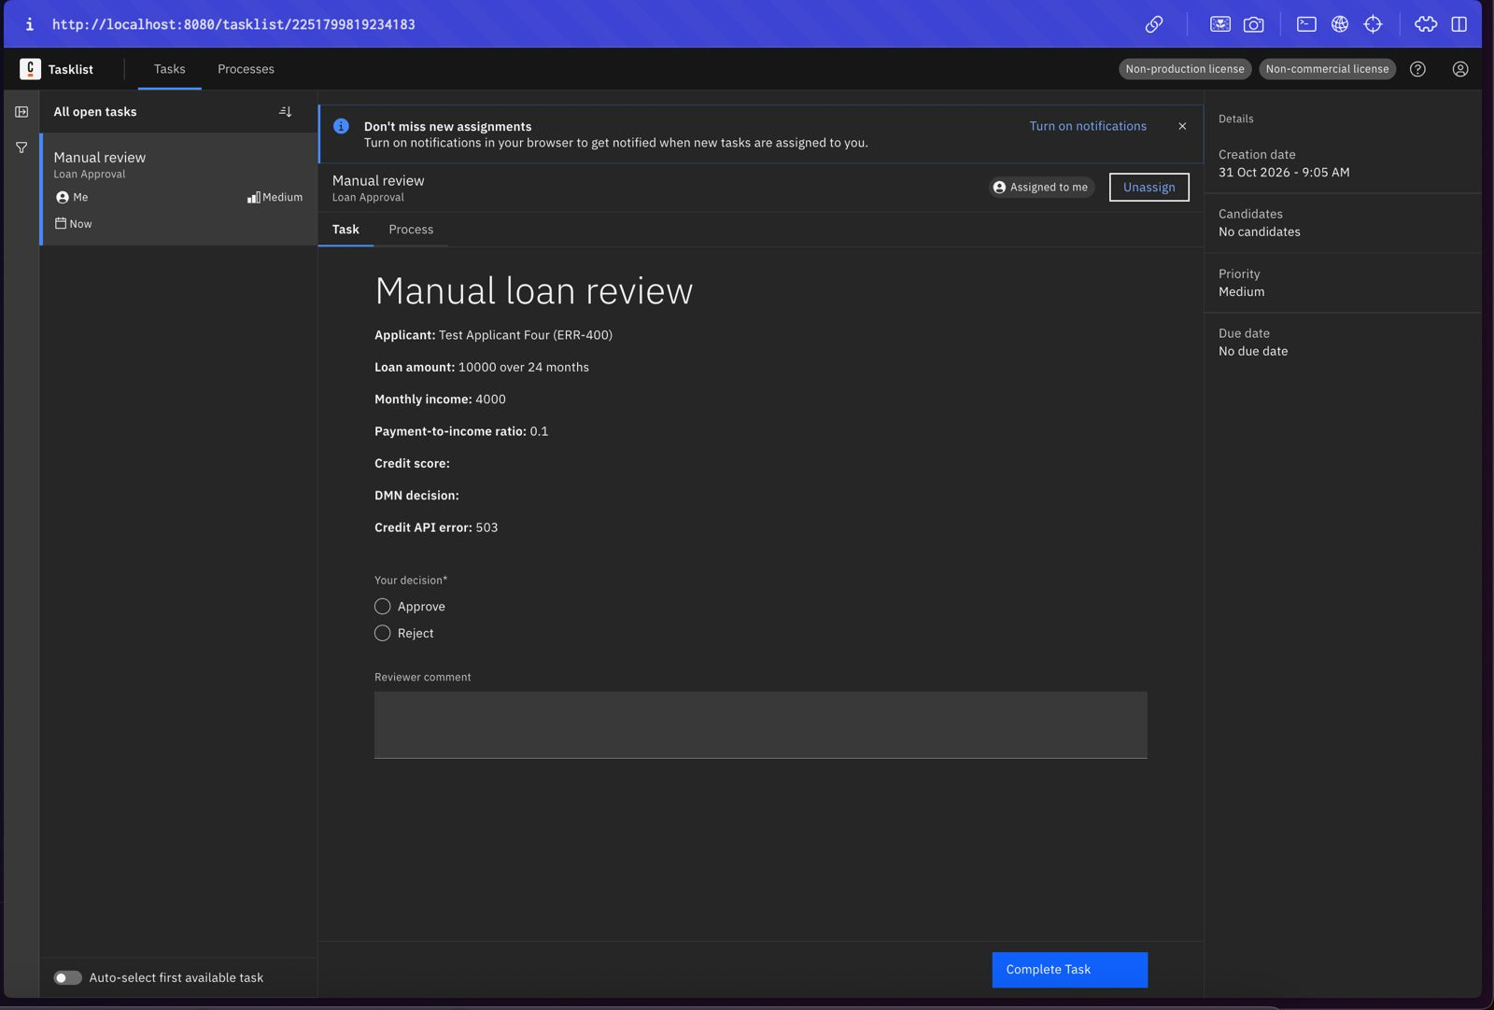
Figure 11: Scenario 4a (ERR-400): Tasklist shows Credit API error 503
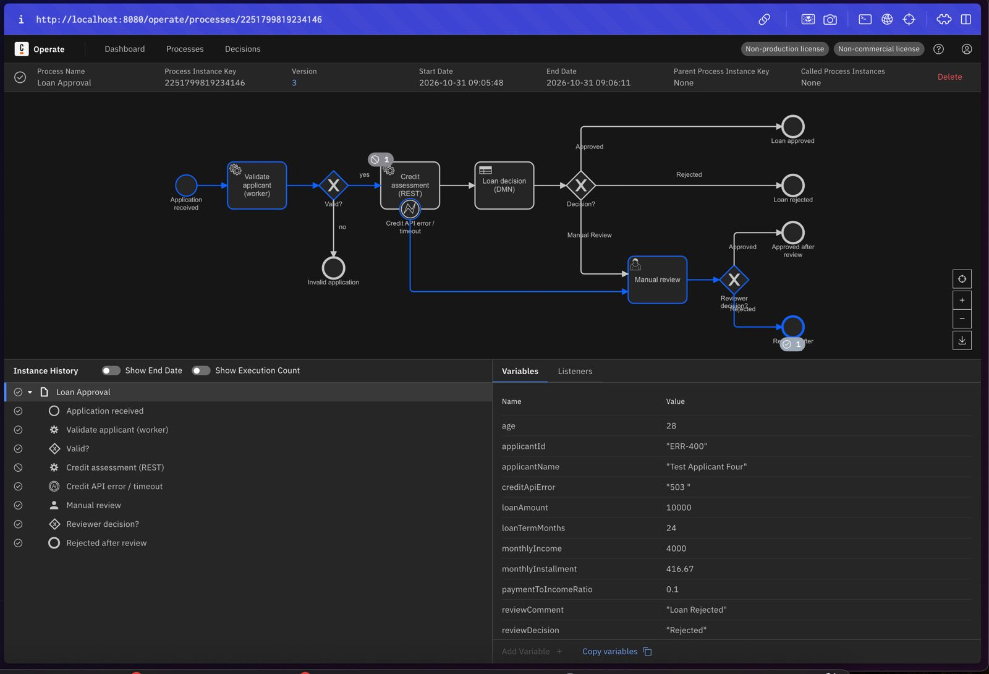
Figure 12: Scenario 4a: REST task interrupted by the error boundary event → Rejected after review

6.5 Scenario 4b: Credit API timeout
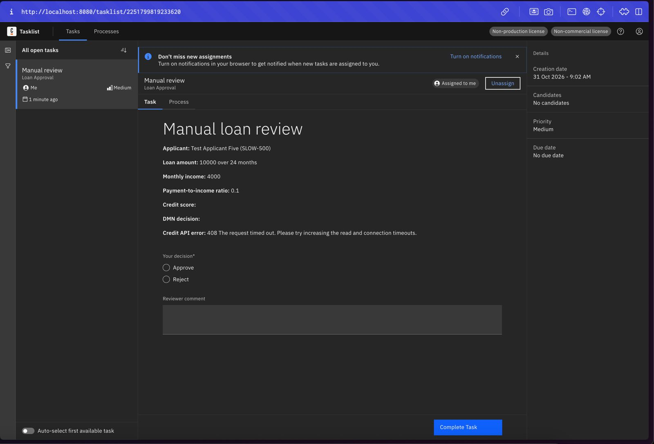
Figure 13: Scenario 4b (SLOW-500): Tasklist shows the 408 read timeout
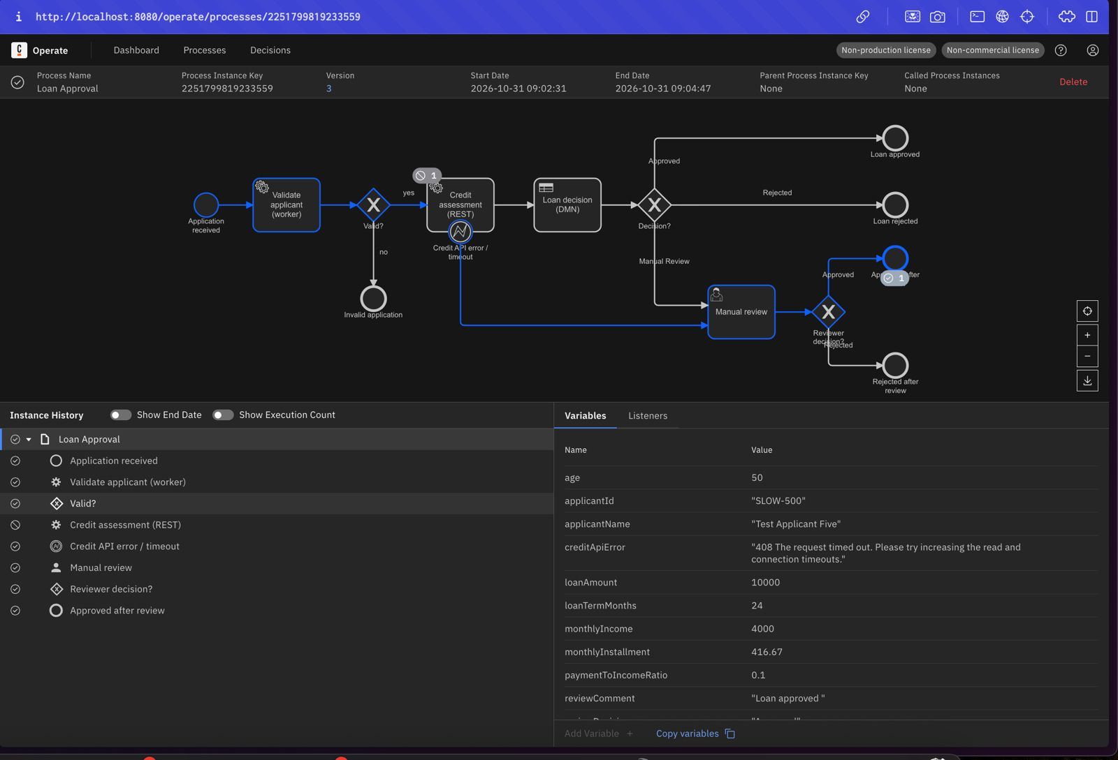
Figure 14: Scenario 4b: timeout routed to manual review → Approved after review

6.6 Scenario 6: Invalid application
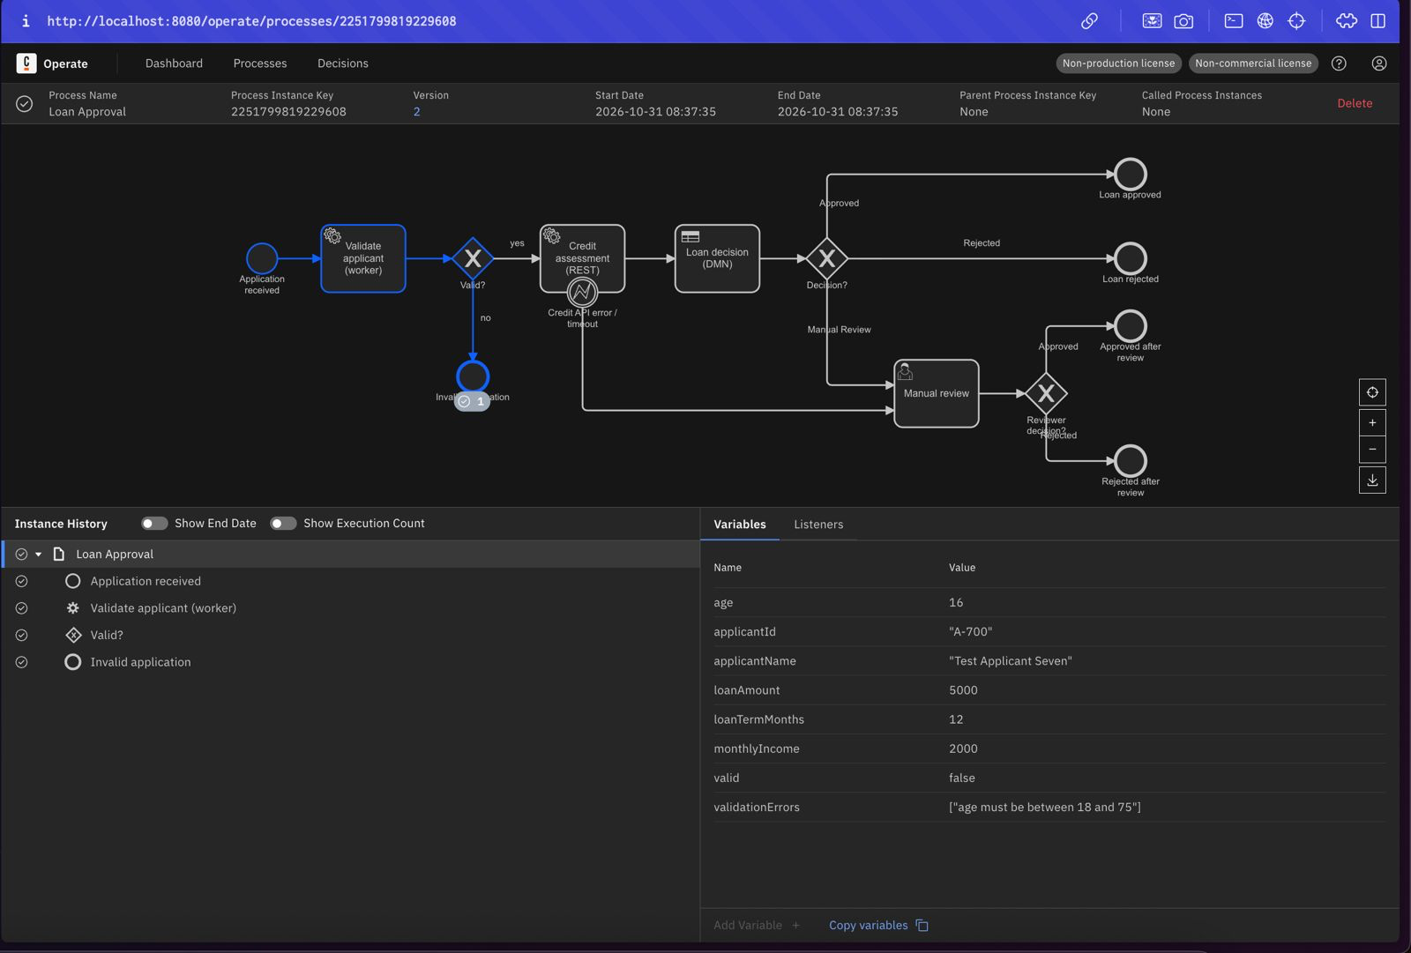
Figure 15: Scenario 6 (A-700): age 16 → valid = false → Invalid application

7. Incident Investigation and Recovery
Scenario 5 was started without monthlyIncome to simulate a worker failure.
- Detect: Operate shows the instance with a red incident on Validate applicant (type JOB_NO_RETRIES) after the worker failed three times.
- Diagnose: the incident message is java.lang.IllegalStateException: monthlyIncome is missing for applicant A-600. The Variables panel confirms monthlyIncome is absent.
- Correct: monthlyIncome = 5000 was added to the instance with Add Variable in Operate.
- Retry: the incident was retried from Operate. The worker completed the job, the credit check returned 760, the DMN approved, and the instance ended at Loan approved at 09:14:07.
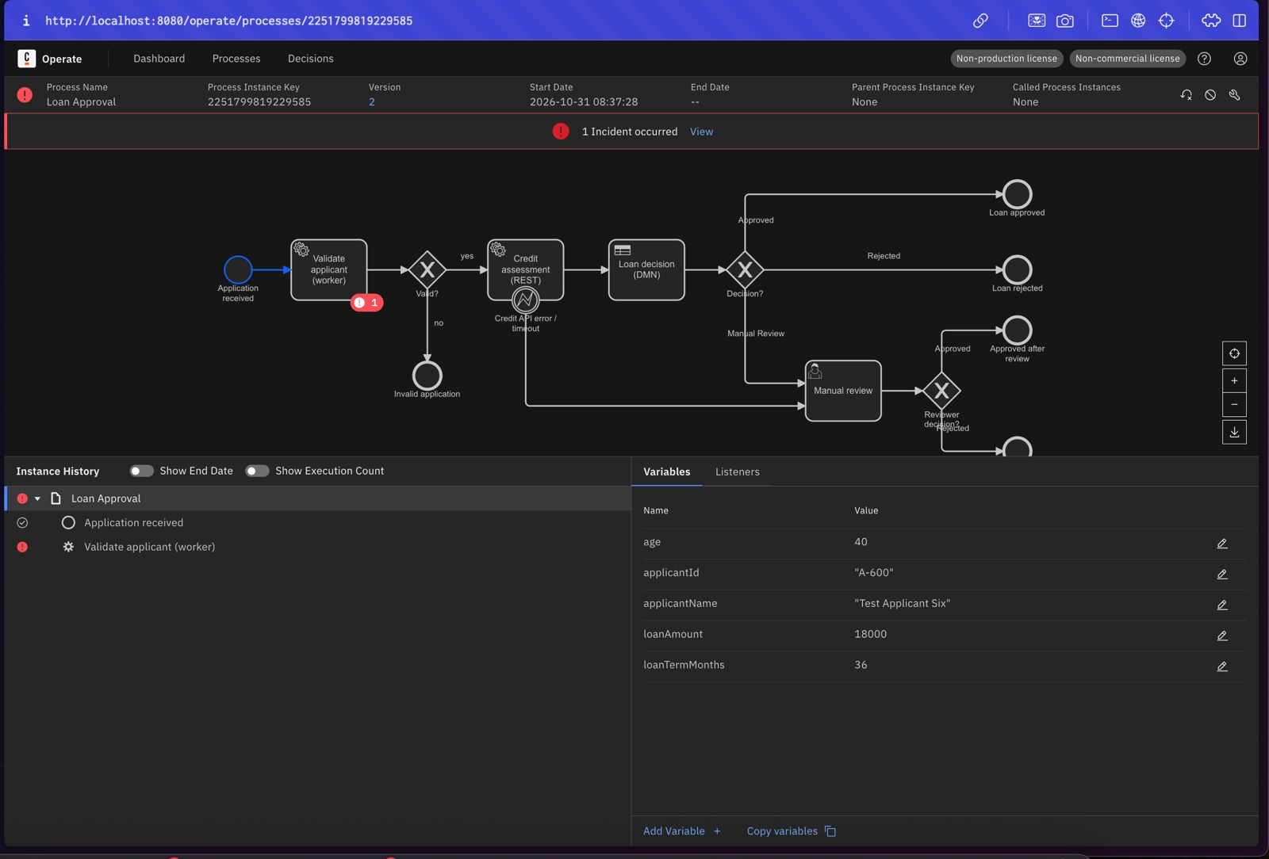
Figure 16: Scenario 5 (A-600): incident on Validate applicant, monthlyIncome missing
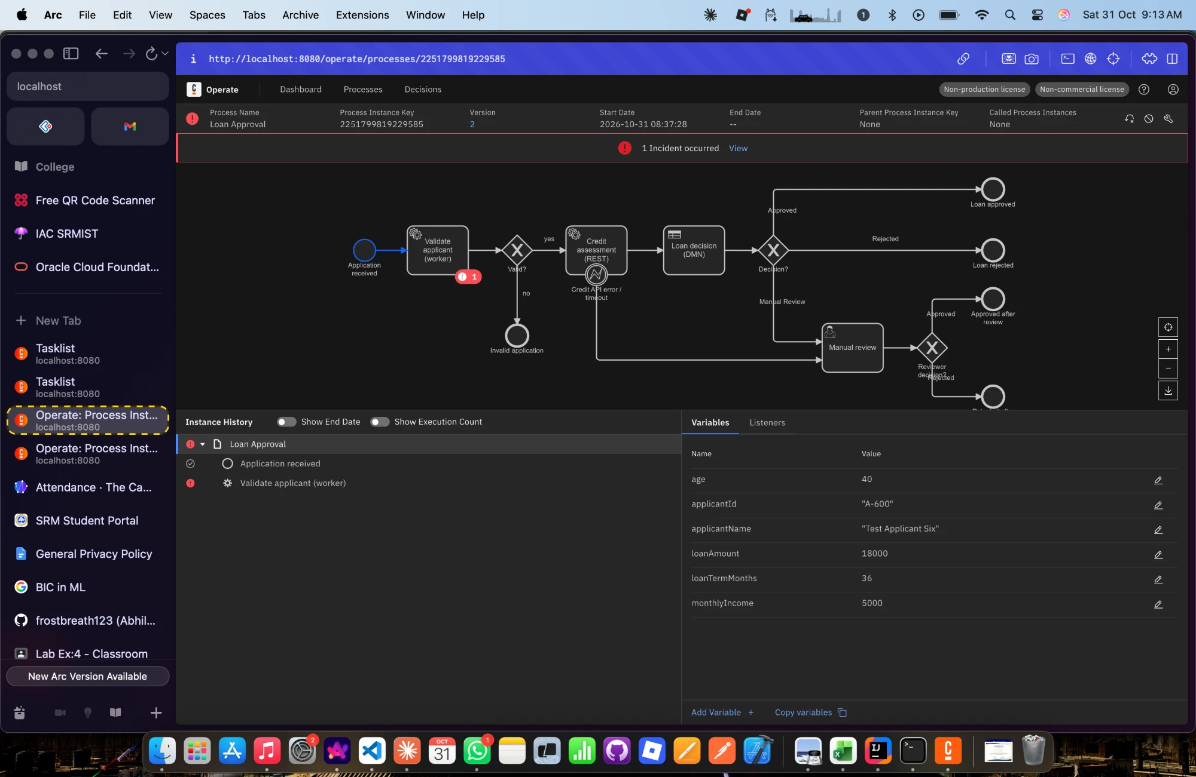
Figure 17: Scenario 5: corrective action, monthlyIncome = 5000 added in Operate
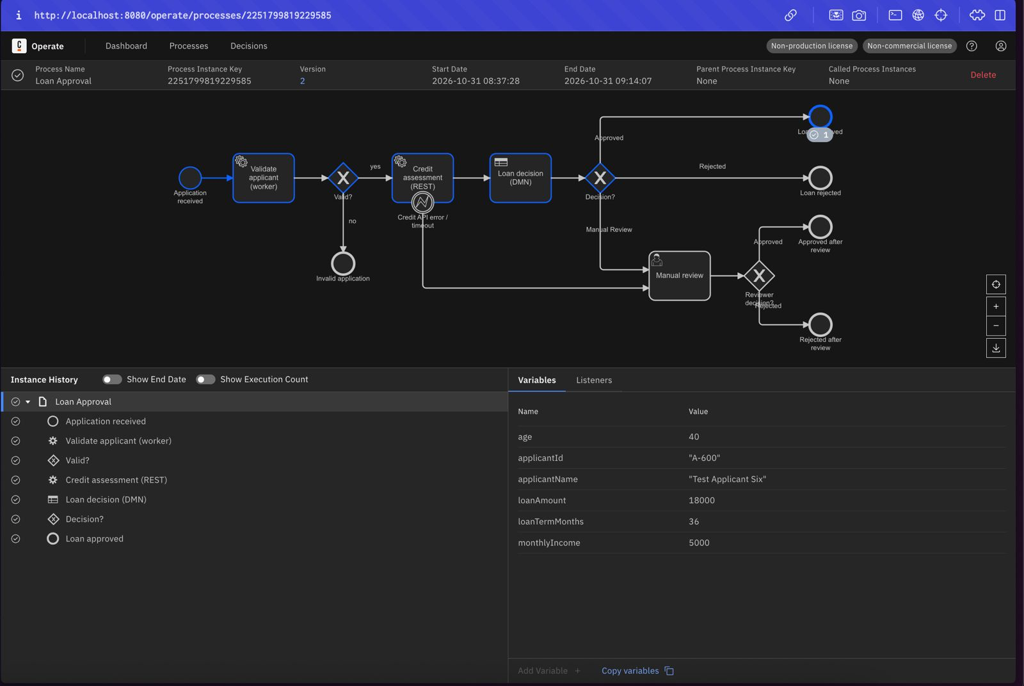
Figure 18: Scenario 5: after Retry the instance completes at Loan approved

7.1 Issue found during testing
In the first runs of scenarios 4a/4b (process version 2), the Tasklist form showed an empty Credit API error field although Operate showed the value. Investigation showed that variables passed with bpmnError(...) in a connector error expression are created locally on the error boundary event and are not visible to the following user task. The fix (version 3) was an output mapping on the boundary event: creditApiError = string join([creditApiError.code, creditApiError.message], " "). After redeployment, the form showed 503 and 408 as expected, and scenarios 3, 4a and 4b were re-run on version 3.

8. Limitations
- Decision rules and the credit scoring are simplified for education; interest is ignored in the installment.
- The credit bureau is a deterministic mock without authentication; there is no real external service.
- Manual review is assigned to the single demo user; there are no candidate groups or SLAs.
- Everything runs on a local single-node c8run; no security, scaling or high-availability setup.
- Only the worker failure was recovered through an incident. Credit API errors are handled in the model by routing to a human instead.

9. Conclusion
The loan approval workflow was modelled, deployed and executed end to end on Camunda 8. BPMN orchestrated a Java job worker, a REST Connector and a DMN decision. Gateways routed each case by process variables, and a Tasklist form let a reviewer decide unclear and failed-credit-check cases. Operate was used to monitor every instance and to diagnose and recover a deliberate worker failure. All seven test scenarios passed.

Appendix: How to Run
- Start Camunda: cd c8run-8.8.32 && ./start.sh
- Start the worker and mock API: cd lab1-loan-approval && mvn spring-boot:run
- Deploy models/loan-decision.dmn, models/loan-manual-review.form and models/loan-approval.bpmn from Desktop Modeler.
- Start scenarios with the curl command in section 5, using the files in test-data/.
- Complete review tasks in Tasklist and inspect instances in Operate.
- Stop: Ctrl+C in the app terminal, then ./shutdown.sh.

