**Sunapu Siddharth**

Whitefield, Bangalore

Cell: 9945160495

sunapusiddharth3@gmail.com

Professional Summary

Strongly skilled and experienced Web Developer with a proven talent for spotting opportunities for innovation. Adept at multitasking working independently or as part of a team. Able to handle work in a high-pressure environment while completing projects on or before deadlines.

Core Qualifications

* Extensive experience in developing web pages using
  + **Front-end technologies : React Js, Redux , Bootstrap , Material UI , HTML , CSS , Javascript , ES6 , jQuery,**
  + **Backend : Node js ,Express, PhP,Python,Flask**
  + **Database: MongoDB, DynamoDB , MySql**
  + **Search : Elasticsearch ,Kibana, Apache solr**
  + **Caching: Redis**
  + **AWS services: AWS Batch, SNS , SQS , SES, ElasticBeanstalk , ASG,ECS , ELB, Dynamo DB, Lambda, Serverless Api , S3, EC2, Elemental Media , SAM ,Cloud formation**
  + **Deployment: Docker**
  + **Others: Microservices , Json, REST ,GraphQL**
  + **CMS: Drupal 7 , 8**
  + **Continuous integration CI/CD: Travis**
* High proficiency in full stackdevelopment using all the above mentioned technologies using microservices, monolithic as well as serverless architecture.
* Good knowledge in deployment using docker
* Extensive expertise with versioning management system (**Github**)
* Good exposure to working in **Agile** based team with knowledge on different tools like **Jira**, **Confluence**.
* Strong ability to manage multiple concurrent projects

Portfolio Projects:

**Fingertip Formulary (POC)**

**Description**: POC for website created for analysts and customers to sell customised health plans. Allows users to create and edit health plans quickly and sell them to different customers through email. Includes interfaces that help customers to view their sell sheets analyze their orders in real time. Retry failed orders. Has a dashboard that shows the different metrics collected .Has a dedicated tab where analysts can handle customer complaints and forward them to respective team. Has a page for invoice management. Site is powered by Elasticsearch to search through sell sheets, orders , customers easily. Has a resilient order system that has 3 pipelines ordering , storage ,searching and replay. Ordering pipeline handles ordering of sell sheet and mailing them to customers ,Searching pipeline is responsible for indexing orders into Elasticsearch ,Storage pipeline stores the orders into S3 glaciers for future compliance .Replay pipeline allows analysts to push the orders back to the pipeline so that failed orders can be re processed again.

**Tech**: Built using MERN stack with additional services including Elasticsearch ,Redis and AWS services like AWS SQS ,SNS ,Lambda ,S3.Frontend is made in React , Back end is made in node js using express framework. Search is provided using Easticsearch. Caching is implemented with Redis. Mongo Db is used as database layer.

**Progress** : Still in Progress

**Link** : http://ec2-13-232-97-206.ap-south-1.compute.amazonaws.com:444

Arch diagram:

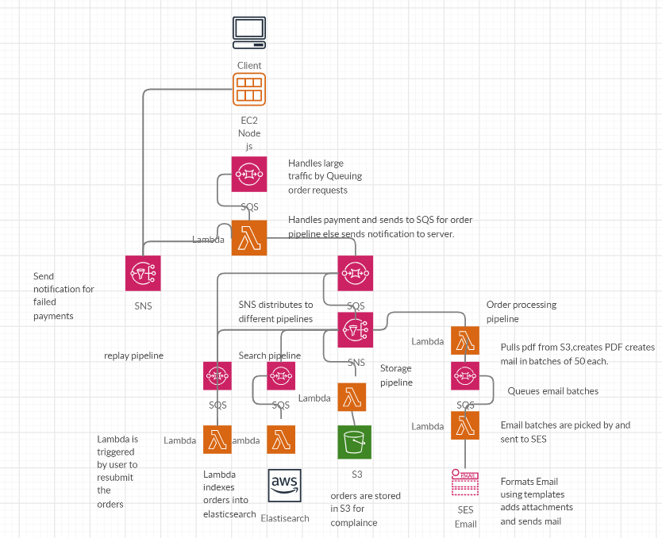

**KaSpr**

**Description**: Video on Demand streaming site. Provides platform to stream videos on demand ,allows users to access video entertainment without a traditional video entertainment device and without the constraints of a typical static broadcasting schedule. can [stream](https://en.wikipedia.org/wiki/Streaming_media) content, either through a traditional [set-top box](https://en.wikipedia.org/wiki/Set-top_box) or through remote devices such as computers, tablets, and smartphones. Allows users to view content in different languages catered based on their preferences. Provides interactive filters , search option and related content to help users find the right content without the hassle of worrying about what to watch next .Has multi step form with live progress and notifications about your uploads. Sends out mails to users when a new content is added. Playlist you favourite movies and shows to show them on home screen.

**Tech**: Built using MERN stack with additional services including Elasticsearch ,Redis and AWS services like AWS lambda for image conversion, S3 for storing images and videos, Elemental Media Convert that uses HLS to transcode videos to different formats.

**Progress** : Still in Progress

**Link** : http://ec2-13-232-97-206.ap-south-1.compute.amazonaws.com:443

Arch diagram

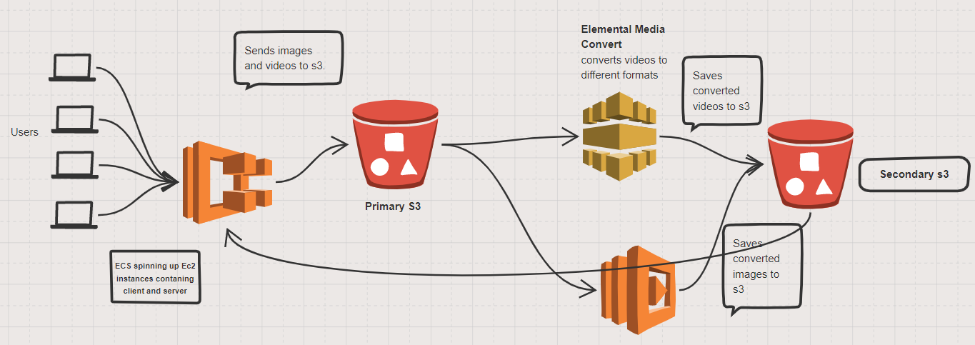

**Crimes Explorer**

**Description**: Micro-service architecture based MERN application including additional services including Elasticsearch Redis D3.Has different pages like blog posts with comments, [live dashboards](http://ec2-13-232-18-179.ap-south-1.compute.amazonaws.com/dashboard) , [search pages](http://ec2-13-232-18-179.ap-south-1.compute.amazonaws.com/crimes/search) that can search content using any piece of info including facets for quick filters, [lots of charts](http://ec2-13-232-18-179.ap-south-1.compute.amazonaws.com/cde) ranging from pie , bar, heat maps, world map all having drill down options to get more detailed info, Live [data tables](http://ec2-13-232-18-179.ap-south-1.compute.amazonaws.com/table) with modern filters like column search , range filters , also has components built under each row like row expands to show another table, row click opens modal with related content spanning multiple tabs inside it. Has tables where users with correct permission can edit their data. For security has authentication using JSON web tokens. Includes nice mega drop down menu. Users can even search for content inside pdf files.

**Tech**: Includes 2 node js micro services, one deals with crimes anther deals with cde(crime data explorer) and one react frontend. MongoDB is used as database with complex queries ranging from facets, aggregations and change-stream is used for live dashboards. Elasticsearch used for providing site wide search and facets for filters, includes searching content inside documents. Charts built using D3 and High charts. Bootstrap is used for UX design.

**Link** : [http://ec2-13-232-97-206.ap-south-1.compute.amazonaws.com](http://ec2-13-232-18-179.ap-south-1.compute.amazonaws.com:443/)

Experience

**Full Stack Developer**

**01/06/2019– Present**

**Company – NTT Data.**

**Bangalore**

**Description**: Working as full stack developer to create end to end healthcare services project.

**Project (MFM )**: Provides platform for managing health insurance data of companies. Application takes in flat files from different companies which is placed in **s3,** this data is then picked in batches and after going through different validation stages is put into dynamo DB. This data is provided through API endpoints to be used by different other projects .To facilitate the better control and to provide additional features that manage the process of flat files going through different processes, a client application has been built using react .Currently the client application has three different business streams in it with live dashboards where different real time processes can be managed.

Backend has been built using node Js micro services and AWS lambda functions.

Data is managed using DynamoDB tables and S3 buckets.

Uses Elasticsearch for textual, document searches and uses real time kibana dashboards for analytics whose data is feeded by dynamoDB using lambda functions.

**Role**:

* Create and manage end to end application.
* Write custom react components and integrate with different plugins/modules to meet the business requirement.
* Perform state management using redux and write optimised components using selectors and different life cycle methods to increase performance of application.
* Apply styling using **bootstrap** and **css** to make UI more appealing
* Create **API’s** with node js using **microservices** and serverless **API gateway**
* Write **AWS lambda** functions and create **e**vent based triggers for **S3** and **DynamoDB**.
* Using **Redis** as caching to improve performance of API’s
* Using **socket io** for live dashboards to provide real-time data.
* Write queries and create indexes to perform CRUDoperationson **DynamoDB**.
* Write **elasticsearch** queries and create **kibana** dashboards.
* Deploy microservices using docker .
* Create CI/CD pipeline for automatic code deployment.

**Project (BATCH 2.0 )**: Provides platform for companies (users) to upload files containing insurance details of it’s employees. Back end core which facilitates ingestion of these files and running operations depending on business requirements is handled by different AWS services built around AWS Batch. Client application is built for displaying different screens about the process of files ingestion and it’s data.

Architecture diagram:

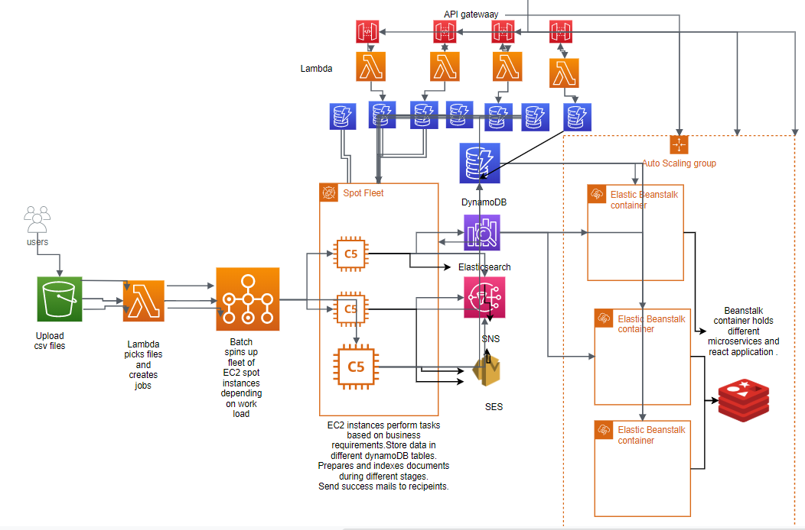

**Role**:

* Configure AWS batch service to run fleet of EC2 spot instances that will handle the processing of files seamlessly with integration for S3,Lambda, DynamoDB, SES and SNS.
* Create docker containers to be used by the EC2 instances .
* Write asynchronous code to parse large files and create and use different modules to meet business requirements.
* Build node js application and lambda functions to process the files according to business requirements.
* Build UI dashboards , charts , tables and different screens to display the data using React ,redux and Bootstrap.
* Create API gateways in lambda functions.
* Create node js microservices.
* Handle database operations using dynamoDB.
* Create CI/CD pipeline to deploy to AWS beanstalk using Travis CI.

**Full Stack Developer (Node JS, React, Mongo DB)**

**Insight Platform 2.0**

**01/11/2016– 24/-5/2019**

**Company - Decision Resource Group.**

**Bangalore**

**Description:** Work as full stack developer.

**Project:** Provides platform for selling and viewing health care reports for different diseases,drugs , companies, medical devices. It is divided into two parts one is for creating the content and another part displays content in different ways. Backend is made of different microservices using nodejs and php with client being made using react.

**Features:**

* **Node JS:**
  + API created following microservice architecture.
  + Swagger used as documentation tool
  + Extensive use of es6 promises with async await.
  + Usage of node js streams and child processes to read and write large files.
  + Node mailer for sending mails
  + Web scrapping
  + Winston for logging
  + Indexing and searching using elasticsearch.
  + Caching implemented using redis.
  + Use of aws sdk to upload , download files from s3, write queries for dynamo DB
  + Parsing of csv files
* **Mongo DB:**
  + Complex queries built using aggregations and facets
  + Creation of blog with comments page which includes hierarchical and paginated comments
  + Creation of indexes and geospatial queries.
  + Live dashboards created using change streams
* **DynamoDB:**
  + CRUD queries using batch operations.
  + Creation of indexes GSI and LSI
  + Recursive queries to fetch all the data
* **Elasticsearch:**
  + Bulk indexing
  + Suggesters for auto complete
  + Creation of custom analyzers and tokenizers
  + Autocomplete using edge ngram
  + Indexing of pdf documents and searching inside them.
  + Geo spatial range queries
  + Using multi-level aggregations that provide data for drill down charts
  + Highlighting of search results.
  + Paginated results
  + Boosting of search results.
  + Nested queries.
* **React:** 
  + Good knowledge on **Redux** and its concepts and the data flow model with working knowledge on creating **actions**, reducers and middleware.
  + Exposure to **redux-persist** to use local Storage for storing data.
  + Worked with **react table** plugin to implement large data sets for viewing and editing. Used react table with **Redux** state management and **Node** JS as backend with **Mongo** **Db** as the database layer.
  + Implementation of charts using **D3** and **highcharts** with live updating , drill down , choropleth , bar ,pie, heat maps and country maps.
  + Implementation of **feature** **flags** to toggle different UI features.
  + Implementation of **live** **dashboards** using socket io.
  + Conditional rendering and importing of components.
  + Implementation of pagination component.
  + Live tables with sorting, filtering, grouping, pagination, expanding rows, sub components inside a row and resizable columns.
  + Used **Redux** forms for loading and saving large forms from Drupal as well as with Node JS and **Mongo** Db. Used **Redux** to save and update the state of forms. Used persistent functionality using **redux-persist** to save the state on browser refresh.
  + Implemented **React** **bootstrap** for creating tabs, dropdowns and other different components.
  + Implemented **infinite scrolling** for Search Page for loading more results.
  + Worked on loading and saving more than 300 forms in single page using **redux-form** and implemented **ckeditor** for the fields which gets instantiated on click.
  + Using CSS, bootstrap and material UI for styling.
  + Used **react virtualized** to efficiently render large amount of data including lakhs of table data in single table and more than 300 forms on single page. This loads limited records on page with additional data being loaded in infinite scroll.
  + Implemented **React lazy loading** using **React lazy** and used **suspense**.
  + Implemented tree structure to show the content hierarchy in which upon clicking the links it loads the respective forms under a content on right side of page in separate component.
  + Implemented **context menu** in React.
  + Implemented creation of invoices and converting them to pdf using puppeteer.
  + Creation of facet components**.**
* **AWS:**
  + Using server less stack to deploy serverless applications .
  + Creation of lambda functions with different event based triggers.
  + Creation of API Gateway.

**Backend Developer (Python, Flask, Mongo DB)** Name – **Publisher**

**01/11/2016– 24/-5/2019**

**Company - Decision Resource Group.**

**Bangalore**

**Description:** Work as back end developer.

**Project:** Flask application to provide back end foruniversal iOS application which is a simple-to-use tool that allows you to determine formulary drug status for health plans in your area from leading real-time formulary database. Allow Pharmaceutical executives, Including brand teams and sales Professionals, to leverage managed care formulary information as a significant and competitive advantage.

**Drupal Developer**

**23/7/2016– 1/11/2016**

**Company - Decision Resource Group.**

**Bangalore**

* **Drupal**
* Maintained new sites within content architecture.
* Implemented **CK Editor** and its different plugins for content creation and authoring.
* Extensively used **Entity Query** to create **JSON** structure of content that includes hierarchical representation of entities and their children (**entity references**).
* Rendering of main content comprising of multiple levels of parent child relationships of site using blocks and **Entity View Builder** and parsing JSON.
* Creating JSON structure for site-wide content storing the hierarchy of nodes with their relationships.
* Created custom style plugin for serialized output formats for views.
* Created views showing different entities and their relationships with other entities.
* Wrote custom twig extensions.
* Used JQuery and bootstrap plugins.
* Performed site-wide search using **Apache SOLR** by writing **SOLR** queries and implementing **Search API** and **SOLR Search** module.
* Imported content into the site using **Feeds** module. Wrote **Xpath** queries to fetch content through Xml document.
* Migrated content and taxonomies from Drupal 7 to Drupal 8 using **Migrate**, **Migrate Tools** and **Migrate Plus**.
* Using **Twig** templates for content rendering and theming.
* Loading and indexing files to AWS server using AWS SDK module using cloud front.
* Created **Blocks** for displaying different blocks of content.
* Using composer to manage Drupal modules and it’s libraries.
* Wrote custom Drush commands.
* Importing and exporting **configurations** and **features**.
* Created different **Views** for displaying content, for admin pages by using Views module and used different hooks of views for meeting client requirements.
* Created different types of **Forms** in Drupal 8 and used different hooks for validation and custom submission.
* Implemented **jQuery** and **CSS** to render theme and template designs for a site re-skinning
* Extensively used **JQuery** and its different plugins along with making **Ajax** callbacks to handle content dynamically.
* Managing and creating module specific tables using install files and using update hooks.
* Created custom **theme**
* **SOLR**:
* Indexing nested documents with child parent relationship.
* Writing custom queries using different query parameters to get the desired results.
* Added and managed field types in managed-schema with good knowledge of analysers ,tokenizers and filters
* Good knowledge in facets and its different parameters to get the categorized results
* using sub queries, child, parent filters and joins to query in nested documents and give the nested results.
* worked with synonyms and stop words to improve the search results.
* using different search expressions and boosting to get more relevant results.
* Extensively used SOLR admin UI to create and debug queries.
* Utilized **agile** and **scrum** methodologies to develop Drupal applications
* Used Atlassian products (**JIRA**/**Confluence**) for project/ticket management
* Maintained codebase using Github with good knowledge in committing, adding, deleting cherry-pick etc.
* Debugged code in server using terminal, debugged database using drush sqlc
* Maintained current knowledge on emerging technologies and their potential applications.
* Collaborated with lead developer to expand Drupal architecture
* **Documenting** and creating confluence pages for technical description and implementation approach.
* Giving knowledge sharing sessions on new technical features on latest technologies.
* Using **MAMP** ,**XAMP** server and **PhyMyAdmin**

**EmberJs Developer**

**11/3/2016 – 23/7/2016**

**Company - Decision Resource Group.**

**Bangalore**

* Created different routes to handle different pages in EmberJs.
* Created Templates using handlebar and created helpers for rendering.
* Created components in Ember to handle events and actions and rendering different parts of page.
* Created models defining the data used for ember and worked with DS Store to write CRUD queries to load specific data
* Working with Ember inspector for debugging

Education

**Bachelor’s Degree – Electronics and Communication Engineering**

**2015**

Lovely Professional University

Punjab