Docker Architecture
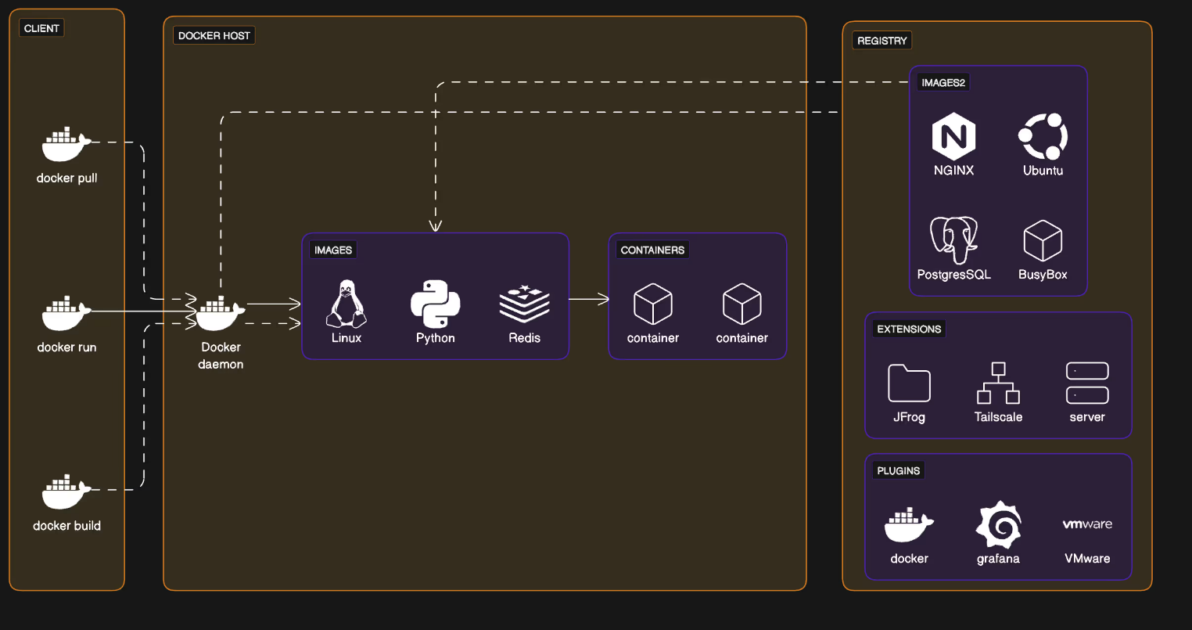
DOCKER
Docker is a containerization platform that uses OS-level virtualization to package software applications and their dependencies into reusable units called containers
IMAGE: Image is an instance of our application.
Container: In simple terms container is a light weight portable package which contains application code and its dependencies, it can be an executable file, framework or library.
In terms of docker container is a running instance of our application.
Docker | Container
It is immutable | It is mutable
I can not be run, stopped and restart | It can be run stopped and restart

DOCKER COMPONENTS
1. Docker Client: This is the user interface for interacting with Docker. It allows users to send commands to the Docker daemon, such as building images, running containers, and managing other Docker objects.
2. Docker Daemon (dockerd): The Docker daemon is a background service that runs on the host machine. It manages Docker objects like images, containers, networks, and volumes. The daemon listens for API requests from the Docker client and performs the requested actions.
3. Docker Images: These are read-only templates that contain the instructions for creating a Docker container. Images include the application code, runtime, libraries, system tools, and dependencies.
4. Docker Containers: Containers are the runtime instances of Docker images. They are isolated environments where applications run.
5. Docker Networking: Docker provides networking capabilities that allow containers to communicate with each other and with the outside world. Different types of networks can be created, such as bridge, host, overlay, and macvlan networks.
6. Docker Registries: These are repositories for storing and distributing Docker images. Docker Hub is a popular public registry, while users can also set up private registries.
7. Docker Compose: Docker Compose is a tool for defining and running multi-container Docker applications. It uses a YAML file to specify the services, networks, and volumes needed for the application.

8 Docker Hub is a specific, cloud-based implementation of a Docker registry, while a Docker registry is a general term for a storage and distribution system for Docker images. Essentially, Docker Hub is a popular public registry, but you can also run your own private registries.

9 Docker Engine is the core component of the Docker platform. It's a client-server application that provides the runtime environment for containers, allowing users to build, run, and manage containerized applications. The Engine consists of a server (the Docker daemon), a REST API, and a command-line interface (CLI).
11: DOCKERFILE:
DOCKER VOLUME: Docker Engine is the core component of the Docker platform. It's a client-server application that provides the runtime environment for containers, allowing users to build, run, and manage containerized applications. The Engine consists of a server (the Docker daemon), a REST API, and a command-line interface (CLI).
https://spacelift.io/blog/docker-networking
DOCKER NETWORK
Docker supports six network types to manage container communication that implement core networking functionality:
1. Bridge Network: Bridge mode is the default networking mode for the Docker containers. In a bridge network, the Docker container is isolated from the host machine and other Docker containers. However, it can communicate with other containers on the same Docker network

2. host: In the host mode, the Docker container shares the network interface with the host machine. This means that the container can access host resources and communicates with other containers directly, without being isolated from the host machine.
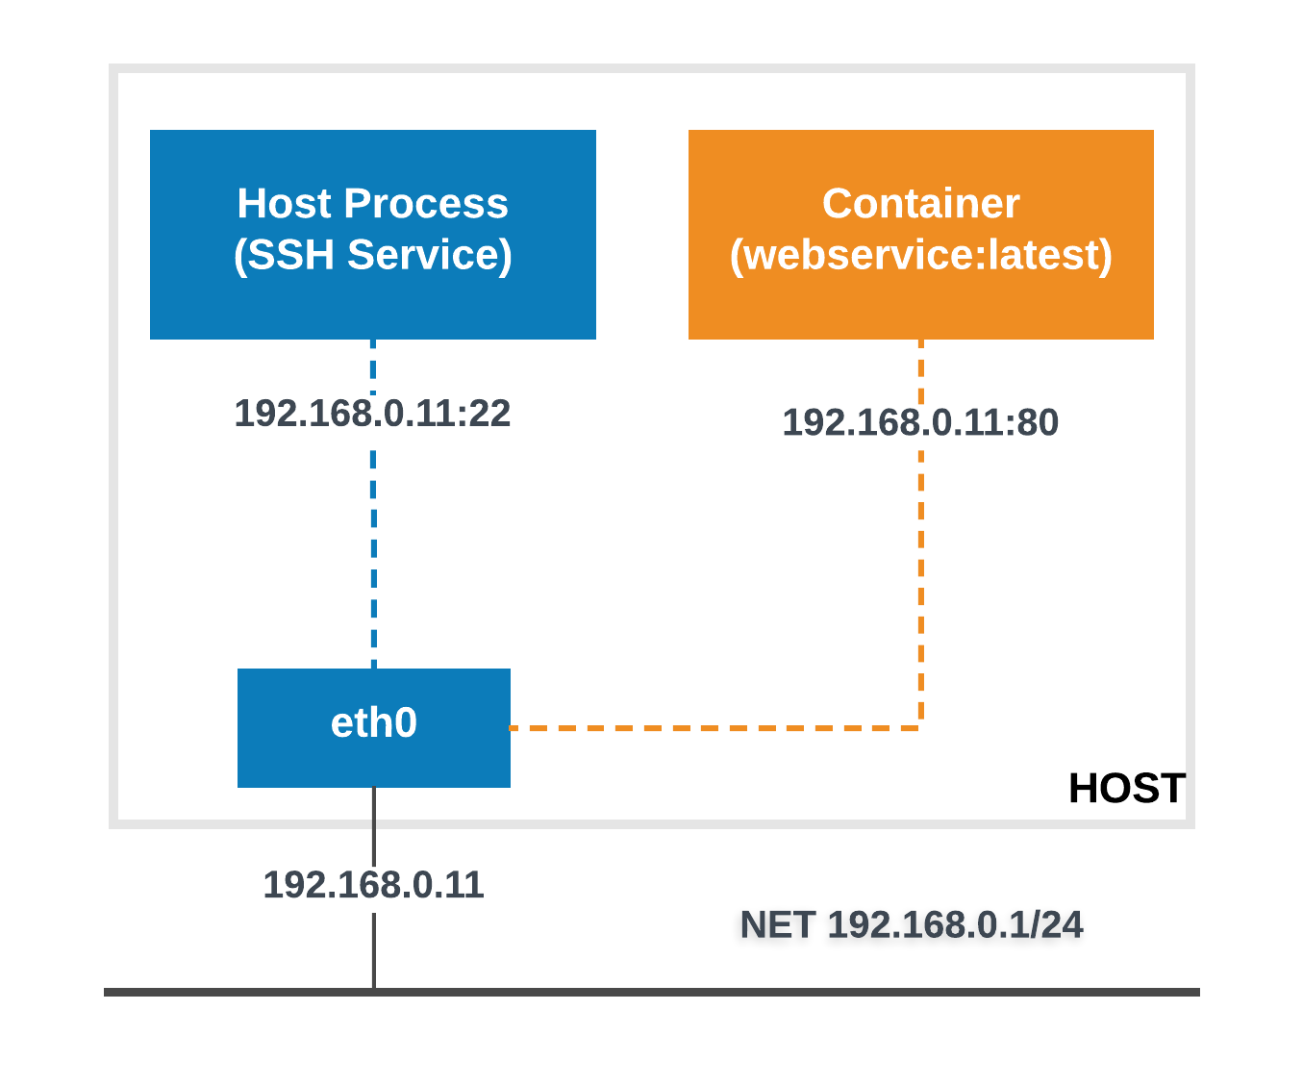
Pros:
- Speed: Because containers directly use the host network stack, there is less overhead, resulting in improved speed.
- Containers have complete access to the host network interfaces and may connect with no additional network address translation (NAT) overhead.
- Port Binding: Ports exposed by containers are immediately accessible on the host network, eliminating the requirement for explicit port mapping.
Cons:
- Security Concerns: Host networking undermines container isolation, possibly exposing critical services operating on the host.
- Containers may have port conflicts if the host ports they seek to bind are already in use.
Use Case:
Host networking is ideal for high-performance applications that require direct access to the host’s network stack, such as network monitoring software or VPN services. However, it is typically not advised for multi-container deployments owing to security concerns.

- none: In the none mode, the Docker container runs without any network interface. As a result, it cannot communicate with other containers on the same Docker network or the host machine.
    - Use Cases: This mode is useful for scenarios where network access is not needed, such as batch processing, security testing, or when running applications that are designed to be completely self-contained.
- overlay: spans the whole Docker cluster, allowing for smooth communication between containers running on various hosts.
  - Pros:
    - Multi-Host Communication: Overlay networks allow containers to communicate transparently between Docker hosts, allowing distributed applications.
    - Service Discovery: Docker Swarm and Kubernetes may use overlay networks to find services and balance loads throughout the cluster.
    - Security:Overlay networks offer encryption and authentication, which improves the security of inter-host communication.
  - Cons:
    - Complex Setup: Overlay networks require more configuration and coordination, particularly in clustered situations.
    - Performance Overhead: Overlay networking adds encapsulation and routing overhead, which may have an impact on performance as compared to bridge or host networking.
  - Use case:
    - Overlay networking is necessary for deploying distributed apps across many Docker hosts or in container orchestration systems such as Docker Swarm and Kubernetes. It allows for easy connectivity and scalability while ensuring network isolation and security.
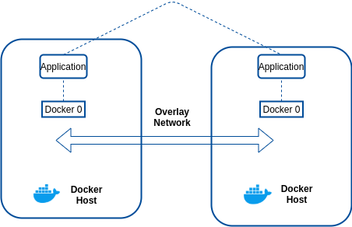
- macvlan: Assigns a MAC address to each container, making it appear as a physical device on the network. Used for scenarios requiring full network integration, such as legacy apps.
- ipvlan: Similar to macvlan but uses a different method for traffic handling. It’s more efficient for high-density environments but less flexible.
https://labex.io/tutorials/docker-docker-local-network-16256
https://www.adaface.com/blog/docker-interview-questions/

