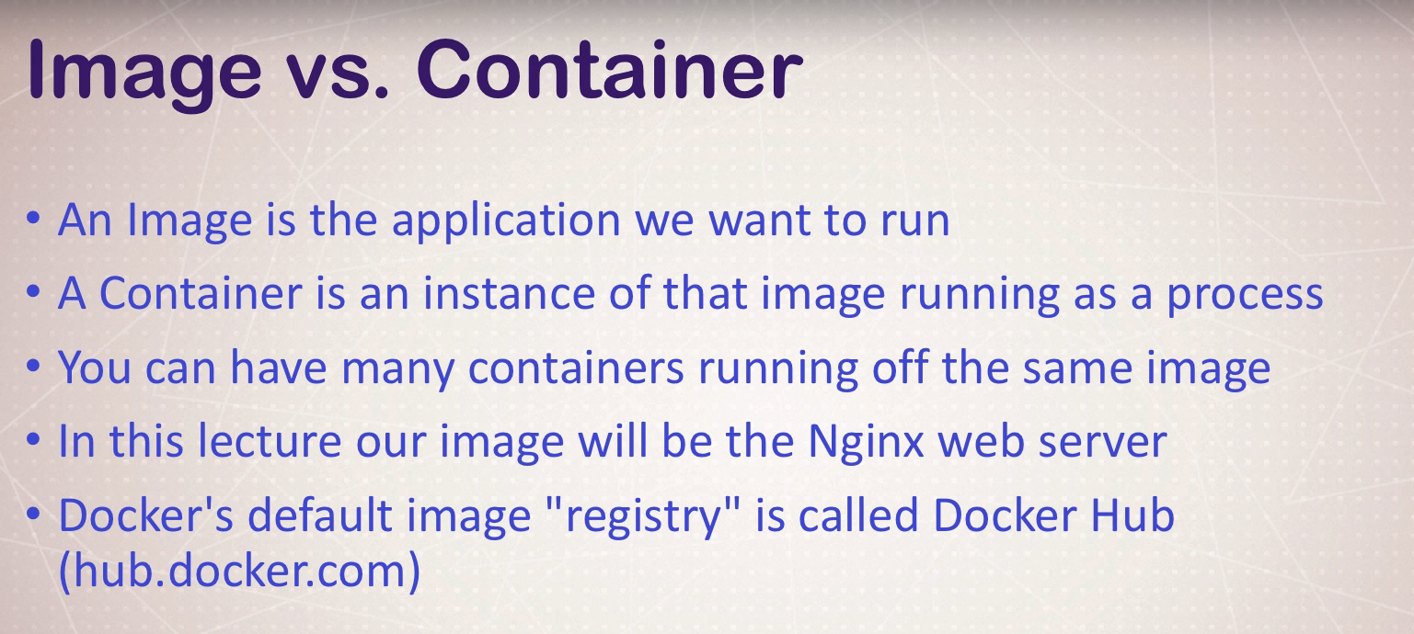
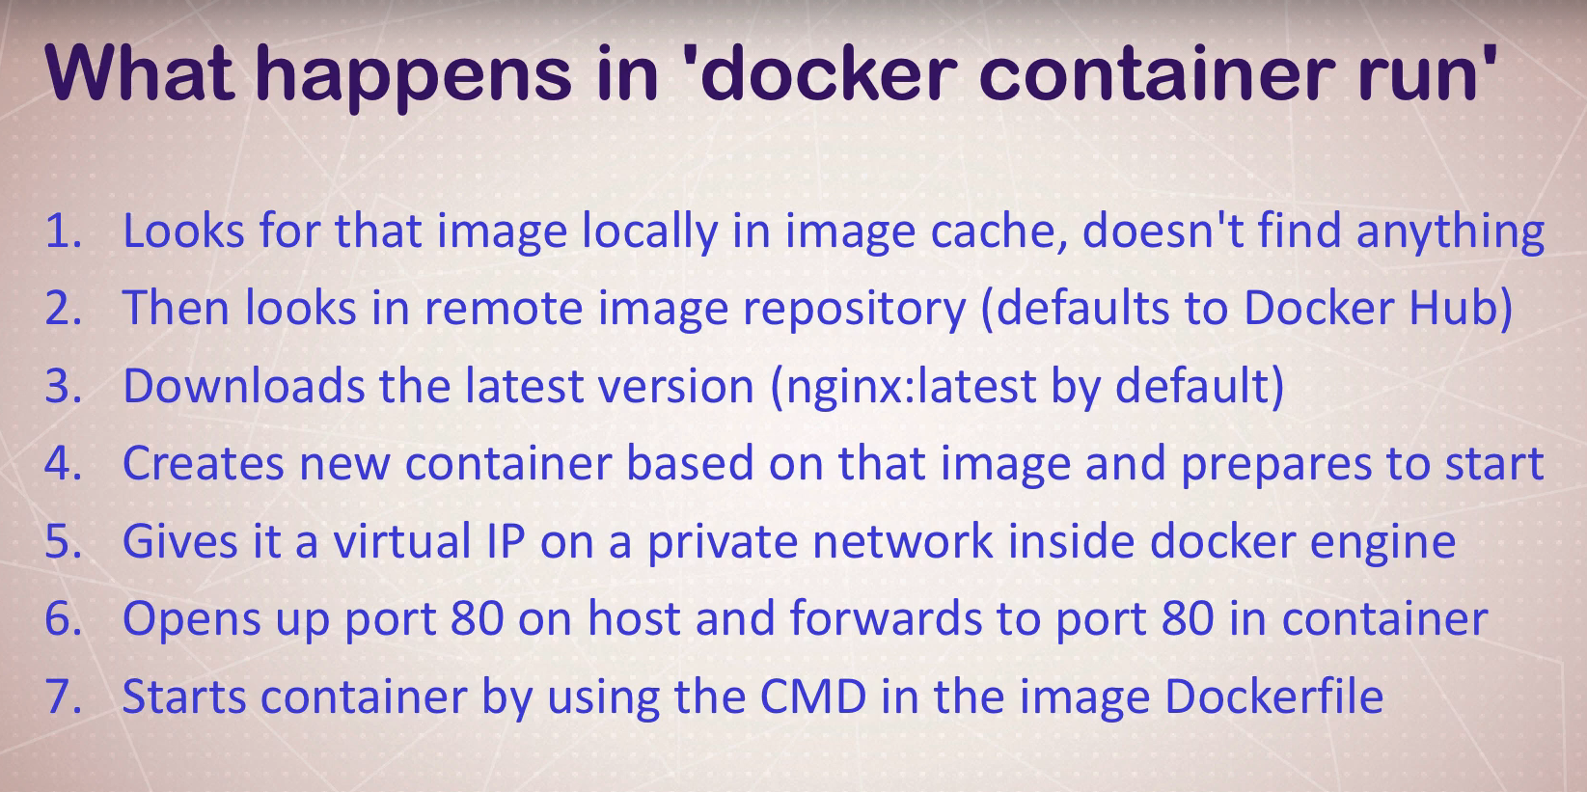
docker container run -d -p 3307:3306 --name db -e MYSQL_RANDOM_ROOT_PASSWORD=yes mysql
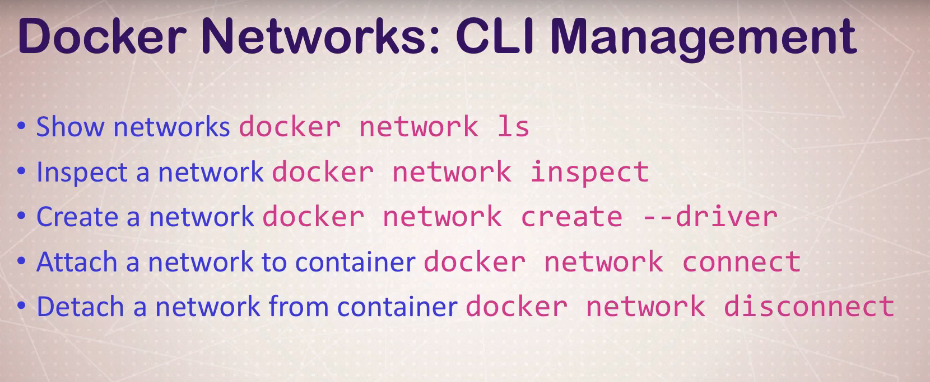
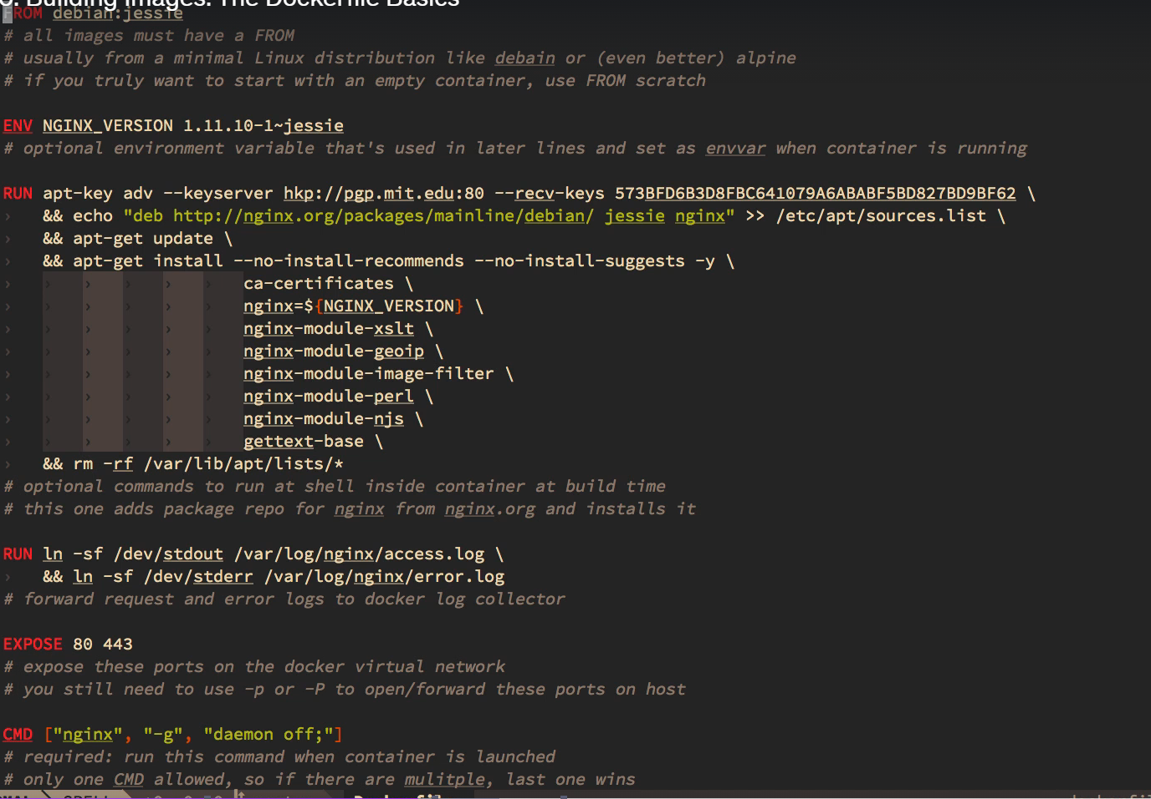
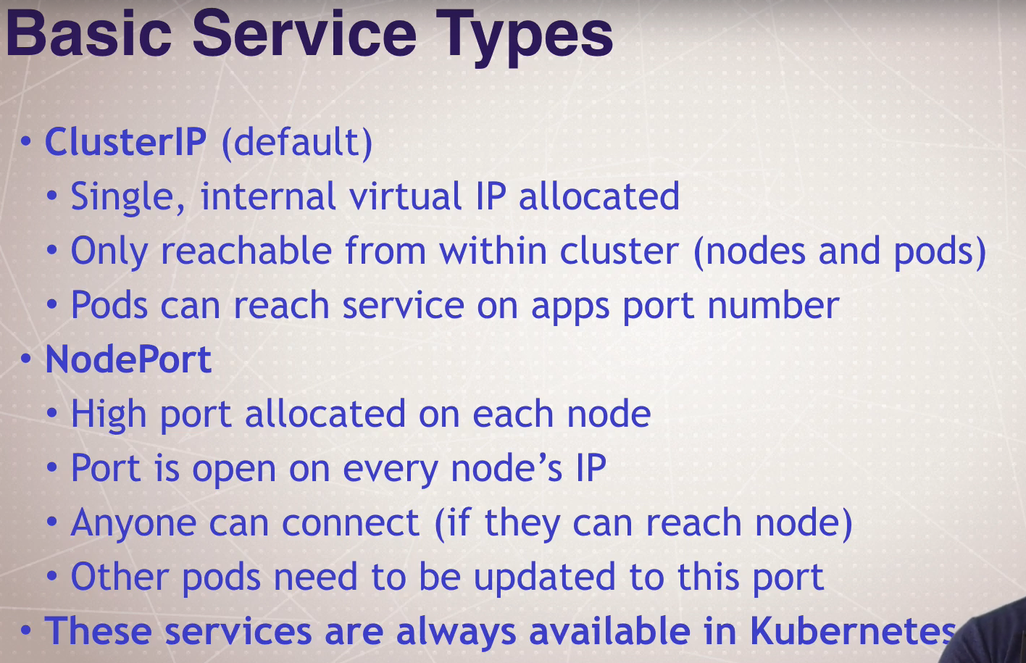

http://127.0.01:8001/api/v1/namespaces/kube-system/services/https:kubernetes-dashboard:/proxy/

kubectl create namespace my-manespace

kubectl -n my-manespace create token admin-user

kubectl apply -f permission1.yml

https://kubernetes.io/docs/tasks/access-application-cluster/web-ui-dashboard/

https://collabnix.com/kubernetes-dashboard-on-docker-desktop-for-windows-2-0-0-3-in-2-minutes/

google search nodes is forbidden: User "system:serviceaccount:my-manespace:admin-user" cannot

docker run --restart=unless-stopped -p 9091:9090 rancher/server
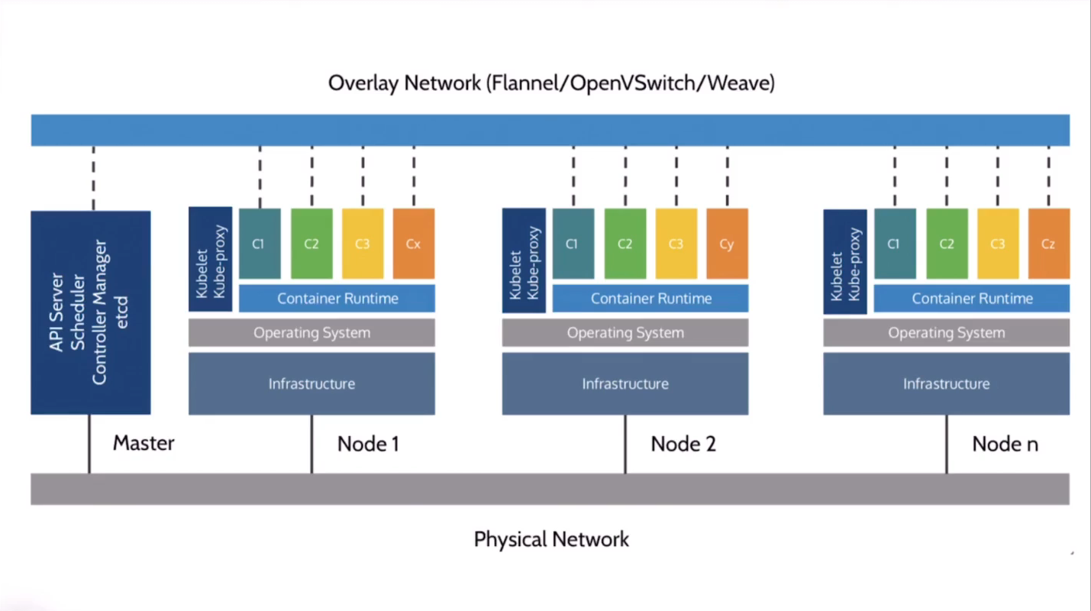

Kubectl: Kubectl communicates with API Service
API: API manages Scheduler and Control Manager
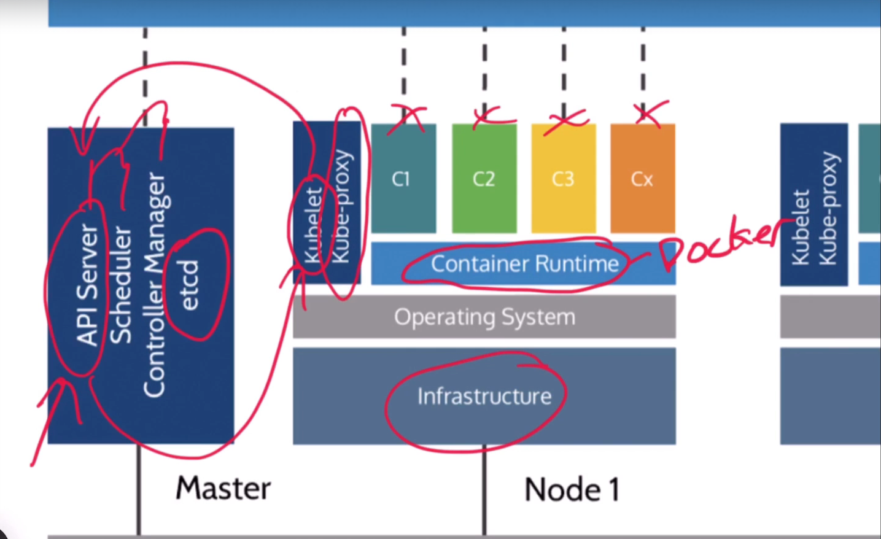

KubeProxy is all about proxy it takes orders from
The kube-proxy is all about networking. It takes orders from the kubelet agent
and it controls the networking configuration on the host. So, it might issue out the IP addresses. It might control the network parameters and settings.
