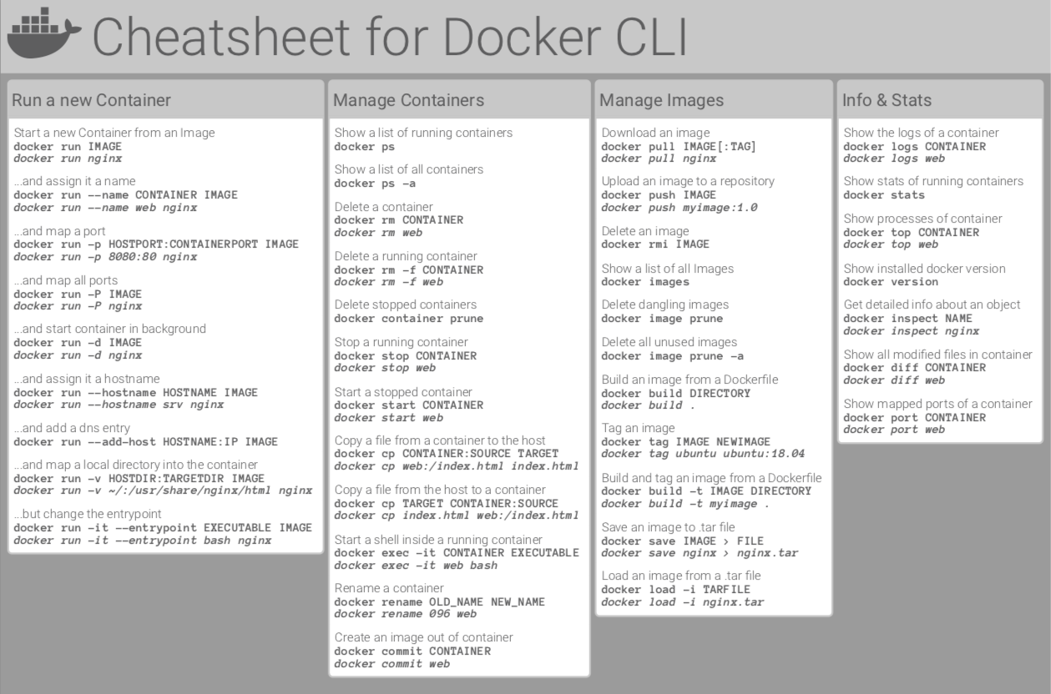

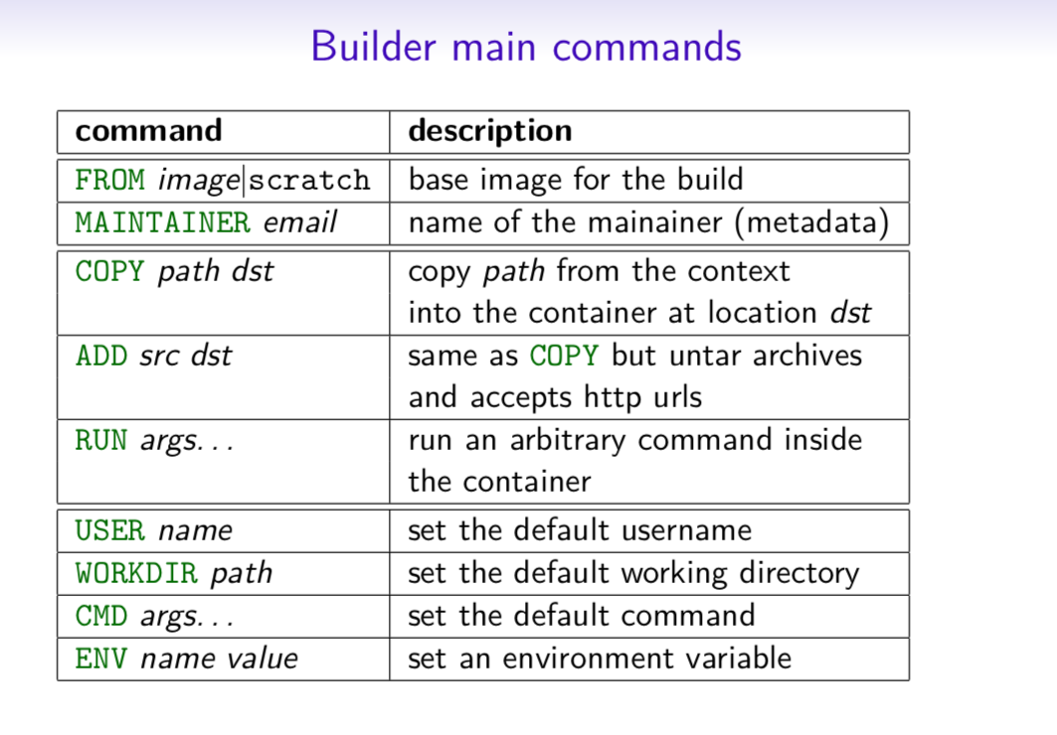
Dockerfile
Inheritance
FROM ruby:2.2.2
Variables
ENV APP_HOME /myapp
RUN mkdir $APP_HOME
Initialization
RUN bundle install
WORKDIR /myapp
VOLUME ["/data"]
# Specification for mount point
ADD file.xyz /file.xyz
COPY --chown=user:group host_file.xyz /path/container_file.xyz
Onbuild
ONBUILD RUN bundle install
# when used with another file
Commands
EXPOSE 5900
CMD ["bundle", "exec", "rails", "server"]
Entrypoint
ENTRYPOINT ["executable", "param1", "param2"]
ENTRYPOINT command param1 param2
Configures a container that will run as an executable.
ENTRYPOINT exec top -b
This will use shell processing to substitute shell variables, and will ignore any CMD or docker run command line arguments.
Metadata
LABEL version="1.0"
LABEL "com.example.vendor"="ACME Incorporated"
LABEL com.example.label-with-value="foo"
LABEL description="This text illustrates \
that label-values can span multiple lines."
https://dockerlabs.collabnix.com/docker/cheatsheet/
https://buddy.works/tutorials/docker-commands-cheat-sheet

Docker container commands
The commands below refer to running and managing Docker containers.
List all running containers
bash
docker ps
Image loading...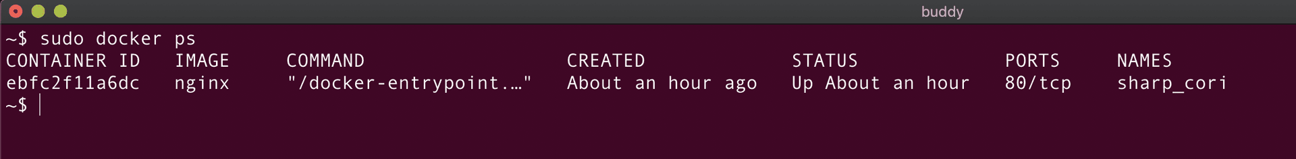
- You can also use docker container ps or docker container ls to list all the running containers.
- There is no difference between docker ps and docker container ps commands with respect to the result of their execution.
- docker ps is old syntax and is supported for backward compatibility.
- The docker container ls command is an appropriate version of the command compared to ps as ls is a shortcut for list.
List all containers (irrespective of state)
This command is used for listing all the containers (active and inactive):
bash
docker ps -all
Image loading...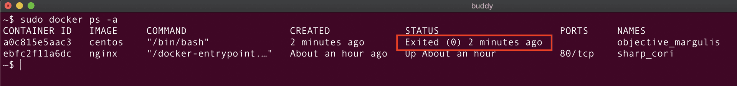
As can be seen from the screenshot above, the container objective_margulis is not running while the container sharp_cori is up since the last hour.
Short form of --all:
bash
docker ps -a

Create new container from Docker image
The docker create command is used to create a new container from a Docker image. It does not run the container, just adds a writable layer on top of the Docker image.
bash
docker create <image_name>
Tip
To run the container, use the docker start command.
As the docker create command interacts with the container object, you can also use the below command:
bash
docker container create <image_name>
Let's create a container using an NGINX Docker image:
bash
docker create nginx
Image loading...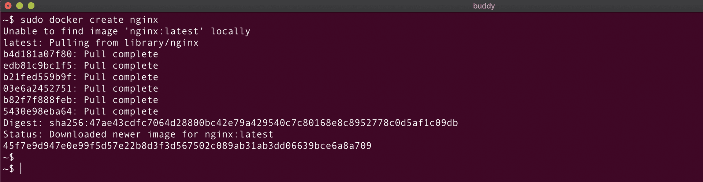
Perfect! The container is created. Let's verify it using the docker ps command:
Image loading...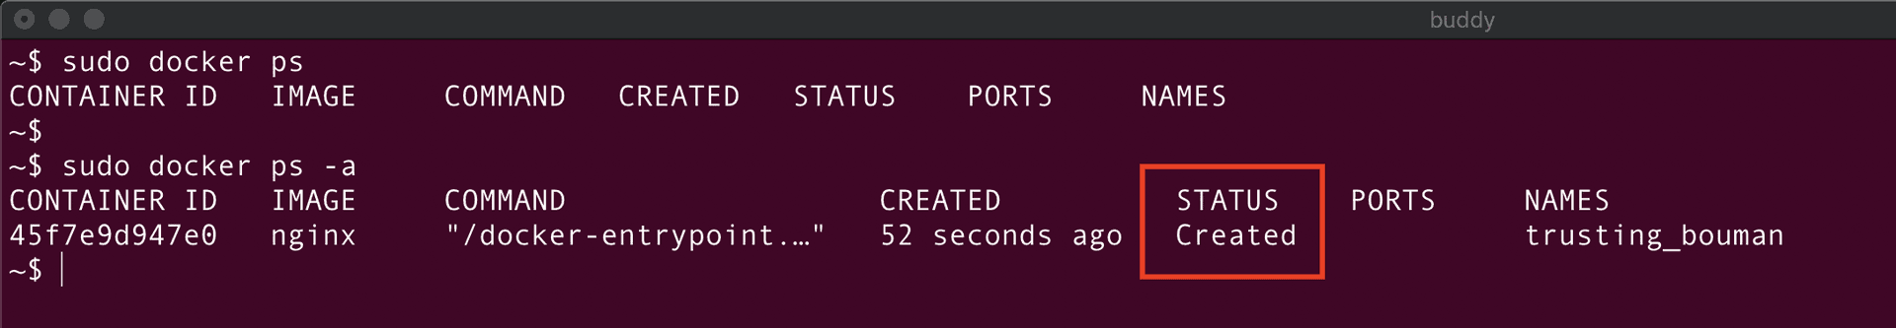
The status of the container is Created as expected!

Create new container from Docker image with fixed name
You can also create a Docker container with fixed names. Let's do that right away:
bash
docker create --name <container_name> <image_name>
Let's create a container named nginx-container using an nginx image:
bash
docker create --name nginx-container nginx
Image loading...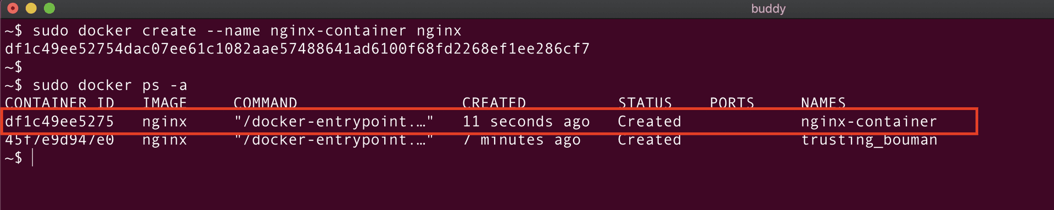
Start container
A created container can be run with the following command
bash
docker start <container_id or container_name>
Let's start the nginx-container:
bash
docker start nginx-container
Image loading...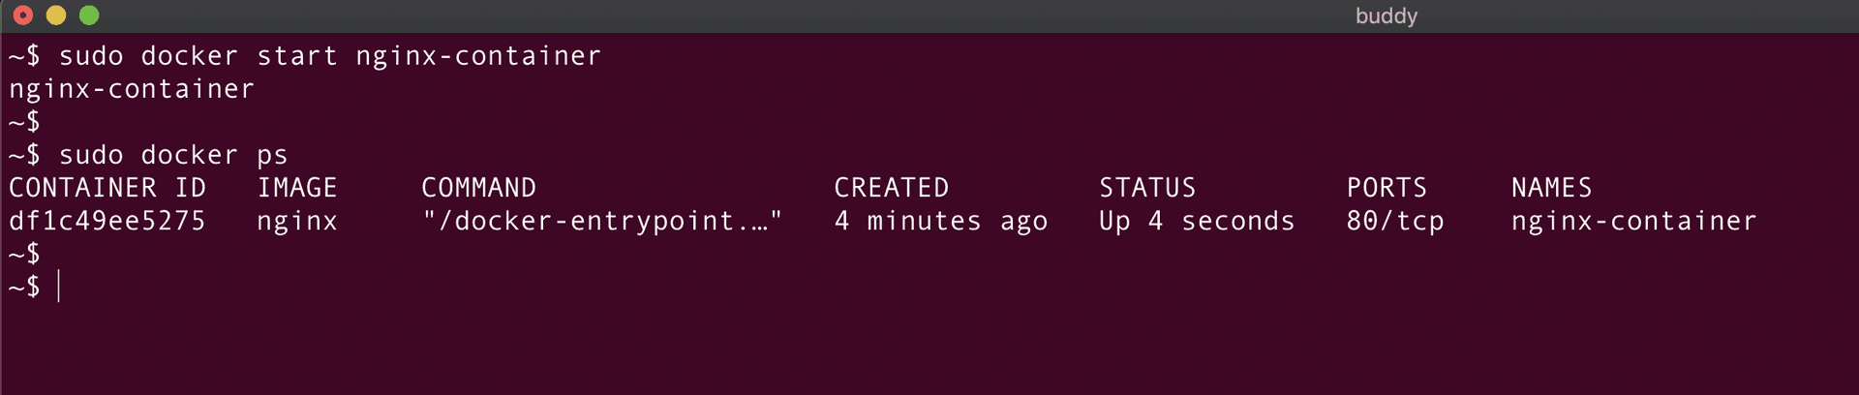
As seen from the above screenshot, nginx-container is created and the docker ps command is used to verify the status of the container.
We can use the docker start command either using the container ID or name. This means we can also start it as:
bash
docker start df1c49ee5275$

Stop running container
To stop a running container, run:
bash
docker stop <container_id or container_name>
Here's the command for stopping our nginx-container:
bash
docker stop nginx-container
Image loading...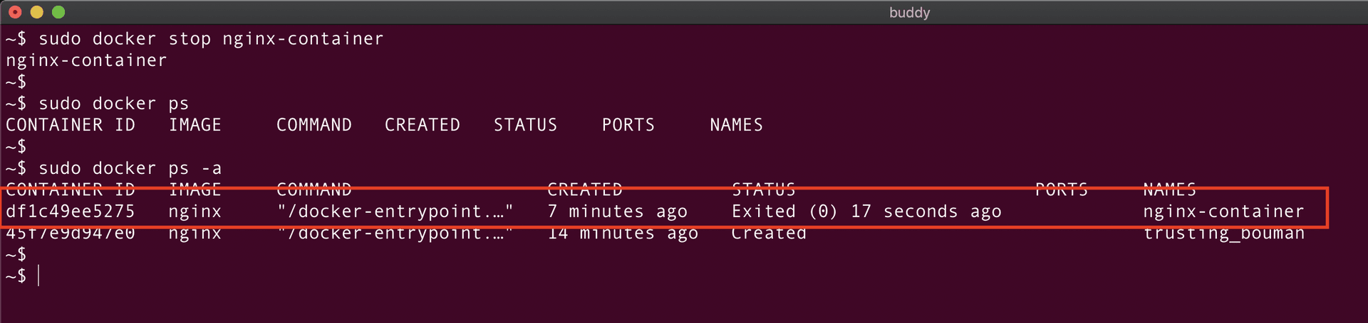
As you can see, the container nginx-container was exited 17 seconds ago. This container won't be listed in the docker ps command.
Restart container
bash
docker restart <container_id or container_name>
Image loading...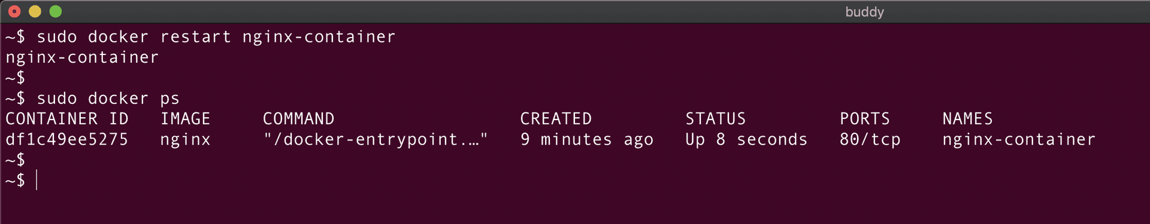
The nginx-container is now restarted and is up for the last 8 seconds.
Pause running container
bash
docker pause <container_id or container_name>
Let's try to pause the nginx-container:

bash
docker pause nginx-container
Image loading...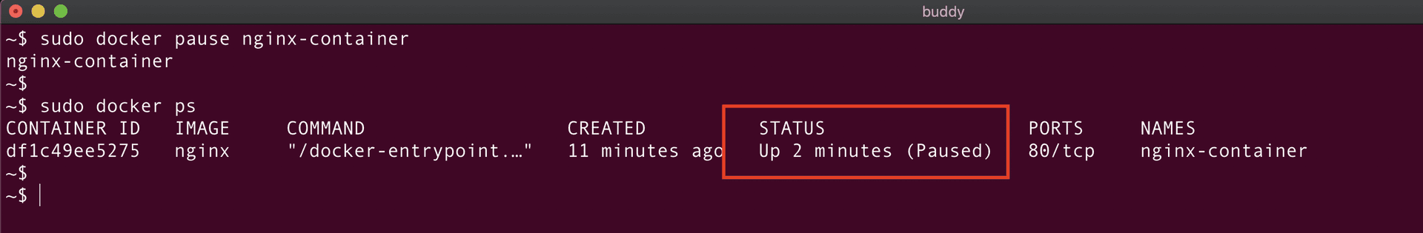
Resume paused container
To resume a paused container, you can use the unpause command:
bash
docker unpause <container_id or container_name>
So, to unpause the nginx-container, we simply run:
bash
docker unpause nginx-container
Image loading...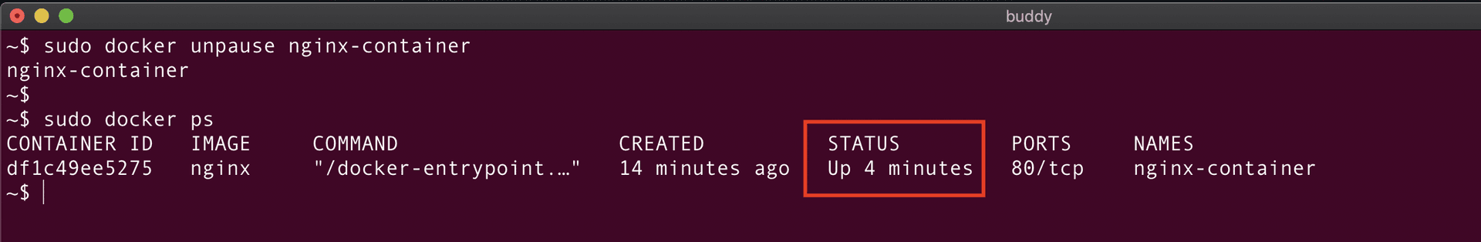
Run container
It rarely happens that we create the container and run it later. Generally, in real-world cases, we create and run the container in one go using the docker run command, which is a combination of create and start commands:
bash
docker run <image_name>
Hint
If the Docker image is locally available, Docker will run the container using that image. Otherwise, it would download the image from Docker Hub, the default repository for Docker images.
Run container in foreground and detached modes
The Docker container can run in two modes:
- Foreground mode (default)
- Background or detached mode
The foreground mode is the default when it comes to running containers. In this mode, Docker starts the root process in the container in the foreground and attaches the standard input (stdin), output(stdout), and error (stderr) of the process to the terminal session.
Warning
In the foreground mode, you cannot execute any other command on the terminal session until the container is running. This is the same as running a Linux process in the foreground mode.
Let's create and run a container in the foreground mode using the nginx Docker image:
bash
docker run nginx
Image loading...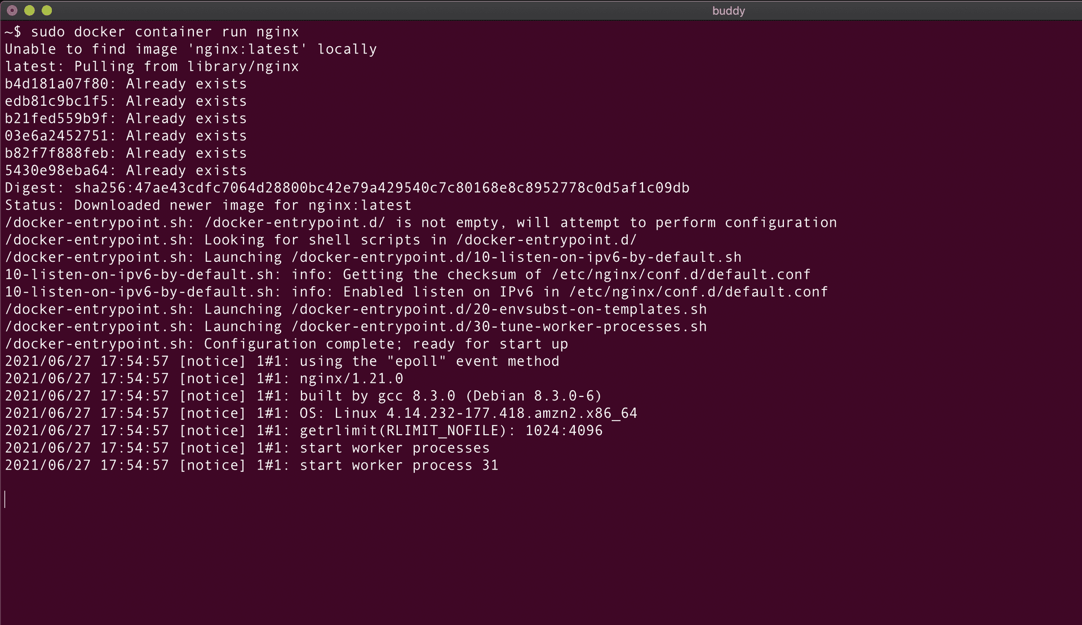
The nginx is running in the foreground, which means this terminal session cannot be used for executing other commands or performing any other operation.
Hint
If we end the terminal session by closing the terminal tab or using the exit command, the container will die automatically and the Nginx process would stop running.
Let's launch a new terminal tab and check the status of the container. We can see the container was created and is running:
bash
docker ps
Image loading...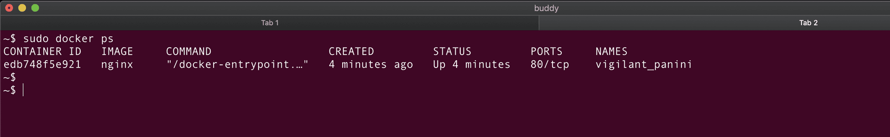
If we end the terminal session by closing the terminal tab or by pressing CMD+C/CTRL + C, the container should die automatically. Running docker ps will confirm this is what indeed happened:
Image loading...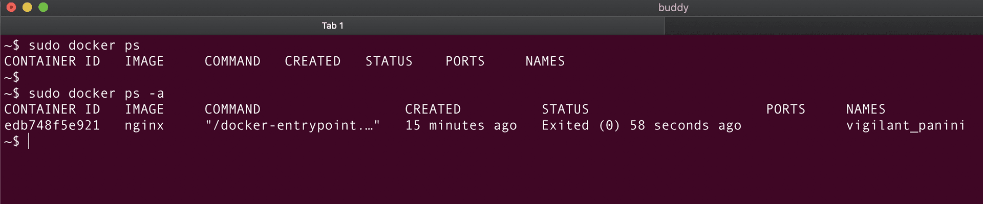
Hint
You can see the status of the container is exited, not deleted. This is because when the container exits or is stopped, the filesystem of the container continues to persist on the host machine.

Delete container on exited status
If you want to delete the container after it is exited, you can start it with the --rm parameter:
bash
docker run --rm nginx
Hint
The --rm option removes the filesystem of the container once it is stopped or when the container exits automatically.
Run container in detached mode
To run the container in the background/detached mode, you can use the --detach parameter:
bash
docker run -d <image_name>
Let's run a container from an nginx image in the background mode:
Image loading...
From the above image, we can see that the container process is not attached to the terminal session and the container is running in the background mode. This is also confirmed by the docker ps command:
Image loading...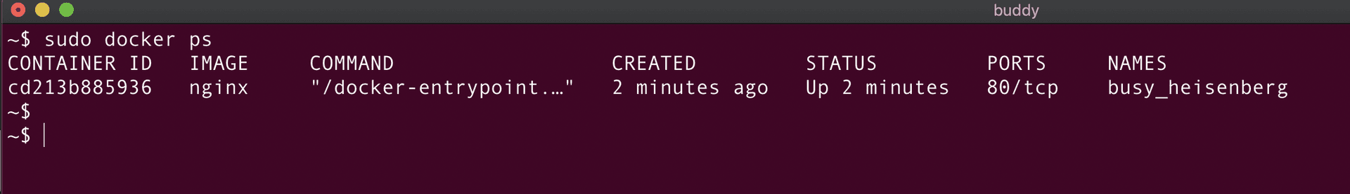
Run container with assigned name
You can assign a name to a container by adding the --name flag to the run command followed by the container details:
bash
docker run -d --name <container_name> <image_name>
In other words, if we want to create a container named nginx-container from nginx image, we run:
bash
docker run -d --name nginx-container nginx
Image loading...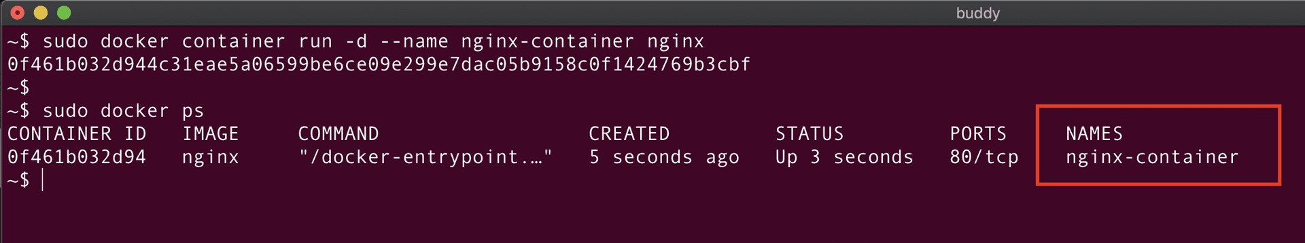
List running processes in container
To list the processes running within a container, run:
bash
docker top <container_name or container_id>
Image loading...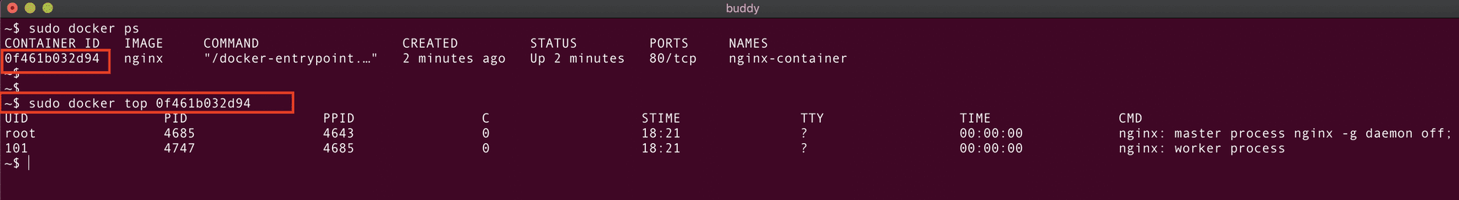
Here, we can see that inside our aptly named nginx-container there are two processes running with the IDs 4685 and 4747.
Map ports of container
Docker exposes the same port on the host machine that is exposed by the container. For example, if the nginx process listens on port 80, a container running nginx will expose it from the port 80 of the host machine.
As we now that one port cannot be used by multiple processes, we can use port mappings to run multiple nginx containers on the same host machine.
You can map the ports of the container by adding the following flags to the docker run command:
bash
docker run --name <container_name> -d -p <host_post>:<container_port> <image_name>
To expose an nginx container (port 80) on port 8080 of the host machine, use the following command:
bash
docker run --name nginx-container -d -p 8080:80 nginx
Image loading...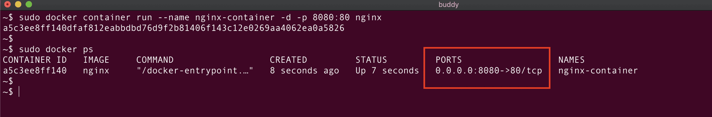
Above we can see that the ports have been properly assigned. Since the container is mapped to the port 8080 of the host machine, we can access the container on port 8080 using the curl command:
Image loading...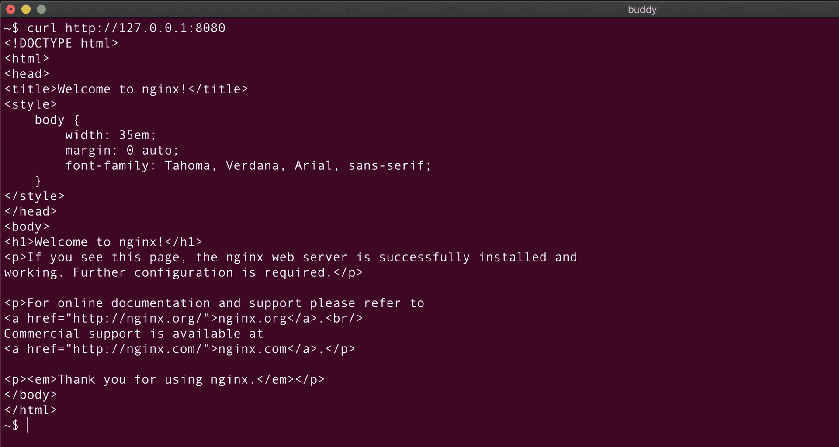

Rename container
To change the name of a Docker container, use the docker rename command:
bash
docker rename <old_name> <new_name>
Let's rename nginx-container to nginx-cont:
bash
docker rename nginx-container nginx-cont
Image loading...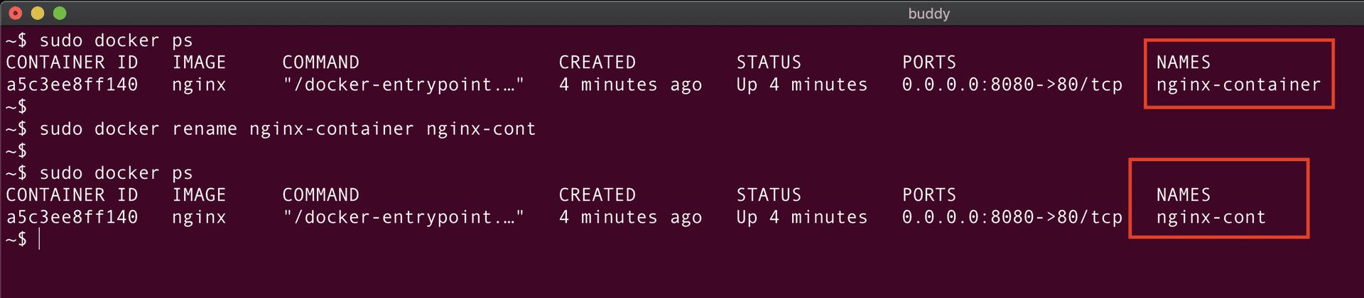
Run container in interactive mode
If we run the container in interactive mode by applying the -it flag, Docker will attach the stdin (standard input) of the container to the terminal. This will give us access to the container and the ability to run any command inside.
In this example, we run the container in interactive mode and start the bash shell inside the container:
bash
docker run -it <image_name> /bin/bash
Let's create a container from our favorite nginx image and run the bash command inside the container:
bash
docker run -it nginx /bin/bash
Image loading...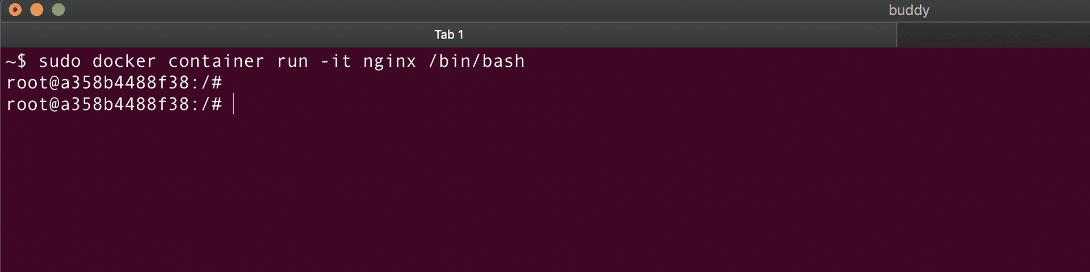
We're in! Now, we can execute any command we want. Open a new terminal tab and list down the running processes:
bash
docker top <container_name>
Image loading...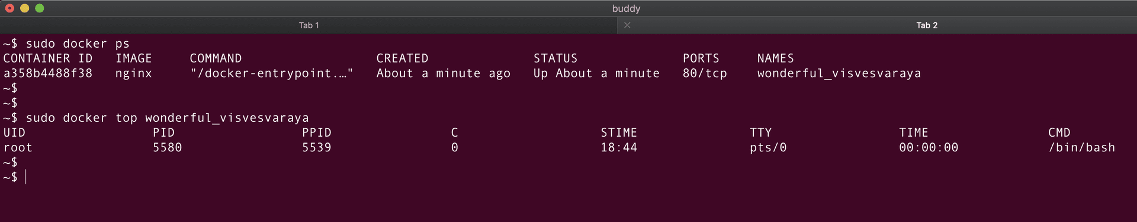
Here we can see there's only one process running in the container. This is the same process that we opened in the first terminal tab.
Hint
Before, there were two processes running inside the container: nginx master and nginx worker. Now, there is only one: bash shell. This is because we passed the /bin/bash command to docker run. This command overrides the Dockerfile's CMD and Entrypoint commands.

Get inside running container
If you want to access a container which is already running, docker exec is the command to go with:
bash
docker exec -it <contaner_id or container_name> /bin/bash
Let's run our container in detached mode and use the command to start a bash shell session:
bash
docker run -d --name nginx-container nginx
docker exec -it nginx-container /bin/bash
Image loading...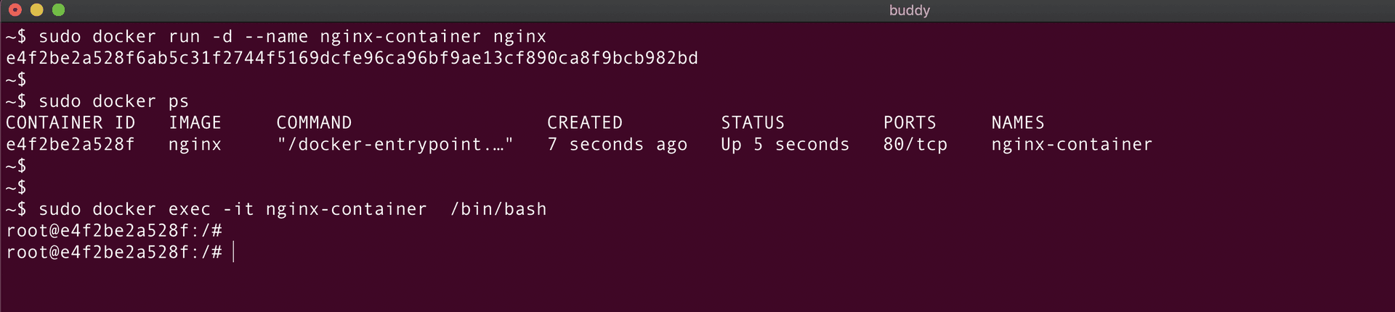
Image loading...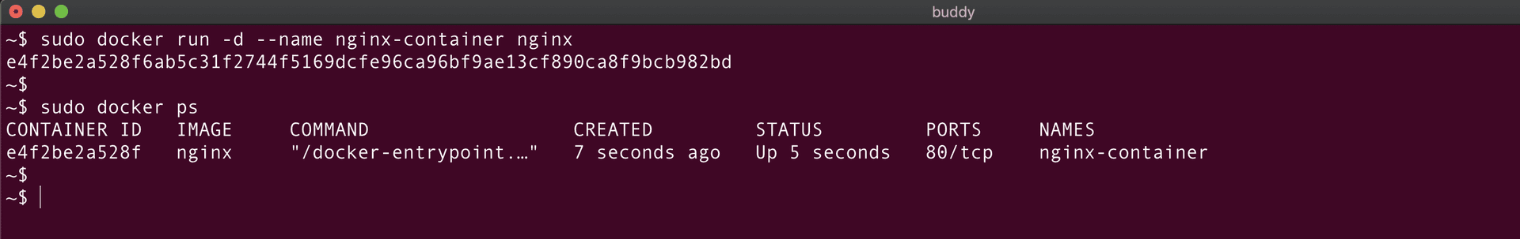
Of course, it is possible to pass any command and execute it in the container, not only /bin/bash. Here's a quick example:
bash
docker exec -it nginx-container echo "Hello, from container"
Image loading...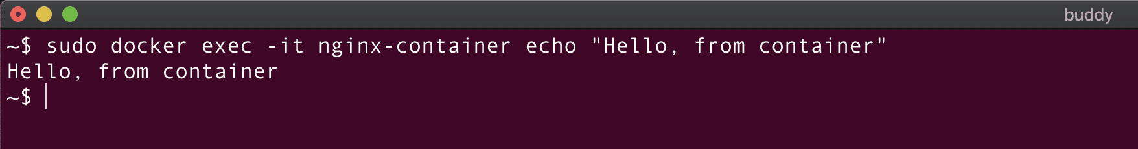
Start container and keep it running
The lifespan of a container depends on the root process inside the container. The process that we used before – nginx – is continuous and keeps the container running. However, if we run a process which is short-lived, the container will be killed as soon as the process has ended.
For example, if we run a container from the centos image, it will die as soon as the default bash command within has been executed:
Image loading...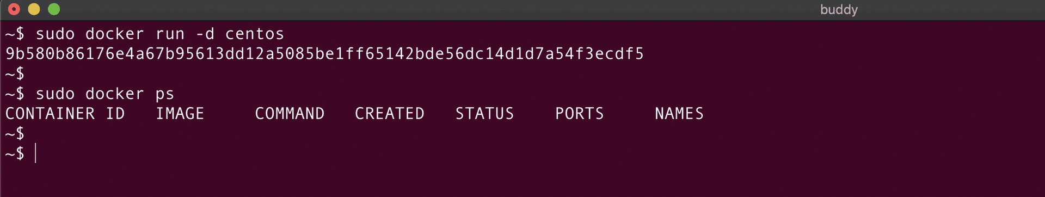
We can trick a short-lived process to keep running by launching it with -dt parameters:
bash
docker run -dt <image_name>
-d – runs the container in detached mode (background) -t – allocates a pseudo-tty (terminal)
This way the container will stay alive and allow you to access it via the terminal.
Here's how it looks in case of the centos image:
bash
docker run -dt centos
Image loading...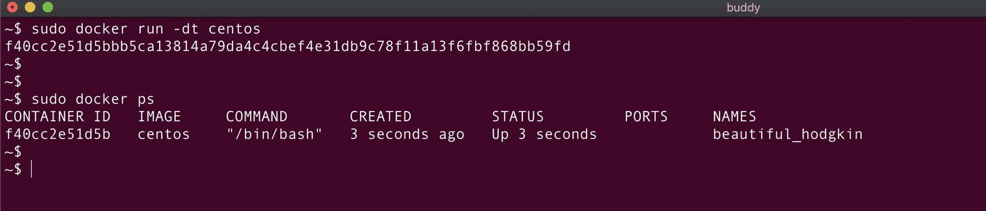

Copy file from container to host
The filesystems of the Docker container and the host are isolated from each other. This means that we need to provide source and target paths for the container and host when copying content between them:
bash
docker cp <container_id or container_name>:<source_file_path> <destination_path>
Let's create a file file_insider_container.txt inside the centos-container:
Image loading...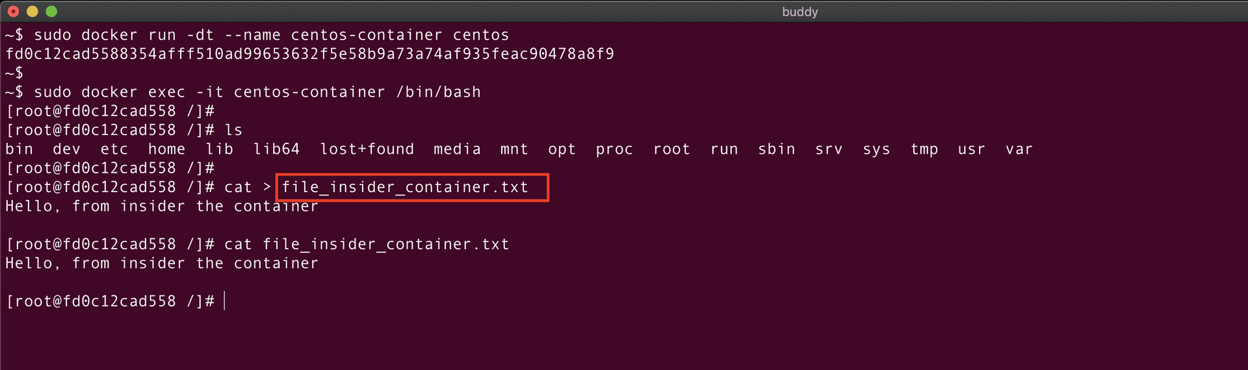
Now, let's copy this file from the container to the host machine:
bash
docker cp centos-container:file_insider_container.txt .
Image loading...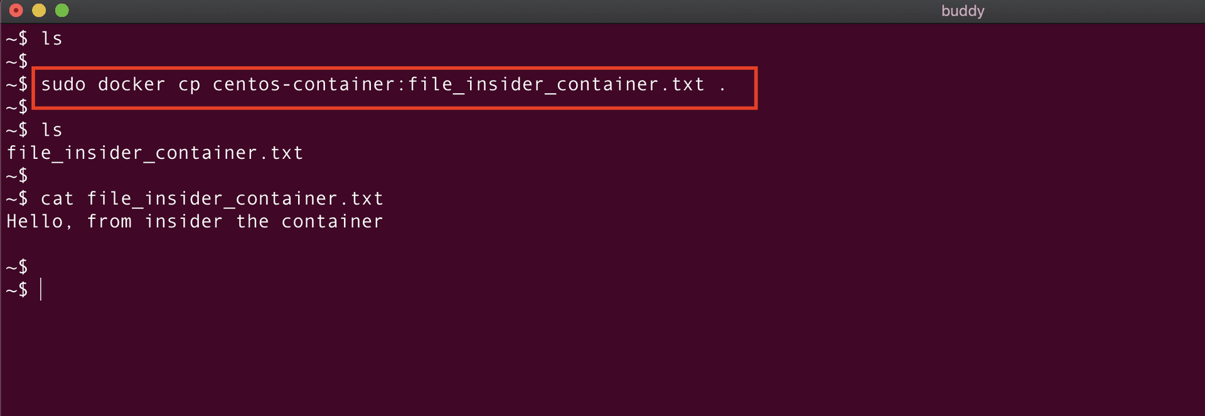
Hint
The . in the command signifies that the destination path is the current location on the host machine.
Copy file from host to container
To copy files from the host to the container, you just need to reverse the order in the copy command:
bash
docker cp <host_file_path> <container_id or container_name>:<target_file_path>
Let's create another file, this time called on the localhost:
Image loading...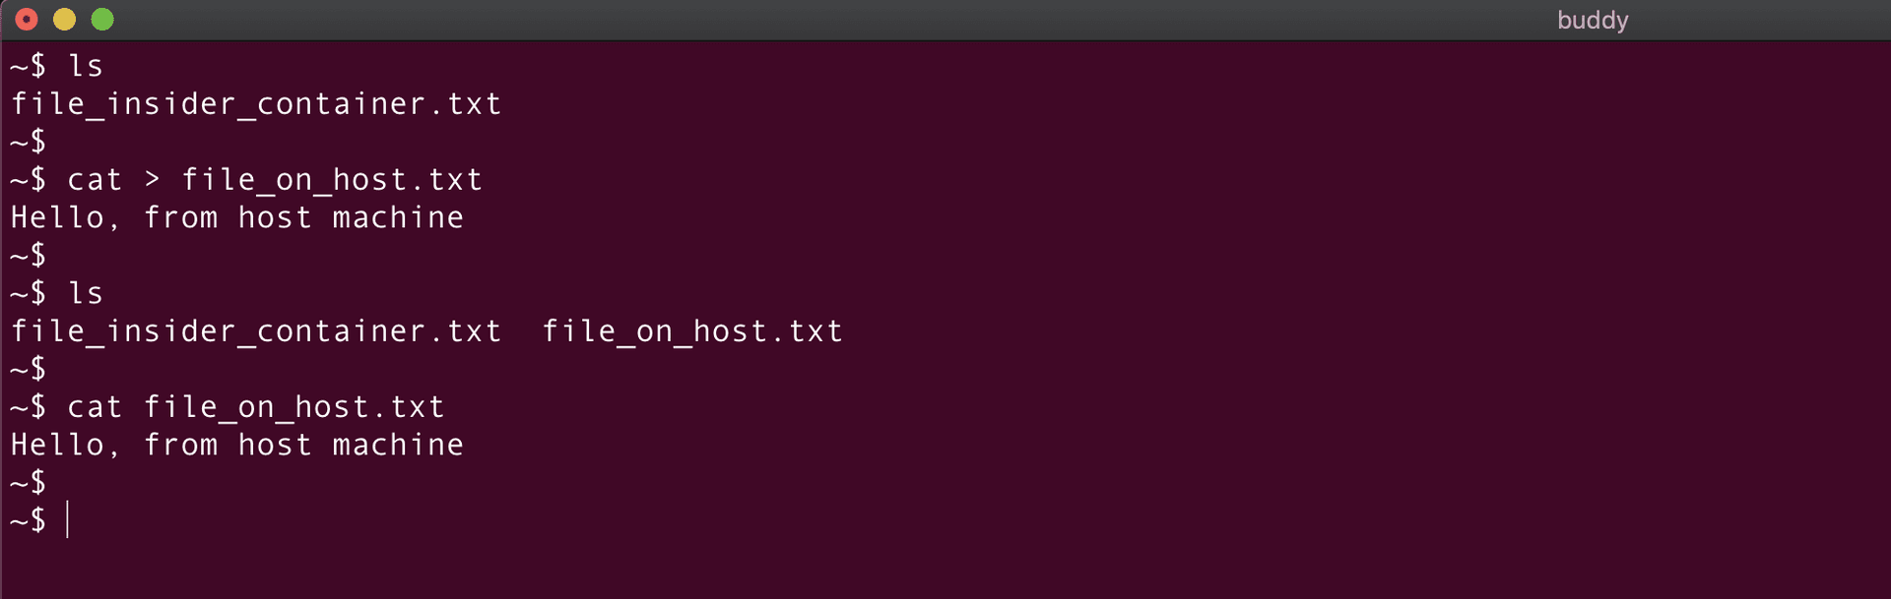
Now, we'll clone it to the CentOS container:
bash
docker cp file_on_host.txt centos-container:/
Image loading...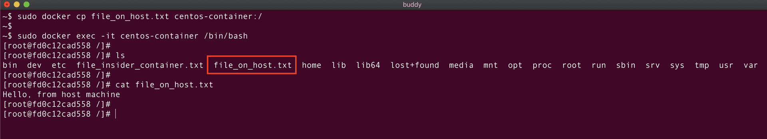

Remove container
You can remove a Docker container with the docker rm command:
bash
docker rm <container_name or container_id>
Image loading...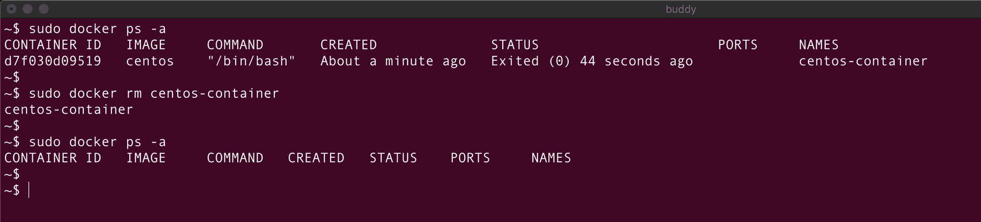
If the container is running, you first need to stop it:
bash
docker stop <container_name or container_id>
Image loading...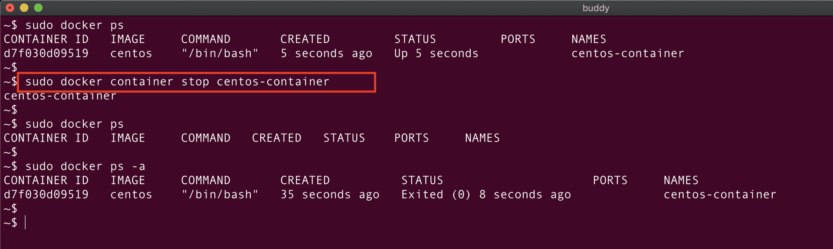
You can also add the --force flag to remove a running container without stopping it:
bash
docker rm -f <container_name or container_id>
Remove container after it exits
Combining run and remove will create and run container that will be automatically deleted the moment it stops:
bash
docker run --rm <image_name>
Delete stopped containers
To purge all stopped containers, use the docker prune command:
bash
docker container prune
Image loading...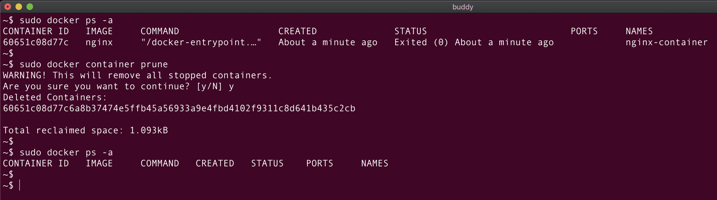
Delete stopped and running containers
To delete all containers regardless of their state, use the following string:
bash
docker rm -f $(docker ps -a -q)
docker container rm -f $(docker ps -a -q)$$
Hint
docker ps -a -q lists the IDs of both active and inactive containers, which are then forced to remove with the docker rm -f command.
Build Docker image from container
You can create Docker images from existing containers with the docker commit command:
bash
docker commit <container_id or container_name> <new_image_name>
docker container commit <container_id or container_name> <new_image_name>
Example: we create a file in our CentOS container:
We'll create a file file_inside_container.txt inside the running container centos-container:
Image loading...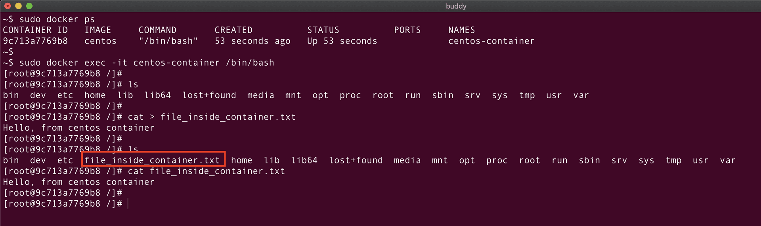
Let's now create an image (centos-with-new-file) from centos-container using the below command:
bash
docker container commit centos-container centos-with-new-file
Image loading...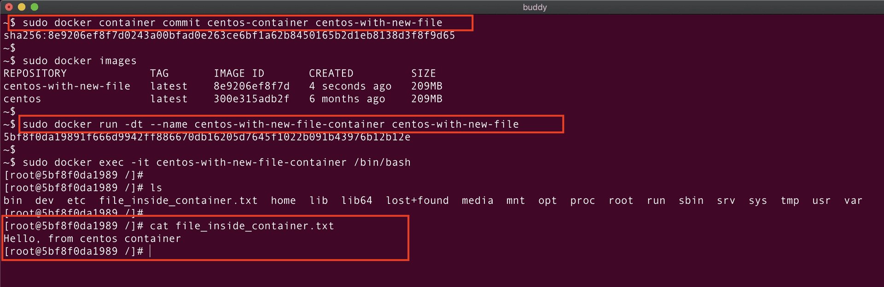
Success
From now on, all containers launched from the image will contain the file.

Set environment variables in container
Environment variables are used to store and access configuration settings, allowing you to control the behavior of your application without modifying its code. It is possible to set variables inside a Docker container using the below command:
bash
docker run --env ENV_VAR1=value1 --env ENV_VAR1=value2 --name <container_name> <image_name>
For example, to create an ENV VAR with the name NAME and the value Buddy inside a CentOS image, you should run:
bash
docker run -dt --env NAME=Buddy --name centos-container centos
Hint
The -dt flag runs the centos-container in detached mode, preventing it from dying immediately upon command execution.
To check if the variable has been set correctly, use the printenv command:
bash
docker exec -it centos-container printenv
Image loading...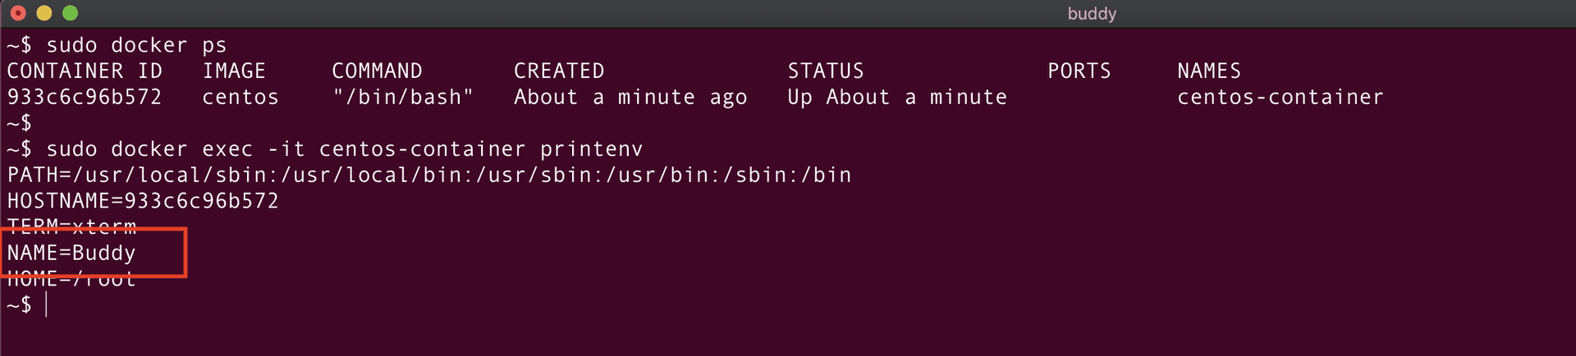
Set environment variables in container from file
Using the --env-file parameter will let import variables directly from a file:
bash
docker run --env-file <path_to_the_file> --name <container_name> <image_name>
Here we have a file named file1.txt consisting of key-value pairs as shown below:
Image loading...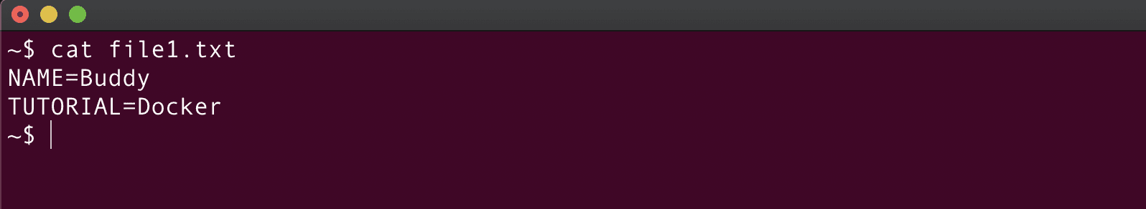
To create ENV VARs from the file inside our CentOS container, run:
bash
docker run -dt --env-file file1.txt --name centos-container-1 centos
Image loading...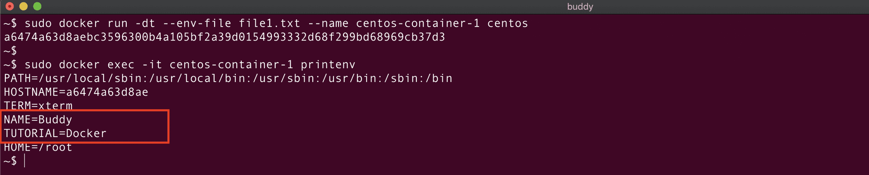
Warning
Each line in the file should be in the format VAR=VALUE.
Let's create environment variables inside the centos-container-1 container using the file file1.txt:
Hint
The -dt flag runs the centos-container in detached mode, preventing it from dying immediately upon command execution.
Docker image commands
Docker images are lightweight standalone packages and contain everything required to run software across different platforms. They are created from Dockerfiles, which define the instructions to build the image. The images are stored in image repositories, such as Docker Hub, Azure Container registry, or Google Artifact Registry.
List all images
To list all images stored locally on your computer, run:
bash
docker images
Image loading...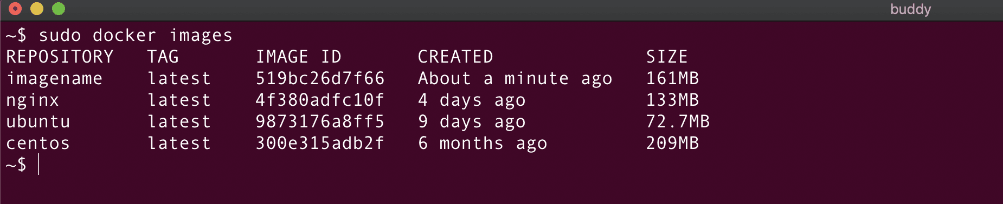
List all images (including dangling images)
Adding the -all parameter will add unused (dangling) and intermediate images:

bash
docker images -a
Image loading...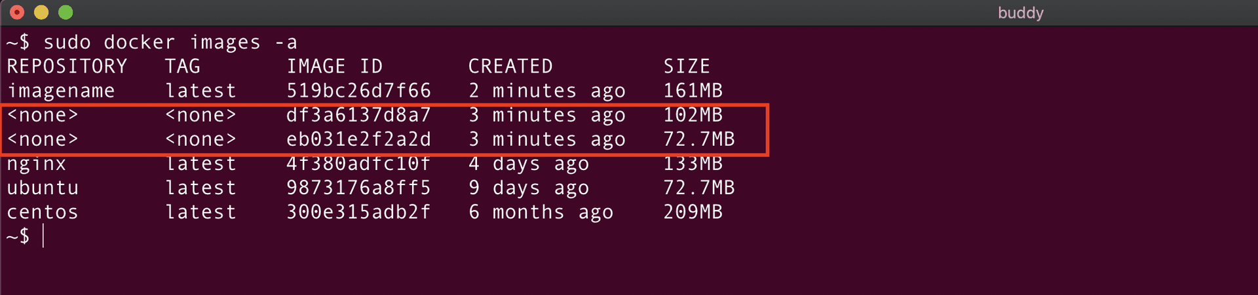
Hint
Intermediate images are images used during the Docker build process.
List image IDs
To list only the IDs of locally stored images, add the -q flag:
bash
docker images -q
Image loading...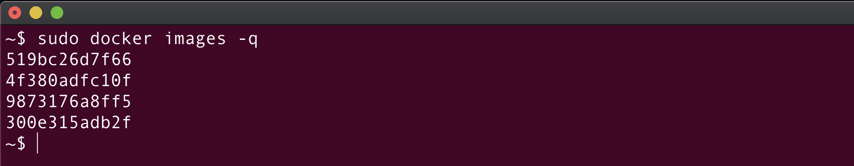
Build image
Docker images are created from Dockerfiles which contain build instructions and configuration.
To build an image from a Dockerfile, run:
bash
docker build -t <image_name> <context_dir>
Hint
<context_dir> is the directory where the Dockerfile is stored.
Let's create a simple Dockerfile in the current directory:
Image loading...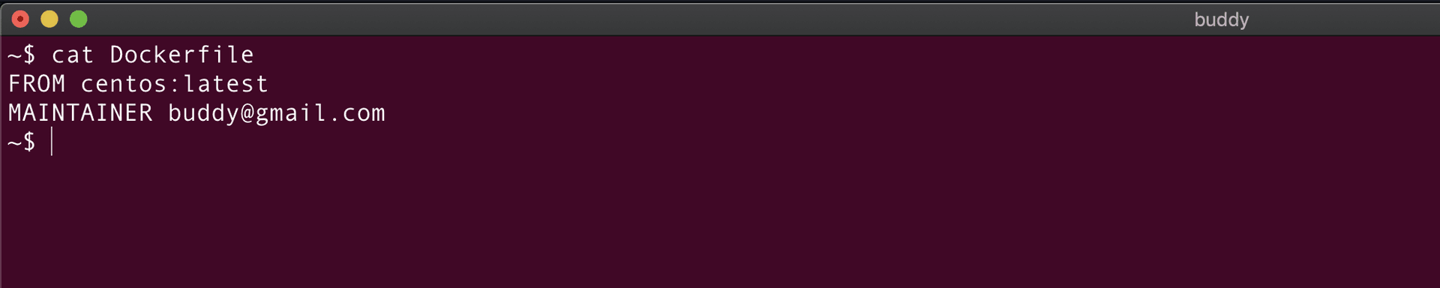
With the Dockerfile created, we can run docker build :
bash
docker build -t centos_buddy
Image loading...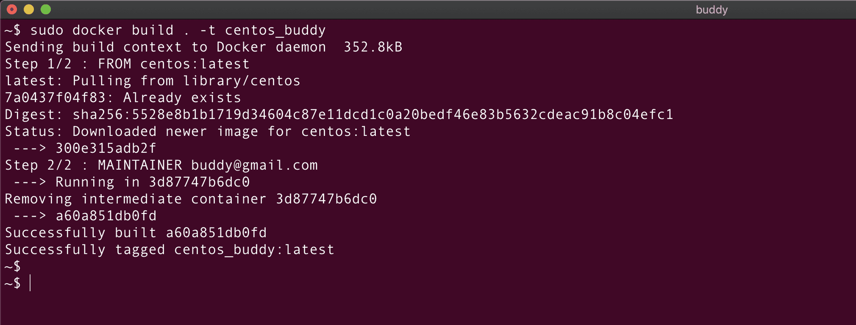
- The command pulls the CentOS image in the newest version from Docker Hub.
- The . in the command indicates that the context directory is the current directory.
Let's verify if the image has been created with the docker images command:
Image loading...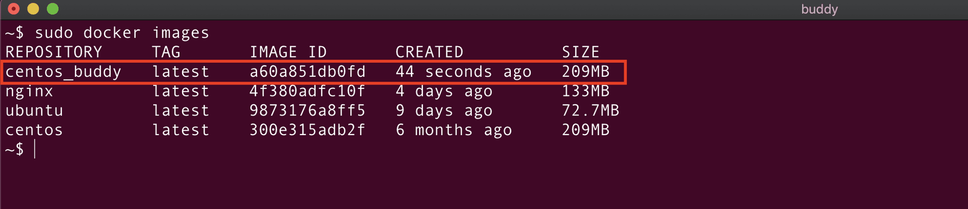
If your Dockerfile is not in your current directory, you can specify it by adding the --file option:
bash
docker build -f </path/to/dockerfilename> -t <image_name> .$
Build image with different tag
You can tag Docker images by running the following string:

bash
docker build -t <image_name>:<tag or version> .$
For example, this command will build an image named centos_buddy with tag 1.8:
bash
docker build -t centos_buddy:1.8 .$
Image loading...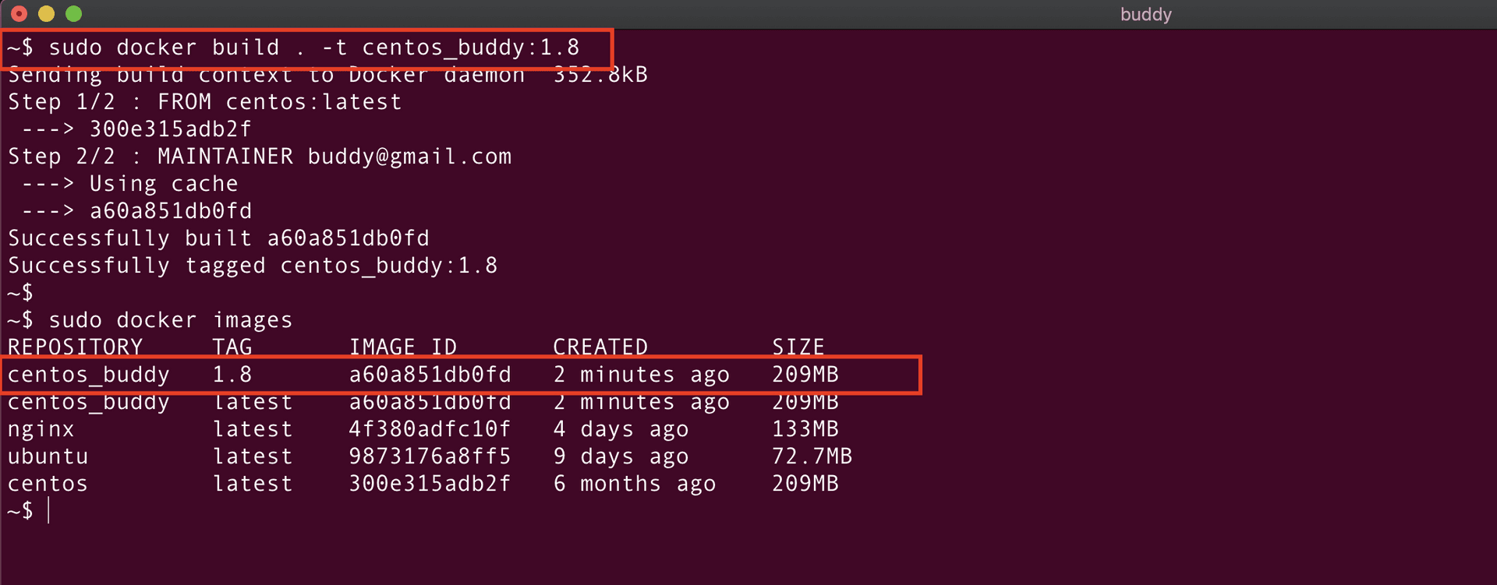
Build image using custom-named Dockerfile
If you have several Dockerfiles for various types of images, you can specify the one to use with:
bash
docker build -f <custom_docker_file_name> -t <image_name> .$
For example:
bash
docker build -f custom_docker_file -t centos_custom .$
Image loading...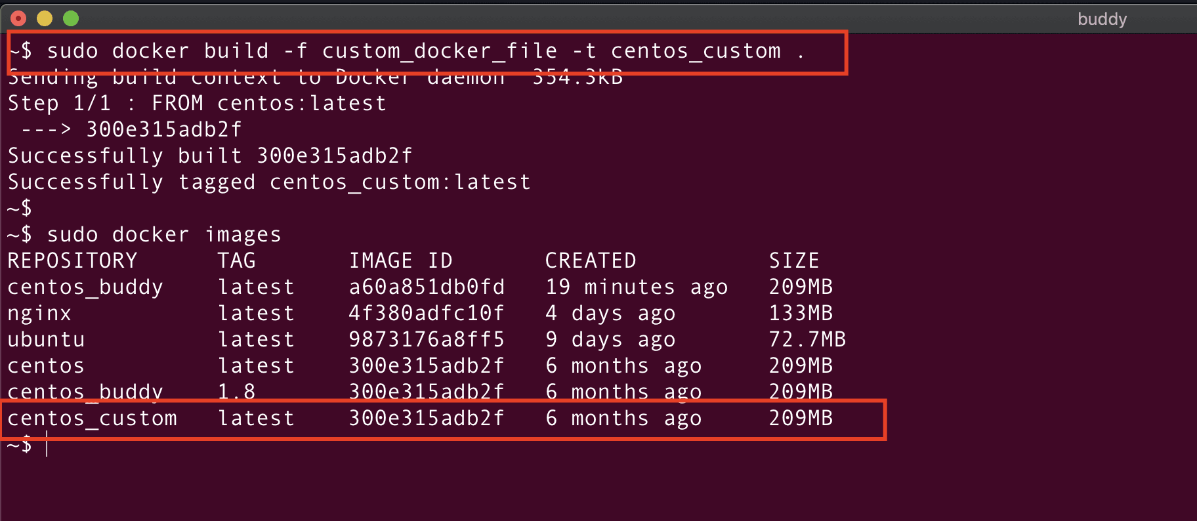
Show image history
To view the history of changes in your Dockerfile, run:
bash
docker history <imagename or imageid>$
Here's an example for our centos_buddy image:
Image loading...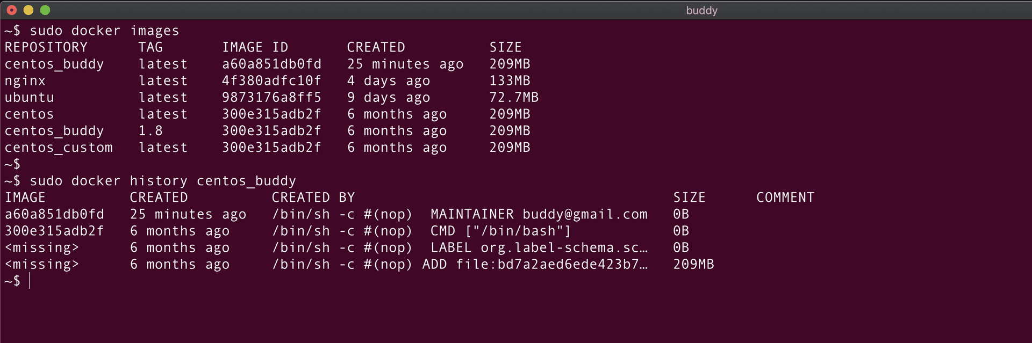
Rename existing image
To change the name of an existing image, run:
bash
docker tag <imagename> <newname>:<version>$
Image loading...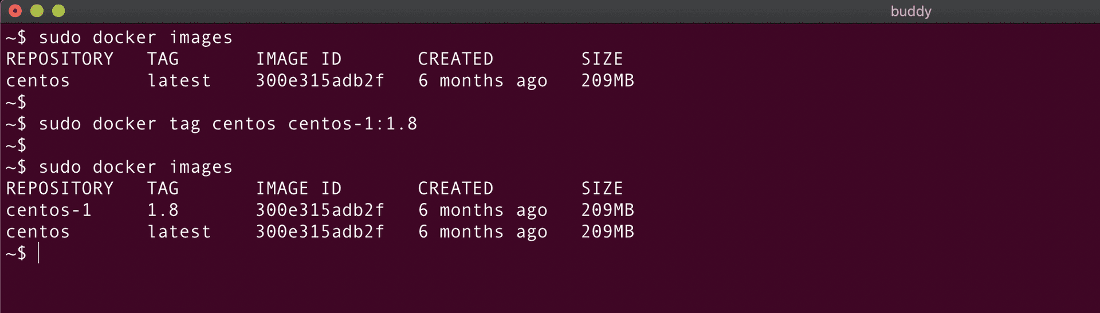
Remove images
If the image is not used by any container, you can delete it with the docker rmi command:
bash
docker rmi <image_name or image_id>$
Image loading...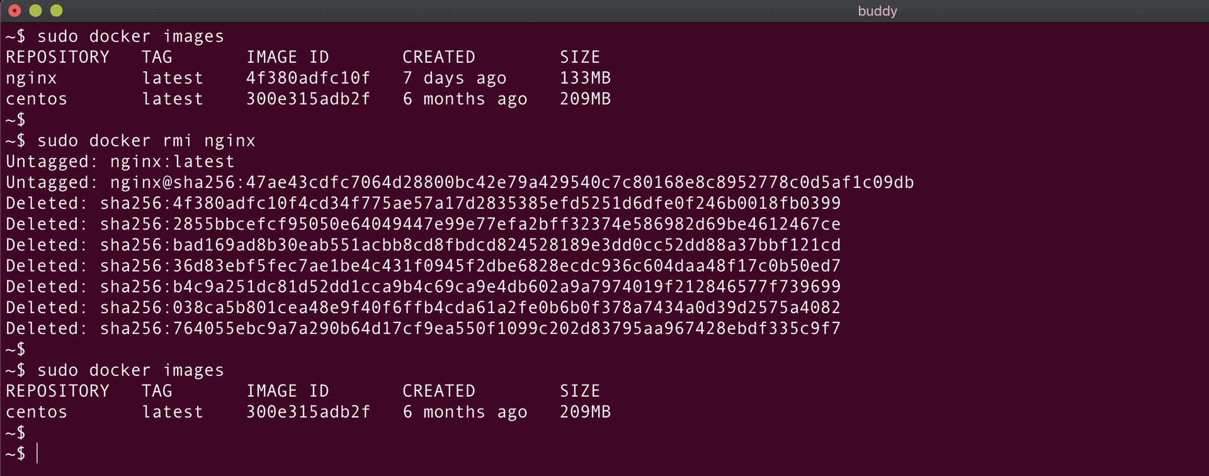
Tip
You can add the --force flag to delete images in use: bash docker rmi -f <image_name or image_id>

Docker logs commands
Let's now learn how to fetch logs from a Docker container.
Get container logs
We can get the logs of the Docker container as:
bash
docker logs <container_id or container_name>$
Image loading...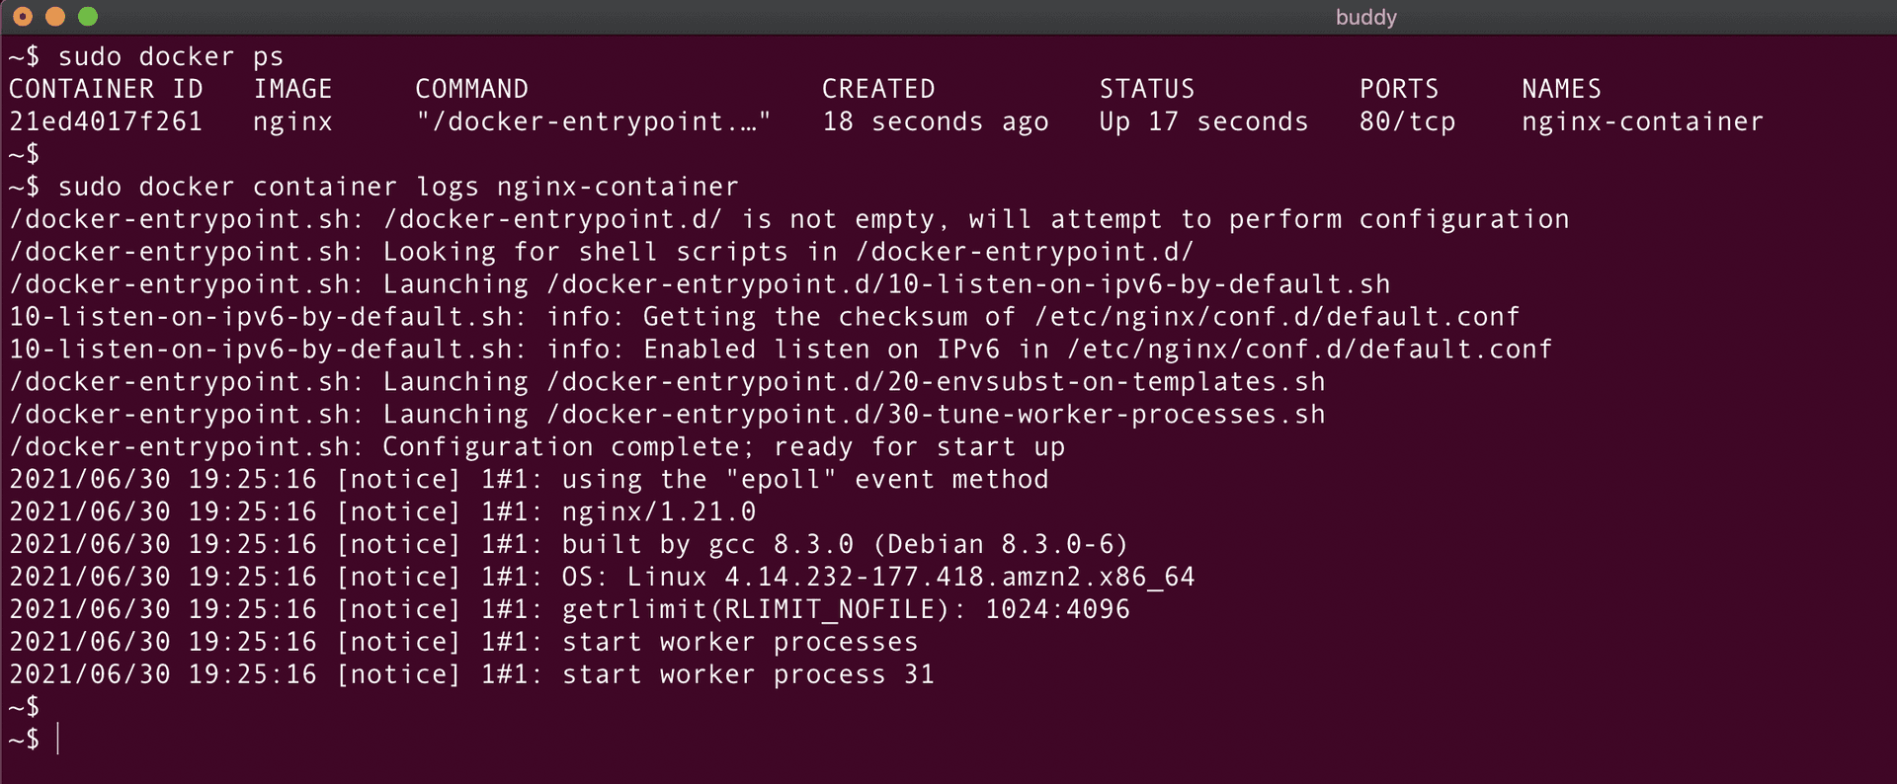
The above screenshot shows the logs of the container nginx-container.
To get a specific number of lines from the logs, you can add the --tail <number> option:

bash
docker logs --tail 2 <container_id or container_name>$
Image loading...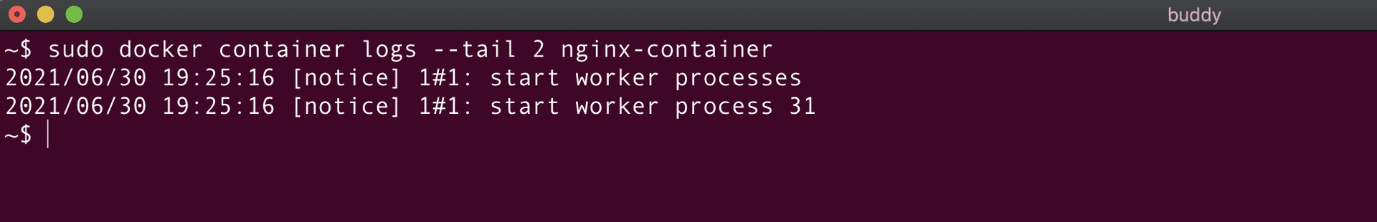
Monitor container logs
To display the last few lines of the container logs and monitor them, we can use the below command:
bash
docker logs -f <container_id or container_name>$
The new messages in the container would be displayed here! This is similar to the tail -f command.
Image loading...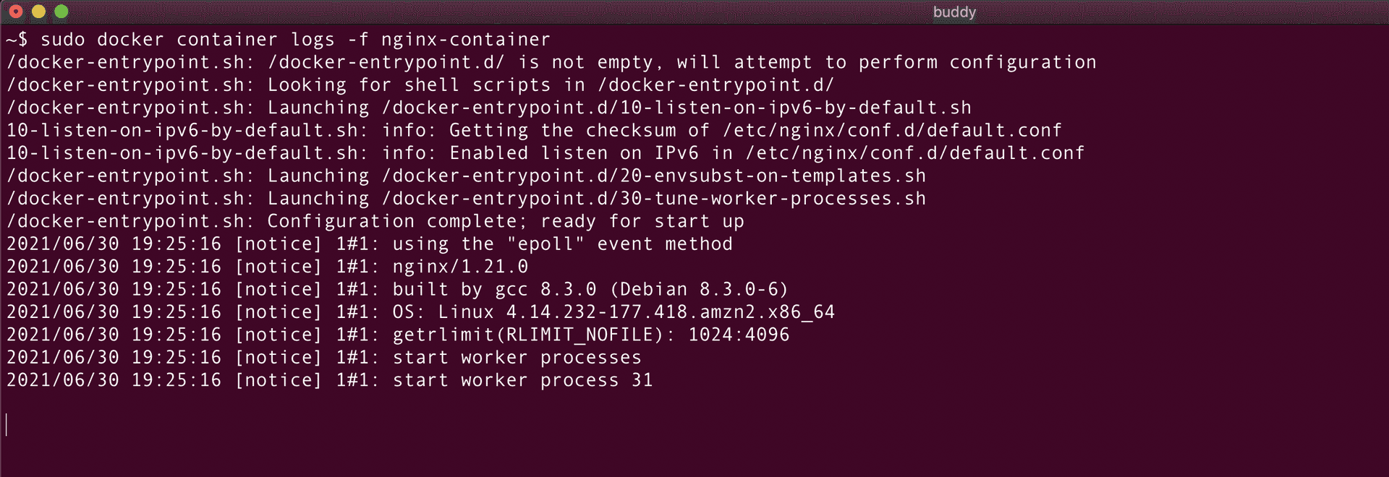
Docker network commands
Docker network commands are used to manage and configure networks in Docker. They allow you to create, list, inspect, connect, and disconnect containers from networks. Here are some of the most useful ones.
List all networks
This command will provide you with a quick overview of the existing networks on your Docker system. You can use this information to identify and select the appropriate network for connecting containers or performing other network-related operations.

bash
docker network ls$
Image loading...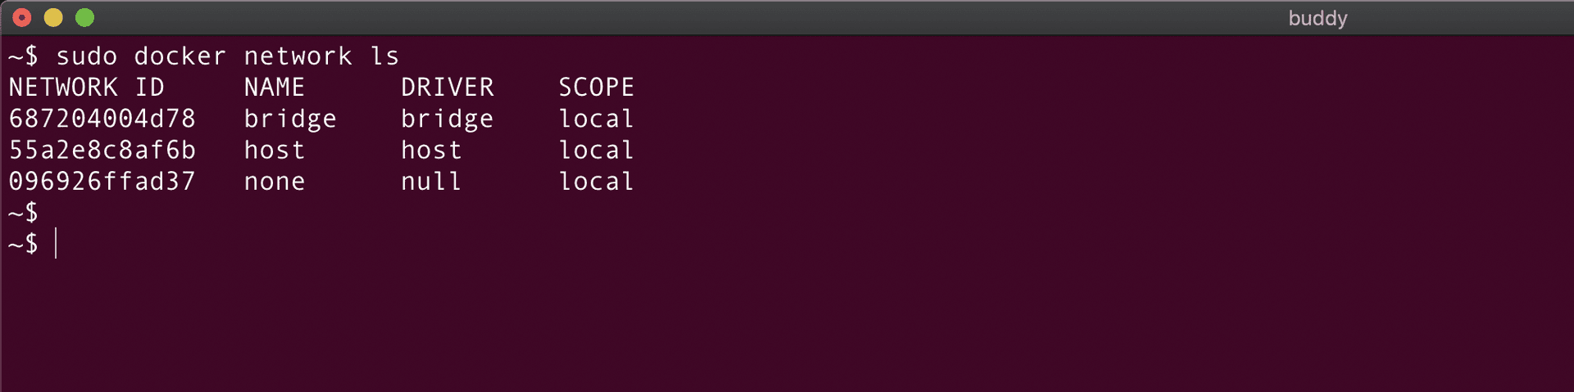
Create network
Creating a Docker network will allow you to connect containers to it so that they can communicate:
bash
docker network create --driver <driver-name> <bridge-name>$
- driver-name can be either bridge or overlay.
- bridge is the default if --driver option is not provided.
For example:
bash
docker network create --driver bridge new-network$
Image loading...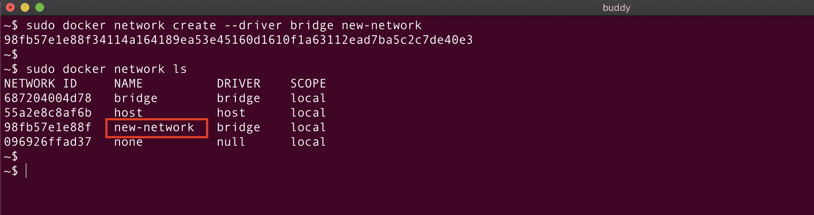
Show network information
To display the details of the Docker network, run:
bash
docker network inspect <network_id or network_name>$
Get IP address of running container
You can fetch the precise IP address of a running container with the following command:

bash
sudo docker inspect -f '{{range.NetworkSettings.Networks}}{{.IPAddress}}{{end}}' <container_name or container_id>$
Image loading...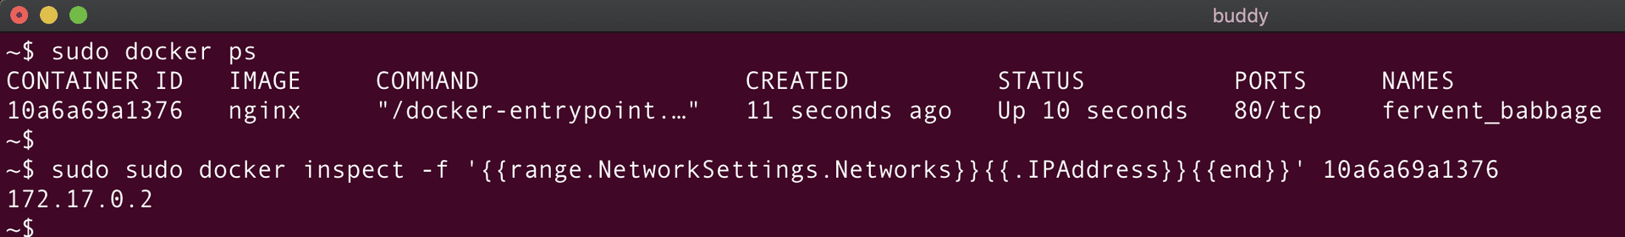
Connect container to network:
This command connects the container with the specified network:
bash
docker network connect <network_id or network_name> <container_id or container_name>$
Let's look at an example:
Image loading...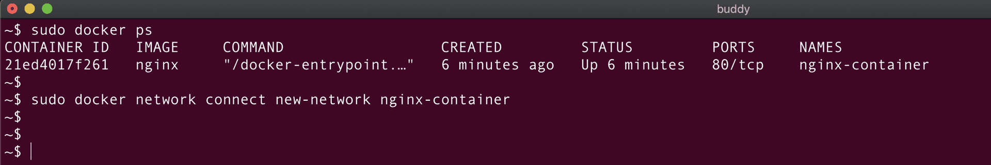
The container nginx-container is connected to the network new-network. We can verify this using docker network inspect:
Image loading...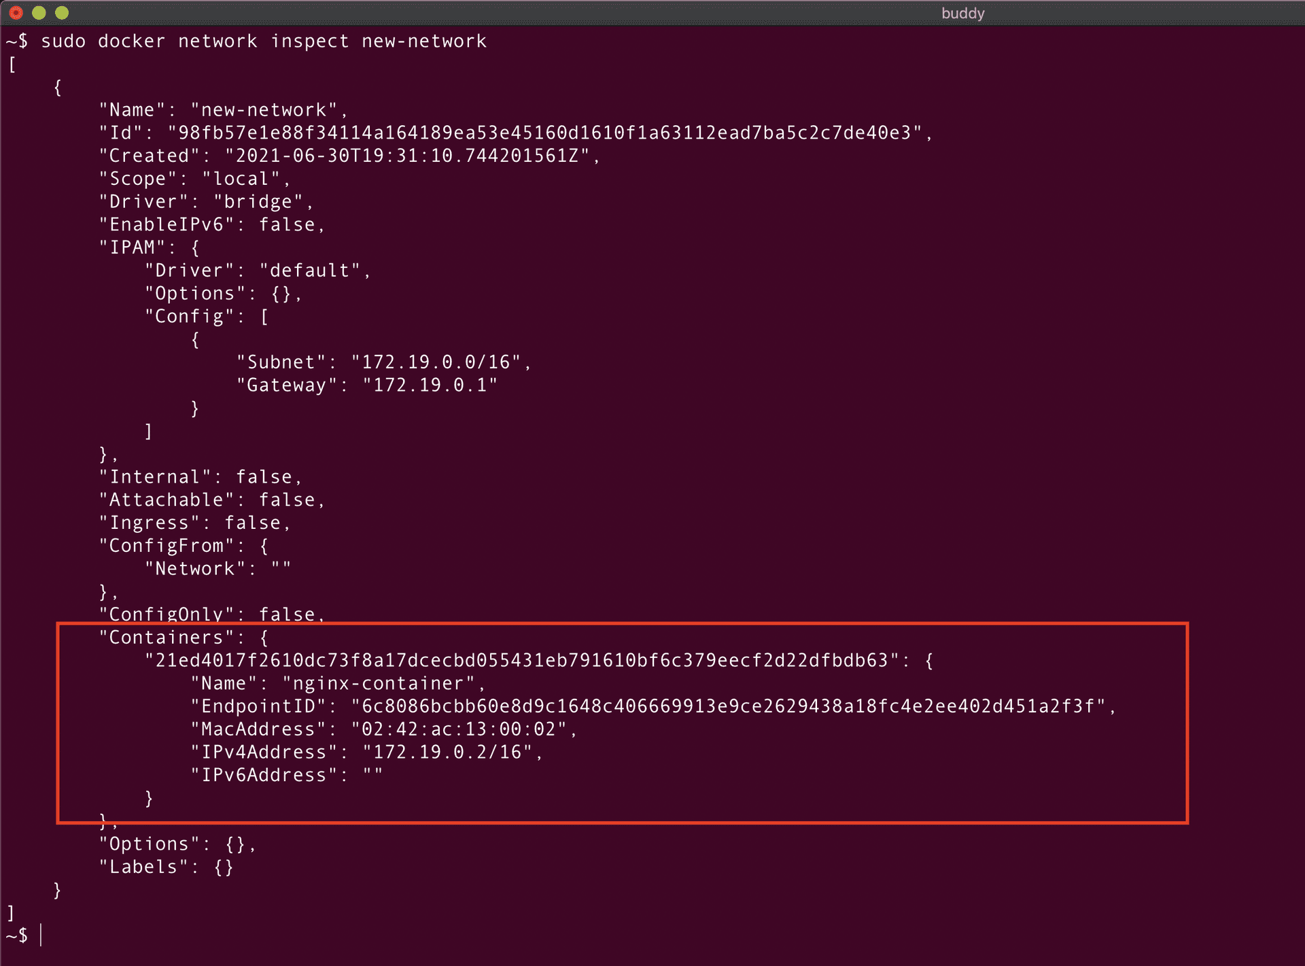
Connect container to network on start
This command automatically connects the Docker container to the network as soon as it starts:

bash
docker run -d --network=<network_name or id> <contaienr_name>$
Disconnect container from network:
To disconnect the container from the network, run:
bash
docker network disconnect <network_name_or_id> <container_name_or_id>$
Image loading...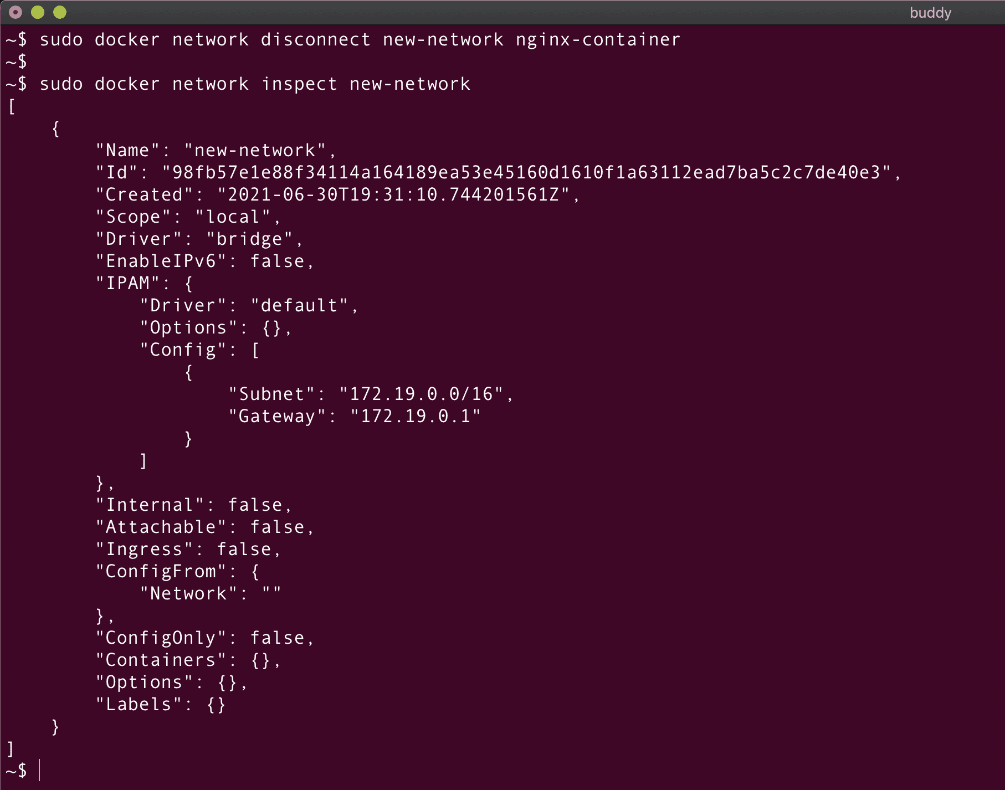
Remove network
To delete an existing Docker network, run the docker network rm command:

bash
docker network rm <network_id or network_name>$
Image loading...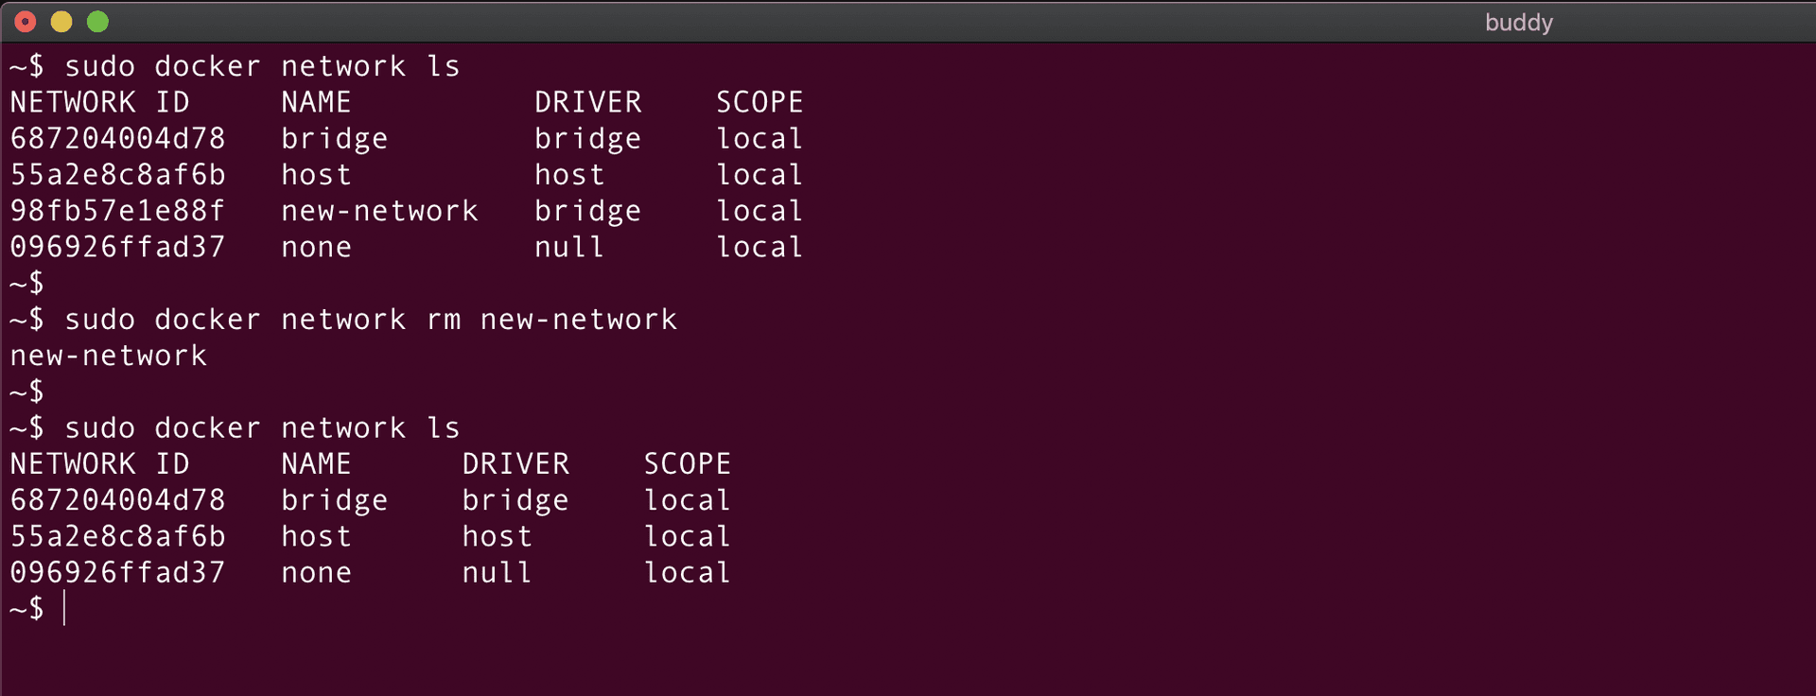
Docker volume commands
A volume in Docker is a directory that is stored outside the container's file system. It allows you to persist and share data between containers or between a container and the host machine. The commands in this section will allow you to manage and manipulate volumes in your Docker containers.
Create volume
To create a new Docker volume, run:
bash
docker volume create --name volume-name$
Image loading...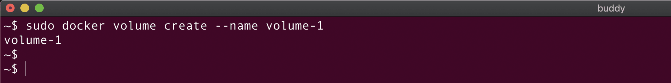
List volumes
To list existing volumes, add ls:
bash
docker volume ls$
Image loading...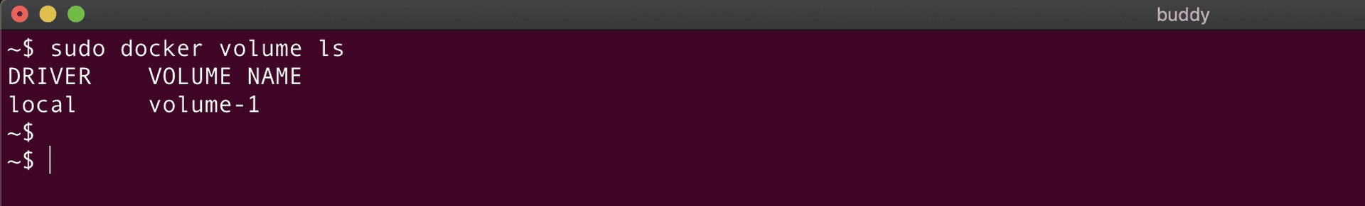
Mount volume using -v flag
We can mount the volume inside the Docker container once it is created using the below command:
bash
docker run -it --name <container-name> -v <volume-name>:<path-in-container-where-volume-is-mounted> <image-name>$
- First, we create and name a new container <container-name> from the image <image-name>.
- Next, we mount the volume volume-name inside the container at the provided path.
Mount volume using --mount flag
The --mount flag is used to mount a directory from the host machine into a specific location inside the container:
bash
docker run -it --name <container-name> --mount source=<volume-name>, destination=<path-in-container-where-volume-is-mounted> <image-name>$
Get volume details
You can fetch information about a specified volume, such as the volume name, driver used, and associated labels:
bash
docker volume inspect <volume-name>$
Remove volume
To remove an existing volume, use the below command:
bash
docker volume rm <volume-name>$
Warning
To remove a volume, your first need to remove all containers using that volume.
Mount volume with bind-mount
To mount any specific host directory inside the container, use the following command:
bash
docker run -it -v /path/on/host:/path/in/contianer/where/volume/should/be/mounted <image-name>$
Create bind-mount volume using --mount flag
Bind-mount in Docker refers to the process of attaching a directory or file from the host machine to a specific location inside a Docker container.
bash
docker run -it --name <container_name> --mount type=bind,source=/path/on/host/,target=/path/on/container first-image$
Warning
Mounting a volume with type=bind will override the contents with the host directory.
Docker registry commands
A Docker registry is a server-side repository that stores and distributes Docker images. By default, all images are pulled from Docker Hub. In fact, creating an account on Docker Hub should be the first thing to do when starting your journey with Docker.
Push image to registry
Once you've logged in, you can push Docker images to the registry using the below command:
bash
docker push repository_name/imagename:tag$
Download image from registry
To pull a Docker image, run:
bash
docker pull imagename:tag$
- If the image is not present on the host machine, Docker will pull the image from the Docker registry.
- If no tag is specified, Docker will pull the latest image.
Image loading...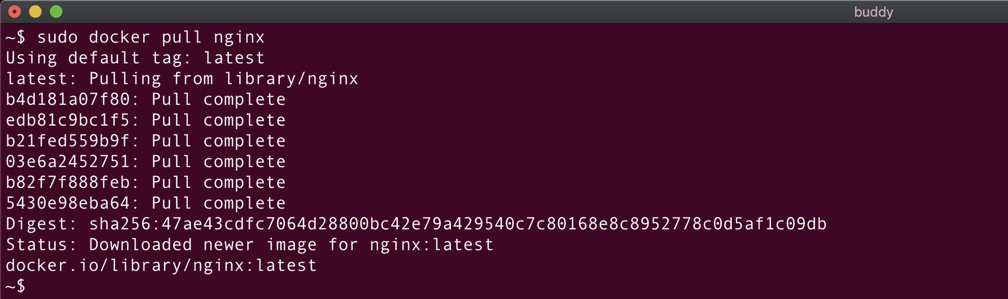
System-wide Docker commands
The last batch of commands will allow you to manage and interact with the Docker environment on your system.

