What are Kubernetes Labels and Selectors?
Labels are key-value pairs that are attached to any Kubernetes resource, including pods, services, deployments, and more. You can think of them as simple tags like env=prod or color=black that are used to identify Kubernetes resources. It is defined in the metadata section of the YAML files of the resources.
Here's an example of what Labels look like in a YAML file:
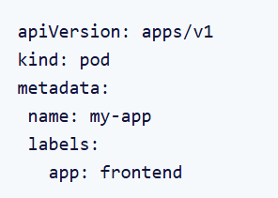
Let’s understand what is being defined in the above YAML file.
- apiVersion: The version of the Kubernetes API being used.
- kind: The type of Kubernetes resource.
- metadata: Contains information that helps identify and describe the resource.
  - name: Sets a name for the pod, here called my-app.
  - labels: Here, the label is app: frontend, meaning this pod is part of the "frontend" application or layer.
The label app: frontend makes it easy to find and work with all pods marked as "frontend". Imagine you have 10 pods and half of them are for the frontend while the others are for the backend. By labeling them, you can quickly filter them by using kubectl commands like kubectl get pods -l app=frontend, this will list out all frontend pods.

Selectors, on the other hand, work in conjunction with labels allowing Kubernetes to find specific resources based on these tags.
For example, let’s understand the service YAML file below:
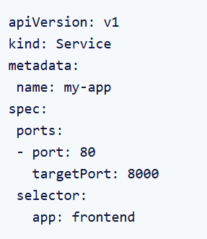
Let’s go through it step-by-step:
- name: The name of the service
- kind: The type of Kubernetes resource
- selector: The selector for the label that we want to target. In this case, we are selecting every pod that has labeled as: app:frontend
- ports: The port and protocols where the service should expose the pod.
The label app: frontend on the pods and the selector in the service work together to make sure traffic only reaches the right pods. Imagine you have a few different types of pods running, some for the frontend, and some for the backend. This setup keeps things organized by routing traffic only to the frontend pods labeled app: frontend.
Types of Selectors
Labels and Selectors are very tightly bound to each other. We cannot have selectors without labels. Now, let’s discuss the types of Selectors provided by Kubernetes.
Equality-Based Selectors
Equality-based selectors are mostly used in the Imperative or Command line statements. These are simple rules that check if a label has a specific value. There are three kinds of operators admitted to it, =, ==, !=.
- =: Checks if a label has a specific value (same as ==).Example: env=production selects resources where the label env is set to production.
- ==: Also checks if a label has a specific value (synonym for =).Example: env==production selects resources where the label env is set to production.
- !=: Checks if a label does not have a specific value.Example: env!=staging selects resources where the label env is not set to staging.
Let’s take an example scenario where we want to filter resources based on exact label matches using Equality Selectors.
You want to find all resources where the env label is set to production
To find resources with the label env=production, you can use the following CLI command:

This command filters and lists all Pods with the env=production label.
Set-Based Selectors
Set-Based selectors are typically used in declarative statements using the YAML file. They provide more flexibility than Equality-Based selectors. Three kinds of operators are supported: In, NotIn, and Exists.
- In: Selects resources with a label that matches any of the given values.
Example: environment In (production, staging) will find resources in either production or staging.
- NotIn: Excludes resources with a label that matches any of the given values.
Example: team NotIn (dev, qa) will skip resources labeled as dev or qa.
- Exists: Selects resources that have the specified label, regardless of its value.Example: tier Exists selects resources that have the tier label.
Here’s an example where we define these selectors in a YAML file:
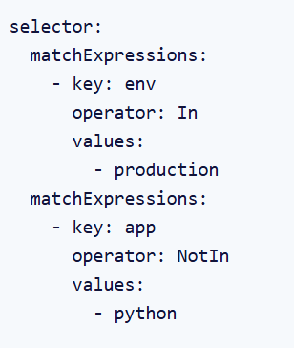
Let’s breakdown the above YAML file:
- The matchLabels section uses In operator to filter out resources where the env label is production.
- The matchExpressions section uses NotIn operator to filter out resources where the app label is python.
In the Set-Based selectors, we select Labels using two keywords. These are as follows:
matchLabels
matchLabels is a very straightforward way to select objects based on label keys and values. You provide a list of labels with their exact values, and Kubernetes will match resources with those labels.
For example, let’s have a look at its syntax and YAML configuration.
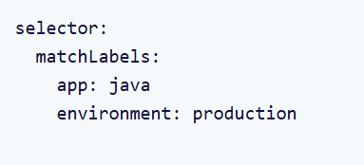

This says that find all resources where app is java and environment is production.
If you look carefully, matchLabels are actually equality conditions.
Here, the app should only be java and environment should only be production. It cannot have multiple values for one key.
matchExpressions
matchExpressions is an extension of matchLabels where we have a label key, an operator (In, NotIn, Exists, and DoesNotexists), and then its values which can be more than one.
Again, let’s understand the syntax and its use through an example:
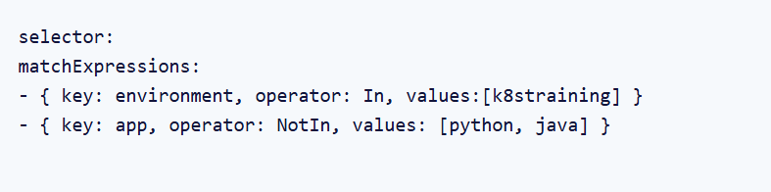
his selector uses matchExpressions to define two conditions for filtering resources based on their labels:
- environment In (k8straining) This condition selects resources that have the label environment with the value k8straining.
- app NotIn (python, java) This condition excludes resources that have the label app with the value python or java. It also includes resources that don’t have the app label at all.
Kubernetes will select resources that:
- Have the environment label set to k8straining.
- Do not have the app label set to python or java.

Why use Kubernetes Labels & Selectors?
So far, we’ve discussed what labels and selectors are and how we use them to organize and select our Kubernetes resources in a simple and efficient way. By now, you might already appreciate their importance. Now, let’s dive into why they’re so essential and look at some real-world scenarios.Here are two key aspects of Kubernetes where Labels and Selectors play a vital role:
- Staying Organized: Labels let you group your resources by categories like environment (production, staging) or app type (frontend, backend). This makes it easy to know what’s what.
- Quickly Find Resources: Using simple commands, you can quickly locate specific resources. For example

This lists all Pods with the label app=frontend.
Now, let’s discuss some real-life examples as well:
- Resource Selection: If you have a backend service that needs to connect to your backend Pods. You can label the Pods with app=backend and use a selector in the Service to find them. For, example in the below YAML, the Service always routes traffic to the pods that have the label backend, even as new Pods are added or removed.
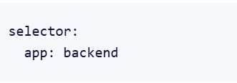
- Distinguishing between applications meant for production or staging environments: If you’re running apps in both production and staging, you can label resources with environment: production or environment: staging. This helps you keep them separate and work with just the ones you need. A Service targeting only the production environment would use a selector as shown in the below YAML. This ensures the Service sends traffic only to Pods in the production environment, keeping staging and production environments isolated.
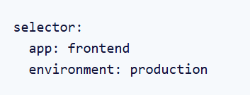
- Grouping Related Resources: Labels are a great way to group all the resources that belong to the same application. For example, if you have an e-commerce app, you can label all its related resources like Deployments, Services, and ConfigMaps with app: e-commerce. This makes it easy to identify and manage all resources for the e-commerce app as a group:
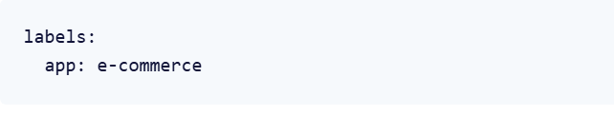
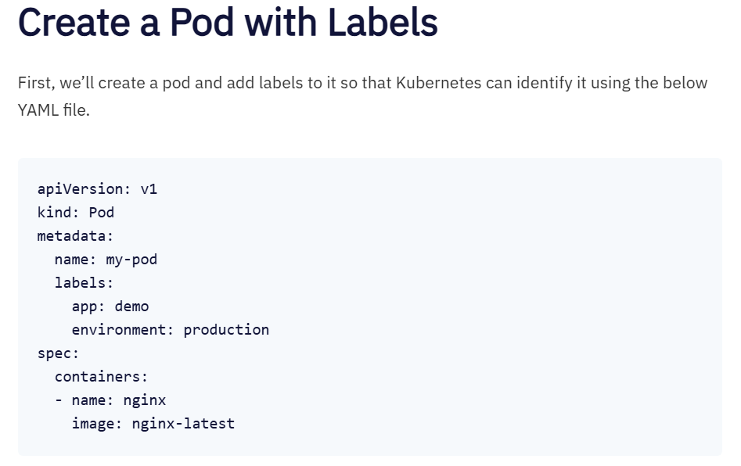
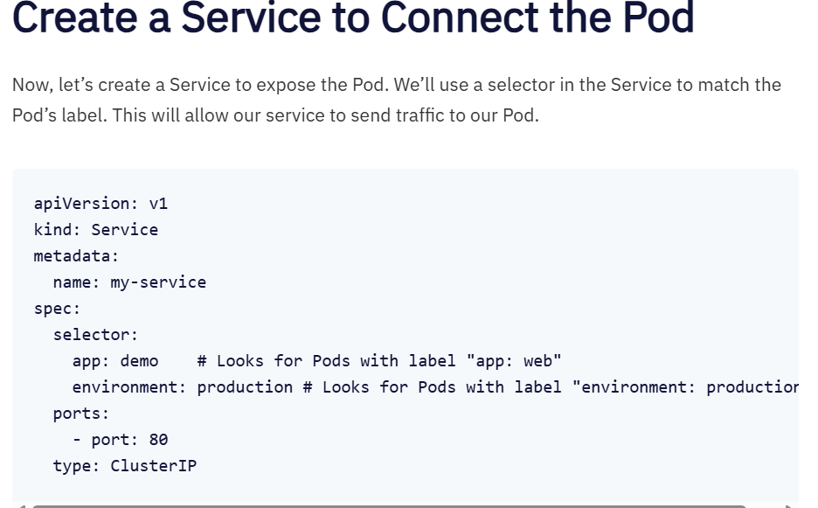
Let’s break the above YAML manifest down again and understand what’s happening before applying it.
- A Service named my-service is created.
- Selector: The Service targets Pods with both app: demo and environment: production labels.
- Ports: The Service listens on port: 80 and forwards traffic to Pods matching the selector.
- Type: The ClusterIP type makes the Service accessible within the Kubernetes cluster using an internal IP.
This Service makes sure only Pods with the right labels get traffic. The service makes use of the selector to make sure that the correct set of pods are being exposed.
You can save the above configuration in a YAML file called as my-service.yaml, and use the below command to create a service.
https://devtron.ai/blog/kubernetes-labels-and-selectors-a-definitive-guide-with-hands-on/

What Problems Do Kubernetes Services Solve?
In Kubernetes, Pods are non-permanent resources; they appear and disappear as needed. This is because Kubernetes constantly checks to make sure the cluster is running the desired number of replicas (copies) of your app. Pods are created or destroyed to match this desired state.
Think of it this way: if you need more replicas of your app because of an increase in incoming traffic (more demand), Kubernetes will spin up some new Pods to handle it. If a Pod fails for some reason, no worries - Kubernetes will quickly create a new one to replace it. If you want to update your app, Kubernetes can destroy old Pods and create new ones with the updated code. So, the set of Pods running at one moment could be totally different from the set running a moment later.
But here's the thing - if you want to access your app, how do you keep track of which Pod to connect to with all these changing IP addresses of Pods?
That's where Services come in. They provide an unchanging location for a group of Pods. So even though the Pods themselves are dynamic, the Services make sure you always have a central location to access your app.
Now that we understand one purpose of Kubernetes Services, let’s examine the different types of available Services.
What is a Kubernetes Service?
The idea of a Service is to group a set of Pod endpoints into a single resource. You can configure various ways to access the grouping. By default, you get a stable cluster IP address that clients inside the cluster can use to contact Pods in the Service. A client sends a request to the stable IP address, and the request is routed to one of the Pods in the Service.
A Service identifies its member Pods with a selector. For a Pod to be a member of the Service, the Pod must have all of the labels specified in the selector. A label is an arbitrary key/value pair that is attached to an object.
The following Service manifest has a selector that specifies two labels. The selector field says any Pod that has both the app: metrics label and the department:engineering label is a member of this Service.
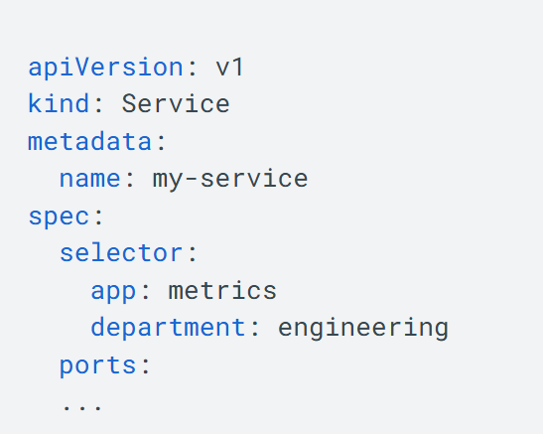
Why use a Kubernetes Service?
In a Kubernetes cluster, each Pod has an internal IP address. But the Pods in a Deployment come and go, and their IP addresses change. So it doesn't make sense to use Pod IP addresses directly. With a Service, you get a stable IP address that lasts for the life of the Service, even as the IP addresses of the member Pods change.
A Service also provides load balancing. Clients call a single, stable IP address, and their requests are balanced across the Pods that are members of the Service.

ClusterIP Service
ClusterIP Services are used for communication between Pods within the same Kubernetes cluster.
The Service gets exposed on a static IP that's unique within the cluster. When you make a request to that IP, the Service takes care of redirecting traffic to one of the Pods it's associated with. And if there's more than one Pod, the Service will automatically balance the traffic, so no single Pod gets bogged down by too many requests.
Note that ClusterIP Services are meant for Pod-to-Pod communication only. They aren't accessible from outside the cluster.
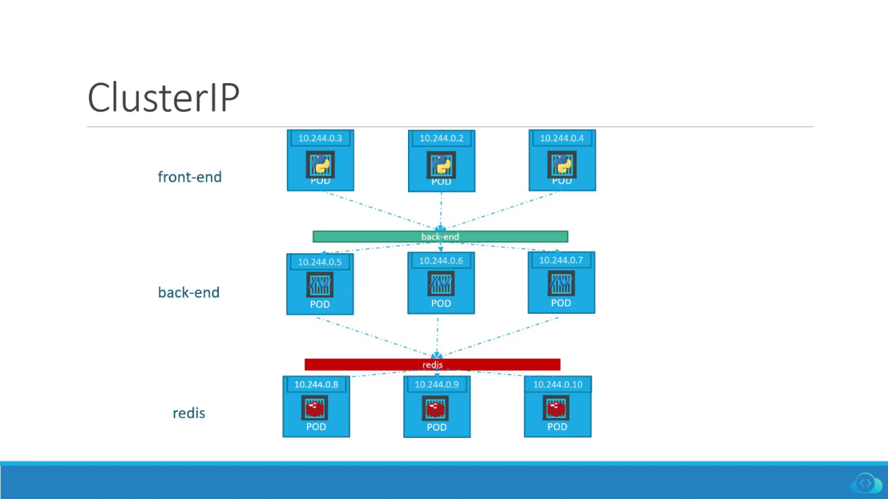ClusterIP
In the image above, the green bar titled "back-end" represents a ClusterIP Service. It sits in front of all the Pods labeled "back-end" and redirects incoming traffic to one of them.
Here is an example of a .yaml file describing a ClusterIP Service object:
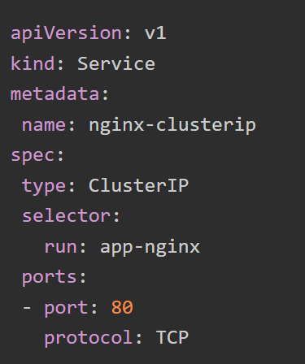

This YAML file defines a Kubernetes Service object of type ClusterIP. Below is an explanation of the important fields in the file:
- kind: Specifies the type of Kubernetes object that is being defined. Here, we are defining a Service.
- name: Specifies the name of the Service, in this case, "nginx-clusterip."
- type: Specifies the type of Service, in this case, a ClusterIP Service.
- selector: Specifies a label selector that defines which Pods should be exposed by this Service. In this example, the Service will expose all Pods that have the label "run" with the value "app-nginx". It's a way of telling Kubernetes: "This Service should sit 'in front' of this collection of Pods. All incoming traffic to this Service should be redirected to one of these Pods."
- port: Specifies the network port that the Service should expose. In this example, the Service exposes port 80.
NodePort Service
The NodePort Service is useful when you need to expose your application to external clients. This means all traffic that is coming from outside of the cluster.
When you create a NodePort Service, Kubernetes opens a port (in the range of 30000 and 32767) on all of its worker nodes. Note that the same port number is used across all of them. All traffic incoming to the worker node's IP address and that specific port is redirected to a Pod linked with that Service.
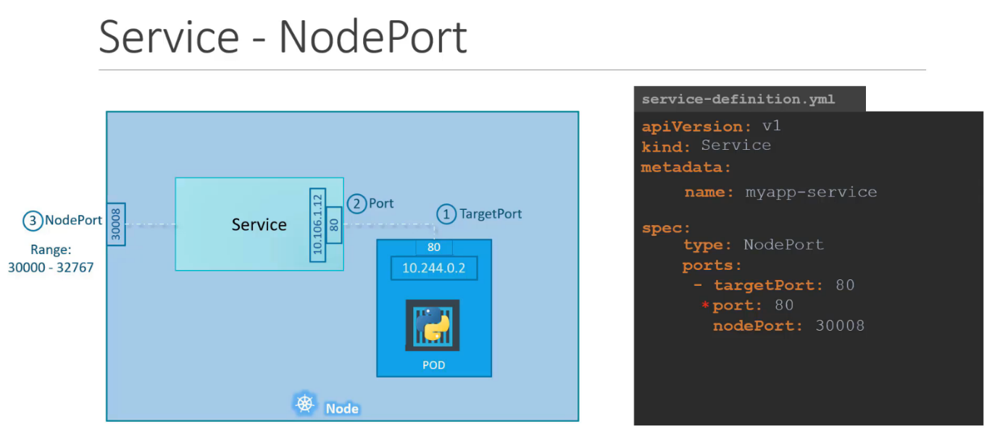

NodePort Service
Keep in mind that a NodePort Service doesn't do any kind of load balancing across multiple nodes. All the incoming traffic goes straight to the node to which the external client is connected. This can result in some nodes getting hit hard with traffic while others are barely used.
Below, we have an example of a .yaml file describing a NodePort Service object:
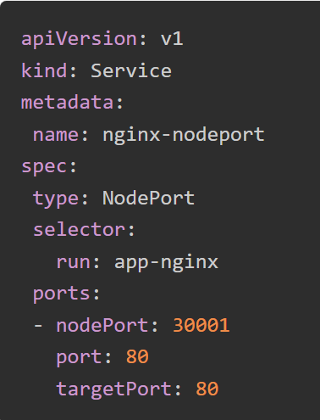

This YAML file defines a Kubernetes Service object of type "NodePort". The "selector" block instructs the NodePort Service to send incoming traffic to one of the Pods with this label. In this case, the "run: app-nginx" label.
In the "ports" block, we have defined three ports:
- nodePort: Tells Kubernetes which port to "open" to the outside world on all of the worker nodes. This makes them accept incoming connections from outside the cluster on the port we chose here, 30001.
- port: Specifies the port that should be "open" to the cluster, internally. Incoming connections will be accepted on this port only if they come from within the cluster. External connections won't be accepted on this port.
- targetPort: The Service will forward incoming connections to one of the Pods it exposes. "targetPort" specifies on which port of the Pod to send traffic to. E.g., with this config, even if traffic comes to port 30001 on the node, it will be sent to port 80 of the Pod (the "targetPort").
LoadBalancer Service
A LoadBalancer Service is another way you can expose your application to external clients. However, it only works when you're using Kubernetes on a cloud platform that supports this Service type.
The LoadBalancer Service detects the cloud computing platform on which the cluster is running and creates an appropriate load balancer in the cloud provider’s infrastructure. The load balancer will have its own unique, publicly accessible IP address. For example, if the cluster is running on Amazon Web Services (AWS), the Service will create an Elastic Load Balancer (ELB) to distribute incoming traffic across multiple nodes in the cluster.
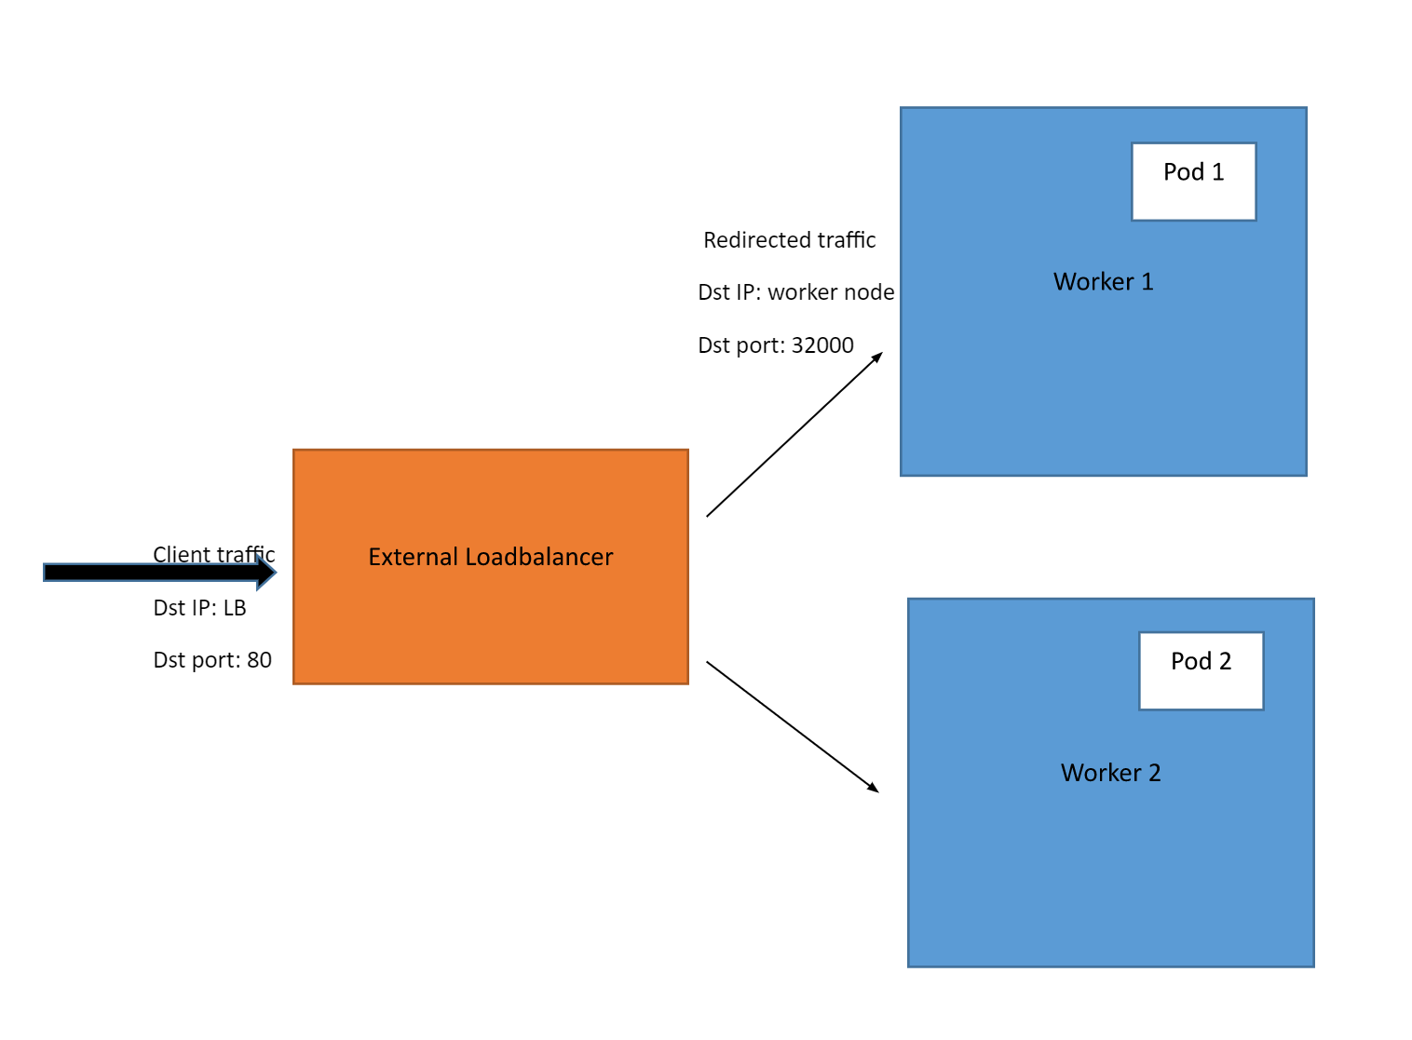
LoadBalancer
For example, say you have a web application running on a Kubernetes cluster and exposed using the LoadBalancer Service. External users can access the application by visiting the external IP address of the load balancer in their web browser. The load balancer will then forward their request to a node.
If another user connects, their connection will be forwarded to a different node. This way, traffic gets distributed evenly across multiple nodes so that none gets overloaded with too many requests. Finally, the connection gets forwarded from node to Pod through a Service that sits in front of them. Each user will then get the response in their web browser. But users won't hit the same node because of our LoadBalancer. So our worker nodes will have an easier time responding to requests.

Below, we have an example of a .yaml file describing a LoadBalancer Service:
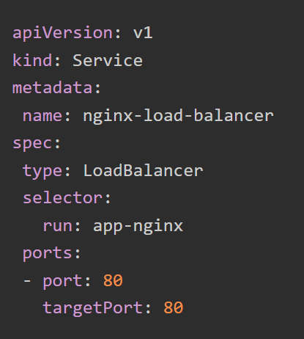
This LoadBalancer Service will be named "nginx-load-balancer". The traffic it receives on port: 80 will be sent to one of the Pods labeled run: app-nginx, on targetPort: 80 of those Pods.

ExternalName Service
An ExternalName Service in Kubernetes is useful when you have a service that is running outside your Kubernetes cluster, such as a database, and you want to access it from within your cluster.
For example, let's say you have an app in a Pod that needs to access an external database running at the domain name "db-prod.example.com". For this database, you can create an ExternalName Service named, say, "db-prod". Then, when the app wants to connect to the database, it will send a request to the local name "db-prod".
Next, Kubernetes will look up the ExternalName Service for "db-prod" and see that it has an external name of "db-prod.example.com". Kubernetes will then use DNS to resolve the external name to an IP address and route the request to the appropriate external service outside the Kubernetes cluster. This process happens automatically and seamlessly. The app doesn’t need to be aware of the details of the external service.
Note: DNS lookup is like looking up a phone number in a directory. When you type in a website address or domain name, your computer sends a request to a special directory called a DNS server to find the IP address of the server hosting that website. This helps your computer connect to the website you want to visit.
We now understand what an ExternalName Service is, but what are the benefits of using one?
One of the key benefits of ExternalName Service in Kubernetes is that it helps you keep the details of your external service separate from your application. Instead of hard-coding IP addresses or domain names, you can give these services a nickname using an ExternalName Service. If the service provider moves to a new IP address or gets a new domain name, you can simply update the ExternalName Service definition to point to the new location.
Kubernetes will handle the DNS resolution of the new address so that the application can continue to access the external service using the same local name. No modifications are required in the application code. This makes managing your external services much easier as you don't have to update the application code each time the external service changes.
Below, we have an example of .yaml file defining an ExternalName Service:
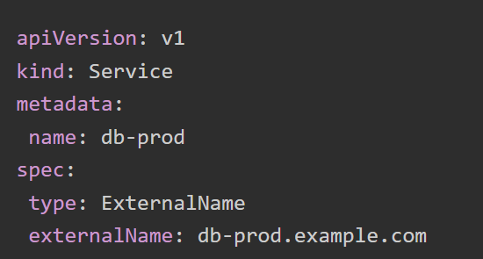

https://kodekloud.com/blog/kubernetes-services/
https://cloud.google.com/kubernetes-engine/docs/concepts/service
Note that an ExternalName Service does not have a selector, as it does not map to any Pods.

In this example, we’re creating an ExternalName Service called "db-prod" that maps to a database running at the domain name "db-prod.example.com". Once this Service is created, our application can simply use the Service name "db-prod" to access this database running outside the Kubernetes cluster.

The following is an explanation of the key fields:

name: This field specifies the name of the Service object, in this case, "db-prod".
type: This field specifies the type of Service. In this case, the value is "ExternalName", indicating that this Service maps to an external service, not a service inside the Kubernetes cluster.
externalName: This field specifies the location at which that external service can be reached at, in this case, "db-prod.example.com".

Service discovery
Three primary components make up Kubernetes service discovery:
‍
- Services: A service in Kubernetes is a stable, abstract entity that groups a set of Pods (the smallest and simplest units in Kubernetes) that perform a specific function. Services define a set of rules and policies for accessing the Pods they represent, providing a consistent way to access them even as the underlying Pods change.
‍
- Endpoints: Endpoints are objects in Kubernetes that represent the IP addresses and ports of the Pods associated with a service. When a service is created, Kubernetes automatically generates an Endpoints object, which is continually updated as Pods are created, modified, or removed.
‍
- Ingress: Ingress is a Kubernetes object that provides a set of rules for routing external traffic to services within the cluster. It offers features like load balancing, SSL termination, and name-based virtual hosting, making it easier to expose services externally and manage external access to the cluster.
Service Discovery in Kubernetes
Service discovery is the mechanism that allows services within a Kubernetes cluster to automatically find and communicate with each other without needing to know the specific IP addresses or ports of other services. This is crucial in a dynamic environment like Kubernetes, where pods (the smallest deployable units) are ephemeral and their IP addresses can change frequently.
Kubernetes provides built-in service discovery mechanisms to handle this:
1. Kubernetes Services
A Service in Kubernetes is an abstraction that defines a logical set of Pods and a policy by which to access them. Services provide a stable IP address (Cluster IP) and a DNS name for a group of pods, enabling other services to communicate with them reliably.

Key aspects of Services for service discovery:
- Stable Endpoint: Services provide a consistent IP address and port that remains the same throughout the service's lifetime, even if the underlying pods are created, deleted, or scaled.
- Load Balancing: Services can distribute traffic across the pods that match their selector, providing basic load balancing.
- Abstraction: Services decouple the clients from the individual pods, so clients don't need to be aware of the number or IP addresses of the backend pods.
- DNS Resolution: Kubernetes automatically assigns a DNS name to each Service in the format service-name.namespace.svc.cluster.local. Pods within the cluster can use this DNS name to resolve the Service's Cluster IP.
Service Discovery in Kubernetes
Service discovery is the mechanism that allows services within a Kubernetes cluster to automatically find and communicate with each other without needing to know the specific IP addresses or ports of other services. This is crucial in a dynamic environment like Kubernetes, where pods (the smallest deployable units) are ephemeral and their IP addresses can change frequently.
Kubernetes provides built-in service discovery mechanisms to handle this:
How Service Discovery Works (Example using DNS):
- A set of pods running a service (e.g., an API) are created, and they have specific labels (e.g., app: my-api).
- A Kubernetes Service is defined with a selector that matches these labels. The Service is given a name (e.g., my-api-service).
- Kubernetes assigns the my-api-service a stable Cluster IP and the internal DNS service creates a DNS record for it (e.g., my-api-service.default.svc.cluster.local resolves to the Cluster IP).
- Another pod running a different service (a client) needs to communicate with the API. Instead of trying to find the IP address of a specific API pod, the client pod resolves the DNS name my-api-service.default.svc.cluster.local.
- The DNS query returns the Cluster IP of the my-api-service.
- The client pod sends traffic to the Cluster IP of the Service.
- Kubernetes, using the Service's configuration and the underlying Endpoints or EndpointSlices, routes the traffic to one of the healthy pods that match the Service's selector. This routing often involves kube-proxy running on each node.
DNS service discovery
In Kubernetes, DNS service discovery allows pods to communicate with each other using service names instead of IP addresses. Kubernetes automatically assigns each service a DNS name, which is resolved to the service's IP address by the cluster's DNS server. This simplifies service discovery and ensures applications can connect to each other even if pod IP addresses change.
Here's a more detailed breakdown:
1. DNS Name Assignment:
- Kubernetes assigns each service a DNS name in the format <service-name>.<namespace>.svc.cluster.local.
- For example, if you have a service named my-service in the default namespace, its DNS name would be my-service.default.svc.cluster.local.
- This name is automatically resolved to the service's ClusterIP.
2. DNS Resolution:
- When a pod needs to connect to a service, it performs a DNS query using the service's DNS name.
- The query is first sent to the DNS cache on the node where the pod is running.
- If the cache doesn't have the information, the query is forwarded to the cluster DNS server (typically CoreDNS or kube-dns).
- The DNS server resolves the service name to the corresponding IP address and port.
3. Benefits of DNS-based Service Discovery:
- Simplified Communication:
Pods can communicate using service names rather than IP addresses, making it easier to understand and maintain applications.
- Resilience:
When pods are created, deleted, or rescheduled, their IP addresses change. DNS-based discovery ensures applications can continue to connect to the service without needing to reconfigure.
- Scalability:
DNS-based discovery is well-suited for large, dynamic environments where services and pods are constantly changing.
4. Kubernetes Components Involved:
- Services: Kubernetes objects that define how to expose applications running as pods.
- DNS Server: A component (like CoreDNS or kube-dns) that resolves DNS queries within the cluster.
- kubelet: A component running on each node that configures the DNS settings for pods.
5. CoreDNS vs. kube-dns:
- Both are DNS servers that can be used in Kubernetes, but CoreDNS is often preferred for its flexibility and ease of use.
- CoreDNS is a single-container deployment, while kube-dns is a more complex deployment with multiple containers.
- CoreDNS is designed to be more flexible and easier to configure than kube-dns.
Environmental Variable Service Discovery
In Kubernetes, environmental service discovery utilizes environment variables injected into each Pod to facilitate communication between services. These variables include the service name, IP address, and port number, enabling seamless communication. This method is straightforward for small to medium-sized deployments but can become complex to manage in large and dynamic environments.
How it works:
- 1. Service Creation:
When a service is created in Kubernetes, it's assigned a name and automatically gets a DNS name in the format service-name.namespace.svc.cluster.local.
- 2. Environment Variable Injection:
Kubernetes injects environment variables into each Pod, providing information about other services in the cluster.
- 3. Service Communication:
Pods can use the environment variables and the DNS name to locate and communicate with other services, including other pods within the same service.
Benefits:
- Simple and Straightforward: Easy to implement and understand, particularly for smaller deployments.
- Dynamic Updates: Kubernetes automatically updates the environment variables if a service changes or gets new pods.
Limitations:
- Scalability Issues:
In large and dynamic environments, the number of environment variables can become unwieldy, making it difficult to manage and maintain.
- Not Ideal for Complex Scenarios:
As deployments become more complex, with multiple services and versions, environment variables can become less effective.
Alternatives:
- DNS-based Service Discovery:
Kubernetes also supports DNS-based service discovery, where services are assigned a DNS name that can be used for communication.
- Service Mesh:
Service meshes, like Istio, provide a more sophisticated approach to service discovery and communication, offering features like traffic management, observability, and security.

