What is Low-Level Design(LLD)?
LLD, or Low-Level Design, is a phase in the software development process where detailed system components and their interactions are specified, along with their implementation. It involves converting the high-level design into a more detailed blueprint, addressing specific algorithms, data structures, and interfaces. LLD serves as a guide for developers during coding, which ensures the accurate and efficient implementation of the system’s functionality.
Low-level designing is also known as object-level designing or micro-level or detailed designing.
How is LLD different from HLD?
High Level Design or HLD is a general system design where we do tradeoffs between different frameworks, components, and different databases and we choose the best considering what the business needs and how the system should work, both in terms of functional and non functional aspects.
Whereas LLD(Low Level Design), translates the HLD into smaller and more specific details, It includes class diagrams, methods, data structures, and algorithms, focusing on how each part will be implemented. It is Primarily used by developers and technical teams.
So what are the different UML diagram types? There are two main categories; structure diagrams and behavioral diagrams. Click on the links to learn more about a specific diagram type.
What are Structural Diagrams?
Structural diagrams in UML (Unified Modeling Language) represent the static structure of a system. They depict the components of the system and their relationships. Structural diagrams are used to visualize the organization, composition, and relationships between the different elements in a system.
What are Behavioral Diagrams?
Behavioral diagrams in UML represent the dynamic behavior of a system. They describe how the components of a system interact with each other and how the system responds to external stimuli. Behavioral diagrams are used to visualize the behavior of a system over time.

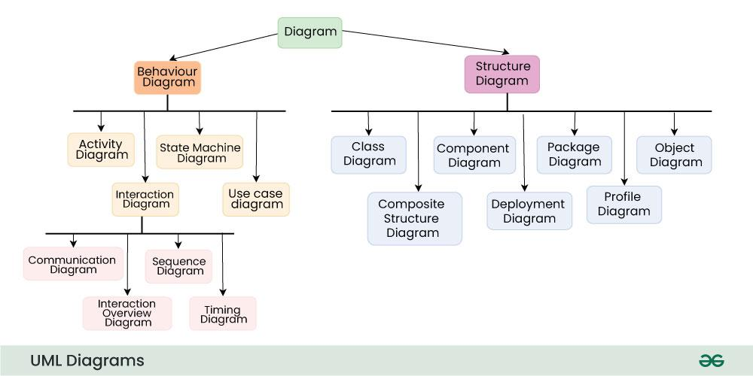
https://www.geeksforgeeks.org/unified-modeling-language-uml-introduction/
https://creately.com/blog/diagrams/uml-diagram-types-examples/
https://www.visual-paradigm.com/guide/uml-unified-modeling-language/behavior-vs-structural-diagram/
https://datavisualexpert.com/uml-class-diagram-cardinality
https://www.geeksforgeeks.org/unified-modeling-language-uml-class-diagrams/

