Sub-Query
Sub-query is a SQL query that is placed inside another query
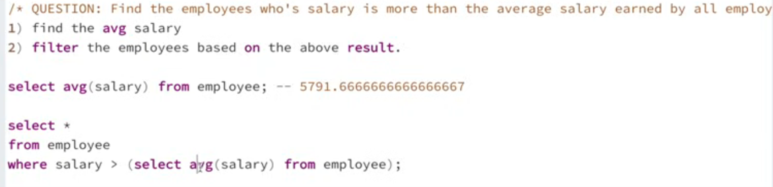


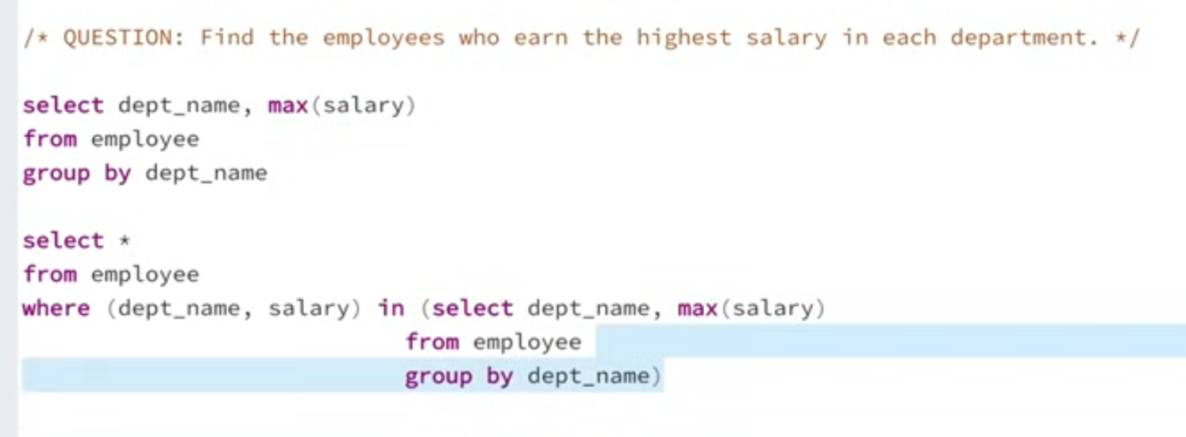
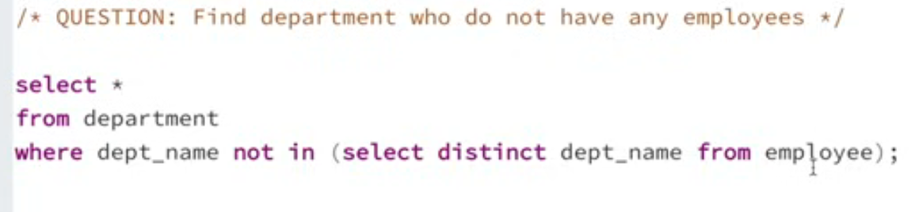
Correlated subquery inner query depends on the outer query
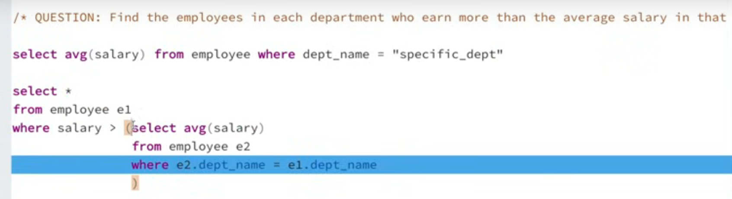
** in that department

