GET: This method is used to retrieve data from the server.
Example: GET http://www.example.com/api/users
POST: This method is used to create new data on the server.
Example: POST http://www.example.com/api/users
PUT: This method is used to update existing data on the server.
Example: PUT http://www.example.com/api/users/1
DELETE: This method is used to delete existing data on the server.
Example: DELETE http://www.example.com/api/users/1
PATCH: This method is used to partially update existing data on the server.
Example: PATCH http://www.example.com/api/users/1
HEAD: This method is similar to GET, but it only retrieves the headers of the response, and not the body.
OPTIONS: This method is used to retrieve information about the communication options available for a resource.
How do you handle errors in RESTful web services?
View Answer
- Returning appropriate HTTP status codes: Each error response should have an appropriate HTTP status code that indicates the nature of the error. Common status codes for errors include 400 Bad Request, 401 Unauthorized, 403 Forbidden, and 404 Not Found.
- Providing meaningful error messages: Along with the HTTP status code, you should include a detailed error message in the response body. This message should help the client understand what went wrong and how to resolve the issue.
- Consistent error response format: It's a good practice to follow a consistent error response format across all the API endpoints. This makes it easier for clients to handle and parse error responses.
- Handling exceptions and returning custom errors: In your code, you should catch any exceptions or errors that occur during request processing and convert them into appropriate error responses. This ensures that clients receive consistent error responses regardless of the type of error.
- Logging: Logging the details of the error can be helpful for debugging purposes. It allows you to track issues, analyze trends, and make improvements to the web service.
- 8.
- What is the difference between versioning through URI and through headers?
- View Answer
- 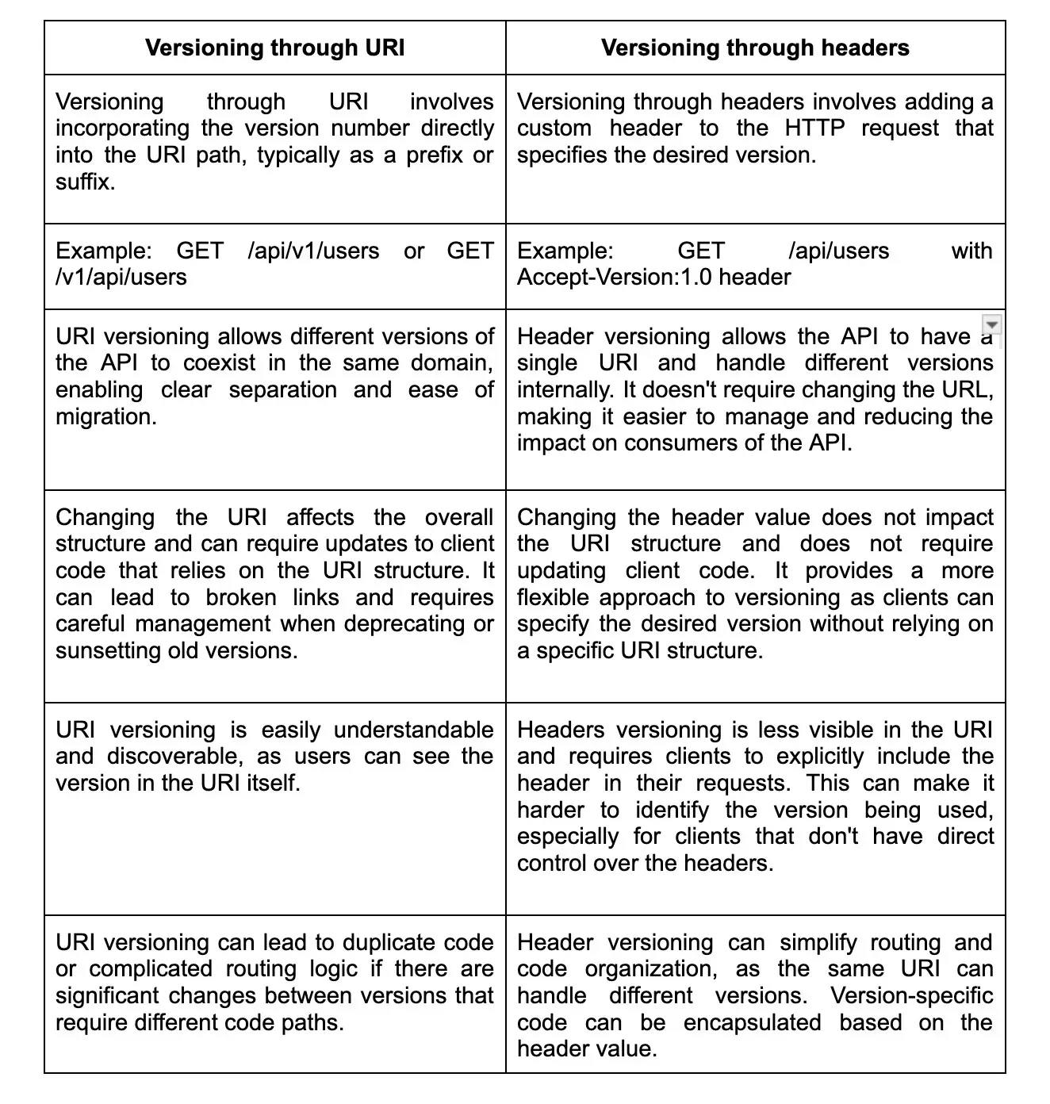

12.
What is the concept of statelessness in REST?
View Answer
The concept of statelessness in REST refers to the server not storing any information about the client's state between requests. In a stateless architecture, each request from the client to the server must contain all the necessary information for the server to understand and process the request. The server does not keep track of any session or state information about the client.
This means that each request is independent and self-contained, and the server does not need to store any client-specific information. The lack of state allows for better scalability and performance as the server does not need to manage or synchronize client state.
Statelessness also aligns with the principles of the REST architectural style, which emphasizes simplicity, scalability, and the uniform interface between clients and servers. It enables the server to be stateless, meaning it can be easily distributed across multiple servers or scaled horizontally without any impact on the overall system.
Can you explain the concept of load balancing in RESTful web services?
Hide Answer
Load balancing is a technique used in RESTful web services to distribute incoming network traffic across multiple servers. The purpose is to optimize resource utilization, improve scalability, and enhance the overall performance of the system.
In load balancing, a load balancer acts as a mediator between the client and the servers. It receives the incoming requests and distributes them among the available servers based on various algorithms, such as round-robin or least connections. This ensures that no single server gets overwhelmed with excessive traffic, leading to increased reliability and responsiveness of the RESTful web service.
.
What is service discovery and how is it used in RESTful web services?
View Answer
Service discovery is a mechanism used in RESTful web services to allow services to find and communicate with each other without manual configuration. It involves a central registry or service registry where services can register themselves and provide information about their location, endpoints, and capabilities.
When a service needs to communicate with another service, it can query the service registry to obtain the necessary information. This eliminates the need for hardcoding or manual configuration of endpoints, making the system more dynamic and flexible. Service discovery enables automatic load balancing, failover, and scaling in distributed systems, as services can easily discover and connect to available instances of other services.
What is the difference between a query parameter and a path parameter in REST API?
View Answer
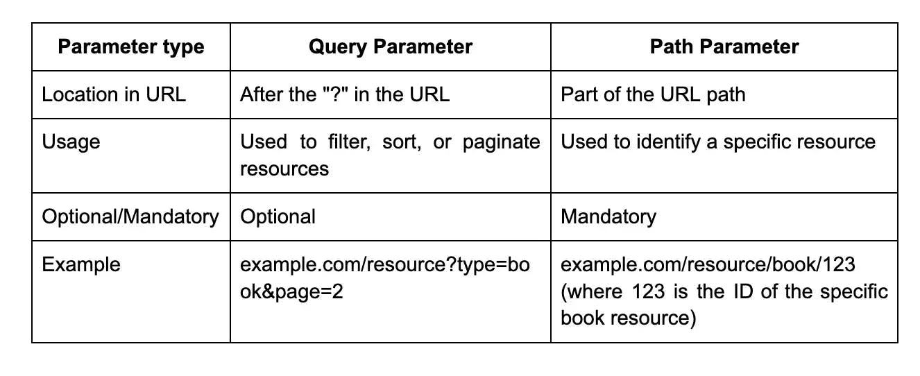
How do you version a REST API?
View Answer
- Use URL Versioning: In this method, the version is included in the URL of the API endpoint. For example, you could have /api/v1/endpoint and /api/v2/endpoint for version 1 and version 2 of the API.
- Use Media Type Versioning: In this method, the version is included in the media type of the request and response. For example, you could have application/vnd.company.v1+json and application/vnd.company.v2+json for version 1 and version 2 of the API.
- Use Custom HTTP Headers: In this method, the version is included in custom HTTP headers. For example, you could use X-API-Version: 1 or X-API-Version: 2 for version 1 and version 2 of the API.
- How do you handle pagination in a REST API?
- View Answer
- In a REST API, pagination is often used to limit the amount of data returned in a single request. There are different approaches to handling pagination. One common approach is to use query parameters, such as "page" and "limit", to specify the desired page number and the number of items per page. The API can then use this information to retrieve and return the appropriate data subset. Alternatively, the API can return a next page token or link in the response, allowing the client to request the next set of data. Pagination is important for improving performance and ensuring that large data sets are processed efficiently.

How does a stateless API differ from a stateful API in REST API?
View Answer
In REST API, a stateless API does not store any client state on the server side. Every time a request is made, it contains all the necessary information for the server to process the request without relying on any previous requests or stored data. This means that the server does not retain any information about the client, which improves scalability and reduces the chances of data loss. Stateless APIs are also easier to cache and distribute.
On the other hand, a stateful API retains information about the client on the server side and relies on this information to process subsequent requests. This means that the server retains client state and interacts with it each time a new request is made. Stateful APIs can be more complicated to implement and scale since the server must manage the client's state and ensure that it remains synchronized across multiple instances.

