TEXAS TREES FOUNDATION | UTRGV COOL SCHOOLS PROJECT
Bringing the Cool Schools Dashboard to Life:
On-Campus Shade Satisfaction & Thermal Pulse Kiosks
Strategic Concept & Implementation One-Pager • Ground-Truthing Human Comfort Across RGV Campuses
1. Executive Summary & Core Value  The TTFS UTRGV Cool Schools Dashboard visualizes tree canopy coverage, heat islands, and cooling benefits across Rio Grande Valley elementary campuses. While satellite GIS models provide powerful spatial intelligence, deploying physical Shade Satisfaction Kiosks on campus bridges the gap between digital data and real-world student/teacher lived experience.  By placing single-touch feedback terminals at outdoor microclimate zones (playgrounds, drop-off lanes, outdoor classrooms, and newly planted tree groves), campuses capture real-time community sentiment on thermal comfort. This turns the dashboard into a living, breathing feedback loop. | 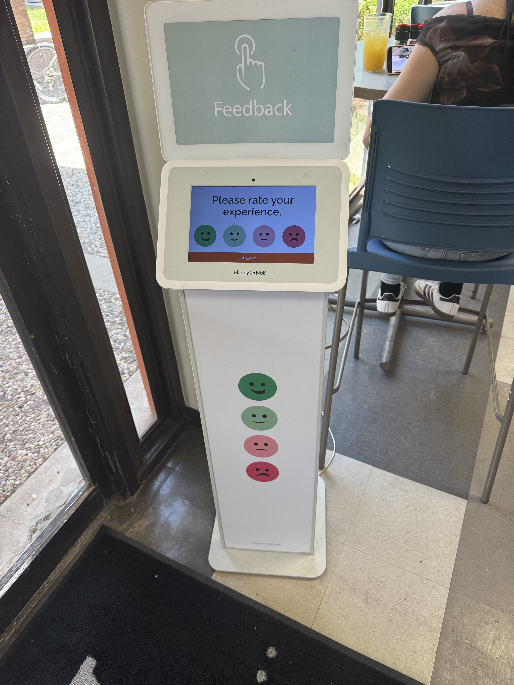  Campus-ready terminal (4-point smiley scale)
2. Why Ground-Truth Kiosks Elevate the Dashboard

• Live Thermal Sentiment vs. Temperature: Correlates ambient weather sensor data with real human satisfaction (e.g., 'At 96°F, the new tree canopy area maintained 88% satisfaction vs. 15% in unshaded asphalt').
• 10-Year Growth Trajectory: Tracks the rising curve of campus shade happiness year-over-year as young trees mature into expansive cooling canopies.
• Frictionless & Engaging: Takes under 2 seconds for students and staff entering from recess or bus pickup—yielding thousands of data points without logins or screen distractions.
• Data-Driven Forest Planning: Pinpoints 'shade deserts' with acute dissatisfaction, giving Texas Trees Foundation and district facility leaders exact locations where additional tree plantings or shade sails are needed most.
3. Targeted Campus Deployment Zones
Zone Location | On-Screen Prompt / Question | Strategic Value to TTFS / District
Zone A: Recess / Playground | "How cool & comfortable is the shade during playtime today?" | Measures peak midday heat vulnerability and child thermal relief.
Zone B: Bus Loop & Pick-Up | "Rate your shade & coolness while waiting for pickup." | Captures thermal burden on waiting parents, staff, and students.
Zone C: TTFS Tree Grove | "How refreshing is the shade in this tree grove today?" | Directly quantifies community appreciation of dedicated planting projects.

Privacy & Compliance Guardrail (COPPA / FERPA Compliant): This hardware adheres strictly to Texas Trees Foundation, UTRGV, COPPA, and FERPA standards. Terminals record zero Personally Identifiable Information (no cameras, student IDs, or logins). Each touch simply emits an anonymized tuple [Timestamp, CampusID, ZoneID, Score 1-4], aggregated solely at the campus level.
4. Procurement Options & Implementation Framework
Solution Model | Hardware & Connectivity | Est. Cost | Best Fit
Turnkey Cellular (HappyOrNot / Ombea) | Freestanding kiosk with built-in SIM card; requires zero campus Wi-Fi setup. | ~$100–$140/mo (HaaS) | Flagship pilot campus, zero IT friction
Managed iPad Kiosk (SurveyStance / Bouncepad) | Rugged anti-theft commercial stand + locked iPad running kiosk mode. | ~$450 upfront + $39–$69/mo | Multi-campus expansion, budget flexibility
Custom IoT Pod (ESP32 / Open Hardware) | 4 weather-sealed arcade buttons syncing via campus Wi-Fi to Firebase API. | ~$120 upfront (no recurring) | Student STEM project / District scale

Next Recommendation: Initiate a single-unit pilot at a Donna ISD or Mercedes ISD campus to test student engagement during recess, connecting live data to the Cool Schools prototype.

