BIG DATA LAB

02/06/2022

Check hadoop version

$ hadoop version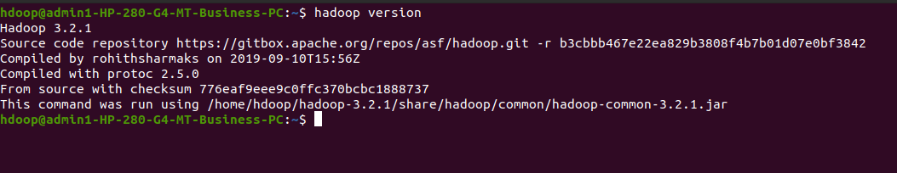

Start hadoop

$ start-dfs.sh

1. Creating a directory

$ hdfs dfs -mkdir /sunayana_m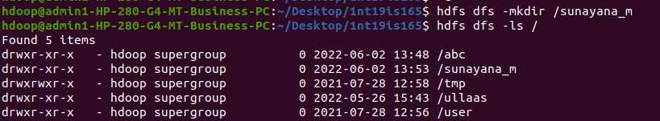

1. Listing all directories

$ hdfs dfs -ls / 

1. Add two empty files into directory

$ hdfs dfs -touchz /sunayana_m/file1.txt

$ hdfs dfs -touchz /sunayana_m/file2.txt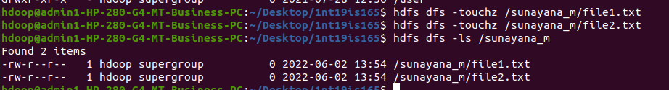

1. Listing all the files in the directory that was created

$ hdfs dfs -ls /sunayana_m

1. Moving file from local to hadoop using put command

$ hdfs dfs -mkdir /1nt19is165

$ hdfs dfs -put /home/hdoop/Desktop/1nt19is165_sunayana /1nt19is165



Checking file at destination

$ hdfs dfs -ls /1nt19is165



1. Moving from hadoop to local

$ hadoop fs -get /1nt19is165/1nt19is165_sunayana /home/hdoop/Desktop

File moved to local

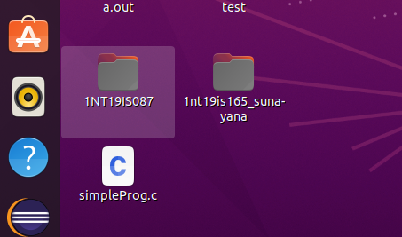

1. Moving file within hadoop

$ hadoop fs -cp /sunayana_m/file1.txt /1nt19is165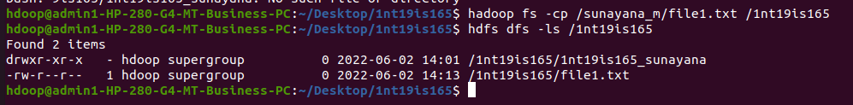

1. Displaying the size of files in directory

$ hadoop fs -du -h /sunayana_m

$ hadoop fs -du -h /1nt19is165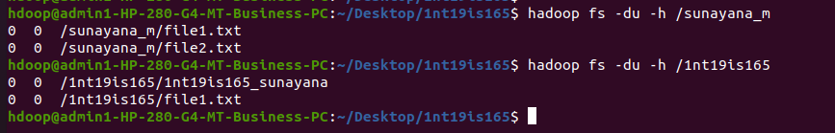

Using stat command

$ hadoop fs -stat /sunayana_m

$ hadoop fs -stat /1nt19is165