BIG DATA LAB

31/03/2022

1. Command to enter MongoDB – mongo
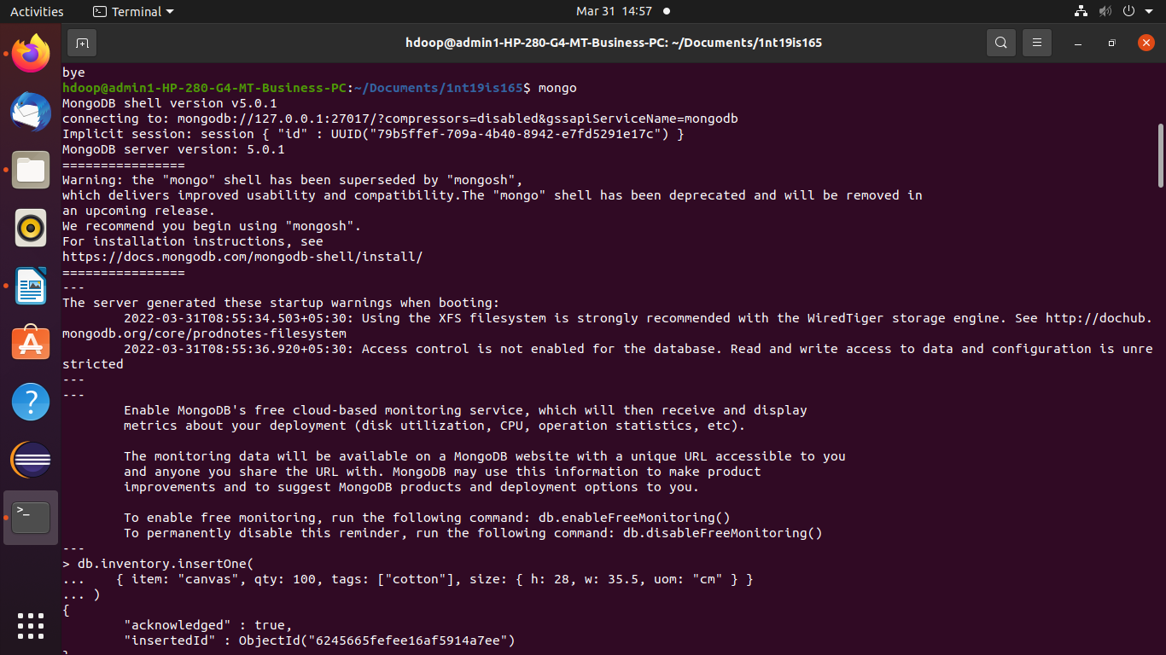
2. Create and use a database – use db_name
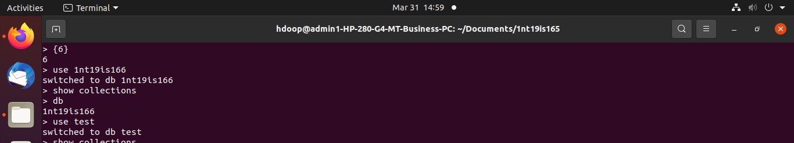
3. Insert one data record – db.db_name.insertOne({<field>:<value>,...})
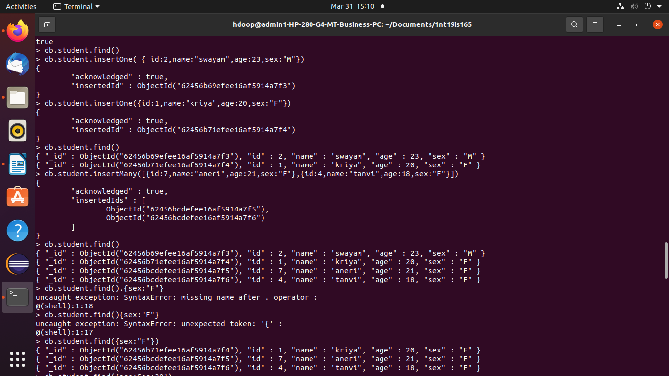
4. Show all databases – show dbs
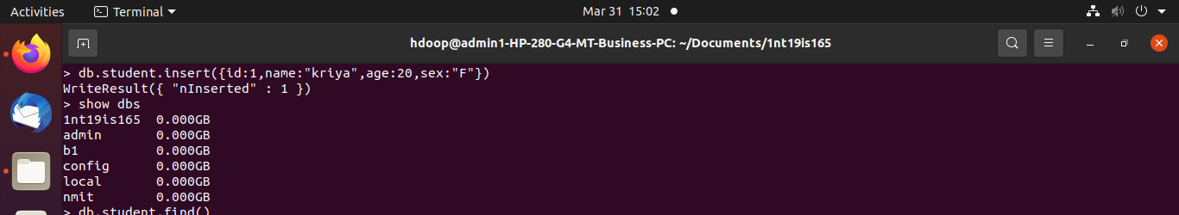
5.Show collections present in database – show collections
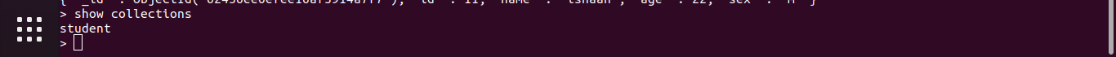
6. Insert many data records into collection – db.db_name.insertMany([{<field>:<value>,...},{<field>:<value>,...}])
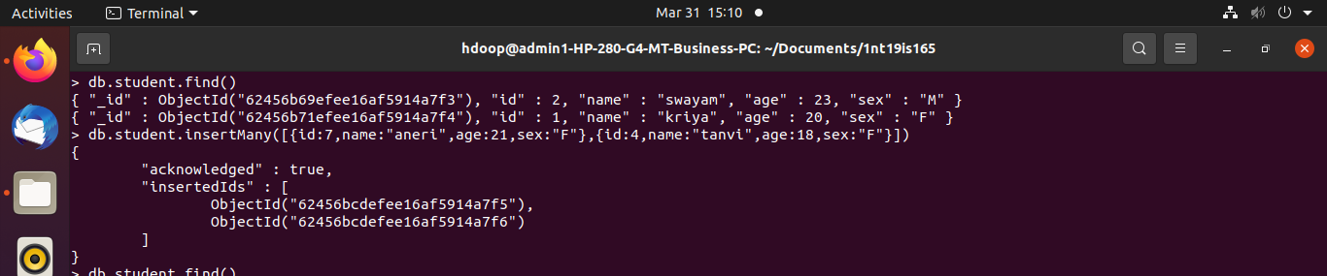
7.Display the contents in collection – db.db_name.find()
With condition
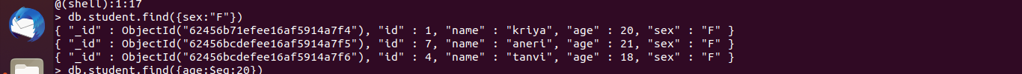
8. Update one record in collection - db.db_name.update( { <field>:<value>}, {$set:{<field>:<value>}})
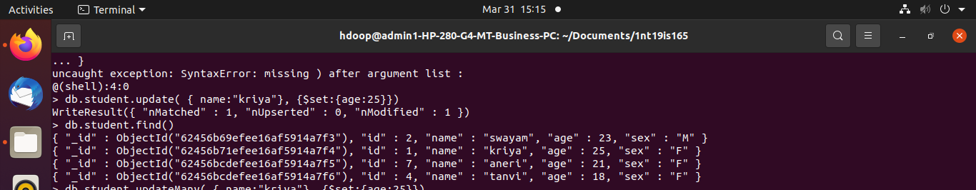
9. Update many records in collection - db.db_name.update( { <field>:<value>}, {$set:{<field>:<value>}})
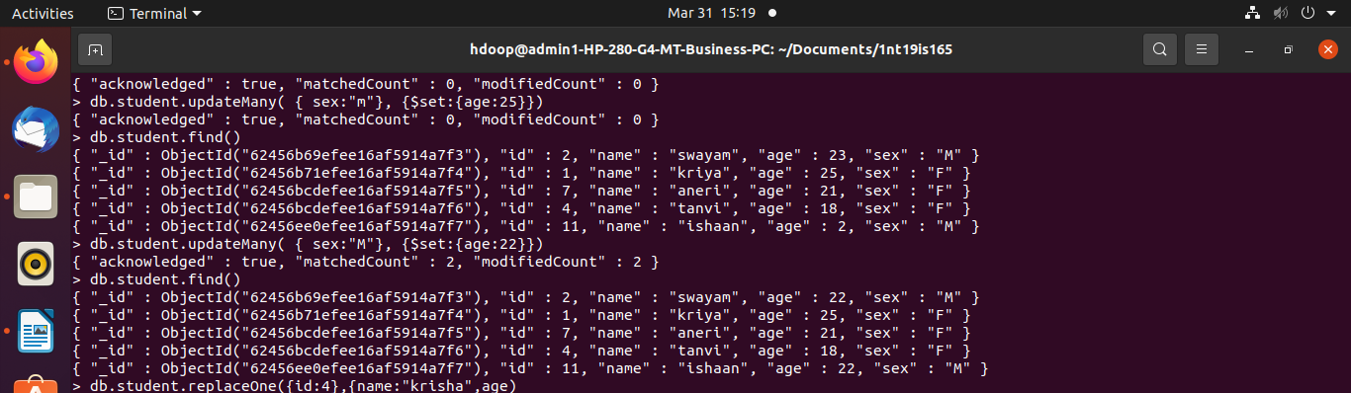
10. Replace one record in collection – db.db_name.replaceOne({<field>:<value>},{<field1>:<value1>,<field2>:<value2>,...})
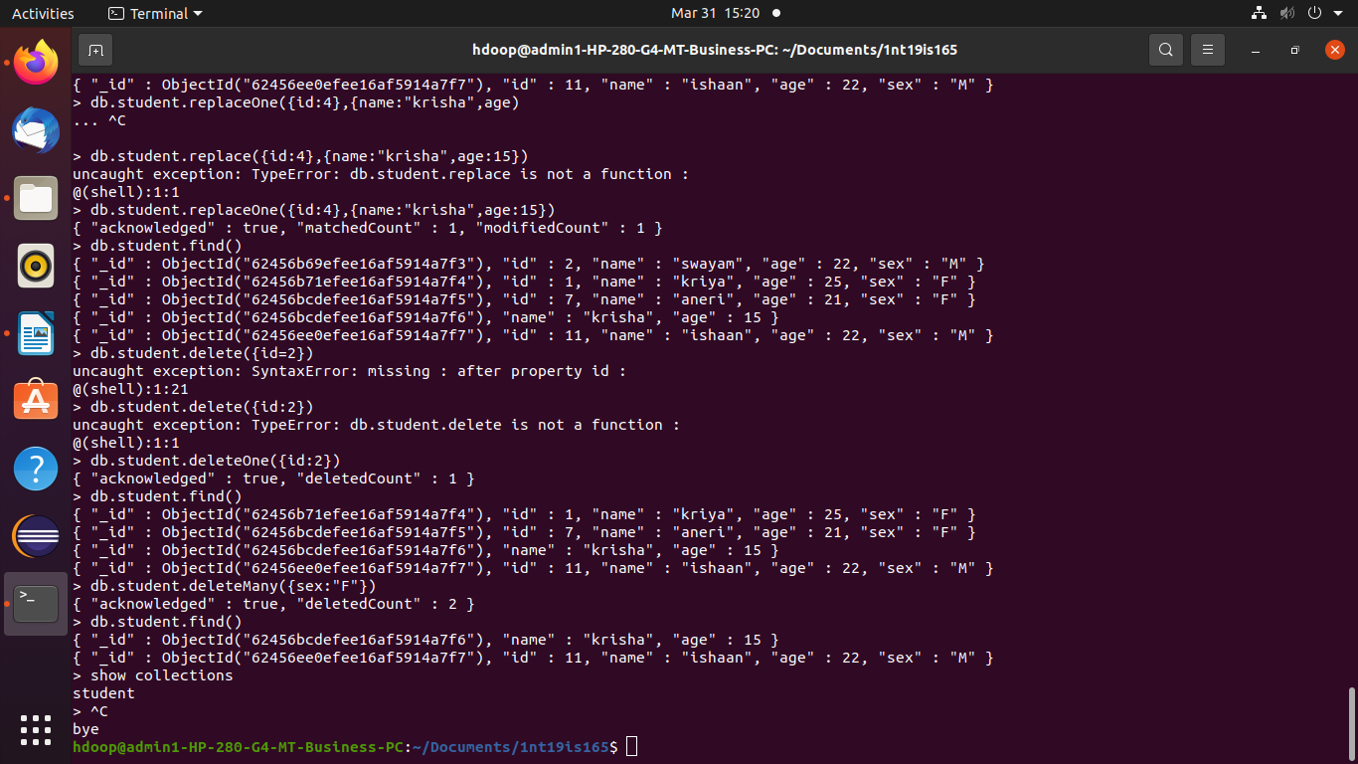
11. Delete one record - db.db_name.deleteOne({id:2})
12. Delete many records – db.db_name.deleteMany({sex:"F"})

Sunayana M
1NT19IS165
6 ‘C’ – batch 2

