**Step 1: SSH Into Your Instance**

First things first, let’s SSH into the Amazon Linux instance where we’re setting up Jenkins. Open up your terminal and run:

ssh -i <your_key>.pem ec2-user@<your_amazon_linux_instance_ip>

This command lets you log in to your instance. Just replace <your_amazon_linux_instance_ip> with your instance's IP address and <your_key> with the actual key name.  
Example: **ssh -i jenkins-server-key.pem ec2-user@44.204.82.51**

All logged in? Perfect! Now, let’s get down to business and start the Jenkins setup.

**Step 2: Update the System**

It’s always a good practice to ensure that your system is up to date. Open a terminal window and enter the following command:

sudo dnf update

**Step 3: Install Java**

Jenkins is a Java application, so Java is a prerequisite. Install Java with the following command:

sudo dnf install java-17-amazon-corretto -y

Verify the installation with:

java -version

**Step 4: Add the Jenkins Repository**

Next, add the Jenkins repository to your system with the following commands:

ssudo wget -O /etc/yum.repos.d/jenkins.repo \  
 https://pkg.jenkins.io/redhat-stable/jenkins.repo

Import a key file from Jenkins-CI to enable installation from the package:

sudo rpm --import https://pkg.jenkins.io/redhat-stable/jenkins.io-2023.key

**Step 5: Install Jenkins**

Now, install Jenkins by running:

sudo dnf install jenkins -y

**Step 6: Start and Enable Jenkins**

Enable and start the Jenkins service using:

sudo systemctl enable jenkins  
sudo systemctl start jenkins

**Step 7: Access Jenkins**

Now, open your web browser and access Jenkins by navigating to:

http://your_amazon_linux_instance_ip:8080

You will see a setup wizard and be prompted to enter the administrator password.

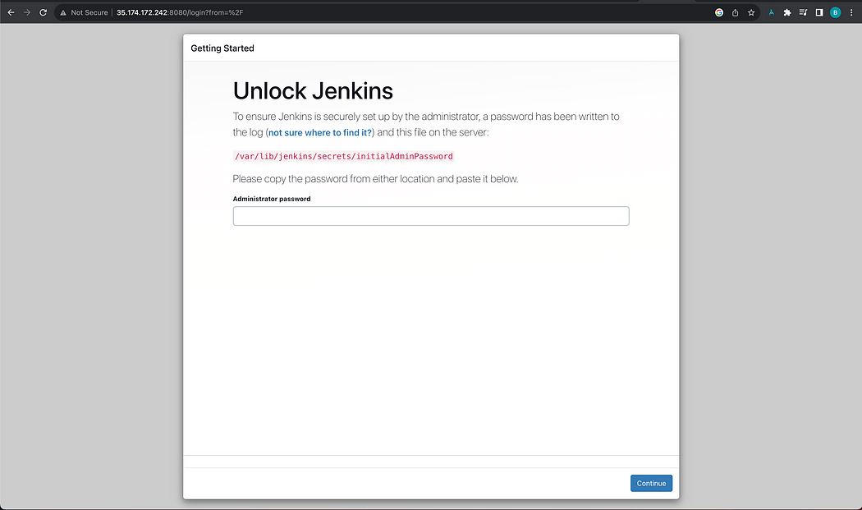

Retrieve the password with the following command:

sudo cat /var/lib/jenkins/secrets/initialAdminPassword

Copy the password and paste it into the Jenkins setup wizard to continue.

**Step 8: Complete the Setup Wizard**

Now for the fun part! After accessing Jenkins in your web browser, you’ll be greeted by the Jenkins setup wizard. Let’s walk through it together:

**1. Install Plugins**

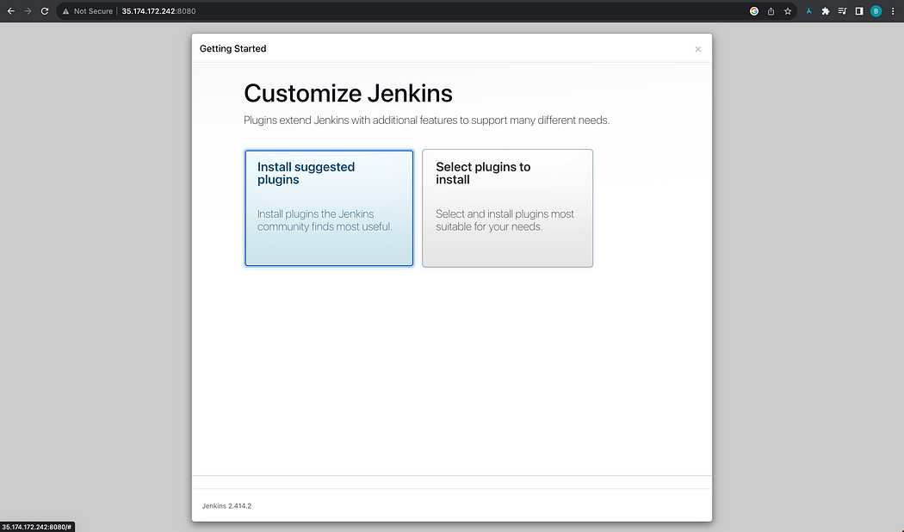

* You’ll be prompted to install plugins. You can opt for installing suggested plugins or select plugins to install based on your preference. The suggested plugins cover most general use cases.

**3. Create the First Admin User**

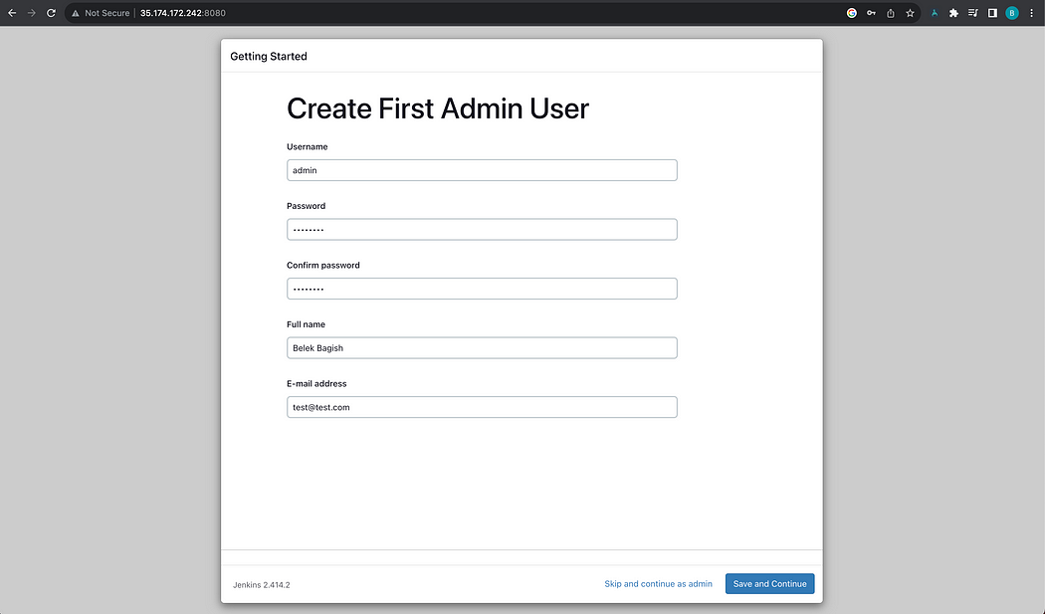

* Next, you’ll set up the first admin user. Fill in the username, password, name, and email fields as prompted.

**4. Instance Configuration**

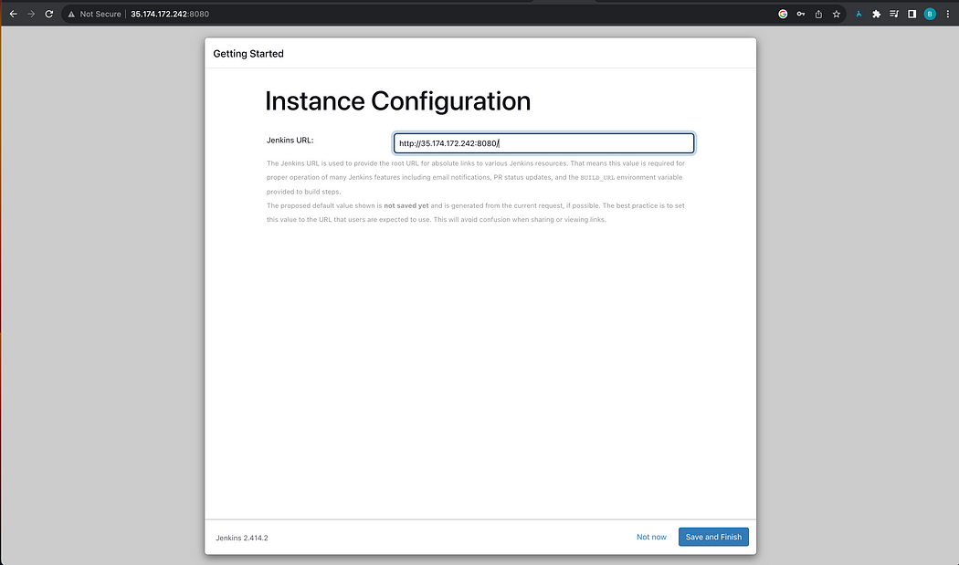

* Confirm the Jenkins URL. It should be set to your instance’s IP or domain name followed by :8080, e.g., [http://your_amazon_linux_instance_ip:8080.](http://your_amazon_linux_instance_ip:8080./)

**5. Finish the Setup**

* Finally, hit “Save and Finish.” Boom, you’ve set up Jenkins!

**6. Start Using Jenkins**

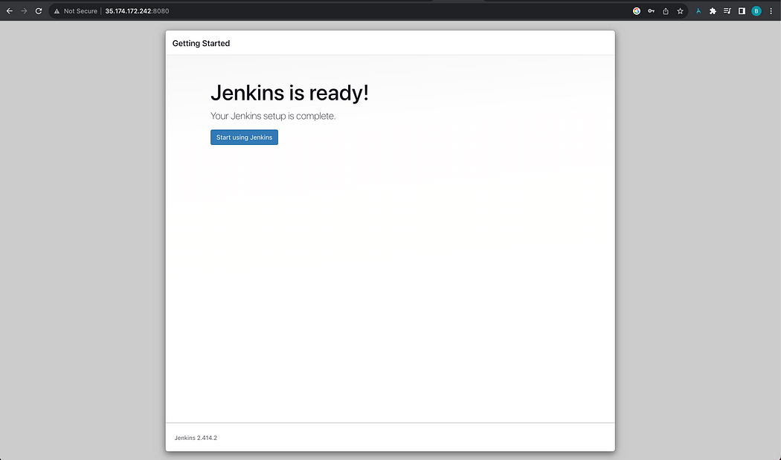

* Click on “Start using Jenkins” to be directed to the Jenkins dashboard, where you can begin creating your first Jenkins pipeline.

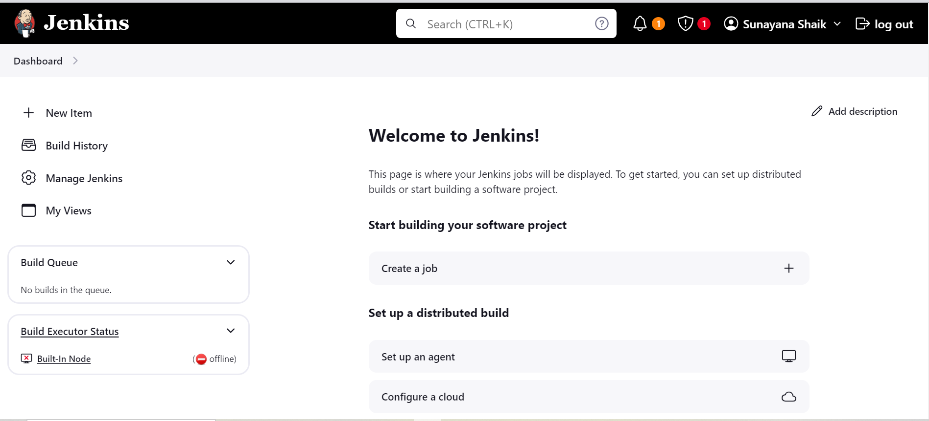

Done with installation of jenkins