1) Setup jenkins CICD pipeline using freestyle job using below code. <https://github.com/betawins/hiring-app.git> Stages:

* Git Clone
* Sonarqube Integration
* Maven Compilation
* Nexus Artifactory
* Slack Notification
* Deploy On tomcat

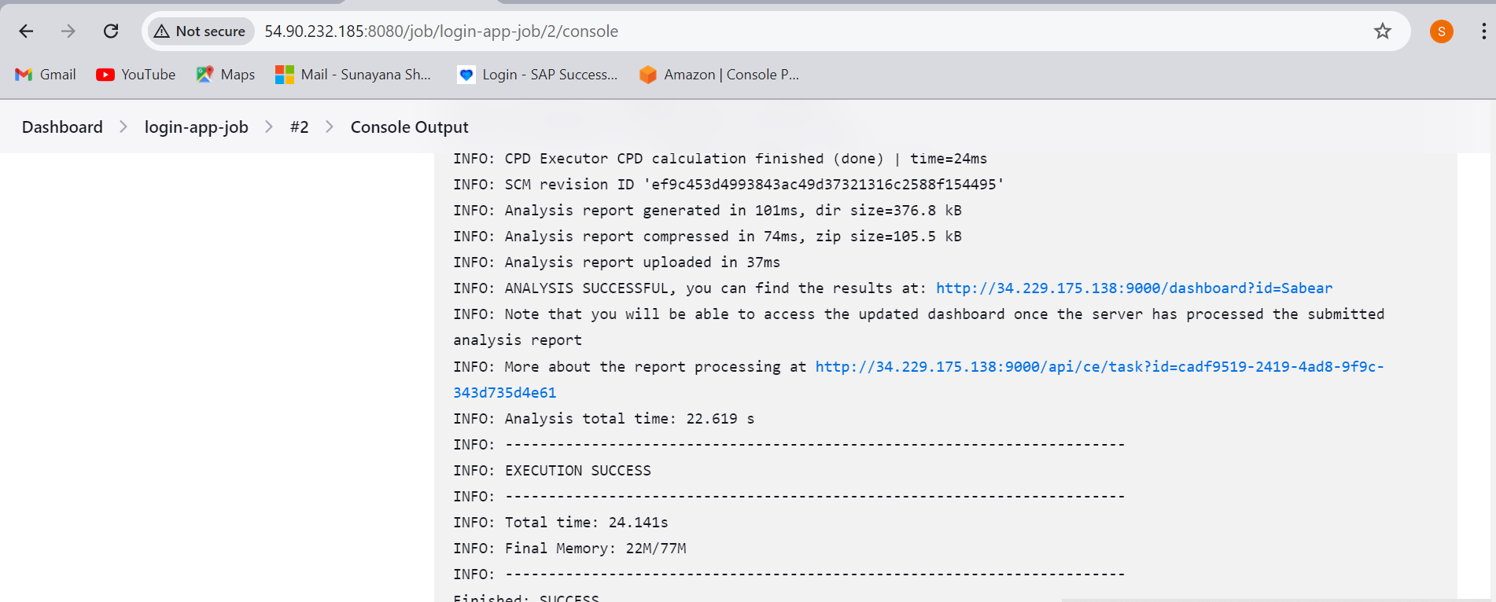

Done sonar integration

**Incase your sonar scanner is asking to re run make it to be auto install in tool configuration install related version of java in cli say for sonar 5.—we need java 17 and build again**

**Now create a package using maven compilation**

**Login to Jenkins server**

**Cd opt**

**Download maven google tar file binary**

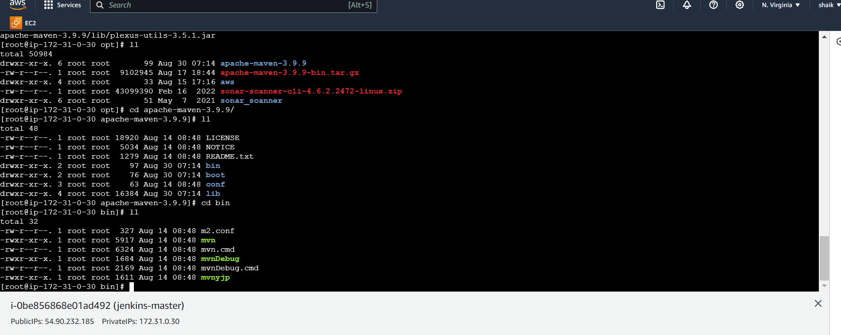

**Now go to home directory and give the location which says Jenkins that home location of maven is below in file vi .bash_profile**

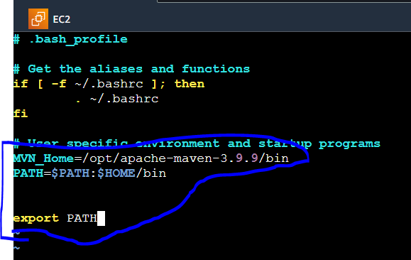

**Error:$HOME_MVN to be added after bin**

**To start this file use source ~/.bash_profile**

**echo $MVN_HOME**

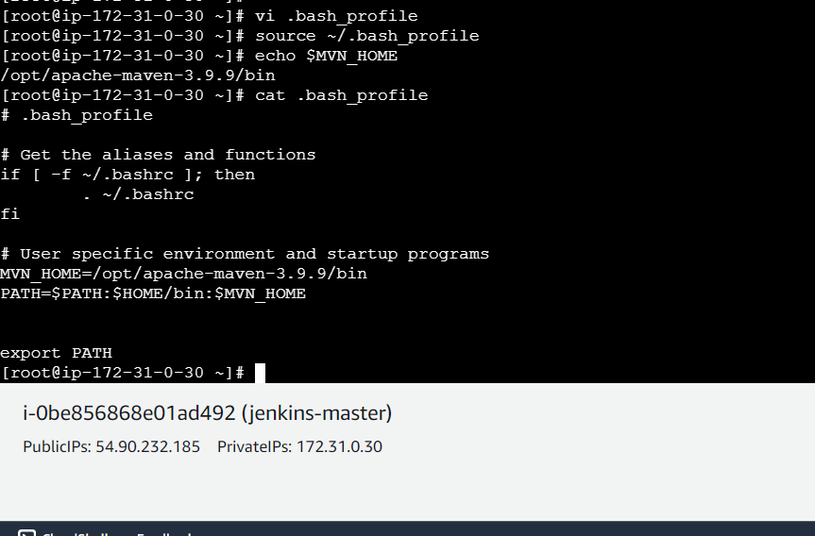

**Error:make sure you give same case characters every where**

Now take this maven home location and paste in Jenkins server same as sonar integration and then go to postbuild in job choose maven invoke as shown below

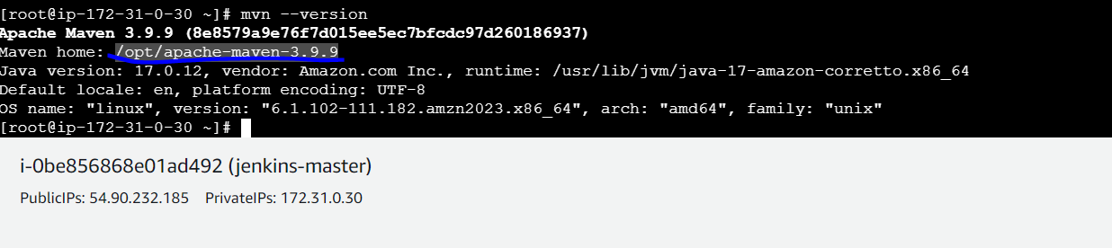

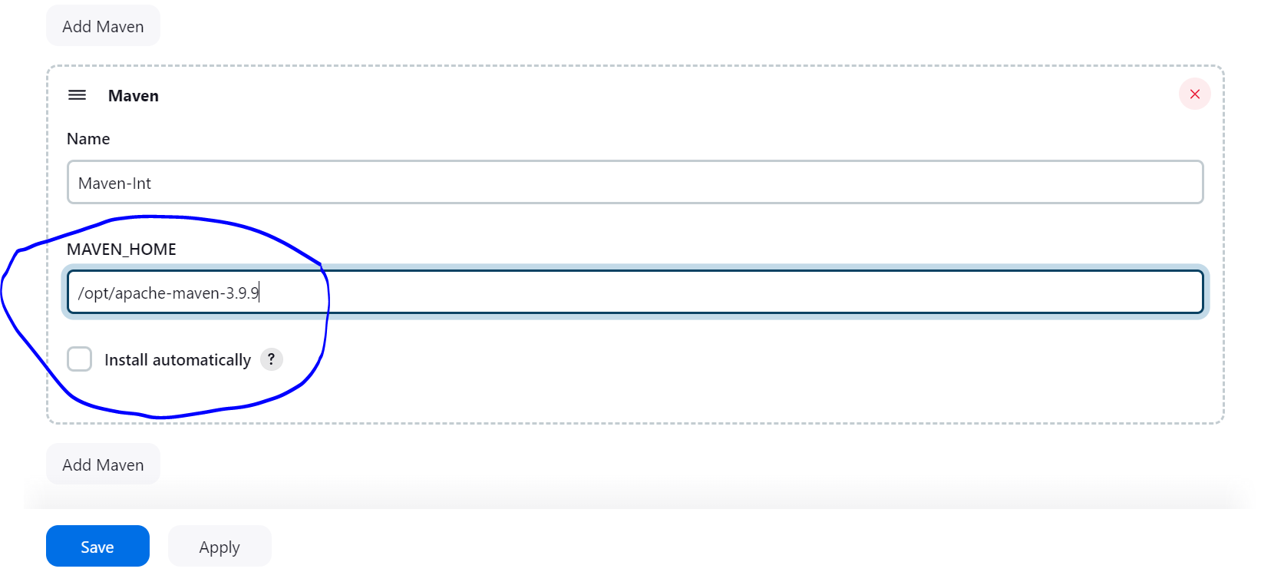

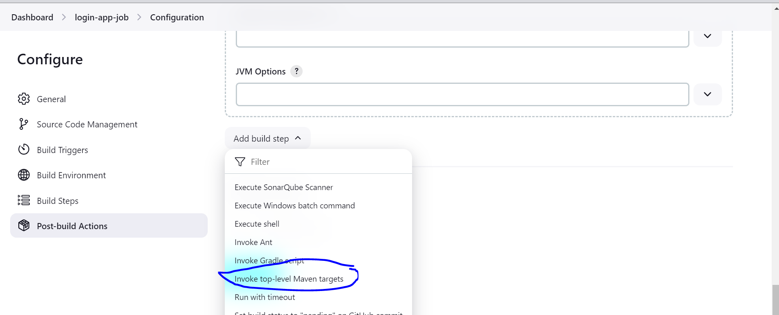

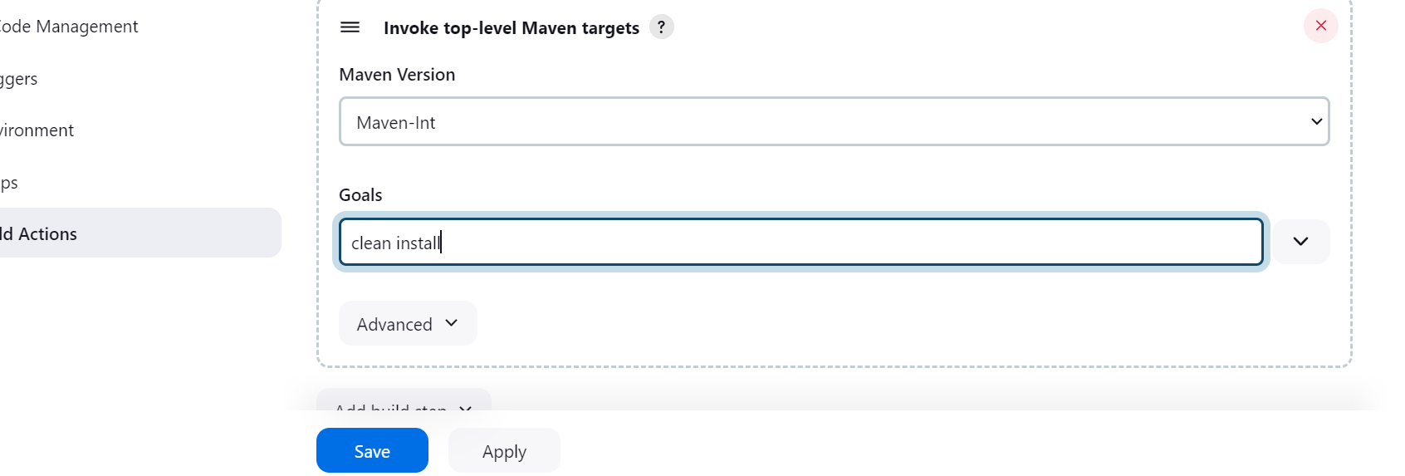

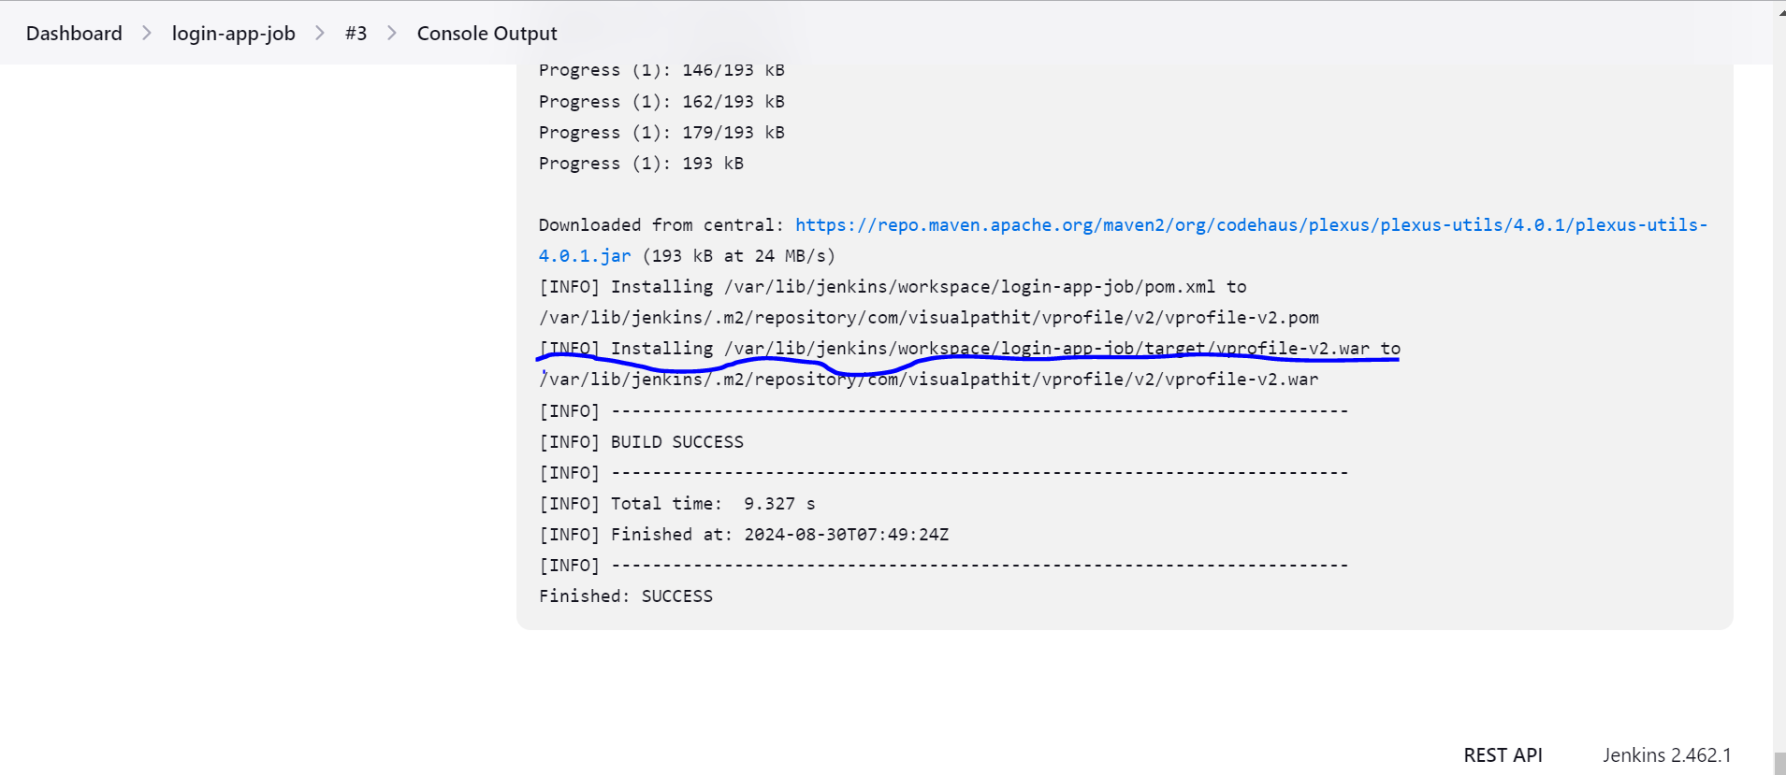

Maven compilation done and .war file created in target

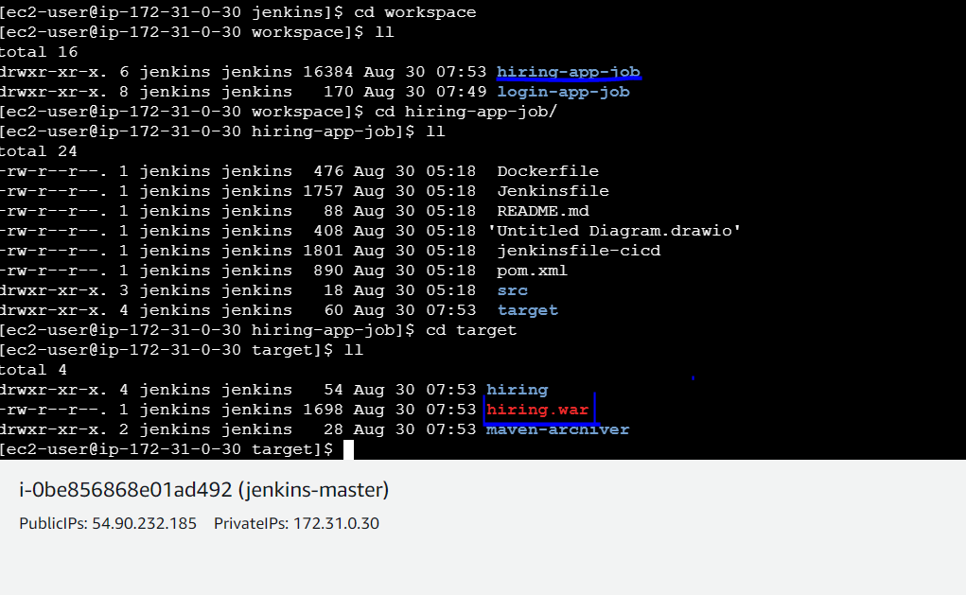

Incase offline all the data is stored in .m2 file

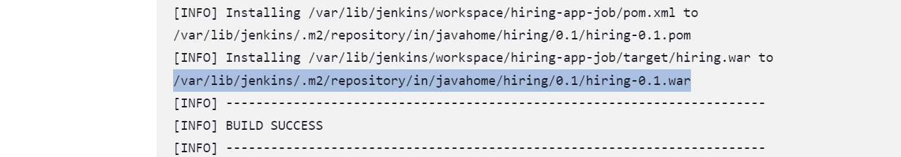

Now store packages in Nexus

With this we can store all the artifactory in central

Install nexus

wget https://sonatype-download.global.ssl.fastly.net/nexus/3/nexus-3.0.2-02-unix.tar.gz

tar -zxvf  nexus-3.0.2-02-unix.tar.gz

mv /opt/nexus-3.0.2-02 /opt/nexus

```

We cannot run nexus with root so e use ec2-user

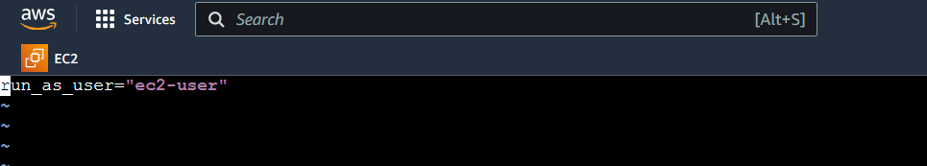

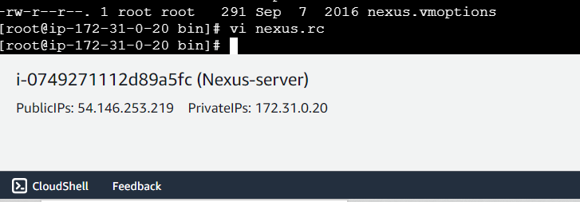

Noe exit from root goto nexus >>bin >>service nexus start

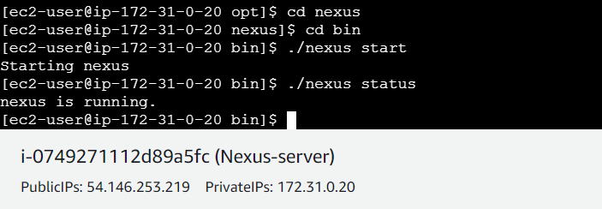

Nexus is running frst go to opt and change owner sudo chown -R ec2-user:ec2-user nexus

Check in browser with 8081

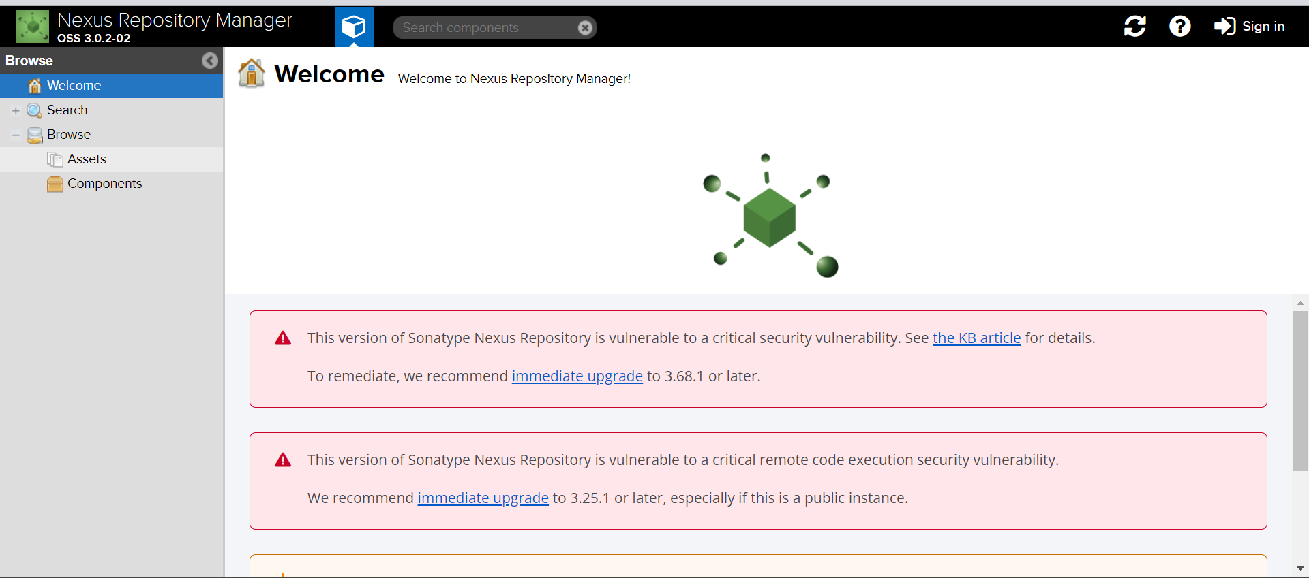

Default id or password—admin—admin123

Now got to Jenkins install plugin nexus artifact uploader

Now go to job there in buil steps we will find option nexus artifact

Give version

Protocol:-http

<url:-nexus> url

credentials create them by using user and password

go to pom.xml

find group id:-

version:-

repository >> go to nexus and create a repository choose maven2 hosted >> give name >>release-final version

snapshot—more versions depends on what it is created

hosted:-allow redeploy

and give this repository in Jenkins

Artifact

Artifact ID_from po.xml

File:-give .war file path

Storing in nexus artifact

/var/lib/jenkins/workspace/hiring-app-job/target/hiring.war

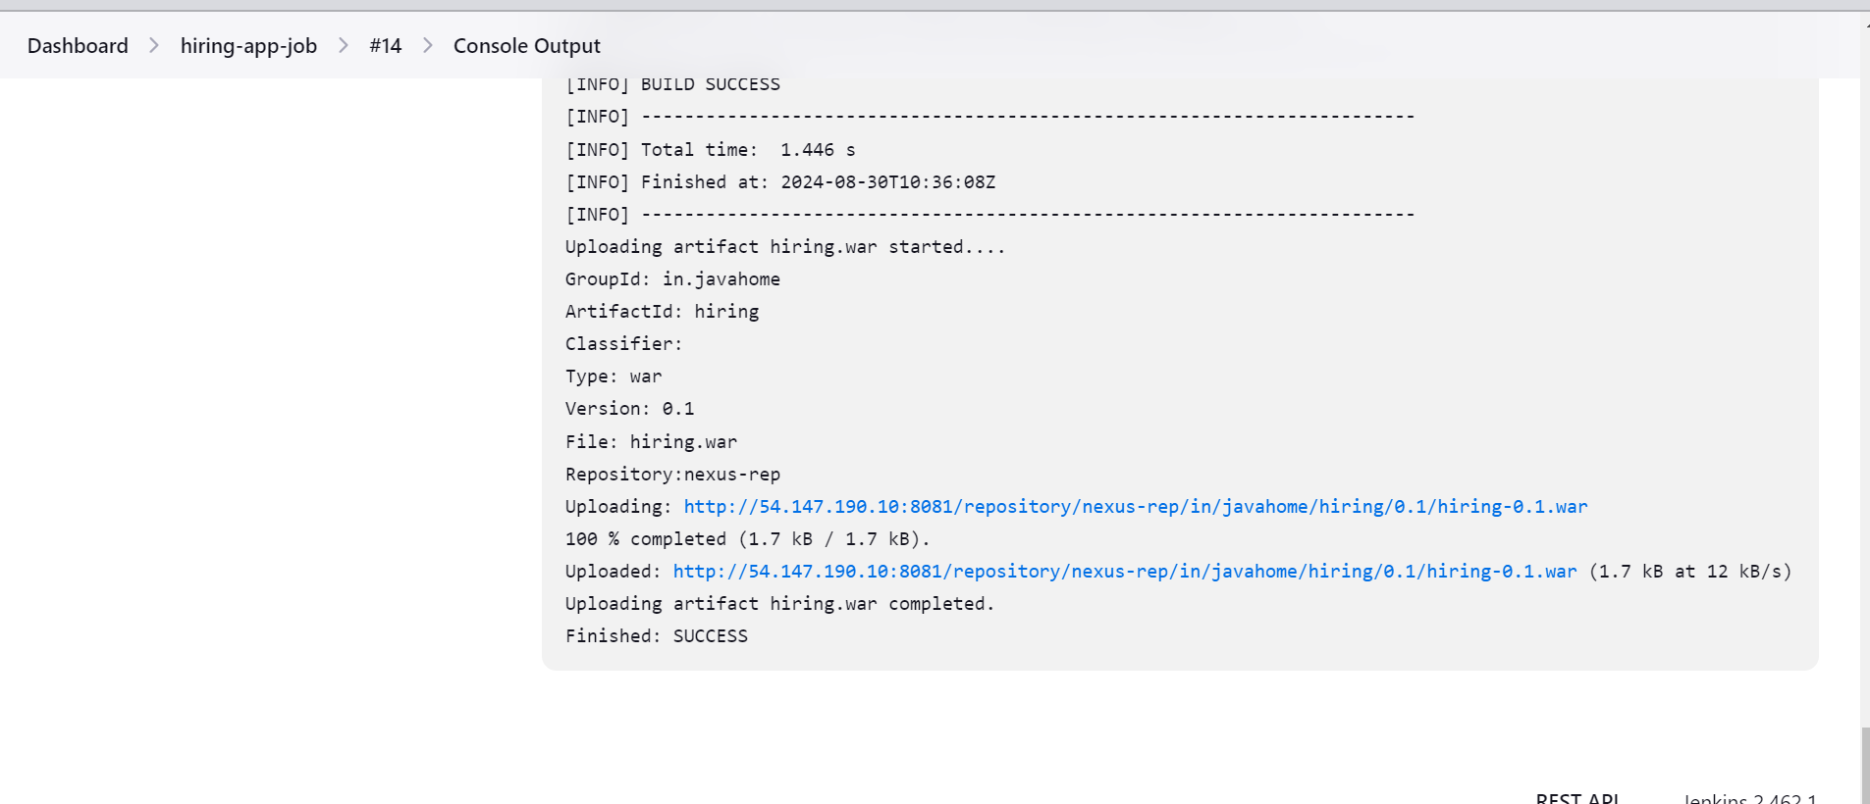

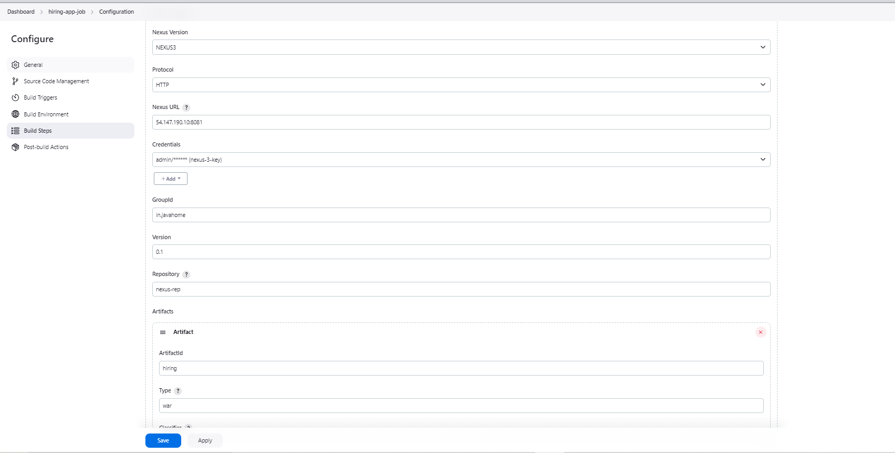

We store artifacts stored here

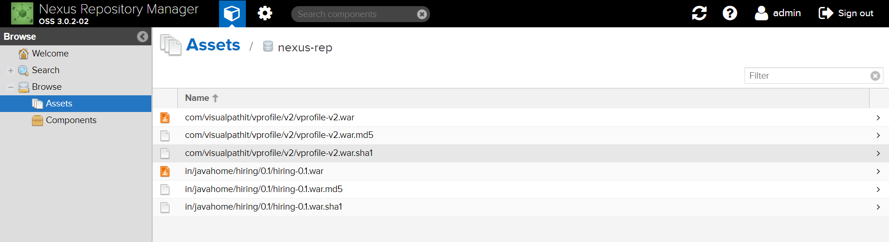

Slack integration

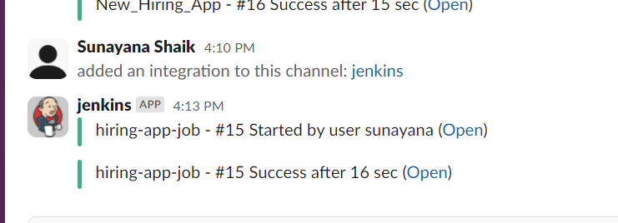

Continuous Deployment

Install plugin **Deploy to container**

**Job >>configure >>post build >>Deploy war/ear to container**

**Uncomment details from below .xml files**

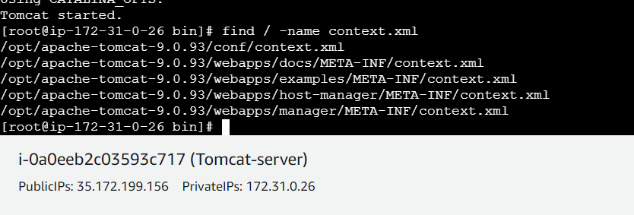

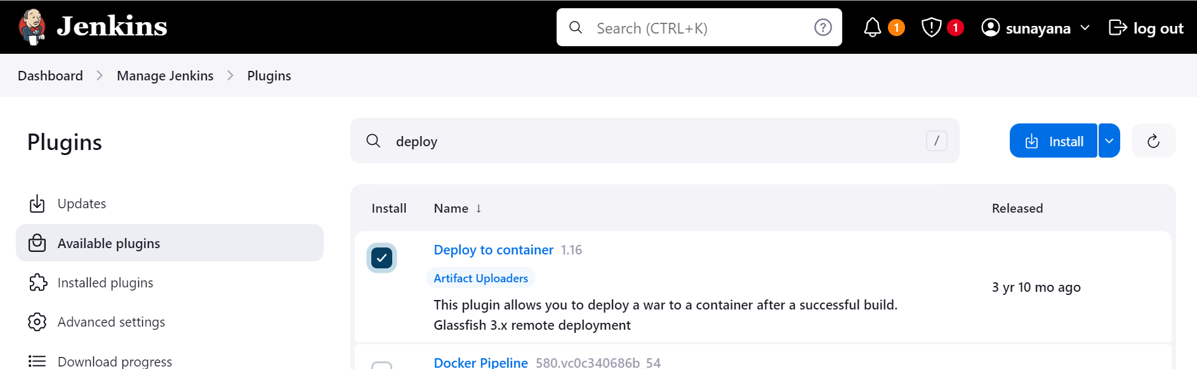

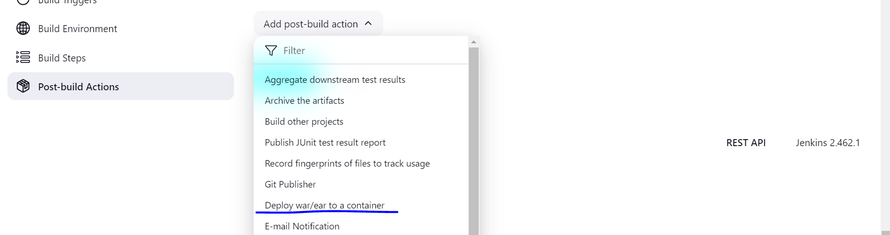

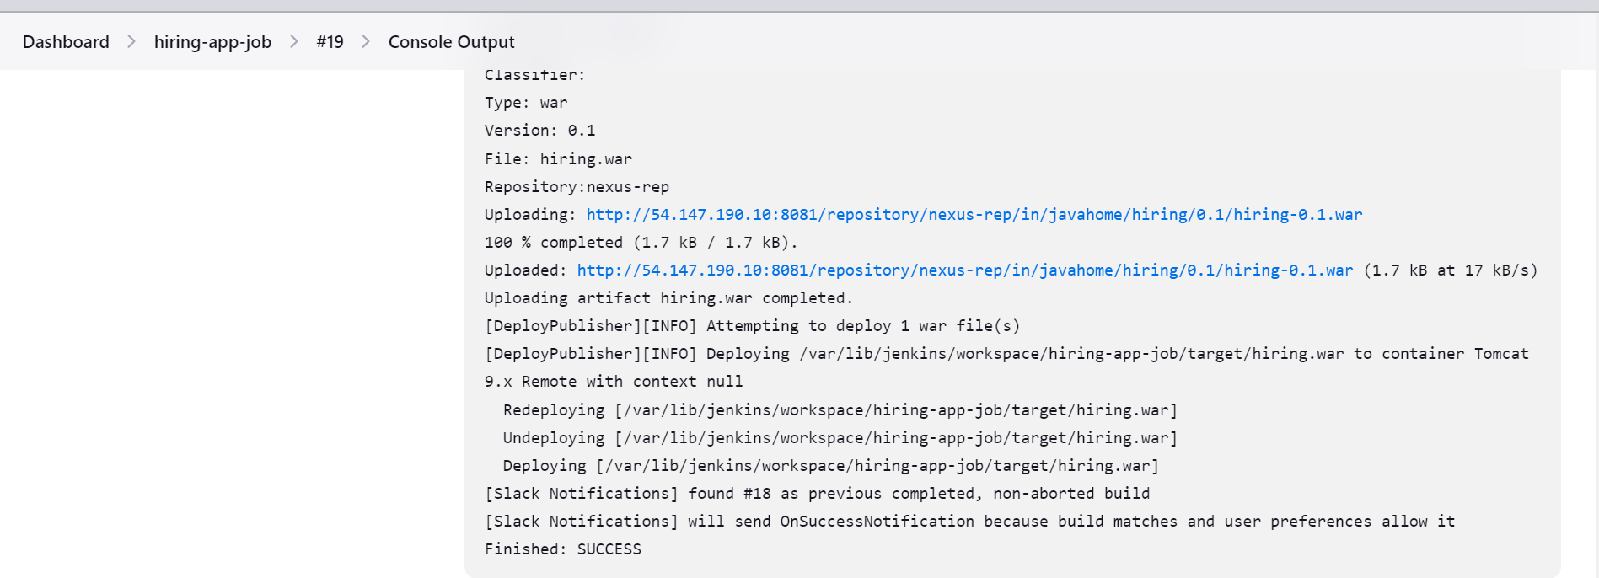

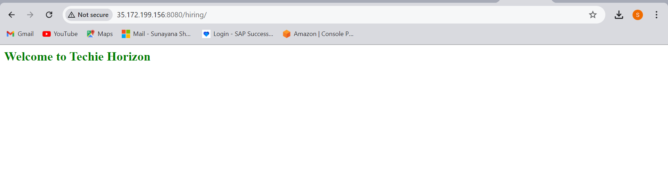

2) Setup jenkins job using freestyle job using below code. <https://github.com/betawins/Techie_horizon_Login_app.git> Stages: 1) Git Clone 2) Sonarqube Integration 3) Maven Compilation 4) Nexus Artifactory 5) Slack Notification 6) Deploy On tomcat

Git clone

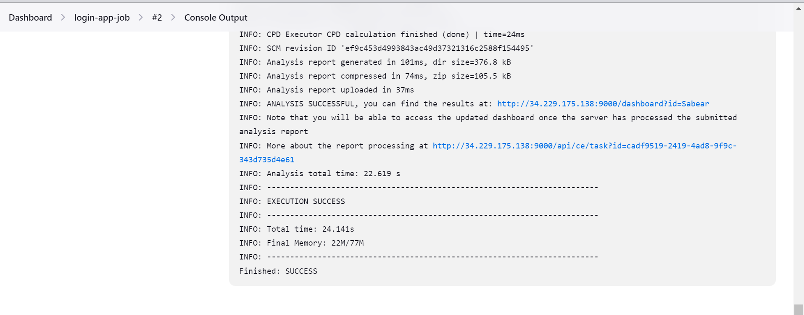

Sonar Integration

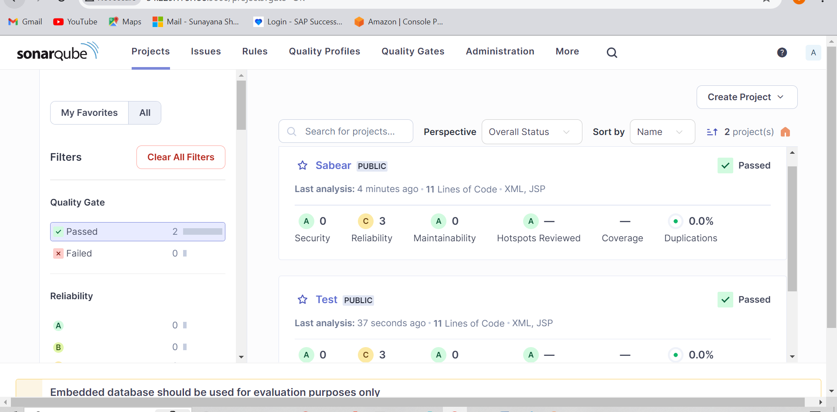

Maven compilation

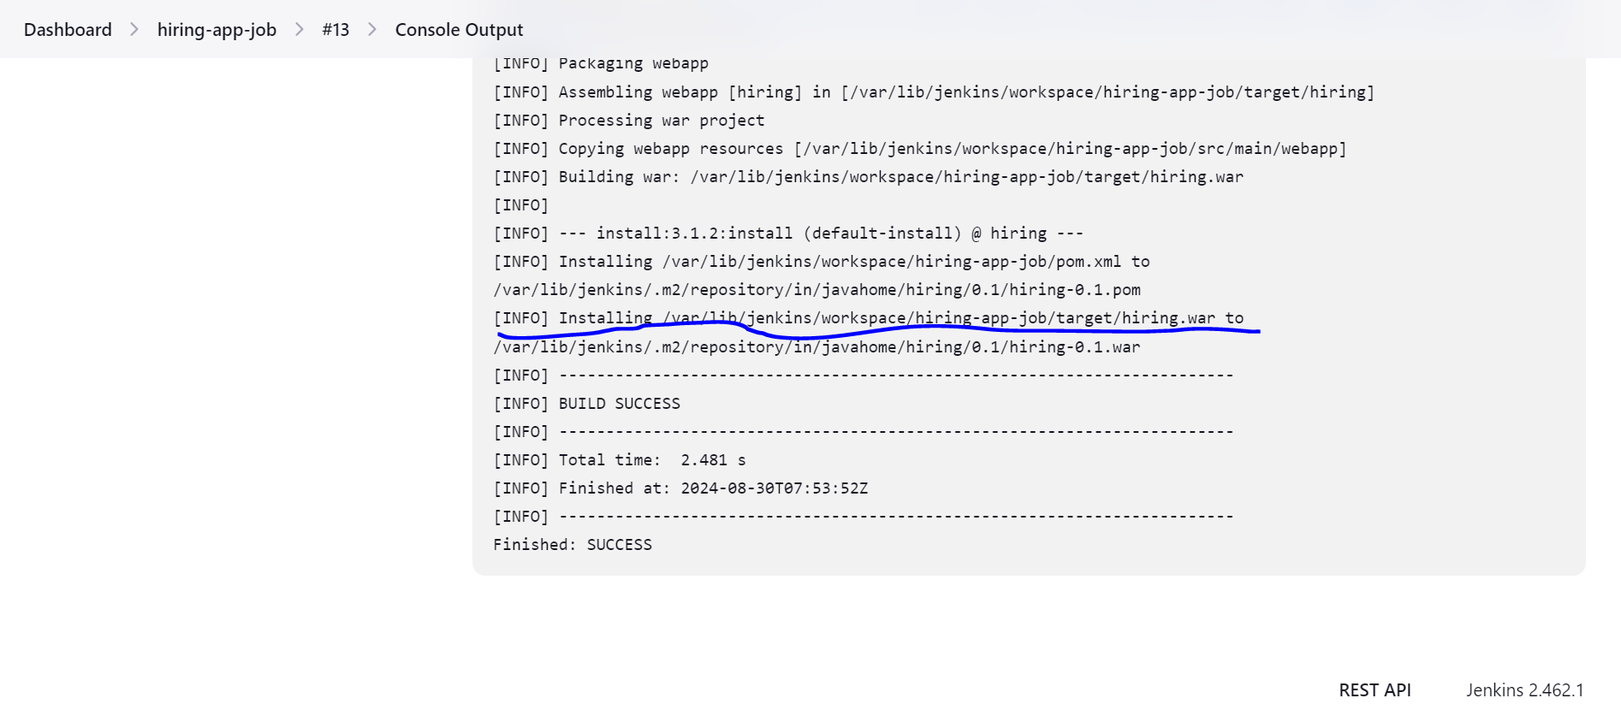

Storing in nexus artifact

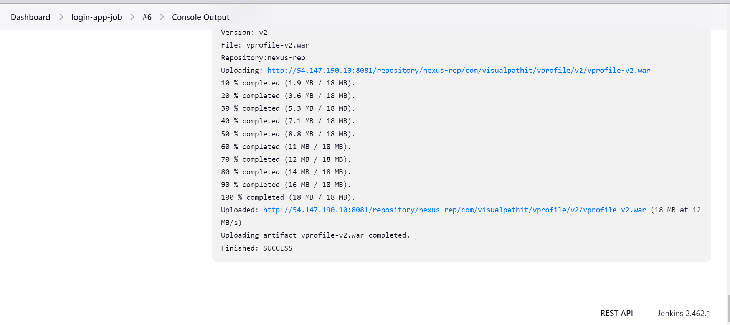

We store artifacts here



Slack integration

Continuous deployment

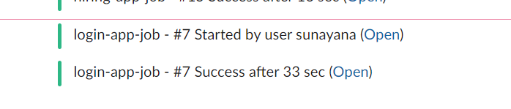

Deployed using tomcat

