How Much Does Air Connectivity Increase Aviation CO2?
Evidence from 184 Countries, 1996-2023
Working draft with full first-pass results, 22 August 2026. Author order TBD.

Abstract
More connectivity means more flying, so aviation CO2 should rise; what is unknown is by how much, whether the rise is more or less than proportional, and how much of it is offset by the efficiency gains of hubbing, since hub consolidation shifts flying into larger aircraft and longer stage lengths that emit less per seat-kilometre. We answer these questions by combining flight-stage-resolved emissions for more than 6,000 airports (1996-2024, EEA/EMEP methodology) with the Global Air Connectivity Index (GACI), instrumenting connectivity with a Feyrer-type air/sea market-access shifter (first-stage F = 153). Connectivity growth increases emissions, and more than proportionally: the elasticity of national aviation CO2 with respect to hub quality is 5.67 (SE 0.41), essentially identical under three emission-allocation rules and three connectivity aggregations, and robust to demanding validity checks. An offsetting efficiency channel is confirmed, emissions per seat-kilometre decline with connectivity at both the country (-0.40) and airport (-0.49) level, and a margin decomposition shows the gain arrives through fleet composition rather than aircraft up-gauging; seat-kilometres expand faster (6.07), so the scale effect dominates. Connectivity growth since 1996 accounts for 356 Mt, or 42.5 percent, of 2023 aviation CO2, concentrated in emerging hubs (China +88 Mt, the United Arab Emirates +25 Mt, Turkey +17 Mt), with declines in mature networks (Germany -16 Mt). Reductions in the level of emissions therefore depend on fuel substitution rather than on efficiency improvements: ReFuelEU-style blending paths reduce the 2023 total from 838 Mt to 457-545 Mt by 2050.

1. Introduction
Aviation is among the hardest-to-abate transport sectors and the most network-dependent one. Countries invest heavily in airports, routes, and air-service liberalisation to improve their position in the global air network. This paper asks the simplest quantitative question about the environmental side of that investment: how much does air connectivity growth increase aviation CO2 emissions?
The direction is intuitive; the magnitude is not. Connectivity growth adds flights and seat-kilometres, which raises fuel burn. At the same time it concentrates flying into hubs, and hub operations use larger aircraft over longer stage lengths, both of which reduce emissions per seat-kilometre; the landing-and-take-off cycle, the most fuel-intensive phase per kilometre, is amortised over more distance. How large the net increase is, whether it is more or less than proportional, and how much the efficiency margin offsets are empirical questions, and to our knowledge no causal estimate of the connectivity-emissions elasticity exists at global scale.
We provide one. Flight-level CO2 computed under the EEA/EMEP Guidebook framework for every scheduled flight from 1996 to mid-2024 is aggregated to the country-year level under three allocation rules and merged with the GACI network panel. Identification uses a Feyrer-type instrument that interacts fixed 1996 air-route geography with the global travel cycle, with the parallel sea market-access channel controlled directly.
Three results emerge. First, connectivity increases emissions, with an elasticity of 5.67, far above one, and the answer does not depend on how emissions are allocated to countries, how national connectivity is aggregated, or which of two independent instruments is used. Second, the efficiency channel operates but is insufficient to offset the scale response: emissions per seat-kilometre decline with connectivity at both the country and the airport level, yet traffic expands more rapidly. Third, the magnitudes are first-order: 42.5 percent of 2023 aviation CO2 is attributable to post-1996 connectivity growth, and reductions in the level of emissions require fuel substitution rather than efficiency alone.

2. Scale, technique, and composition: why the magnitude is an empirical question
Emissions can be decomposed as traffic (seat-kilometres) times emissions per seat-kilometre, with the mix of domestic and international flying shifting both terms. Connectivity growth plausibly moves all three margins: it scales traffic upward; it improves technique, because hub consolidation raises average aircraft size and stage length; and it recomposes traffic toward international long-haul. The net elasticity therefore depends on how far the technique and composition margins offset the scale margin, which theory does not pin down. The magnitudes can be resolved empirically because the outcomes map directly onto the three margins: seat-kilometres (scale), CO2 per seat-kilometre (technique), and the international share and international emissions (composition).

3. Data

3.1 Emissions
Flight-level CO2 is computed from OAG schedules under the EEA/EMEP Guidebook (2023) framework, Section 1.A.3.a: fuel burn by engine type and stage length, multiplied by a fixed emission factor (3.15 kg CO2 per kg of Jet A; 3.10 for AvGas piston traffic). The delivery is stage-resolved at the airport-month level, split by domestic and international, with departure-side phases (taxi-out, take-off, climb-out, cruise) and arrival-side phases (approach, taxi-in, cruise) kept separate, together with flights, seats, and seat-kilometres. Coverage is 1 January 1996 to 30 June 2024; the partial July 2024 rows are dropped and annual analysis ends in 2023. Emissions are schedule-based (no load factors, weather, or airline-specific procedures) and cover aircraft operations only.

3.2 Allocation rules
Because cruise emissions occur between countries, allocation is a choice. We build three country aggregations from the stages: LTO-territorial (each landing-and-take-off phase at its own airport); fuel-uplift (LTO plus cruise assigned to the departure airport, the IEA bunker convention; our headline); and a 50/50 cruise split. Cruise is recorded once on each side of a flight and used exactly once.

3.3 Validation
The 2019 world total is 0.919 Gt against the ICCT estimate of 0.92 Gt for commercial aviation; the LTO share is 11.8 percent, in the standard range. The log-log correlation with the independent OWID/ICCT country series is 0.99 in every overlapping year (2013-2023), with a level ratio of 1.05-1.10 consistent with full-capacity scheduling. After crosswalk patches for closed and relocated airports, 100 percent of GACI panel airport-years match the emissions data.

3.4 Connectivity and sample
Connectivity is the GACI panel (degree, flow betweenness, closeness, eigenvector, and regional importance, combined by year-wise principal components), aggregated to countries as the capacity-weighted mean (hub quality, headline), the maximum, and the sum. The estimation sample is 184 countries, 1996-2023, N = 4,634 country-years.

4. Empirical strategy
We estimate, by two-stage least squares with country and year fixed effects and robust standard errors,
ln CO2(c,t) = beta ln GACI_cwm(c,t) + gamma ln pop(c,t) + delta ln seaMA(c,t) + alpha_c + tau_t + e(c,t).
The instrument is a Feyrer-type air/sea market-access shifter: fixed 1996 air-route geography interacted with the global travel cycle, with the sea market-access channel controlled directly. The first-stage Kleibergen-Paap F is 153. Two properties matter. First, the instrument survives the most demanding relevance check we impose, interacting the global cycle with baseline population, GDP, and seat capacity (F falls only from 120 to 106); the same check reduces a tourism-heritage alternative from F = 14 to zero, which is why the tourism shifter serves only as a secondary lens below. Second, Conley plausibly-exogenous bounds show the estimates tolerate direct instrument effects of up to 85 percent of the reduced form before losing significance.
A tourism-heritage instrument (natural and mixed UNESCO endowment times the global tourism cycle) is retained as a secondary lens: its compliers are hub-quality changes rather than market-access growth, it covers the post-2010 era where the Feyrer instrument is weak, and its composition results are informative even though its first stage is fragile. Airport-level regressions are reported as descriptive mechanism evidence only; a pilot airport-level heritage-proximity instrument failed the same size-cycle check (F 59 to 2.3) and was abandoned. Causal statements are confined to the country level.

5. Results

5.1 Main estimates: a more-than-proportional emissions response
Table 1. Main 2SLS estimates (Feyrer instrument). Treatment: ln GACI hub quality.
 | Total CO2 | LTO only | 50/50 | International | Seat-km | CO2/seat-km
ln GACI (cwm) | 5.669*** | 5.921*** | 5.620*** | 5.690*** | 6.068*** | -0.399***
(SE) | (0.412) | (0.448) | (0.409) | (0.415) | (0.443) | (0.118)
Wald p (beta = 1) | 0.000 | 0.000 | 0.000 | 0.000 | 0.000 | 0.000
KP F | 153.6 | 153.6 | 153.6 | 152.7 | 153.6 | 153.6
N | 4,634 | 4,634 | 4,634 | 4,633 | 4,634 | 4,634
Country and year FE; controls: ln population, ln sea market access; robust SE. Emission allocations: fuel-uplift (headline), LTO-territorial, 50/50 cruise split. *** p<0.01.
The emissions elasticity of connectivity is 5.67 and statistically indistinguishable across the three allocation rules (5.62-5.92). Proportionality is rejected decisively: a Wald test of beta = 1 gives p < 0.001 in every column. Traffic responds slightly faster than emissions (6.07 versus 5.67), so emissions per seat-kilometre decline (-0.399, SE 0.118): the efficiency channel operates but is dominated by the scale response.

5.2 Robustness: measurement, aggregation, timing, and instrument validity
Table 2. Robustness of the sign and size. Outcome: ln international CO2 (panel A), ln international CO2 by period (panel B).
Panel A: connectivity aggregation | Hub quality (cwm) | Sum | Maximum
ln GACI | 5.690*** | 2.291*** | 4.836***
(SE) | (0.415) | (0.237) | (0.343)
KP F | 152.7 | 89.5 | 171.0
Panel B: period (Feyrer IV) | Pre-2010 | Post-2010
ln GACI (cwm) | 6.262*** | 1.051
(SE) | (0.590) | (1.463)
KP F | 126.9 | 7.0
Panel B continued (tourism IV) | Pre-2010 | Post-2010
ln GACI (cwm) | n/a (F = 0.2) | 1.639***
(SE) |  | (0.618)
KP F | 0.2 | 27.7
The two instruments identify complementary eras with the same sign: the Feyrer shifter is strong before 2010, the tourism shifter after 2010.
Table 3. Validity: size-cycle stress test and Conley bounds.
First-stage F when cycle x baseline size is controlled | Baseline | + pop/GDP cycles | + capacity cycle
Feyrer instrument | 120.1 | 115.5 | 105.8
Tourism instrument | 13.8 | 0.0 | 0.6
Airport heritage pilot (abandoned) | 59.5 |  | 2.3
Conley bounds (gamma up to share f* of reduced form) | 2SLS beta | UCI at 30% | Breakdown f*
ln international CO2 | 5.690 | [3.25, 6.50] | 0.85
ln total CO2 | 5.669 | [3.25, 6.48] | 0.85
ln CO2/seat-km | -0.399 | [-0.51, -0.17] | 0.42
Top block: 1996-observed sample. Bottom block: union-of-CI bounds allowing a direct instrument effect gamma in [0, gmax], gmax expressed as a share of the reduced-form coefficient; f* is the largest share at which the interval still excludes zero.
Quintile reduced forms of the Feyrer shifter are flat across baseline income, baseline connectivity, and remoteness (all bins near 0.7): the scale response is homogeneous, so the aggregate elasticity is not driven by any subgroup.

5.3 Mechanism: the scale response is a frequency response
Table 4. Margin decomposition of the emissions elasticity (Feyrer instrument). Identity: ln CO2 = ln flights + ln seats per flight + ln km per seat + ln CO2 per seat-km.
 | Flights | Seats per flight | Stage length (km/seat) | CO2/seat-km | LTO share | Intl share of seat-km
ln GACI (cwm) | 6.976*** | -0.303 | -0.605*** | -0.399*** | 0.014 | 0.096**
(SE) | (0.570) | (0.226) | (0.211) | (0.118) | (0.025) | (0.048)
KP F | 153.6 | 153.6 | 153.6 | 153.6 | 153.6 | 153.6
N | 4,634 | 4,634 | 4,634 | 4,634 | 4,634 | 4,634
Country and year FE; controls: ln population, ln sea market access; robust SE. The first four columns decompose the Table 1 total-CO2 elasticity exactly: 6.976 - 0.303 - 0.605 - 0.399 = 5.669. LTO share and international share are in levels (shares of emissions and of seat-kilometres). *** p<0.01, ** p<0.05.
Because emissions are the product of flight frequency, aircraft gauge, stage length, and fuel intensity, the log-linear specification decomposes the headline elasticity exactly: the four component elasticities sum to 5.67 by construction. Table 4 reports each margin under the Feyrer instrument. First, the scale response is a frequency response: instrumented connectivity growth raises departures with an elasticity of 6.98, while average aircraft size does not change (-0.30, SE 0.23). Second, average stage length shortens (-0.60), indicating that market-access-driven growth adds short-haul frequencies rather than long-haul routes. Third, emissions per seat-kilometre fall (-0.40) even though neither up-gauging nor stage-lengthening occurs, so the technique margin operates through equipment, a shift toward aircraft types with lower fuel burn per seat at given stage lengths. The international share of seat-kilometres rises modestly and the LTO share of emissions is unchanged. Connectivity growth therefore multiplies flights faster than emissions because fleets improve, not because networks consolidate into larger aircraft.

5.4 The efficiency margin: operative but insufficient to offset scale
Table 5. Airport-level mechanism evidence (descriptive). Airport FE + country x year FE; SE clustered by airport.
 | ln CO2 | ln seat-km | ln CO2/seat-km | International share
ln GACI (airport) | 3.717*** | 4.184*** | -0.494*** | 0.331***
(SE) | (0.113) | (0.123) | (0.044) | (0.019)
N | 93,051 | 92,855 | 92,855 | 92,855
97,165 airport-years, 5,354 airports. Descriptive associations: GACI embeds seat capacity, so the CO2 and seat-km columns are partly mechanical; the informative margins are intensity and the international share. *** p<0.01.
Within a country, an airport whose network position improves becomes cleaner per seat-kilometre and more international. The cross-sectional ladder in Figure 1 makes the same point without regression: median CO2 per 1,000 seat-kilometres falls monotonically from 284 kg in the least connected ventile of airports to 77 kg in the most connected, while the international share of seat-kilometres rises from about 1 to about 60 percent. Node-level efficiency improves exactly where connectivity concentrates; the national totals of Table 1 nevertheless rise because traffic scales faster.
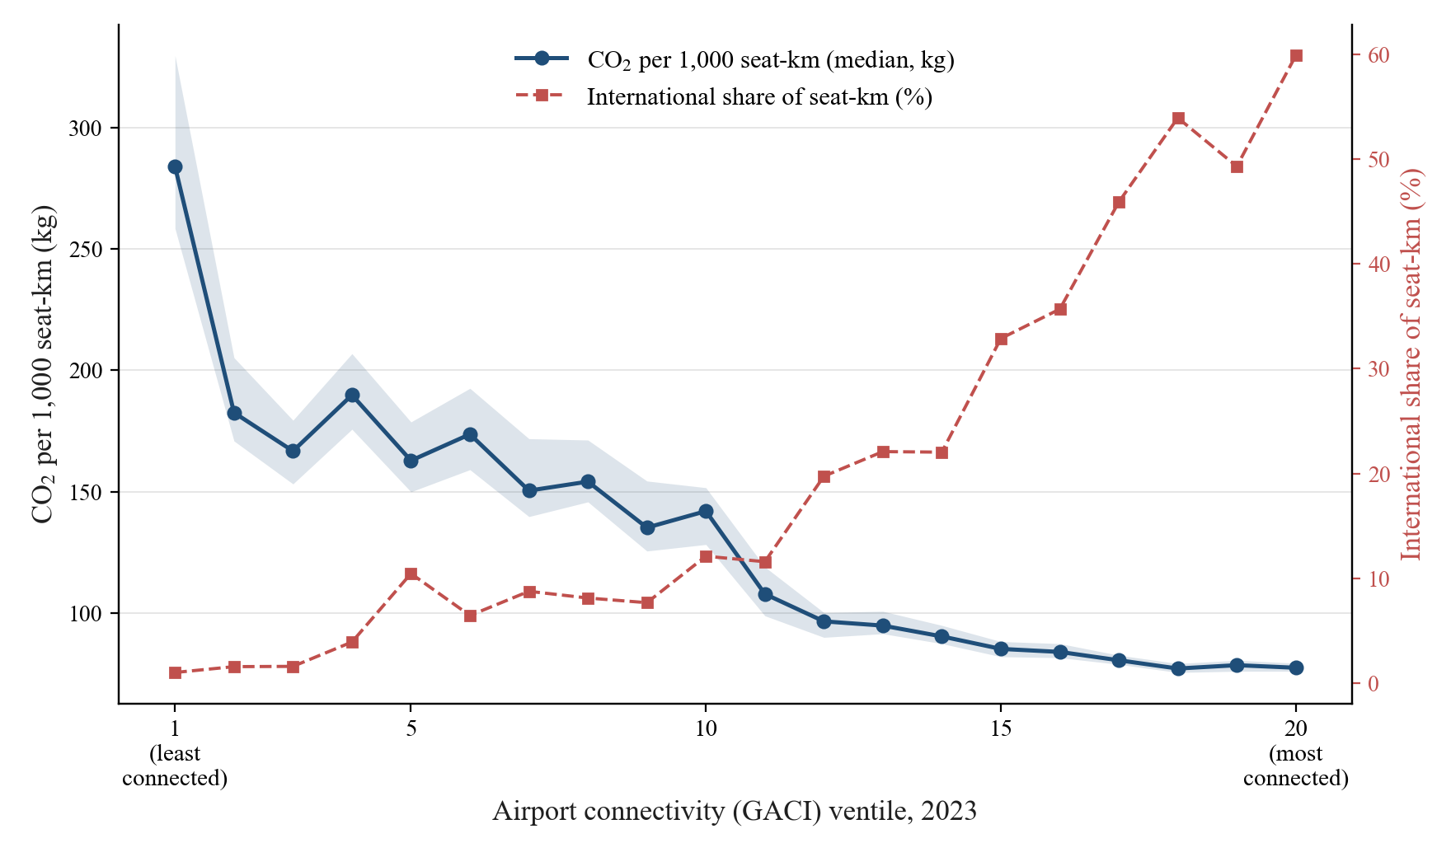
Figure 1. The hub efficiency ladder, 2023: median CO2 per 1,000 seat-km (with bootstrapped 95% CI) and international share of seat-km, by GACI ventile.

5.5 The composition lens (secondary instrument)
Table 6. Tourism-heritage instrument (hub-quality compliers). Country and year FE; robust SE; KP F = 18.0.
 | Total CO2 | International CO2 | Seat-km | CO2/seat-km
ln GACI (cwm) | 1.162 | 3.164*** | -0.066 | 1.228***
(SE) | (0.863) | (0.766) | (1.115) | (0.460)
N | 4,642 | 4,641 | 4,642 | 4,642
Interpret with the fragility documented in Table 3 in mind. *** p<0.01.
Hub-quality changes, the tourism instrument's compliers, do not scale total traffic or total emissions; they recompose flying toward international long-haul, raising international emissions and measured intensity. Read together with Table 1, market-access growth scales the system while hub-quality change internationalises it; both raise the emissions margin that matters for climate accounting.

5.6 Heterogeneity: who drives the elasticity
Table 7. Group heterogeneity of the emissions elasticity (Feyrer instrument). Outcome: ln international CO2 (Panels A-C) and ln CO2 per seat-km (Panel D); specification as in Table 1, split-sample 2SLS with pooled interaction tests.
 | beta | (SE) | KP F | N | Countries
Panel A: baseline income terciles
Low income | 11.431*** | (1.338) | 35.2 | 1,595 | 62
Middle income | 5.906*** | (0.782) | 48.2 | 1,547 | 61
High income | 0.350 | (1.106) | 10.1 | 1,491 | 59
Interaction: MA x top tercile | -3.083*** | (0.235) | 69.1 | 4,633
Panel B: baseline connectivity terciles
Low connectivity | 9.018*** | (0.656) | 117.4 | 1,452 | 61
Middle connectivity | 5.642*** | (0.908) | 29.9 | 1,526 | 60
High connectivity | 0.452 | (2.201) | 1.8 | 1,655 | 61
Interaction: MA x top tercile | -2.484*** | (0.256) | 71.0 | 4,633
Panel C: macro regions
Europe | 0.236 | (0.616) | 55.5 | 1,189 | 44
Asia-Pacific | 5.424*** | (0.667) | 64.4 | 1,110 | 45
Africa | 8.385*** | (1.688) | 20.2 | 1,230 | 49
Latin America | 3.229*** | (0.900) | 14.1 | 683 | 28
Panel D: intensity outcome by income tercile
Low income | -1.057*** | (0.299) | 35.5 | 1,596 | 62
Middle income | -0.372 | (0.241) | 48.2 | 1,547 | 61
High income | 1.012 | (0.715) | 10.1 | 1,491 | 59
Terciles are defined over countries by the earliest observed GDP per capita and hub quality. Interaction rows report the coefficient on ln GACI x top-tercile dummy, both instrumented (Feyrer shifter and its interaction). The Middle East and North America splits are omitted as underidentified (KP F below 2; 13 and 3 countries). In the high-connectivity cell the instrument has little remaining variation (KP F = 1.8), so the interaction test is the preferred inference. *** p<0.01.
The headline elasticity is an average over very different national trajectories, so Table 7 asks where it comes from. First, splitting the sample by baseline income yields elasticities of 11.4 and 5.9 in the bottom and middle terciles against a precise zero in the top tercile, and the pooled interaction confirms the gap (-3.08, KP F = 69). Second, the same pattern holds for baseline connectivity: countries entering the network from a low base drive the response, while established networks show none, a cell in which the instrument itself has little remaining variation (KP F = 1.8), so we rely on the interaction test (-2.48, F = 71). Third, the regional splits reproduce the gradient, with Africa (8.4) and Asia-Pacific (5.4) at one end and Europe (0.2, n.s.) at the other. The efficiency margin follows the same geography: intensity falls with connectivity only in the bottom income tercile (-1.06). The scale response is therefore a property of network entry, not of mature hub competition.

5.7 Attribution: the contribution of connectivity growth to 2023 emissions
Table 8. Emissions attributable to 1996-2023 connectivity growth (attributed share = 1 - exp(-beta x dln GACI), applied to 2023 levels; beta = 5.67).
 | Attributed 2023 CO2 | Share of 2023 total
World, total allocation | 356 Mt | 42.5% of 838 Mt
World, international only | 212 Mt | 41.2% of 514 Mt
Emerging hubs
China | +87.7 Mt
United Arab Emirates | +24.7 Mt
Turkey | +16.6 Mt
India | +15.9 Mt
Mature networks
United States | +36.4 Mt
Japan | +17.4 Mt
Korea | +14.1 Mt
Germany (declining connectivity) | -15.8 Mt
Partial-equilibrium accounting. Because the elasticity is far above one, attributed shares for the fastest-growing countries approach their full 2023 emissions; the world total remains moderate because many countries changed little. Not a general-equilibrium counterfactual.

5.8 Sustainable aviation fuel scenarios
Table 9. World aviation CO2 under ReFuelEU-style SAF blending (life-cycle accounting; Panel A) and the connectivity accounting of the fuel path (Panel B; beta = 5.67). Applied to the 2023 total of 838 Mt.
Milestone (blending share) | LCA saving 50% | LCA saving 65% | LCA saving 80%
Panel A: world aviation CO2 (Mt)
2025 (2%) | 830 Mt | 827 Mt | 825 Mt
2030 (6%) | 813 Mt | 805 Mt | 798 Mt
2035 (20%) | 754 Mt | 729 Mt | 704 Mt
2040 (34%) | 696 Mt | 653 Mt | 610 Mt
2045 (42%) | 662 Mt | 609 Mt | 556 Mt
2050 (70%) | 545 Mt | 457 Mt | 369 Mt
Panel B: saving (share of the 356 Mt attributed to connectivity growth)
2025 (2%) | 8 Mt (2%) | 11 Mt (3%) | 13 Mt (4%)
2030 (6%) | 25 Mt (7%) | 33 Mt (9%) | 40 Mt (11%)
2035 (20%) | 84 Mt (24%) | 109 Mt (31%) | 134 Mt (38%)
2040 (34%) | 142 Mt (40%) | 185 Mt (52%) | 228 Mt (64%)
2045 (42%) | 176 Mt (49%) | 229 Mt (64%) | 282 Mt (79%)
2050 (70%) | 293 Mt (82%) | 381 Mt (107%) | 469 Mt (132%)
Emissions-neutral hub-quality growth by 2050 | 7.9% | 11.3% | 15.6%
Panel A: E(s) = E x [(1 - s) + s x (1 - r)]; fuel backed out as CO2 / 3.15. Panel B: saving = 838 x s x r, expressed relative to the 356 Mt attributed to 1996-2023 connectivity growth in Table 8. The final row inverts the attribution formula: the hub-quality growth exp(-ln(1 - sr)/beta) - 1 that the 2050 blend absorbs at constant emissions, with beta = 5.67; realised worldwide hub-quality growth over 1996-2023 was approximately 10 percent. Illustrative: a country-level elasticity applied at the world aggregate. Accounting simulation: no behavioural response, no SAF supply constraint, combustion CO2 of SAF equals Jet A, savings are life-cycle.
Because the efficiency margin improves with connectivity yet does not offset the scale response, reductions in the level of emissions on current network trends require fuel substitution. A 2035 mandate implies savings of 84-134 Mt per year; a 2050 mandate implies savings of 293-469 Mt against the 2023 level.
Panel B links the fuel path to the causal estimate. First, measured against the 356 Mt that Section 5.7 attributes to 1996-2023 connectivity growth, a 2035 mandate offsets 24-38 percent of that contribution, and only the full 2050 blending share, at life-cycle savings of 65 percent or above, offsets it entirely. Second, the same arithmetic defines an emissions-neutral rate of network growth: a blending share s with saving r permits hub-quality growth of exp(-ln(1 - sr)/beta) - 1 at constant emissions, which reaches 11 percent by 2050, approximately the hub-quality growth realised worldwide over 1996-2023. The ReFuelEU path therefore buys back roughly one generation of connectivity growth.

6. The geography of emissions attribution
Because cruise emissions occur between countries, the assignment of responsibility depends on the allocation rule, and the differences are systematic. Within a year, departure-side and arrival-side cruise nearly cancel for every country (round-trip symmetry; the largest national imbalance is 0.7 Mt), so the binding margin is fuel-uplift attribution versus physical LTO. In 2023 the fuel-uplift convention assigns 1.4 percentage points more of world emissions to the United States and the United Arab Emirates, and 1.0 more to the United Kingdom, than physically occurs in their landing-and-take-off cycles, while emerging, domestically oriented networks are assigned correspondingly less (China, 3.5 points). At the airport level the gap is positive at every international mega-hub (Heathrow +1.17, Dubai +1.11) and negative at the large domestic hubs of emerging networks (Shanghai Hongqiao, Xi'an, Shenzhen, Kunming, Chongqing, Wuhan). Combined with Section 5.7, the countries where connectivity-driven emissions grew fastest are not the countries to which those emissions are assigned under bunker accounting, which bears directly on CORSIA coverage and on how national aviation targets should treat international cruise.
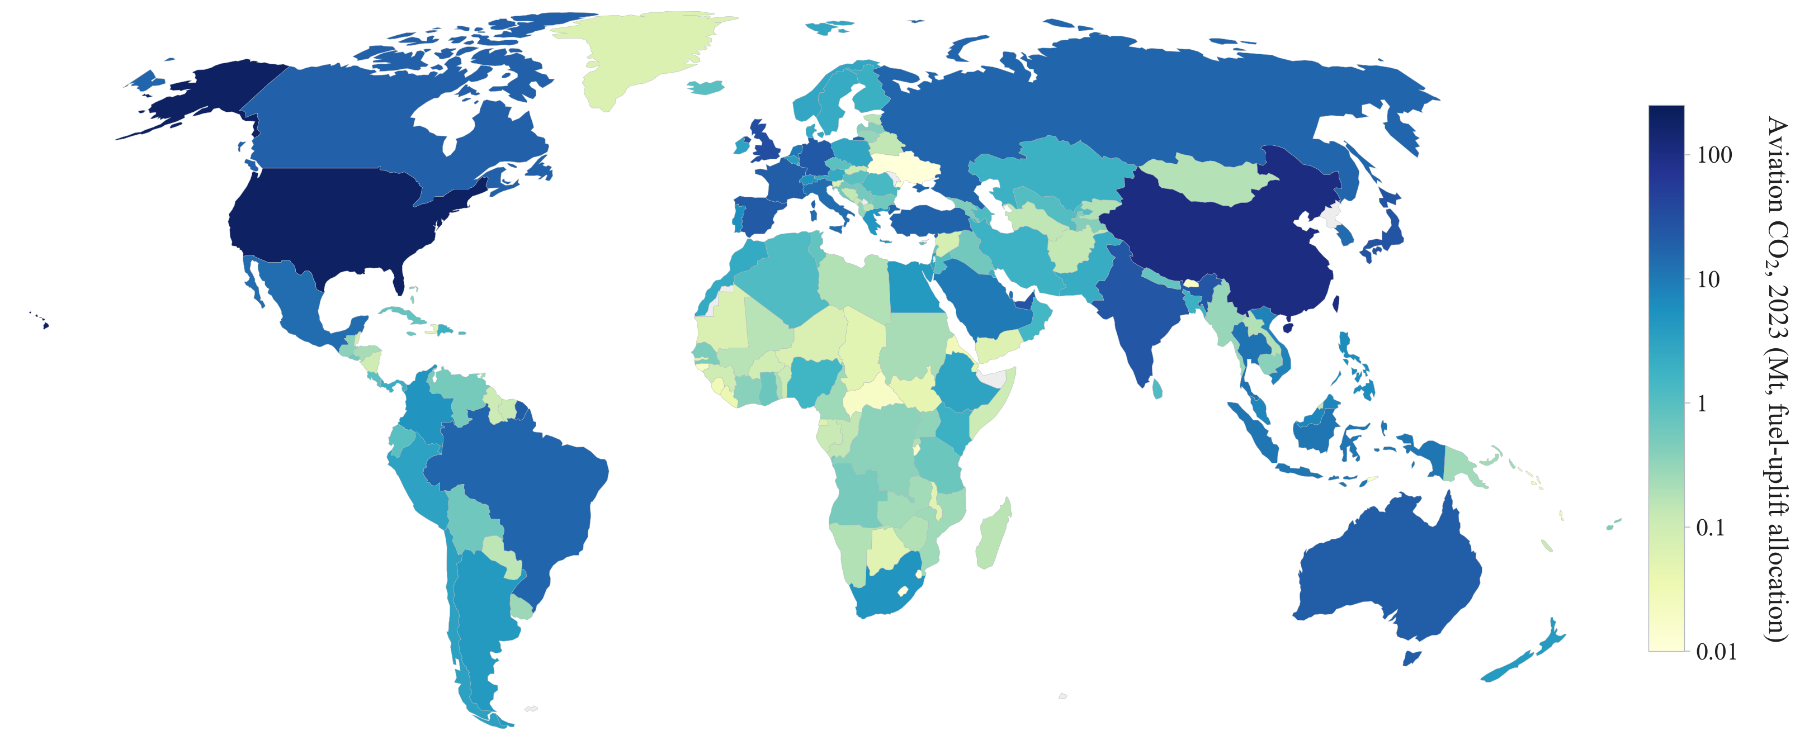
Figure 2. Aviation CO2 by country, 2023 (fuel-uplift allocation, Mt, log scale).
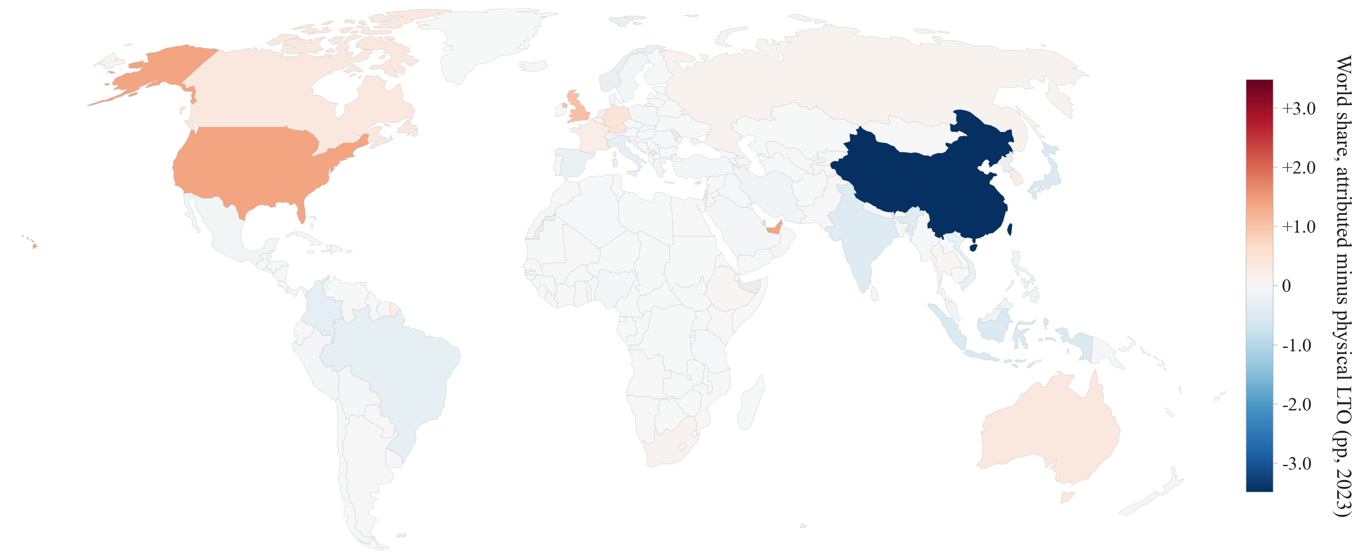
Figure 3. The attribution mismatch, 2023: world share under fuel-uplift minus share of physical LTO emissions (percentage points).
Figures 4 and 5 map the attribution of Section 5.7 and its driver. Emissions attributable to 1996-2023 connectivity growth concentrate in China, the Gulf, Turkey, Korea, and the United States, while Germany and Italy carry negative contributions from declining hub quality; the underlying hub-quality changes show the same geography, with the largest gains in Korea, Turkey, and the Gulf and losses concentrated in parts of western Europe and the former Soviet Union.
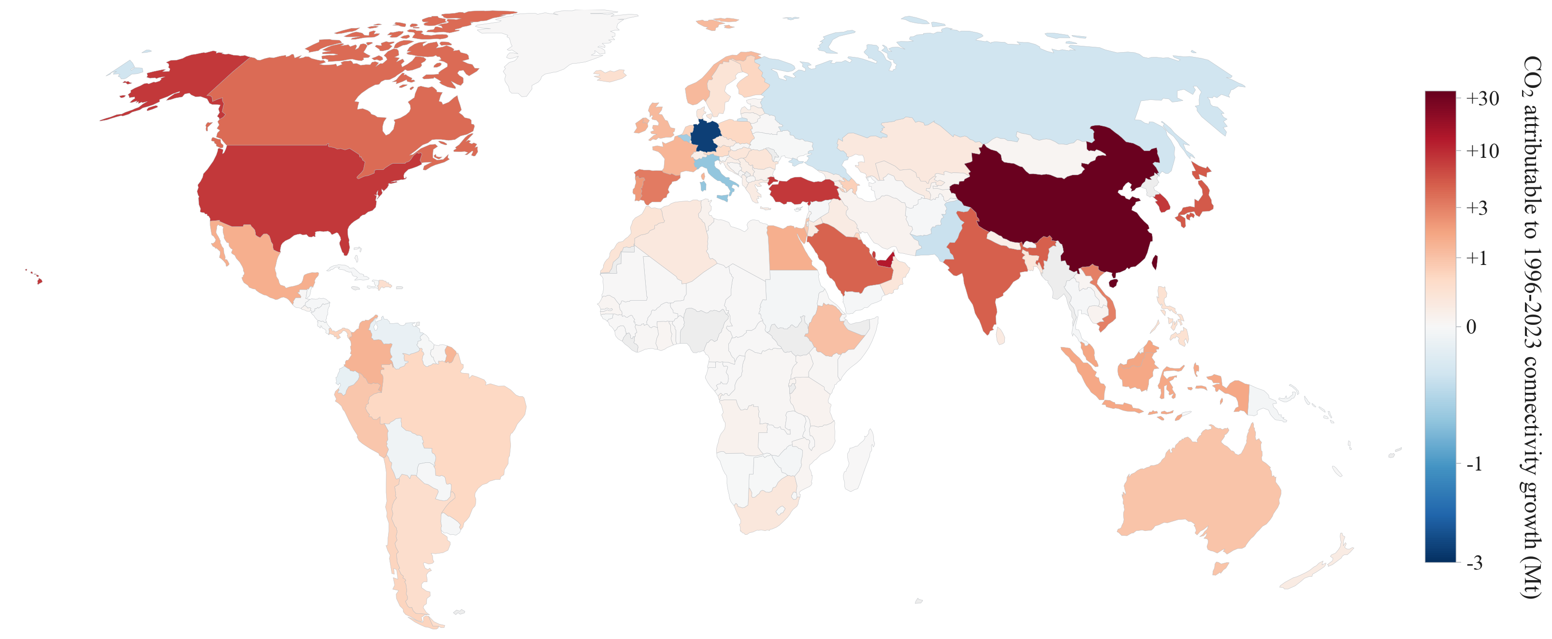
Figure 4. CO2 attributable to 1996-2023 connectivity growth (Mt; attributed share = 1 - exp(-beta x dln GACI) applied to 2023 levels, beta = 5.67; signed arcsinh colour scale).
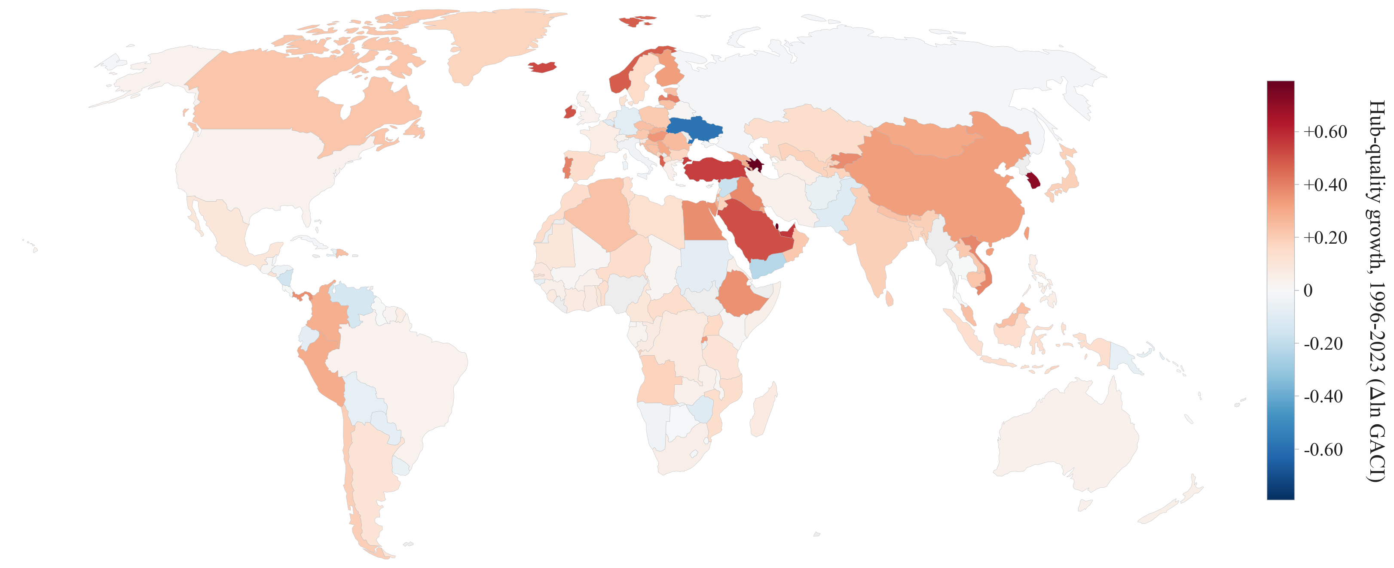
Figure 5. Hub-quality growth, 1996-2023 (change in ln GACI, capacity-weighted country mean).

7. Discussion and limitations
The title question has a quantitative answer: connectivity growth increases aviation CO2 by roughly 5.7 percent for each 1 percent gain in hub quality, and two and a half decades of network growth account for over 40 percent of today's aviation emissions. The offsetting efficiency channel is confirmed, highly connected hubs exhibit the lowest emissions per seat-kilometre, but it recovers only about 0.4 log points against a scale response of roughly 6, and the margin decomposition shows the gain arrives through fleet composition rather than aircraft up-gauging or longer stages. Policies that rely on hub efficiency to decarbonise network growth are therefore unlikely to succeed; the effective instruments are fuel substitution and demand-side measures, and the question of how cruise emissions are assigned across countries deserves attention in CORSIA design.
Limitations. Emissions are schedule-based and exclude load factors, weather, and airline-specific operations; estimates capture scheduled capacity rather than realised traffic. The primary instrument draws its power from pre-2010 variation, with the post-2010 era covered only by the weaker tourism lens. Airport-level results are descriptive; an accident-exposure instrument based on predetermined route dependence is the planned upgrade, together with network-spillover regressions once base-year bilateral route shares are available. Scenario calculations are partial equilibrium, and non-CO2 effects (contrails, NOx) are outside scope.

