Final

Bingren Sun 27720161153026

HW Unit 1

Q1. Calculate the i**ncrea**se of memory of PCs over the last 30 years and check whether the FMRI analysis could have been done 20 years ago.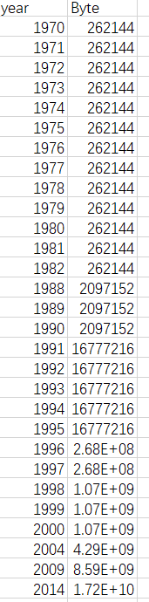

2. prepare 2-5 slides explaining logistic regression



 

3. I have done that and my account is Bingren Sun026.

HW Unit 2

1. memory.df = read.csv("byte.csv",header = TRUE)

plot(memory.df$Byte~memory.df$year,type="o",main="The development of internal memory")

1. splines.reg.l1 = smooth.spline(x = memory.df$year, y = memory.df$Byte, spar = 0.2)

splines.reg.l2 = smooth.spline(x = memory.df$year, y = memory.df$Byte, spar = 1)

splines.reg.l3= smooth.spline(x = memory.df$year, y = memory.df$Byte, spar = 2)

lines(splines.reg.l1, col = "green", lwd = 2)

lines(splines.reg.l2, col = "pink", lwd = 2)

lines(splines.reg.l3, col = "blue", lwd = 2)

1. lambda=4

x=6

dpois(x,lambda)

lambda=5

x=0

dpois(x,lambda)

HW Unit 3

1. #install.packages("digest",repos='http://cran.us.r-project.org')

library(digest)

digest("I learn a lot from this class when I am proper listening to the professor","sha256")

digest("I do not learn a lot from this class when I am absent and playing on my Iphone","sha256")

1. Make 3-5 slides (in PPTX) on the DSA (Digital Signature Algorithms)

   

1. library(rjson)

library(readr)

data <- read_csv("~/R/Home-Work-for-BDIF/data.csv")

json_ratedata <- toJSON(data,method = "C")

data

json_ratedata

 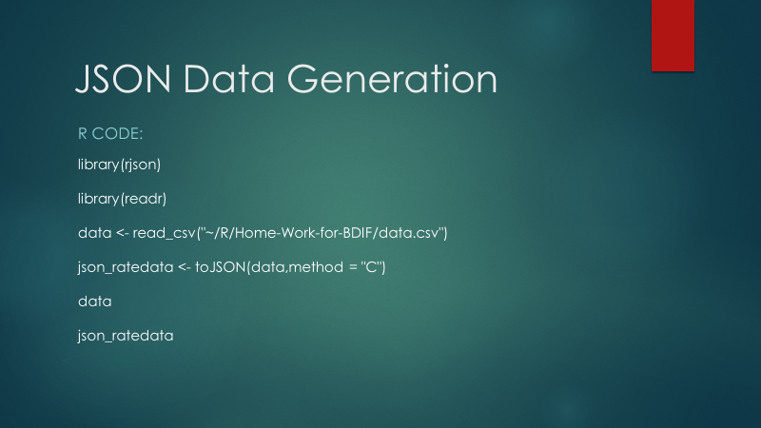

1. #install.packages("rjson", repos="http://cran.us.r-project.org")

library(rjson)

json_file = "http://crix.hu-berlin.de/data/crix.json"

json_data = fromJSON(file=json_file)

crix <- Reduce(rbind,json_data)

crix_data_frame <- as.data.frame(crix)

lst <- lapply(json_data,function(x){

df<-data.frame(date=x$date,price=x$price)

return(df)

})

crix_data_frame <- Reduce(rbind,lst)

plot(crix_data_frame$date,crix_data_frame$price)

#library(forecast)

#library(tseries)

plot(crix_data_frame)

HW Unit 4

 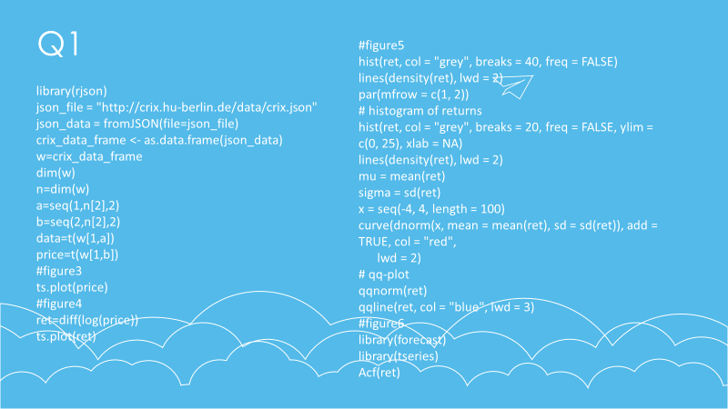 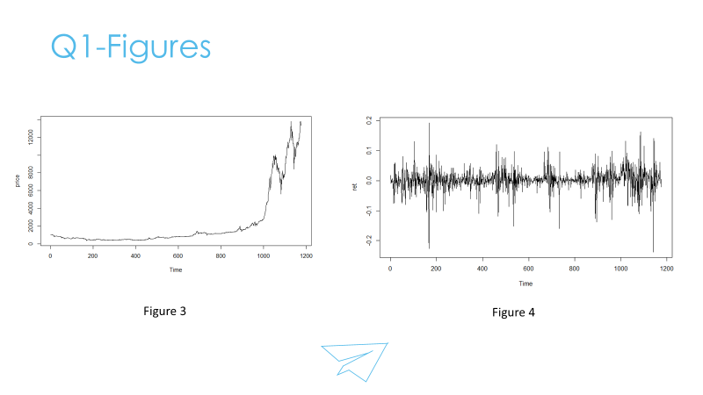 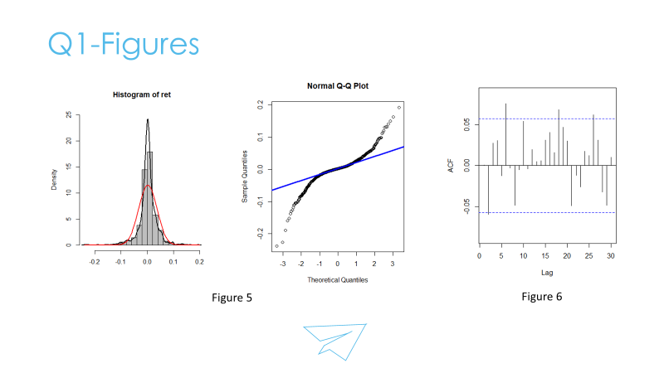 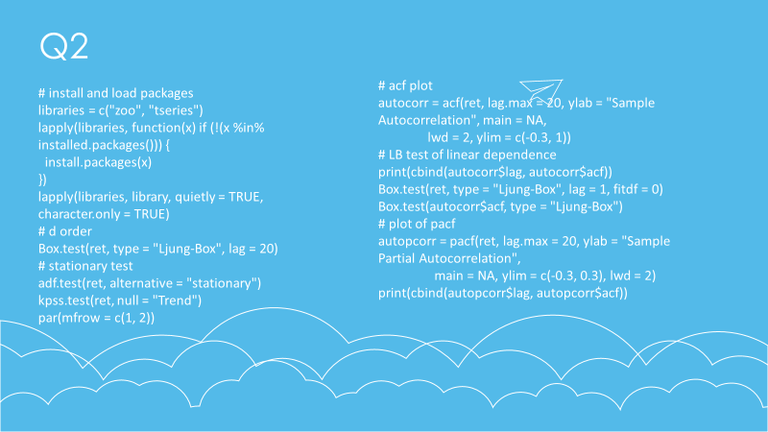 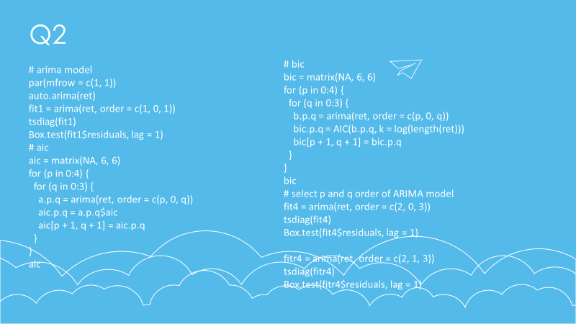 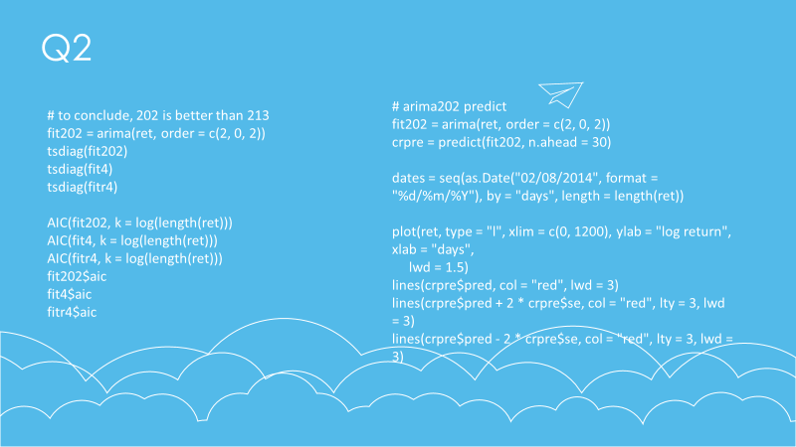 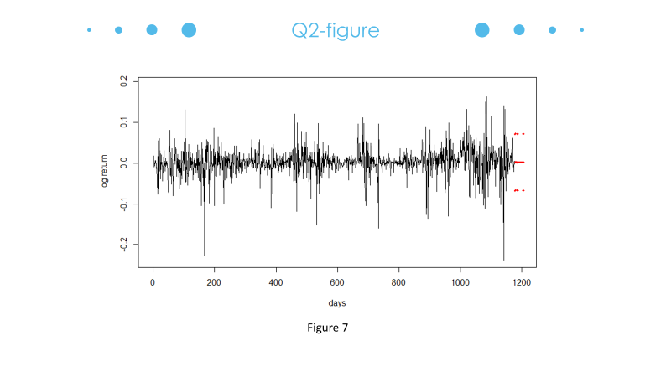  Question1

library(rjson)

json_file = "http://crix.hu-berlin.de/data/crix.json"

json_data = fromJSON(file=json_file)

crix_data_frame <- as.data.frame(json_data)

w=crix_data_frame

dim(w)

n=dim(w)

a=seq(1,n[2],2)

b=seq(2,n[2],2)

data=t(w[1,a])

price=t(w[1,b])

#figure3

ts.plot(price)

#figure4

ret=diff(log(price))

ts.plot(ret)

#figure5

hist(ret, col = "grey", breaks = 40, freq = FALSE)

lines(density(ret), lwd = 2)

par(mfrow = c(1, 2))

# histogram of returns

hist(ret, col = "grey", breaks = 20, freq = FALSE, ylim = c(0, 25), xlab = NA)

lines(density(ret), lwd = 2)

mu = mean(ret)

sigma = sd(ret)

x = seq(-4, 4, length = 100)

curve(dnorm(x, mean = mean(ret), sd = sd(ret)), add = TRUE, col = "red",

lwd = 2)

# qq-plot

qqnorm(ret)

qqline(ret, col = "blue", lwd = 3)

#figure6

library(forecast)

library(tseries)

Acf(ret)

Question2

#rm(list = ls(all = TRUE))

#graphics.off()

# install and load packages

libraries = c("zoo", "tseries")

lapply(libraries, function(x) if (!(x %in% installed.packages())) {

install.packages(x)

})

lapply(libraries, library, quietly = TRUE, character.only = TRUE)

# d order

Box.test(ret, type = "Ljung-Box", lag = 20)

# stationary test

adf.test(ret, alternative = "stationary")

kpss.test(ret, null = "Trend")

par(mfrow = c(1, 2))

# acf plot

autocorr = acf(ret, lag.max = 20, ylab = "Sample Autocorrelation", main = NA, lwd = 2, ylim = c(-0.3, 1))

# LB test of linear dependence

print(cbind(autocorr$lag, autocorr$acf))

Box.test(ret, type = "Ljung-Box", lag = 1, fitdf = 0)

Box.test(autocorr$acf, type = "Ljung-Box")

# plot of pacf

autopcorr = pacf(ret, lag.max = 20, ylab = "Sample Partial Autocorrelation", main = NA, ylim = c(-0.3, 0.3), lwd = 2)

print(cbind(autopcorr$lag, autopcorr$acf))

# arima model

par(mfrow = c(1, 1))

auto.arima(ret)

fit1 = arima(ret, order = c(1, 0, 1))

tsdiag(fit1)

Box.test(fit1$residuals, lag = 1)

# aic

aic = matrix(NA, 6, 6)

for (p in 0:4) {

for (q in 0:3) {

a.p.q = arima(ret, order = c(p, 0, q))

aic.p.q = a.p.q$aic

aic[p + 1, q + 1] = aic.p.q

}

}

aic

# bic

bic = matrix(NA, 6, 6)

for (p in 0:4) {

for (q in 0:3) {

b.p.q = arima(ret, order = c(p, 0, q))

bic.p.q = AIC(b.p.q, k = log(length(ret)))

bic[p + 1, q + 1] = bic.p.q

}

}

bic

# select p and q order of ARIMA model

fit4 = arima(ret, order = c(2, 0, 3))

tsdiag(fit4)

Box.test(fit4$residuals, lag = 1)

fitr4 = arima(ret, order = c(2, 1, 3))

tsdiag(fitr4)

Box.test(fitr4$residuals, lag = 1)

# to conclude, 202 is better than 213

fit202 = arima(ret, order = c(2, 0, 2))

tsdiag(fit202)

tsdiag(fit4)

tsdiag(fitr4)

AIC(fit202, k = log(length(ret)))

AIC(fit4, k = log(length(ret)))

AIC(fitr4, k = log(length(ret)))

fit202$aic

fit4$aic

fitr4$aic

# arima202 predict

fit202 = arima(ret, order = c(2, 0, 2))

crpre = predict(fit202, n.ahead = 30)

dates = seq(as.Date("02/08/2014", format = "%d/%m/%Y"), by = "days", length = length(ret))

plot(ret, type = "l", xlim = c(0, 1200), ylab = "log return", xlab = "days",

lwd = 1.5)

lines(crpre$pred, col = "red", lwd = 3)

lines(crpre$pred + 2 * crpre$se, col = "red", lty = 3, lwd = 3)

lines(crpre$pred - 2 * crpre$se, col = "red", lty = 3, lwd = 3)

HW5



