class 6: R functions

Sunyoung Lee

January 24, 2020

## This is a level 2 heading

This is a **regular** old *text*!

and a list of stuff

* thing one
* ting two
* and another thing

plot(1:5, col="blue", type="o")

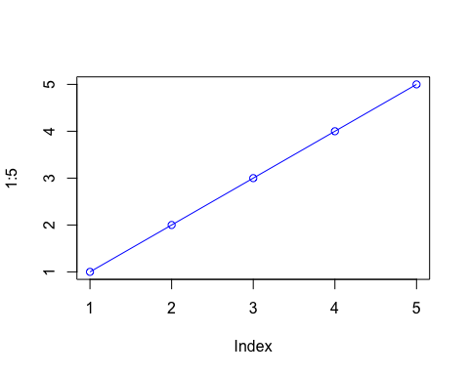

let’s insert a code chunk with the shortcut Option-CMD-i:

x <- c(1:10)  
x

## [1] 1 2 3 4 5 6 7 8 9 10

Here is my analysis of your new data. It looks ok.. the mean of your data is 5.5.

## More on reading input files

We will use the read.table() function again.

read.table("test1.txt")

## V1  
## 1 Col1,Col2,Col3  
## 2 1,2,3  
## 3 4,5,6  
## 4 7,8,9  
## 5 a,b,c

x <- read.table("test1.txt", header = TRUE, sep=",")

read.csv("test1.txt")

## Col1 Col2 Col3  
## 1 1 2 3  
## 2 4 5 6  
## 3 7 8 9  
## 4 a b c

Try the 2nd file

read.table("test2.txt", sep="$", header=T)

## Col1 Col2 Col3  
## 1 1 2 3  
## 2 4 5 6  
## 3 7 8 9  
## 4 a b c

read.table("test3.txt")

## V1 V2 V3  
## 1 1 6 a  
## 2 2 7 b  
## 3 3 8 c  
## 4 4 9 d  
## 5 5 10 e

## Our first function

This is an example function named add with input x and y

add <- function(x, y=1) {  
 # Sum the input x and y  
 x + y  
}

Lets try using it

^

add(x=c(1,6,2),y=4)

## [1] 5 10 6

add(1,6)

## [1] 7

x <- c(10,4,22,6)  
min(x)

## [1] 4

max(x)

## [1] 22

#range(x)

A 2nd example function to re-scale data to lie between 0 and 1

rescale <- function(x) {  
 rng <-range(x)  
 (x - rng[1]) / (rng[2] - rng[1])  
}

Lets test this function

rescale(c(1:10, 30, 100))

## [1] 0.00000000 0.01010101 0.02020202 0.03030303 0.04040404 0.05050505  
## [7] 0.06060606 0.07070707 0.08080808 0.09090909 0.29292929 1.00000000

rescale( c(1:10, NA))

## [1] NA NA NA NA NA NA NA NA NA NA NA

x <- c(1:10, NA)  
rng <- range(x, na.rm=T)  
rng

## [1] 1 10

?range

rescale2 <- function(x) {  
 rng <- range(x, na.rm=TRUE)  
 (x - rng[1]) / (rng[2]-rng[1])  
}

rescale2( c(1:10, NA) )

## [1] 0.0000000 0.1111111 0.2222222 0.3333333 0.4444444 0.5555556 0.6666667  
## [8] 0.7777778 0.8888889 1.0000000 NA

Taking things a bit too far…

rescale3 <- function(x, na.rm=TRUE, plot=FALSE) {  
 if(na.rm) {  
 rng <-range(x, na.rm=na.rm)  
 } else {  
 rng <-range(x)  
 }  
 print("Hello")  
   
 answer <- (x - rng[1]) / (rng[2] - rng[1])  
  
   
 print("is it me you are looking for?")  
 if(plot) {  
print("please don't sing again!")  
 plot(answer, typ="b", lwd=4)  
 }  
 print("I can see it in ...")  
}

rescale3(x, plot=TRUE)

## [1] "Hello"  
## [1] "is it me you are looking for?"  
## [1] "please don't sing again!"

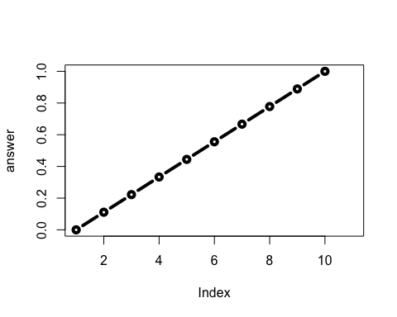

## [1] "I can see it in ..."

## Working with the bio3d package

To use the functions from any packagewe have installed we use the library() function to load it.

library(bio3d)

s1 <- read.pdb("4AKE") # kinase with drug

## Note: Accessing on-line PDB file

s2 <- read.pdb("1AKE") # kinase no drug

## Note: Accessing on-line PDB file  
## PDB has ALT records, taking A only, rm.alt=TRUE

s3 <- read.pdb("1E4Y") # kinase with drug

## Note: Accessing on-line PDB file

s1.chainA <- trim.pdb(s1, chain="A", elety="CA")  
s2.chainA <- trim.pdb(s2, chain="A", elety="CA")  
s3.chainA <- trim.pdb(s3, chain="A", elety="CA")  
  
s1.b <- s1.chainA$atom$b  
s2.b <- s2.chainA$atom$b  
s3.b <- s3.chainA$atom$b  
  
plotb3(s1.b, sse=s1.chainA, typ="l", ylab="Bfactor")

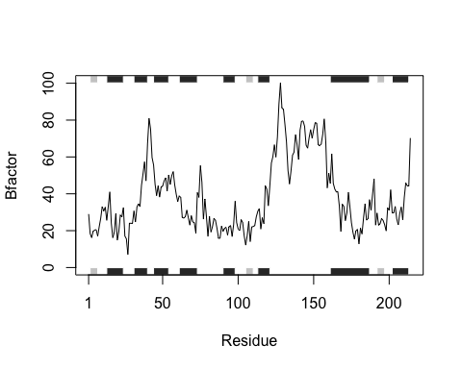

plotb3(s2.b, sse=s2.chainA, typ="l", ylab="Bfactor")

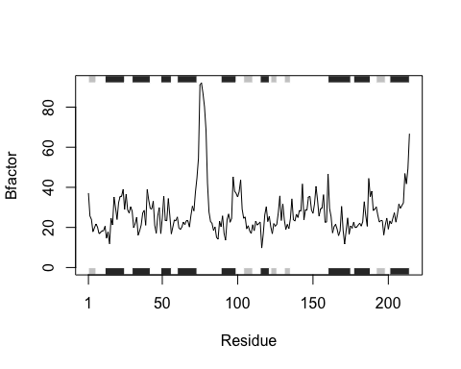

plotb3(s3.b, sse=s3.chainA, typ="l", ylab="Bfactor")

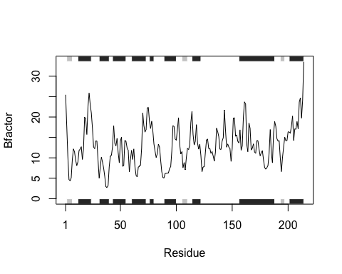

hc <- hclust( dist( rbind(s1.b, s2.b, s3.b) ) )  
plot(hc)

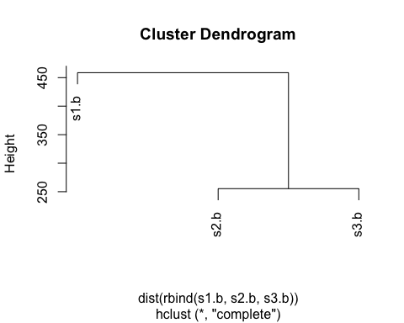

s1 <- read.pdb("4AKE")

## Note: Accessing on-line PDB file

## Warning in get.pdb(file, path = tempdir(), verbose = FALSE): /var/folders/0x/  
## c198hqn51m33f69hlllmyvlw0000gn/T//RtmpqR9RxC/4AKE.pdb exists. Skipping download

s1

##   
## Call: read.pdb(file = "4AKE")  
##   
## Total Models#: 1  
## Total Atoms#: 3459, XYZs#: 10377 Chains#: 2 (values: A B)  
##   
## Protein Atoms#: 3312 (residues/Calpha atoms#: 428)  
## Nucleic acid Atoms#: 0 (residues/phosphate atoms#: 0)  
##   
## Non-protein/nucleic Atoms#: 147 (residues: 147)  
## Non-protein/nucleic resid values: [ HOH (147) ]  
##   
## Protein sequence:  
## MRIILLGAPGAGKGTQAQFIMEKYGIPQISTGDMLRAAVKSGSELGKQAKDIMDAGKLVT  
## DELVIALVKERIAQEDCRNGFLLDGFPRTIPQADAMKEAGINVDYVLEFDVPDELIVDRI  
## VGRRVHAPSGRVYHVKFNPPKVEGKDDVTGEELTTRKDDQEETVRKRLVEYHQMTAPLIG  
## YYSKEAEAGNTKYAKVDGTKPVAEVRADLEKILGMRIILLGAPGA...<cut>...KILG  
##   
## + attr: atom, xyz, seqres, helix, sheet,  
## calpha, remark, call

class(s1)

## [1] "pdb" "sse"

str(s1)

## List of 8  
## $ atom :'data.frame': 3459 obs. of 16 variables:  
## ..$ type : chr [1:3459] "ATOM" "ATOM" "ATOM" "ATOM" ...  
## ..$ eleno : int [1:3459] 1 2 3 4 5 6 7 8 9 10 ...  
## ..$ elety : chr [1:3459] "N" "CA" "C" "O" ...  
## ..$ alt : chr [1:3459] NA NA NA NA ...  
## ..$ resid : chr [1:3459] "MET" "MET" "MET" "MET" ...  
## ..$ chain : chr [1:3459] "A" "A" "A" "A" ...  
## ..$ resno : int [1:3459] 1 1 1 1 1 1 1 1 2 2 ...  
## ..$ insert: chr [1:3459] NA NA NA NA ...  
## ..$ x : num [1:3459] -10.93 -9.9 -9.17 -9.8 -10.59 ...  
## ..$ y : num [1:3459] -24.9 -24.4 -23.3 -22.3 -24 ...  
## ..$ z : num [1:3459] -9.52 -10.48 -9.81 -9.35 -11.77 ...  
## ..$ o : num [1:3459] 1 1 1 1 1 1 1 1 1 1 ...  
## ..$ b : num [1:3459] 41.5 29 27.9 26.4 34.2 ...  
## ..$ segid : chr [1:3459] NA NA NA NA ...  
## ..$ elesy : chr [1:3459] "N" "C" "C" "O" ...  
## ..$ charge: chr [1:3459] NA NA NA NA ...  
## $ xyz : 'xyz' num [1, 1:10377] -10.93 -24.89 -9.52 -9.9 -24.42 ...  
## $ seqres: Named chr [1:428] "MET" "ARG" "ILE" "ILE" ...  
## ..- attr(*, "names")= chr [1:428] "A" "A" "A" "A" ...  
## $ helix :List of 4  
## ..$ start: Named num [1:19] 13 31 44 61 75 90 113 161 202 13 ...  
## .. ..- attr(*, "names")= chr [1:19] "" "" "" "" ...  
## ..$ end : Named num [1:19] 24 40 54 73 77 98 121 187 213 24 ...  
## .. ..- attr(*, "names")= chr [1:19] "" "" "" "" ...  
## ..$ chain: chr [1:19] "A" "A" "A" "A" ...  
## ..$ type : chr [1:19] "5" "1" "1" "1" ...  
## $ sheet :List of 4  
## ..$ start: Named num [1:14] 192 105 2 81 27 123 131 192 105 2 ...  
## .. ..- attr(*, "names")= chr [1:14] "" "" "" "" ...  
## ..$ end : Named num [1:14] 197 110 7 84 29 126 134 197 110 7 ...  
## .. ..- attr(*, "names")= chr [1:14] "" "" "" "" ...  
## ..$ chain: chr [1:14] "A" "A" "A" "A" ...  
## ..$ sense: chr [1:14] "0" "1" "1" "1" ...  
## $ calpha: logi [1:3459] FALSE TRUE FALSE FALSE FALSE FALSE ...  
## $ remark:List of 1  
## ..$ biomat:List of 4  
## .. ..$ num : int 1  
## .. ..$ chain :List of 1  
## .. .. ..$ : chr [1:2] "A" "B"  
## .. ..$ mat :List of 1  
## .. .. ..$ :List of 1  
## .. .. .. ..$ A B: num [1:3, 1:4] 1 0 0 0 1 0 0 0 1 0 ...  
## .. ..$ method: chr "AUTHOR"  
## $ call : language read.pdb(file = "4AKE")  
## - attr(*, "class")= chr [1:2] "pdb" "sse"

s1$seqres

## A A A A A A A A A A A A A   
## "MET" "ARG" "ILE" "ILE" "LEU" "LEU" "GLY" "ALA" "PRO" "GLY" "ALA" "GLY" "LYS"   
## A A A A A A A A A A A A A   
## "GLY" "THR" "GLN" "ALA" "GLN" "PHE" "ILE" "MET" "GLU" "LYS" "TYR" "GLY" "ILE"   
## A A A A A A A A A A A A A   
## "PRO" "GLN" "ILE" "SER" "THR" "GLY" "ASP" "MET" "LEU" "ARG" "ALA" "ALA" "VAL"   
## A A A A A A A A A A A A A   
## "LYS" "SER" "GLY" "SER" "GLU" "LEU" "GLY" "LYS" "GLN" "ALA" "LYS" "ASP" "ILE"   
## A A A A A A A A A A A A A   
## "MET" "ASP" "ALA" "GLY" "LYS" "LEU" "VAL" "THR" "ASP" "GLU" "LEU" "VAL" "ILE"   
## A A A A A A A A A A A A A   
## "ALA" "LEU" "VAL" "LYS" "GLU" "ARG" "ILE" "ALA" "GLN" "GLU" "ASP" "CYS" "ARG"   
## A A A A A A A A A A A A A   
## "ASN" "GLY" "PHE" "LEU" "LEU" "ASP" "GLY" "PHE" "PRO" "ARG" "THR" "ILE" "PRO"   
## A A A A A A A A A A A A A   
## "GLN" "ALA" "ASP" "ALA" "MET" "LYS" "GLU" "ALA" "GLY" "ILE" "ASN" "VAL" "ASP"   
## A A A A A A A A A A A A A   
## "TYR" "VAL" "LEU" "GLU" "PHE" "ASP" "VAL" "PRO" "ASP" "GLU" "LEU" "ILE" "VAL"   
## A A A A A A A A A A A A A   
## "ASP" "ARG" "ILE" "VAL" "GLY" "ARG" "ARG" "VAL" "HIS" "ALA" "PRO" "SER" "GLY"   
## A A A A A A A A A A A A A   
## "ARG" "VAL" "TYR" "HIS" "VAL" "LYS" "PHE" "ASN" "PRO" "PRO" "LYS" "VAL" "GLU"   
## A A A A A A A A A A A A A   
## "GLY" "LYS" "ASP" "ASP" "VAL" "THR" "GLY" "GLU" "GLU" "LEU" "THR" "THR" "ARG"   
## A A A A A A A A A A A A A   
## "LYS" "ASP" "ASP" "GLN" "GLU" "GLU" "THR" "VAL" "ARG" "LYS" "ARG" "LEU" "VAL"   
## A A A A A A A A A A A A A   
## "GLU" "TYR" "HIS" "GLN" "MET" "THR" "ALA" "PRO" "LEU" "ILE" "GLY" "TYR" "TYR"   
## A A A A A A A A A A A A A   
## "SER" "LYS" "GLU" "ALA" "GLU" "ALA" "GLY" "ASN" "THR" "LYS" "TYR" "ALA" "LYS"   
## A A A A A A A A A A A A A   
## "VAL" "ASP" "GLY" "THR" "LYS" "PRO" "VAL" "ALA" "GLU" "VAL" "ARG" "ALA" "ASP"   
## A A A A A A B B B B B B B   
## "LEU" "GLU" "LYS" "ILE" "LEU" "GLY" "MET" "ARG" "ILE" "ILE" "LEU" "LEU" "GLY"   
## B B B B B B B B B B B B B   
## "ALA" "PRO" "GLY" "ALA" "GLY" "LYS" "GLY" "THR" "GLN" "ALA" "GLN" "PHE" "ILE"   
## B B B B B B B B B B B B B   
## "MET" "GLU" "LYS" "TYR" "GLY" "ILE" "PRO" "GLN" "ILE" "SER" "THR" "GLY" "ASP"   
## B B B B B B B B B B B B B   
## "MET" "LEU" "ARG" "ALA" "ALA" "VAL" "LYS" "SER" "GLY" "SER" "GLU" "LEU" "GLY"   
## B B B B B B B B B B B B B   
## "LYS" "GLN" "ALA" "LYS" "ASP" "ILE" "MET" "ASP" "ALA" "GLY" "LYS" "LEU" "VAL"   
## B B B B B B B B B B B B B   
## "THR" "ASP" "GLU" "LEU" "VAL" "ILE" "ALA" "LEU" "VAL" "LYS" "GLU" "ARG" "ILE"   
## B B B B B B B B B B B B B   
## "ALA" "GLN" "GLU" "ASP" "CYS" "ARG" "ASN" "GLY" "PHE" "LEU" "LEU" "ASP" "GLY"   
## B B B B B B B B B B B B B   
## "PHE" "PRO" "ARG" "THR" "ILE" "PRO" "GLN" "ALA" "ASP" "ALA" "MET" "LYS" "GLU"   
## B B B B B B B B B B B B B   
## "ALA" "GLY" "ILE" "ASN" "VAL" "ASP" "TYR" "VAL" "LEU" "GLU" "PHE" "ASP" "VAL"   
## B B B B B B B B B B B B B   
## "PRO" "ASP" "GLU" "LEU" "ILE" "VAL" "ASP" "ARG" "ILE" "VAL" "GLY" "ARG" "ARG"   
## B B B B B B B B B B B B B   
## "VAL" "HIS" "ALA" "PRO" "SER" "GLY" "ARG" "VAL" "TYR" "HIS" "VAL" "LYS" "PHE"   
## B B B B B B B B B B B B B   
## "ASN" "PRO" "PRO" "LYS" "VAL" "GLU" "GLY" "LYS" "ASP" "ASP" "VAL" "THR" "GLY"   
## B B B B B B B B B B B B B   
## "GLU" "GLU" "LEU" "THR" "THR" "ARG" "LYS" "ASP" "ASP" "GLN" "GLU" "GLU" "THR"   
## B B B B B B B B B B B B B   
## "VAL" "ARG" "LYS" "ARG" "LEU" "VAL" "GLU" "TYR" "HIS" "GLN" "MET" "THR" "ALA"   
## B B B B B B B B B B B B B   
## "PRO" "LEU" "ILE" "GLY" "TYR" "TYR" "SER" "LYS" "GLU" "ALA" "GLU" "ALA" "GLY"   
## B B B B B B B B B B B B B   
## "ASN" "THR" "LYS" "TYR" "ALA" "LYS" "VAL" "ASP" "GLY" "THR" "LYS" "PRO" "VAL"   
## B B B B B B B B B B B B   
## "ALA" "GLU" "VAL" "ARG" "ALA" "ASP" "LEU" "GLU" "LYS" "ILE" "LEU" "GLY"

s1.chainA <- trim.pdb(s1, chain="A", elety="CA")  
s1.chainA

##   
## Call: trim.pdb(pdb = s1, chain = "A", elety = "CA")  
##   
## Total Models#: 1  
## Total Atoms#: 214, XYZs#: 642 Chains#: 1 (values: A)  
##   
## Protein Atoms#: 214 (residues/Calpha atoms#: 214)  
## Nucleic acid Atoms#: 0 (residues/phosphate atoms#: 0)  
##   
## Non-protein/nucleic Atoms#: 0 (residues: 0)  
## Non-protein/nucleic resid values: [ none ]  
##   
## Protein sequence:  
## MRIILLGAPGAGKGTQAQFIMEKYGIPQISTGDMLRAAVKSGSELGKQAKDIMDAGKLVT  
## DELVIALVKERIAQEDCRNGFLLDGFPRTIPQADAMKEAGINVDYVLEFDVPDELIVDRI  
## VGRRVHAPSGRVYHVKFNPPKVEGKDDVTGEELTTRKDDQEETVRKRLVEYHQMTAPLIG  
## YYSKEAEAGNTKYAKVDGTKPVAEVRADLEKILG  
##   
## + attr: atom, helix, sheet, seqres, xyz,  
## calpha, call

?trim.pdb

plotb3(s1.b, sse=s1.chainA, typ="l", ylab="Bfactor")  
points(s2.b, col="light blue", typ="l", lwd =3)  
points(s3.b, col="pink", typ="l", lwd = 3)

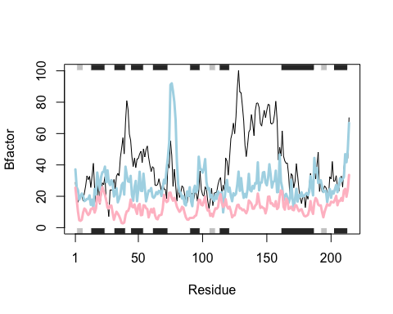 library(bio3d) s1 <- read.pdb(“4AKE”) # kinase with drug s2 <- read.pdb(“1AKE”) # kinase no drug s3 <- read.pdb(“1E4Y”) # kinase with drug

s1.chainA <- trim.pdb(s1, chain=“A”, elety=“CA”) s2.chainA <- trim.pdb(s2, chain=“A”, elety=“CA”) s3.chainA <- trim.pdb(s1, chain=“A”, elety=“CA”)

s1.b <- s1.chainA $atom$ b s2.b <- s2.chainA $atom$ b s3.b <- s3.chainA $atom$ b

plotb3(s1.b, sse=s1.chainA, typ=“l”, ylab=“Bfactor”) plotb3(s2.b, sse=s2.chainA, typ=“l”, ylab=“Bfactor”) plotb3(s3.b, sse=s3.chainA, typ=“l”, ylab=“Bfactor”)