EXERCISE 1

This one I am inserting into the cd.facilities table, with the values listed. Columns are not specified because they are already there and reamain the same.

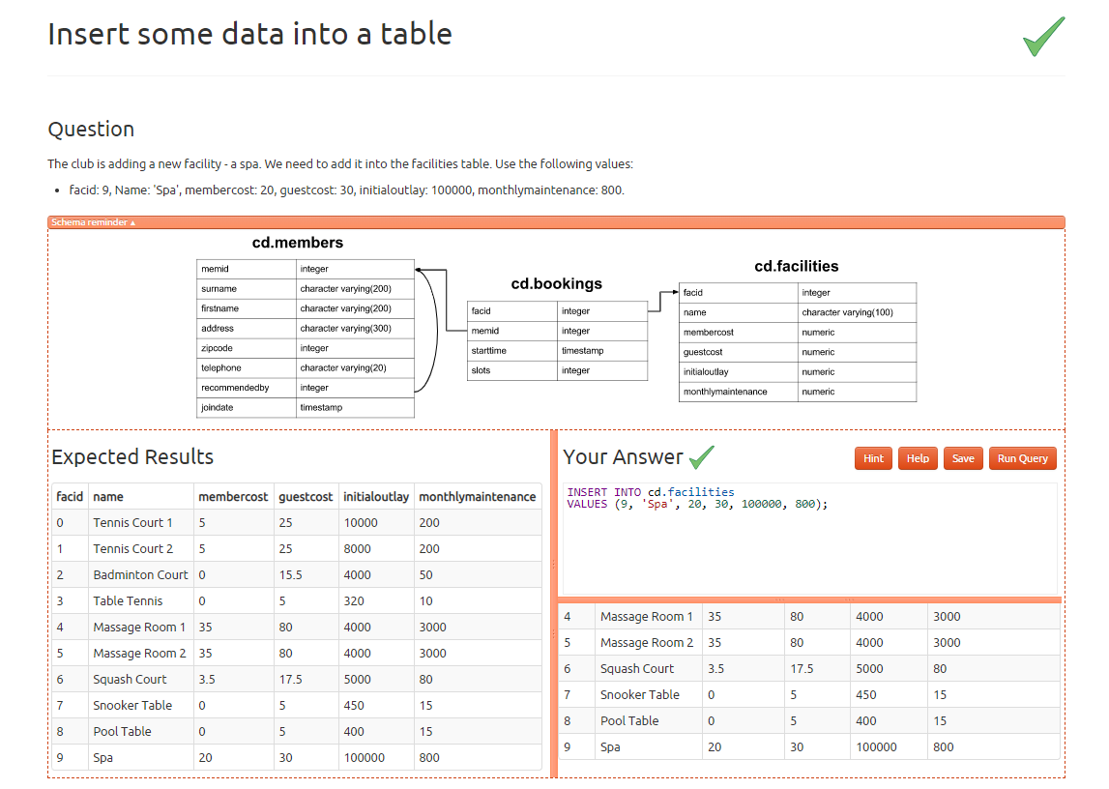

EXERCISE 2

Again in this exercise inserting into the cd.facilities table with the values requested. Columns not specified because it is unnecessary since they are not changing.

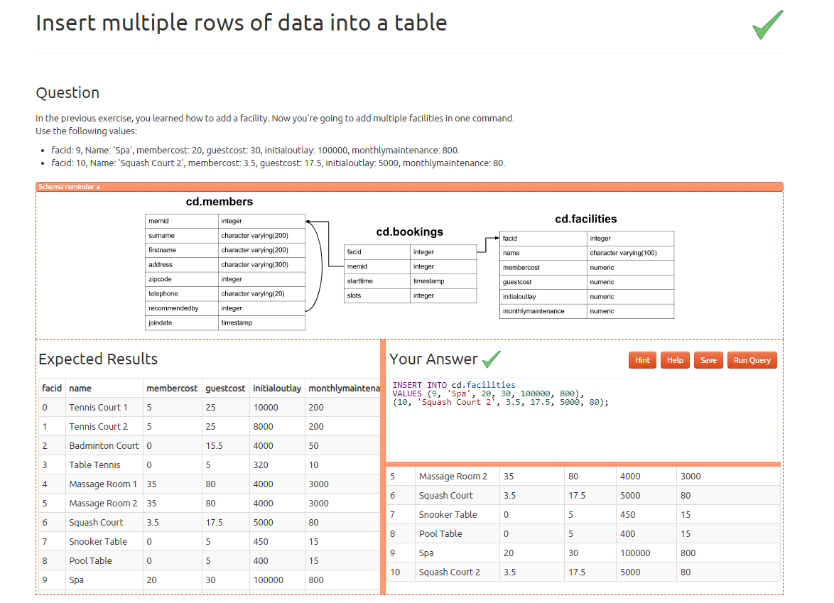

Exercise 3

In this exercise I am inserting into the cd.facilities tables, listing the column names, then selecting the max facid and adding 1 to the highest number of facid column.

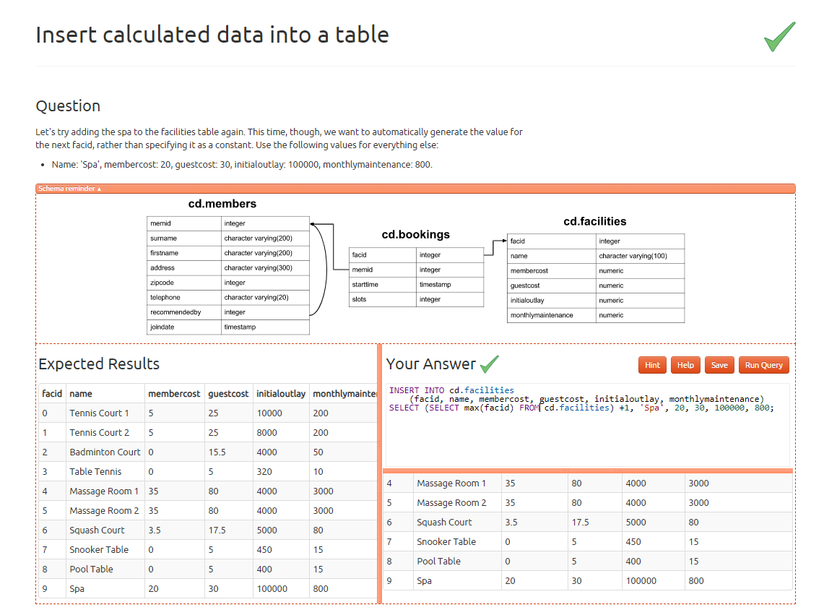

EXERCISE 4

In this exercise I am updating the cd.facilities table and setting the initialoutlay column equal to 10000 if the facid is equal to 1.

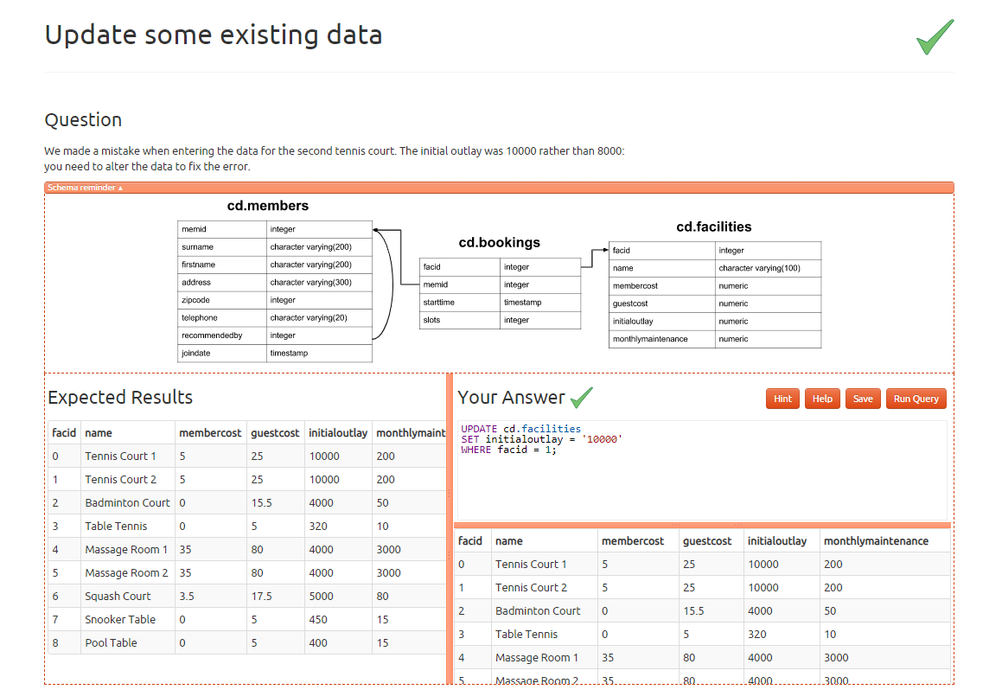

EXERCISE 5

Here I am updating the cd.faclilites table and setting the column membercost equal to 6 and guestcost = 30, only where there is the string starting with Tennis in the name column.

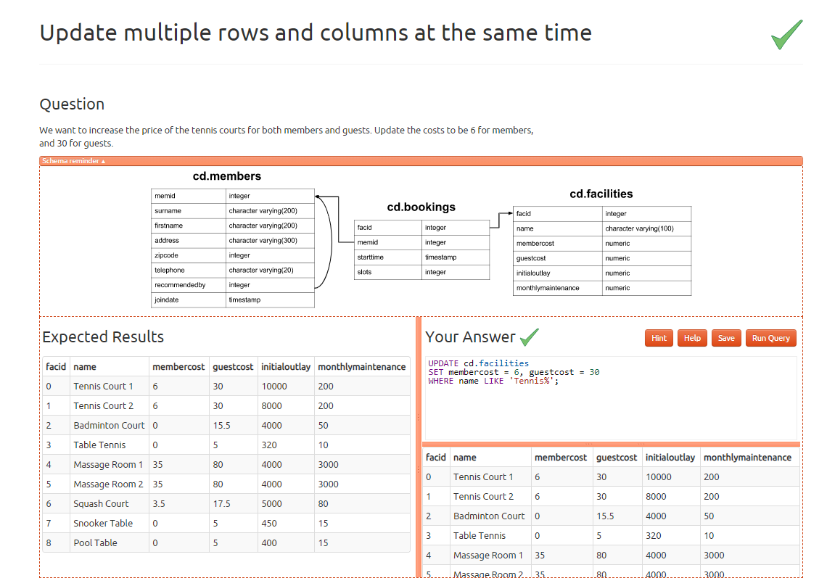

EXERCISE 6

In this exercise I am updating the cd.facilities table and setting membercost and guestcost to 10% more of what they currently are in facid equal to 0. Then I am taking that value that was just increased by 10% and adding it to facid equal to 1

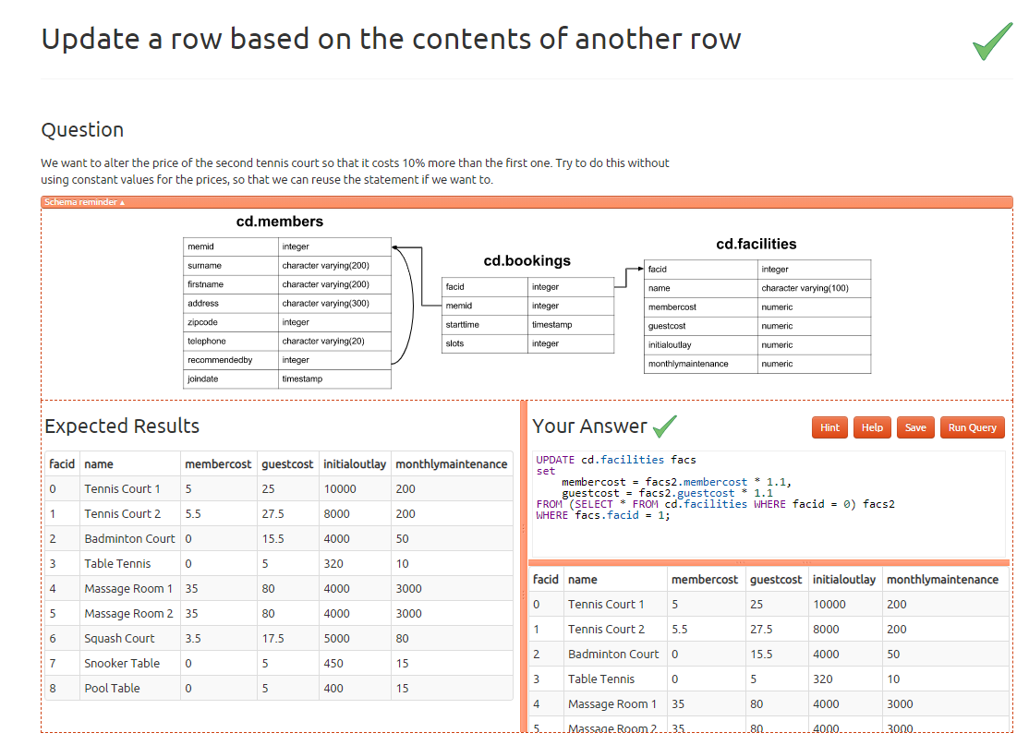

EXERCISE 7

I am just deleting all the rows from the cd.bookings table.

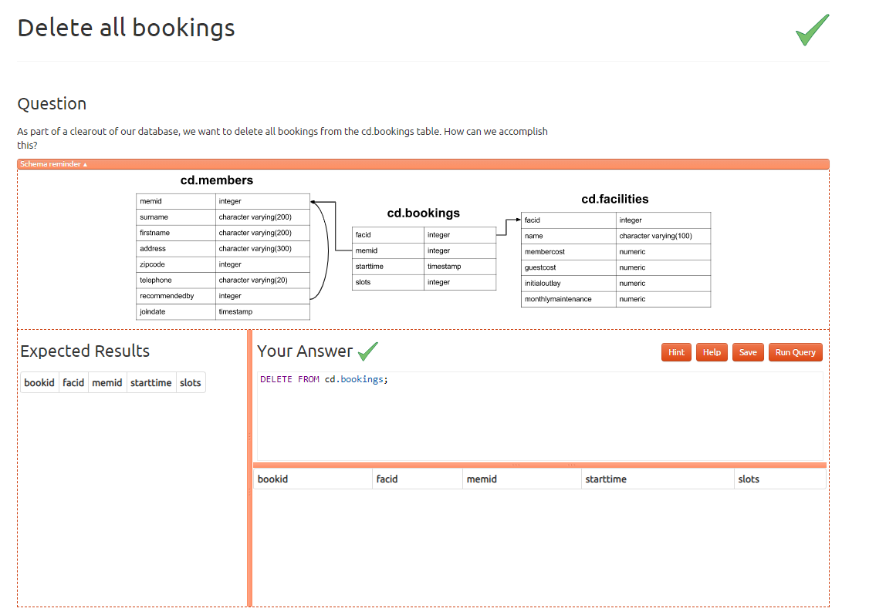

EXERCISE 8

Here I am deleting the row in cd.members table where the memid equals 37.

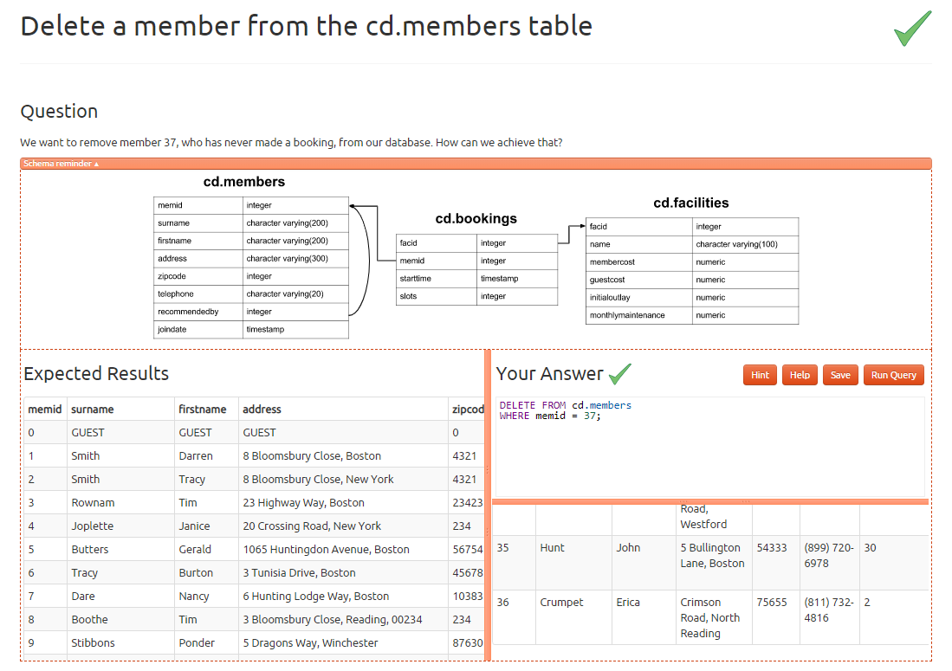

EXERCISE 9

In this exercise I am deleting any rows from cd.members table where the memid does not match any memid values from cd.bookings table.

