PINTOS

AIM: To study the flow of Pintos and implement better versions for busy waiting,priority scheduling and implement mlfq(Multi-Level Feedback Queue) scheduling

Part1: Installing Pintos and understanding the flow of Pintos and how to add our files in it

->Installation:
Installing pintos is a tricky task indeed and we followed these steps to install pintos:
- Installed Qemu simulator on the system(to run pintos over it)
- Downloaded pintos source code folder ‘pintos.tar.gz’ from the official site
- Extracted it to the home directory
- Edited pintos-gdb file to edit gdb-macros to the home directory path
- Edited Make.vars file and used the simulator option as ‘--qemu’
- run make command
- Edited per file pintos to use simulator qemu and set path to home directory as needed
- Edited Pintos.pm file to set correct path to the loader.bin
- set path in the environment using the following command
  - ‘export PATH=$HOME/os-pintos/pintos/src/utils:$PATH’ in .bashrc file in root
- DONE !!!
- running pintos: ‘$pintos run alarm-multiple’
-it will run the alarm-multiple file defined in pintos

->Adding Files in Pintos:
->In this section we understand the file structure in pintos directory.
->to add hello_pintu.c to run from pintos
- create hello_pintu.c in ../tests/threads
- make its entry in Make.tests , tests.c and tests.h
- re-compile the kernel and use the following command:
    - $pintos run hello_pintu.c
    - output: $Hello Pintos //(on qemu emulator)
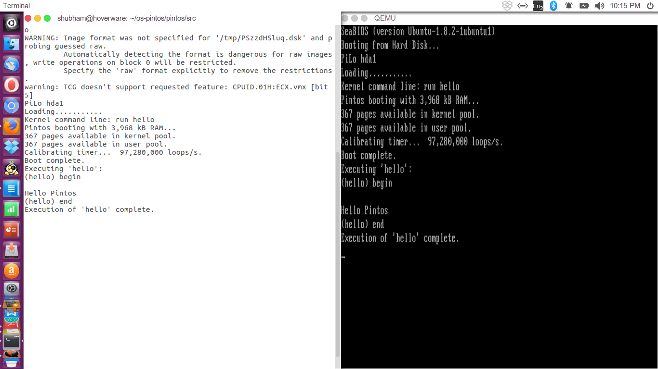
Part2: Preemption of threads
->Learnt about threads and timer functionality and dobserved its bechaviour that it wastes CPU cycles in busy waiting, in the already implemented version of busy waiting.
->In this part we studied about what happens when a currently running thread goes to sleep and it is found that when a thread goes to sleep the CPU continuously checks its timer count whether it is the correct time to wake it up(i.e. the thread has finished its sleep or not), but the flaw in this busy waiting is that the CPU continuously checks whether the thread’s time has been completed or not, instead it can entertain other thread at that time.
Solution of it:
->We create and declare a variable named ‘timetick’ in ‘thread.h’ file under thread structure and used it to store the ticks count associated with every sleeping(or blocking) thread.
->Now, everytime the thread is created it has its timetick variable associated with it that stores its ticks count which is nothing but the time for which the thraed has been blocked/sleeped.
->Moreover, we reimplemented the busy waiting solution already given in the pintos source by our implementation and used an ‘alarm-clock’ to handle the busy waitingi.e.:
- when a thread is spawned, first of all the interrupts are disabled and its current state is stored in a variable.
- Then the thread is blocked using thread_block(), defined in thread.c that solves our problem of busy waiting.
- After blocking the thread, the previous state of the interrupt is restored by using the previous variable in which we have stored the state before blocking the thread.
- Also, after every timer interrupt(i.e. interrupt caused by every timer tick), we used ‘foreach()’ function its timetick count is decremented by 1 and when it reaches to 0 or negative it is unblocked.
Output of various test cases on some standard files as:
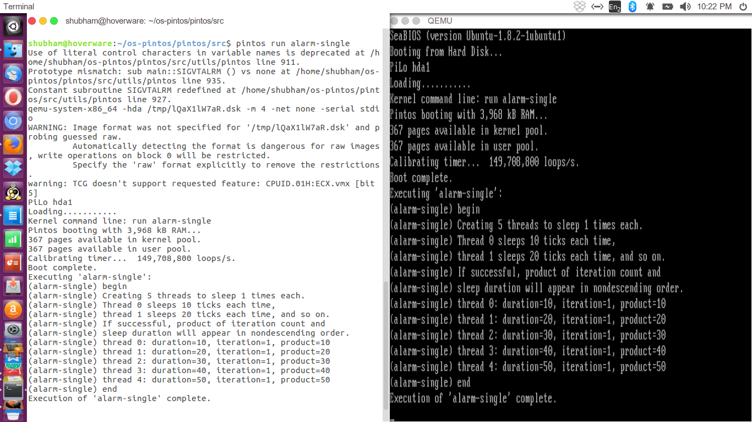
1-alarm-single

2-alarm-zero
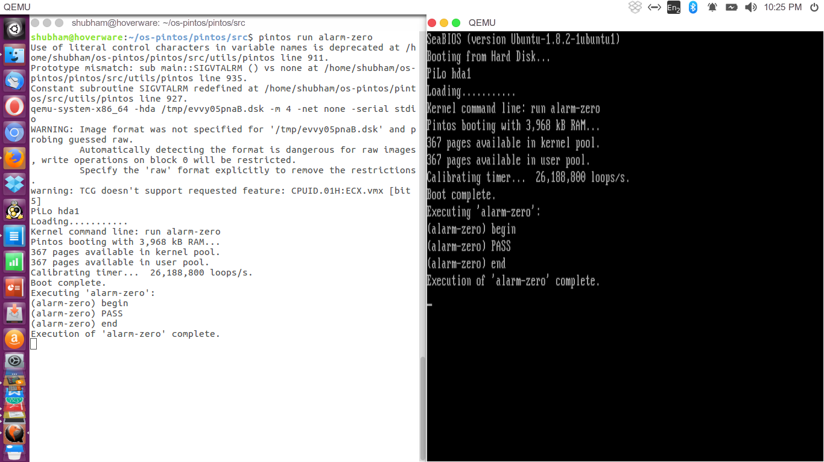

3-alarm-negative
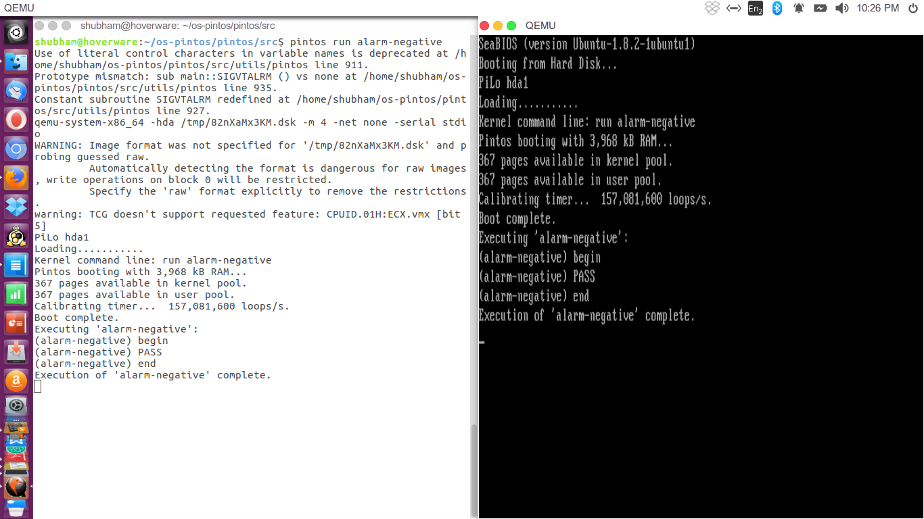
4-alarm-simultaneous
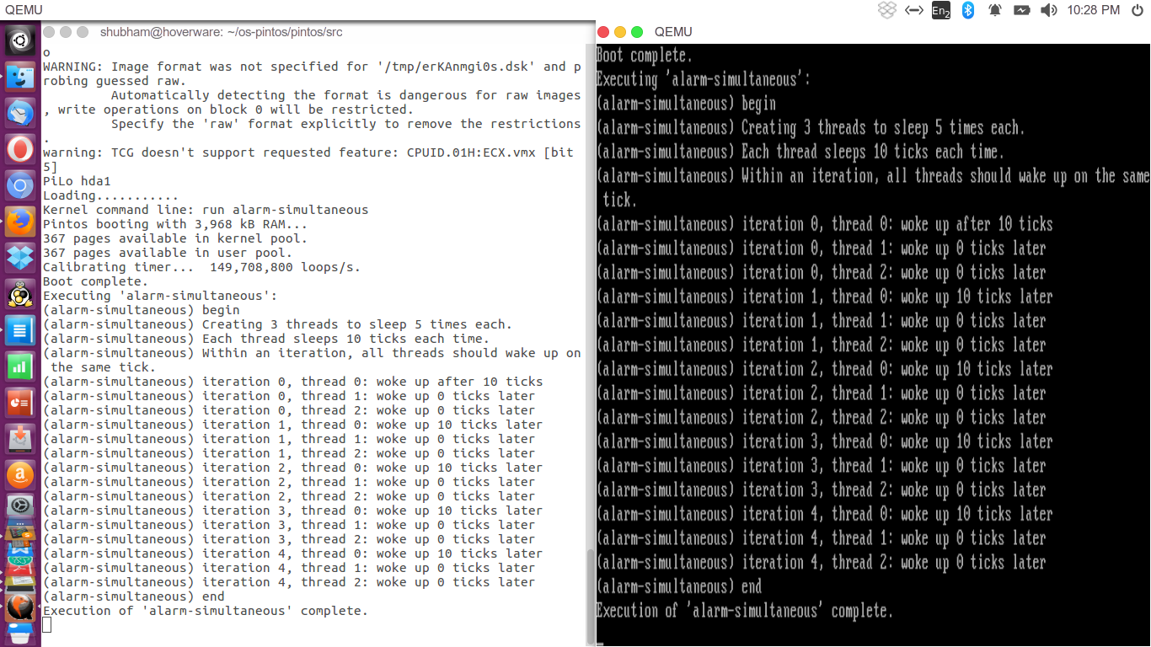

5-alarm-multiple
