Hw2

Chunmei Sun

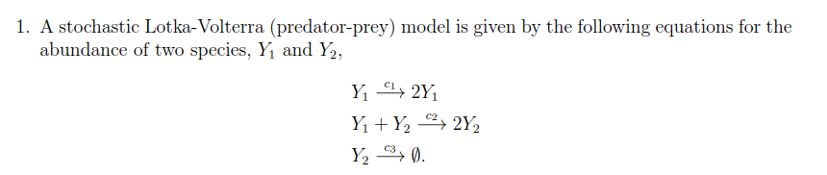

1. 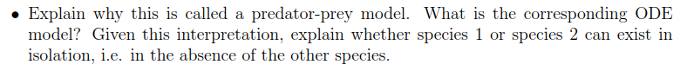

**Answer:**

Y1 is able to reproduce by itself. Just like the prey. Y2 can only reproduce after it is combined with Y1. Just like the predator needs to eat the prey to obtain energy. Y2 will come to be none if no Y1 exists. Just like the predator will extinct if no prey exists.

**Species 1 can exist in isolation.**

1. 

**See python code Question1_2.ipynb**

1. 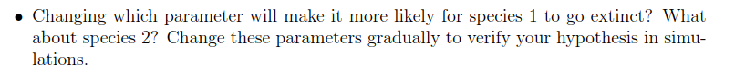

**Answer:**

**See python code Question1_3.ipynb**

Increase C1 can increase Y1 at the beginning. However, the Y2 number will increase as well. When the Y2 number is too high, the Y1 number will decrease and extinct. **Increase C1 can make Y1 more likely to extinct**

Increase C2 can reduce the max number of Y1. Then Y1 number will reduce quickly and extinct. At the same time, since there is no Y1 available, Y2 number reduce as well. **Increase C2 can make Y1 more likely to extinct**

**Increase C3 can make Y2 more likely to extinct.**

1. 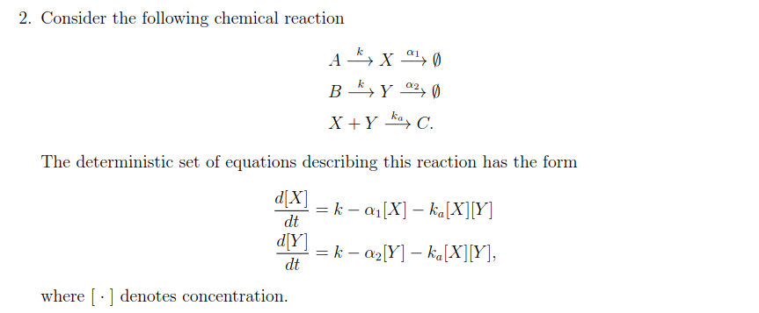
2. 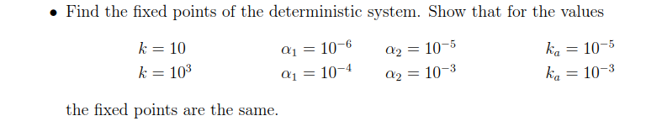

**Answer:**

At the fixed points:

Case1:

$$\frac{dx}{dt}=10-{10}^{-6}x-{10}^{-5}x*y=0$$

$$\frac{dy}{dt}=10-{10}^{-5}y-{10}^{-5}x*y=0$$

So,

$$10-{10}^{-6}x-{10}^{-5}x*y=10-{10}^{-5}y-{10}^{-5}x*y$$

$$x=10y$$

Then,

$$\frac{dx}{dt}=10-{10}^{-6}x-{10}^{-6}x^{2}=0$$

$$x=\frac{\sqrt{40000001}-1}{2}$$

$$y=\frac{\sqrt{40000001}-1}{20}$$

Fixed points is ($\frac{\sqrt{40000001}-1}{2}, \frac{\sqrt{40000001}-1}{20})$

Case2:

$$\frac{dx}{dt}=1000-{10}^{-4}x-{10}^{-3}x*y=0$$

$$\frac{dy}{dt}=1000-{10}^{-3}y-{10}^{-3}x*y=0$$

So,

$$1000-{10}^{-4}x-{10}^{-3}x*y=1000-{10}^{-3}y-{10}^{-3}x*y$$

$$x=10y$$

Then

$$\frac{dx}{dt}=1000-{10}^{-4}x-{10}^{-4}x^{2}=0$$

$$x=\frac{\sqrt{40000001}-1}{2}$$

$$y=\frac{\sqrt{40000001}-1}{20}$$

Fixed points is ($\frac{\sqrt{40000001}-1}{2}, \frac{\sqrt{40000001}-1}{20})$

Therefore, the fixed points from the two cases are the same.

1. 

**Answer:**

**See python code Question2_2.ipynb**

**The distribution plots are shown below:**

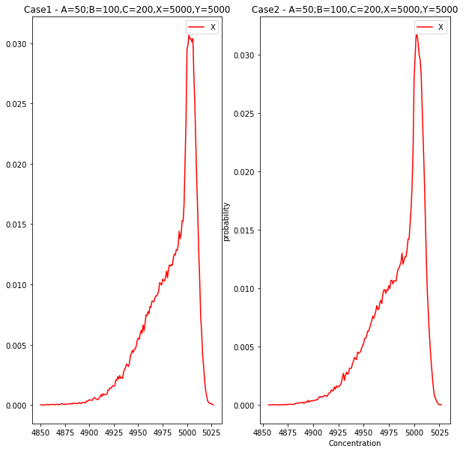

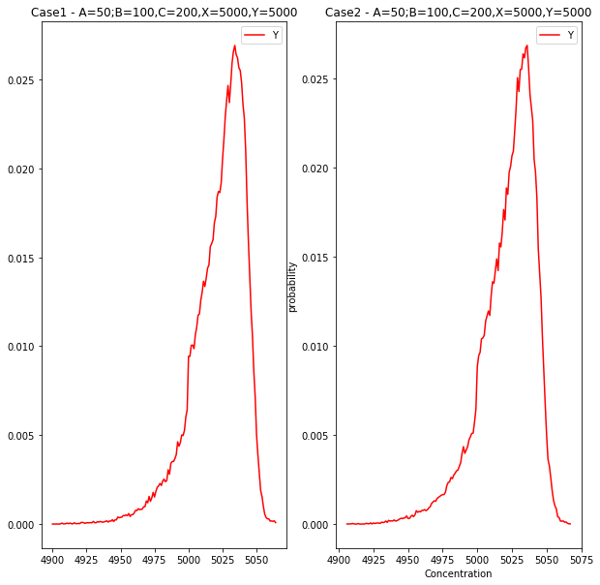

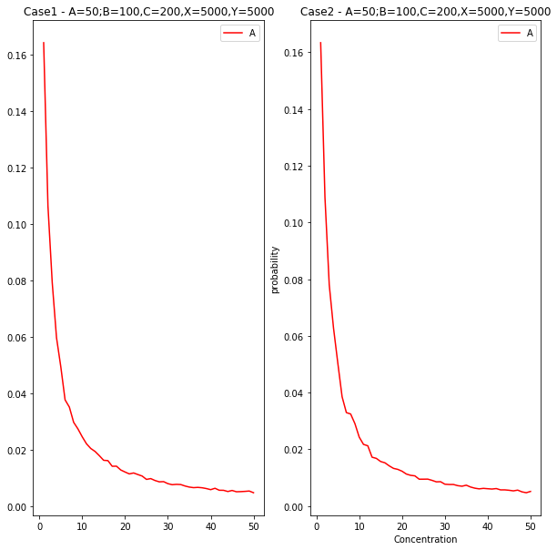

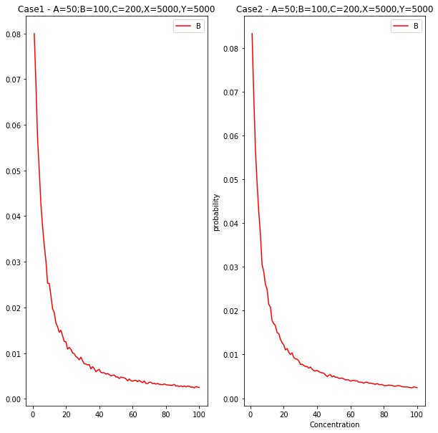

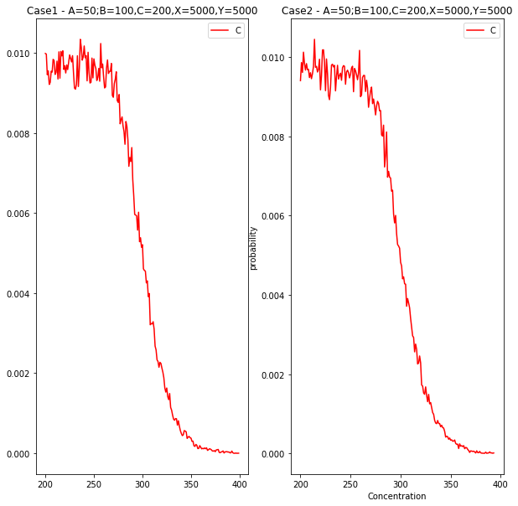

1. 

**Answer:**

From the results it is noticed that the time scale of the two cases are different. The case 2 is almost 100 times faster than case1. **This is because all rates in case 2 are 100 times as case1.**

1. 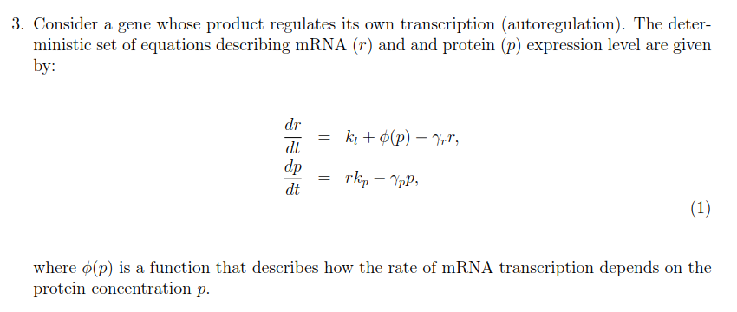
2. 

**Answer:**

The transition matrix A is:

$$A=\left[\begin{matrix}1 & 0 & 0 \\ \frac{k_{l}+∅\left(p\right)-γ_{r}r}{r} & 1-\frac{k_{l}+∅\left(p\right)-γ_{r}r}{r} & 0 \\ 0 & \frac{r*k_{p}-γ_{p}p}{p} & 1-\frac{r*k_{p}-γ_{p}p}{p}\end{matrix}\right]$$

1. 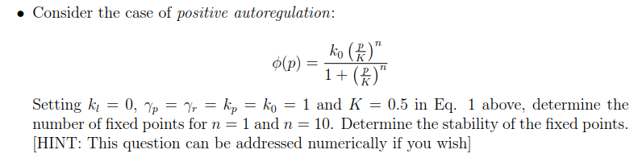

**Answer:**

**When n=1:**

$$\frac{dr}{dt}=\frac{2p}{1+2p}-r$$

$$\frac{dp}{dt}=r-p$$

For fixed points,

$$\frac{dr}{dt}=\frac{2p}{1+2p}-r=0$$

$$\frac{dp}{dt}=r-p=0$$

So

$$r=p$$

$$\frac{2p}{1+2p}-p=0$$

Then

$$r=\frac{1}{2}$$

$$p=\frac{1}{2}$$

**The number of fixed points is 1 for n=1**

When n=10,

$$\frac{dr}{dt}=\frac{{\left(2p\right)}^{10}}{1+{\left(2p\right)}^{10}}-r$$

$$\frac{dp}{dt}=r-p$$

For fixed points,

$$\frac{dr}{dt}=\frac{{\left(2p\right)}^{10}}{1+{\left(2p\right)}^{10}}-r=0$$

$$\frac{dp}{dt}=r-p=0$$

So

$$r=p$$

$$\frac{{\left(2p\right)}^{10}}{1+{\left(2p\right)}^{10}}=p$$

Then

$$r_{1}=p_{1}=0.5$$

$$r_{2}=p_{2}=0.999015$$

**There are two fixed points for n=10.**

1. 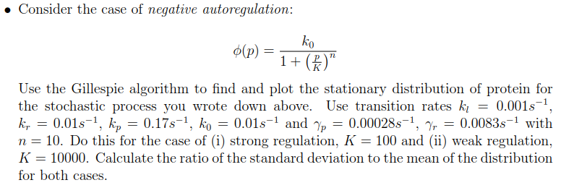

**Answer:**

**See python code: Question3_3.ipynb**

**The distribution plots for r and p are shown below:**

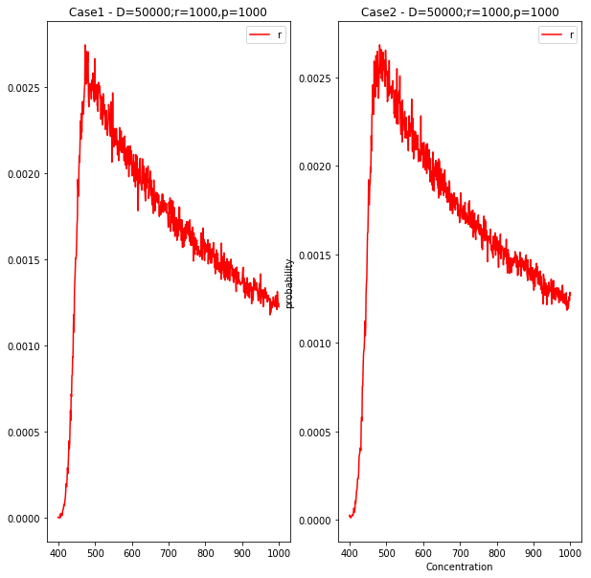

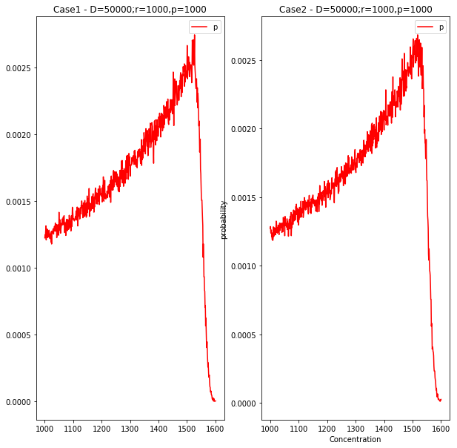

Mean of r in Case1 is [686.06532794]. Std of r in Case1 is [1820.82949267]. **Ratio of r in Case1 is [2.65401765]**

Mean of r in Case2 is [685.9945871]. Std of r in Case2 is [1819.48106537]. **Ratio of r in Case2 is [2.65232569]**

Mean of p in Case1 is [1313.93467206]. Std of p in Case1 is [3695.04756842]. **Ratio of p in Case1 is [2.81220037]**

Mean of p in Case2 is [1314.0054129]. Std of p in Case2 is [3690.41685985]. **Ratio of p in Case2 is [2.80852485]**