Global Grant Proposal

A Model to Create a Sustainable Rise Out of Poverty for Generations

**Table of Contents**

Proposal (Summary)

Program Assessment

Summary

Demographic information

Correlations

Business analysis

Conclusions

Project Plan

Goals

Project Outreach Indicators

Organization Background and Project Location

Approach

Initial Evaluation and Ongoing M&E

Training

Mentor Groups

Community grants

Financial Proposal

Budget Narrative

Financial Management

Collaboration

Resources

Appendix

Figure 1.

Figure 2.

Figure 3.

Table 1.

Table 2.

Figure 4.

Figure 5.

Table 3.

Table 4.

Table 5.

# Proposal (Summary)

This project seeks to provide 150 women with business management training, equipment to start their businesses, and grants. The beneficiaries of this project come from Narok county in Kenya, an area predominantly occupied by the Maasai community. The Maasai’s are a marginalized community whereby one out of almost a thousand children pursues secondary education, most being boys. Owing to cultural and economic hindrances, women in Narok county remain some of the most financially excluded. In order to provide sustainable change, community participation is key. This project actively engages the community at each phase of the project: community assessment, outreach, training, and monitoring and evaluation.

Our solution to this problem is to equip women with the skills and tools to build a stream of income and uplift themselves out of poverty. Ultimately, this project will improve and expand the livelihood sources of the identified beneficiaries and their dependents in many ways. The training will assist the women to either find job placement, create a business, or expand a business they already own allowing them to generate more income for themselves and their families. The women will undergo training for specific skills needed for job placement or building a businesses. The women will be technically trained with vocational skills and with financial and marketing skills as well. Kiba will work with these women on an on-going capacity for 4 years to provide mentorship to allow for growth of their job skills or businesses.

We are expecting to see 150 women lifted out of poverty within 1 year, which means that approximately 1,650 people will directly benefit from this program as the average number of people in the immediate family is typically 7. From the data we have collected, we know that usually, these women don’t just use their income to support their immediate family; they also support their extended family, which brings that number closer to 11 people impacted by each woman having a business. Therefore, by providing 150 women with companies, close to ***1,650 people will be directly impacted by their income within 1 year.***

One of our Cooperating Organizations, Kiba, has already started small businesses with Destiny Shaper Primary School, Glory Primary School, and Olbolet Primary School in Narok County. We, therefore, would like to work with mothers who have at least one child at these schools to build a small business to help ensure that these women can continue to educate their children, feed their families, and provide healthcare for themselves and those they care about.

# Program Assessment

Data collection was provided by Casey Tall, Regional Manager, and Cole Harmon, Ph.D., M.P.H., Board Chair

Analysis and Interpretation were provided by Kerry Lewis, Ph.D., CEO, and Cole Harmon, Ph.D., M.P.H., Program Director

## Summary

Kiba currently partners with three schools that each have small businesses operating at their facilities. East Africa is undergoing severe drought and is now faced with extreme hunger. A report published in Oxfam and Save the Children on May 17th, 2022 suggests one person is likely to die of hunger every 48 seconds in drought-ravaged Ethiopia, Kenya, and Somalia. The purpose of these evaluations is to assess the individual women who have at least one child within our school system to identify their interest and ability as an entrepreneur. Survey questions included demographic information, information regarding their businesses and income, geographical location, and market knowledge.

## Demographic information

All applicants were female as Kiba will be working directly with women in each family to establish a sustainable small business. In this study, there are over 180 applicants, 85% of them speak Maa, 14% of them speak Swahili, and 1% of them speak English as their primary language. The majority of applicants’ ages lie within 20 to 50 years old (**Figure 4A**) and 20% of them do not have husbands, this typically correlates to them being the sole breadwinner of the household. These data show that the majority of families have 5-8 children (**Figure 4B**) and 87% of women generate $1-5/day with the majority generating around $2 per day (**Figure 4C**). Of the participants, 48% of them are completely illiterate in Swahili and 70% are completely illiterate in English. Overall 61% of the women self-identify their mathematical ability as moderate and 27% as high. When it comes to computer literacy, 84% of the respondents self-identify as having low computer literacy, but 23% of them identify themselves as having moderate and 30% high digital/phone literacy. Of all respondents, 75% of them have only a Mpesa account, but only 10% just keep cash, thus the remaining percentage have either a Mpesa or bank account.

From previous surveys, we looked at correlations between family income and the number of children. In order to get a better understanding of the relationship between certain variables, including the number of kids, income (kshs per month), age, and percentage of kids in a school of the total, we plotted these variables against each other and calculated the correlation value (R2) for each relationship. The closer the R2 value is to 1, the more linear the relationship. An R2 value close to 0 suggests that there is no correlation/linear relationship between the variables. We first examined the relationship between the number of kids and income (kshs per month) (**Figure 5A**). We observed a statistically significant linear relationship between these variables, suggesting that as the number of children increases, so does income, however, the R2 value was only 0.08317. We hypothesize that as the number of kids in a family increases, parents/mothers have to work more (more jobs, longer hours, find higher-paying jobs, etc.) in order to support the needs of the increased number of kids. We next looked at age versus income (kshs per month) (**Figure 5B**). We expected that for those individuals of much greater age, income would be drastically reduced. However, surprisingly we observed no relationship between these variables. We also compared age to the number of kids, and again found no linear relationship between these variables (**Figure 5C**). The most striking correlation that we observed was that between income (kshs per month) and the percentage of kids in school who are old enough (of the total number of children) (**Figure 5D**). The R2 value for this relationship was 0.1233 and was statistically significant, meaning that as income increases, the number of children able to attend school also increases. This is likely because mothers who make more income are able to afford school fees and supplies for a greater number of children.

## Business dynamics

The women were asked whether they already had businesses and 30% suggested that they did have a business within the family (**Chart 3**), but as previously mentioned the majority of them were making 200 kshs per day. **This means that ALL families consider 3 meals per day, education, and healthcare luxuries.** **None of the families are able to afford education, 3 meals per day, or healthcare at the same time, so decisions needed to be made to prioritize one luxury over another.**

Although none of these women have a formal educational degree, many of them have marketable skills (**Table 4**). When asked what the women already had skills in, 47% responded that they had skills in animal husbandry, 46% in marketing or selling products, 40% in farming, 25% in cooking, 30% in beading, 26% in sewing, 12% in beauty and hair, 12% in building houses, 7% in accounting, and 6% in technology (respondents could choose multiple answers). When asked what factors kept them from starting a business or growing their business 86% of the women suggested that start-up funds were the main challenge, but 33% also said that family expenses were a significant factor. Others sighted market demand (15.9%), environment (drought) (15%), customer base (15.9%), and debt (19%). When asked about what the respondents could invest themselves, 64% said time, 26% said money, and 27% said collateral. Respondents were also asked if they had anyone who could work with them to start up a business, 43% suggested that their husbands would help, 33% said another family member and 27% said they would start a business on their own. We additionally found through a market analysis that sewing, catering, and beauty and hair businesses were all viable business options for women.

Both in surveys taken in 2022 and in previous surveys, women showed that they had a variety of skills that allow them to respond diversely to challenges as they are met. We have included a qualitative analysis of the significant challenges they face (**Table 5**). Many women do 2-3 businesses at a time to maintain the ability to feed their families and educate their children. However, it is clear that no single applicant has been able to connect their business with larger markets. All applicants sell within their local community and since many of them have similar skills there is often oversaturation of the local markets.

## Conclusions

A majority of families have livestock businesses and a significant number of women sell vegetables, water, and firewood to earn approximately 200 kshs per day. These businesses do not make the families significant funds and all of these families are facing hunger due to a lack of funds. The majority of women have living expenses that far exceed their income. Therefore, the model implemented will rely on resources, training, and grants to ensure that these women can start productive businesses.

# 

# 

# 

# 

# 

# 

# 

# 

# Project Plan

## Goals

| **Objective** | To empower poor women socially and economically |
| --- | --- |
| **Output** | 150 women provided with micro-finance support for income generation and training for either job placement and/or business creation. |
| **Activity** | All women will undergo our evaluation process, for the women who are selected will receive the training for job placement or their businesses along with finance training. Kiba will also provide long-term courses and mentoring. |

| **Objective** | To mobilize the women to organize groups. |
| --- | --- |
| **Output** | Groups of women formed of ~10-25 women/group |
| **Activity** | Group meetings will facilitate conversation between women, mentors, and leaders to assist in job placement, business creation, and long-term stability |

| **Objective** | To teach the importance of savings |
| --- | --- |
| **Output** | 150 target families saved Ksh 20,000 kshs within one year. |
| **Activity** | Facilitate the recruitment of women group leaders through group meetings and introduce a weekly savings culture among trained participants |

## Project Outreach Indicators

| **Number of Direct Rural Beneficiaries** | | | |
| --- | --- | --- | --- |
| Women | Children | Men | Total |
| 150 | - | - | 150 |

| **Number of Indirect Rural Beneficiaries** | | | |
| --- | --- | --- | --- |
| Women | Children | Men | Total |
| 330 | 1073 | 247 | 1,650 |

*From previous data, Kiba has found that when women have businesses, they tend to spend their income primarily on their immediate family, which typically consists of about 7 people. When women have an additional income, they spend funds on their extended family, even in times of hardship. We find that typically women spend their income on approximately 11 people.

## Organization Background and Project Location

Kiba currently work with schools in Narok county, specifically in Ngoswani north, south, and Nkoilale. This project will build upon the ongoing work that Kiba has established with the community. All the current schools that Kiba works with are shown on the map below.

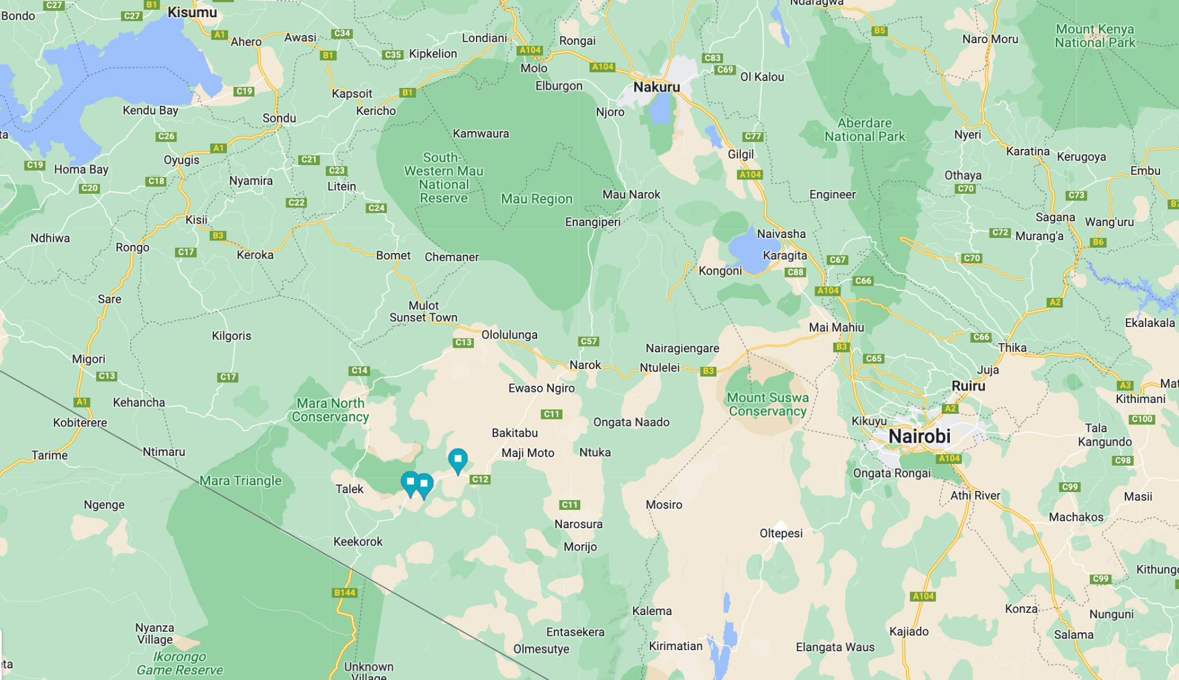

Kiba provides small businesses for schools in impoverished areas so they can educate the next generation and ensure they rise out of generational poverty. Since operations began in 2016, Kiba has seen a steady and significant increase in the profitability of our small businesses for our schools. Our sophisticated data collection program shows that schools have increased their income by 50% and increased their savings by 100% within the first 1 year of working with us (**Figure 1**). The new funding led to a 66% increase in enrollment, which equated to more tuition for the school as a whole and a better quality of education because of the new students and the small business (**Figure 2**). Due to the funds from the small business the quality of education increased by increasing the number of books, the number of staff, increasing the level of nutrition at the school, adding additional classrooms, adding recreational programs, electricity, and internet (**Table 1**). This resulted in increased student retention, where 20% more students were attending school more often after the school was generating more money (**Figure 2**). Research shows that each year a child is in school they increase their potential income by 8%, ensuring a way to close the gap in generational poverty once and for all sustainably for a one-time financial contribution.

The small business led to fewer requests from the school to the parents for payment and 80% of parents said this positively affected their income (**Table 2**). The parents were able to save the money they were sent to the school and utilize the funds in a myriad of different ways. Parents reported sending more children to school, eating more meals, purchasing more household items, spending more money on healthcare. This showed that when primary schools have access to sustainable sources of income, parents are positively impacted, and they then can utilize their additional funds to stimulate the local economy.

By reducing health-related absences, we have seen a 14% increase in attendance and an 8% increase in grades (**Figure 2**). The WASH program showed a significant 36% decrease in malaria, typhoid, and dysentery after just one year of implementation, leading to reduced healthcare costs at school and at home (**Figure 3**). By reducing preventable diseases, schools can spend less money on clinic visits. WASH+ has reduced healthcare hospitalization costs for the schools by 23% (**Figure 3**). This data showed that there was still a significant need for families to have their own source of income as many families still had to choose certain children to get an education versus others or make difficult decisions such as choosing between education or healthcare. It was clear that families were still living in extreme poverty even though the school was increasing its own standards and providing a better quality of education.

Therefore, to ensure that community financial sustainability can be reached by partnering with schools that already have these programs and ensuring that families with one child in school can bring about significant change. Data shows that every year a child is in school it increases their potential income by 8%. Data also shows that when women have access to businesses they are more likely to spend their income on their family, children’s education, food, and health care.

## Approach

To ensure women who have at least one child within our school system have a way of generating income, they will undergo a training and mentorship program to ensure that they have the skills necessary to enter the workforce or create a business. Our approach involves engaging with community leaders, government leaders, community-based organizations, and industry experts.

Kiba will work with 150 women in several phases to accomplish the skills needed for job placement and business creation. The phases will be as follows: Evaluation, Vocational Training, Financial Literacy Training, Mentor Groups, and Monitoring and Evaluation. This [calendar](https://docs.google.com/spreadsheets/d/1UMvlBvGaIZQNp_lQef0BA0u8it7zOsGRe-5HLLKdryA/edit#gid=1115838130) shows the events over the course of the next year. These dates will fluctuate based on the official start date of the grant.

### Initial Evaluation and Ongoing M&E

**Project manager:** Dr. Cole Harmon

**Project support:** Saruni L, Godwin K, Sintamei Musa, Phydy Masago, Naanyu Sunati, Nick Mashipei

The assessment of the community was done in 2021 and 2022, data from both evaluations was used for the assessment.

The analyses will relies on mixed-method surveys of women to evaluate baseline conditions prior to starting the program so that the data can be compared after the program to identify improvements. The mixed-method surveys will be analyzed using Chi-square analysis to determine differences and logistic regression analysis will be used to assess and control for the effects of demographics and intervention elements in outcomes.

Data collected during these evaluation sessions will happen on a monthly basis during the group mentor meetings with the assistance of a translator. All the evaluations can be found here:

**Initial Evaluation**

* [Baseline Evaluation](https://drive.google.com/open?id=1U5sgOJ6cdgSmF9uDcLV46WAON0yzSQSa&authuser=daphne%40humansforeducation.org&usp=drive_fs)
* [Program Application](https://drive.google.com/open?id=1U0GRfZL4NEYzmDBvduFO1kfyoXRHQTm1&authuser=daphne%40humansforeducation.org&usp=drive_fs)
* [Business Proposal](https://drive.google.com/open?id=1U3YxCYj1J-EW7GgaXc9_sYYVdqCndRBx&authuser=daphne%40humansforeducation.org&usp=drive_fs)

**Ongoing Evaluation**

* [Ongoing Evaluation](https://drive.google.com/open?id=1U5sgOJ6cdgSmF9uDcLV46WAON0yzSQSa&authuser=daphne%40humansforeducation.org&usp=drive_fs)

Assessment will be ongoing and will help to evaluate the success of the program. Along with the baseline evaluations these assessments will be assessed in a [randomized control trial](https://www.poverty-action.org/about/randomized-control-trials), where 150 women of approximately equal caliber without a business or training will be evaluated at the same time to allow us to compare the data historically and to controlled subjects. The control group will not receive any training or grants but will receive a small amount of compensation for participating in the evaluation. Participation can come in the form of unconditional cash transfers, feeding programs, or scholarships.

### Training

**Project manager:** Mr. Saruni Letoluo

**Project support:** Narok Vocational Training Centre, Gabriel Emmanuel, Rotary Club of Muthaiga, Rotaract D9212, Rotary Club of Folsom

Kiba is partnering with [NITA-trained](https://www.nita.go.ke/) partners for the vocational training aspect of the Global Grant. The National Industrial Training Authority (NITA) is a state corporation established under the Industrial Training (Amendment) Act of 2011. Its mandate is to promote the highest standards in the quality and efficiency of Industrial Training in Kenya and ensure an adequate supply of properly trained manpower at all levels in the industry. There is a training center in Narok town (~84 km from Nkoilale; ~60 km from Ngoswani) that has the ability to house all 150 women at once for the training. The training facility offers a variety of training, including:

​​

| **NITA COURSES** | **KNEC COURSES (ARTISAN/NVCET)** |
| --- | --- |
| Motor Vehicle mechanic | Fashion design and garment making |
| Motor Vehicle Electrician | Appropriate carpentry and joinery |
| Tailoring | Building technology |
| Dress Making | Motor vehicle technology |
| Electrical wireman | Electrical and electronics technology |
| Electrical fitter | Information communication technology (ICT) |
| Carpentry & Joinery | Hairdressing and beauty therapy |
| Masonry | Food Technology |
| Plumbing | Metal processing technology |
| Hair Dressing |  |
| Beauty Therapy |  |
| Arc Welding |  |
| Catering |  |

*The curriculum from the training facility can be found [here](https://drive.google.com/open?id=1URGOgAHGyibv6PNwZ6R2fY1PlOHs4qO4&authuser=daphne%40humansforeducation.org&usp=drive_fs). For any additional information on the curriculum, please let us know which curriculum you would like to see.

The facility's training offers NITA and Kenya National Examinations Council ([KNEC](https://www.knec.ac.ke/)) certifications for their training. These certifications are recognized throughout the country. This facility is run by a Maasai woman, who has experience training illiterate groups of women. For full certifications, only fully literate women who speak Swahili and English will be able to receive the certification as the exams are given in those languages. Over 95% of the participants we work with do not speak either language or read or write. For illiterate populations, the facility is able to provide a course completion certificate and a recommendation letter.

Training for the women we work with will proceed over 6 months. The training will take place in Ngoswani, Nkoilale, and Nkenji. As this training will be specialized for these women, there will be specialized trainers who will only focus on training our participants in these 6 months. The training will be segmented into 3-month sections, with a break each month to allow time for participants to go home to see their families.

The first three months will allow the women to gain the basic necessary skills in their trade and learn to utilize the tools of their trade. The women will then be brought back to their homes to practice and put their skills to use for a three-month period while they undergo financial literacy training, learn to start their own businesses, and begin the mentorship program. The financial literacy training courses have been developed by Kiba in collaboration with several business schools and can be found [here](https://drive.google.com/open?id=1CAmPLRnXha4yY1sUuckPTM_73Ox2U6rt&authuser=daphne%40humansforeducation.org&usp=drive_fs). The women will then go back to the center for 3 months of advanced training and receive their certification and their grants.

### Mentor Groups

**Project manager:** Mr. Saruni Letoluo

**Project support:** Narok Vocational Training Centre, Rotary Club of Muthaiga, Rotaract D9212, Rotary Club of Folsom

Data shows that when training and mentoring are used together they create an effective strategy for poverty reduction. In a study done in 2016, entrepreneurs in Kenya who received training and mentoring saw increases three times as large as those assigned to training only.

The mentoring program will provide personalized, hands-on problem-solving support and peer learning to the women who go through our vocational and business training. The mentoring program should have a goal of reinforcing intended business training outcomes from management skills to business growth.

Each mentee under this global grant shall receive 18 mentoring sessions (1 per month during training and 2 per month after training). Each mentor will be assigned a group of 10-25 mentees.

The table below summarizes the topics to be covered during the group mentoring sessions. To ensure there are enough mentors 6-15 mentors will need to be recruited for this process. Rotaract has previously participated in training and mentoring sessions and found it to be an enjoyable experience. Kiba has the ability to engage Folsom Rotary through zoom if they would like to participate. Additionally, for the Rotary Club of Muthaiga, we have accommodation available in the Mara for anyone interested in participating.

| Session | Name | Objective/Module | Outcome |
| --- | --- | --- | --- |
| 1 | Introduction, objectives, and agreement | * Introduction of mentor mentees * Definition of objectives * Understanding the mentoring agreement | * Knowing each other * Being clear on the mentorship objective and expectations * Understanding and signing the mentoring agreement |
| 2 | GROW goal | Goals review | Mentees goals established   * How the mentees will look like when they are successful * How will the business look like after growing, as regards to sourcing, production, marketing, packaging, sales, networking, access to finance and general business management |
| 3 | Savings | Savings review | Mentees establish savings goals:   * How much they are looking to save in 1 year * How will these saving enable them to grow as an entrepreneur, family member, community member |
| 4 | Guest Speaker | Field Expert | * Field Expert comes out to speak to them about how they accomplished growing, scaling, and sustaining a business |
| 5 | GROW reality | Reality analysis | Current status established   * Where is the mentee right now in view of her personal and business goals * Business performance established in terms of; sourcing, production, marketing, packaging, sales, networking, access to finance and general business management |
| 6 | GROW gap analysis | Identifying key gaps (goals vis-àvis current status) | * Gaps identified. This will be done by exploring the difference between the goal and the current reality. |
| 7 | Guest Speaker | Field Expert | * Field Expert comes out to speak to them about how they accomplished growing, scaling, and sustaining a business |
| 8 | GROW exploring options | Exploring options to address identified gaps | * A list of options to close each of the gaps identified (in terms of capabilities, skills and assets). * This should be a conversation among the women about what is working and what is not working. How can the women help each other |
| 9 | Goals review | Goals review | Mentees review goals:   * Review the goals they set for themselves a few months ago * How are they doing so far? * How much have they made? * How much have they saved? * What is holding them back? * What can launch them forward? |
| 10 | Feasibility assessment | Financial analysis | * Exploring the feasibility of filling in the gaps * What is the cost of implementing the options * What will be the source of finance required to close the gaps |
| 11 | Guest Speaker | Field Expert | * Field Expert comes out to speak to them about how they accomplished growing, scaling, and sustaining a business |
| 12 | GROW way forward /action points | Plan of action to address identified gaps | * Analysing options and agree on way forward * Drawing an action plan with clear timelines and budget |
| 13 | Implementing the way forward | Evaluating progress | * Exploring what the mentee has done on the agreed Action Points * Identifying successes, challenges, way forward |
| 14 | Guest Speaker | Field Expert | * Field Expert comes out to speak to them about how they accomplished growing, scaling, and sustaining a business |
| 15 | Implementing the way forward | Evaluating progress | * Exploring what the mentee has done on the agreed Action Points * Identifying successes, challenges, way forward |
| 16 | Projections | Considering the future | * Based on the progress they have seen what can they consider for the future * What will help them guard against market variability * What strategies will they use * Build projections for 3 years |
| 17 | Guest Speaker | Field Expert | * Field Expert comes out to speak to them about how they accomplished growing, scaling, and sustaining a business |
| 18 | Evaluation, review of action plan and sustainability | End of program evaluation, review of action plan and agreement on sustainability plan | * Documenting the impact of the mentorship, i.e. how has the mentee and business benefited from the mentoring sessions * Reviewing the action plan based on sessions 8 and 9’s outcomes * Agreeing on a sustainability plan after the end formal mentorship |

*If anyone has thoughts or suggestions, please feel free to make them!

### Community grants

After the women have undergone the training process they will be eligible for community grants. To be eligible for these grants the women will have to follow these guidelines:

* **Attendance Requirements Percentage** The trainees are expected be present for at least 80% of attendance and mentorship classes to be eligible for assessments and community grants.
* **Project Work** The training shall be competency-based with the trainee being subjected to supervised, simple, and routine projects to reinforce learning.
* **Assessments of work** will be conducted in terms of practical and theoretical knowledge. Trainees will need to receive at least an 85% or higher to pass.
* **Business proposals** will be a requirement for those seeking grants.

Grants will be awarded to those who have successfully completed the course. Funds for the grants will be distributed via a partnership with Safaricom directly to the women’s own Mpesa lines as a conditional cash transfer. M-Pesa is a mobile phone-based money transfer service, payments, and micro-financing service, launched in 2007 by Vodafone and Safaricom, the largest mobile network operator in Kenya. 100% of the women we work with have a Mpesa line for funds transfer and 0% of them have a bank account. Kiba has used this method in the past for scholarship funds transfers.

After the grants have been transferred the women will still be required to attend the mentorship programs and as part of the program, they will have community service. This community service will be allocated in 2 different ways. Once the women have begun making a net profit for at least 6 months they will be eligible to enter the community service phase of this program. This part of the program is a requirement of the program as all of the electronics and supplies are still owned by Kiba and can be transferred to other women in the program for non-compliance.

During the program, the women will be given a savings account that they will not be able to draw funds from for 12 months. As the participants begin to make profits they will be checking in with their mentor groups and Kiba will track their savings progress. Each participant is encouraged to save 10-20% of their earnings each week or month. After the first year, Kiba will direct the women back to the community service aspect of the program, where the participants of the first training program will need to give microgrants to the participants of the second program of the same amount that they received. Additionally, the participants of the first training program will also participate as mentors in the mentorship program for the second training program. In exchange for their community service, at the end of their community service, they will officially receive independence from the program and all machinery and resources will officially be theirs to own.

# Financial Proposal

## Budget Narrative

The budget provided specifically reflects Kiba’s capacity to implement small businesses for 150 women, impacting 1,650 lives within 12 months in collaboration with the Rotary Club of Muthaiga, Rotaract D9212, and the Rotary Clubs of Northern California. This budget demonstrates there is a significant way to empower women of the Maasai community. Upon doing the program assessment for this project, we went to the Area Chiefs to discuss this project. They were so enthusiastic that they had their wives campaign with us door to door to help explain the importance of allowing women to join the workforce. Needless to say, the support of the community is strongly behind this initiative. We have had letters of support from the local community government. This budget shows a total of $107,050 for the total implementation, but it doesn’t show that this is approximately $60 per person impacted. Our data shows that each woman that has a business impacts 11 other people. Additionally, the budget doesn't show that these businesses or job-created will go on to generate funds for years to come. Each business we have built is still standing. These businesses have weathered COVID-19, extreme droughts, unstable governments, and are still generating income years after initial implementation. This is due to careful implementation, planning, and ongoing program support, monitoring, and evaluation. **These women have 5-8 children to feed, mostly all on their own, and we can help provide resources so they can create sustainable futures for their whole families.**

**The updated budget can be found** [**here**](https://docs.google.com/spreadsheets/d/1G1I0T-c1FO8IASfLktxlnnoFoETOLylicGjepIizodU/edit#gid=1016565932)**.**

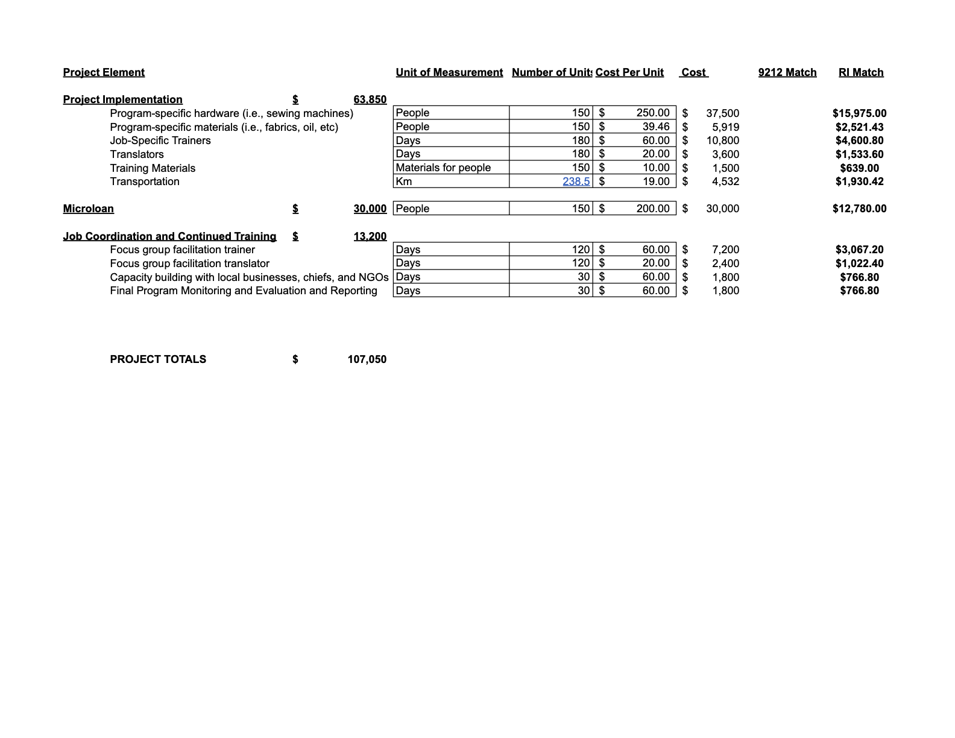

**Embedded in these projections is sustainability.** As the women begin to generate income we begin to allocate 30% of the net profit alone towards payback of the funds of the microloans. This gives a buffer to the women to ensure that they can begin to produce net profit and also a safe timeline in which to pay back the funds. These funds are then allocated to building a business for another woman in the community, which perpetuates community empowerment. This payback program creates a system where the original woman can act as a mentor to the new woman creating reliability within the community itself.

## Financial Management

The financial management of this project is the most crucial step. As such, we work with our partner women for several years to help them gain independence in running their businesses on their own. The majority of gaining independence is their ability to properly manage their finances. During this evaluation period, the families have to keep detailed financial records, and receipts, create budgets & projections and have audits by the Kiba team on a frequent basis.

## Collaboration

In collaboration with the Rotary Club of Muthaiga, Rotaract D9212, and the Rotary Clubs of Northern California, Kiba can build off of each other’s expertise to create a model system that can truly end generational poverty by constructing businesses for schools and families simultaneously. We both believe in a world free of extreme poverty and with a model that sustainably creates community financial freedom, generational financial independence, and education for all we can eradicate extreme poverty within our lifetime.

Over the next 3 years, Kiba is looking to scale to 10 schools, impacting 1,500 students and 15,000 family members. Thus, this grant allows us to start that journey in creating the opportunity for us to showcase the work with 150 women to create sustainable businesses so that these families can send more children to school, earn living wages, and break the cycle of poverty once and for all. The work we do together can create ripples for thousands of families across Kenya and eventually globally, “if you want to go far, go together”. Together, we can go far.

# Appendix

## **Figure 1.**

Figure 1. Small business program impact on school finances.

## **Figure 2.**

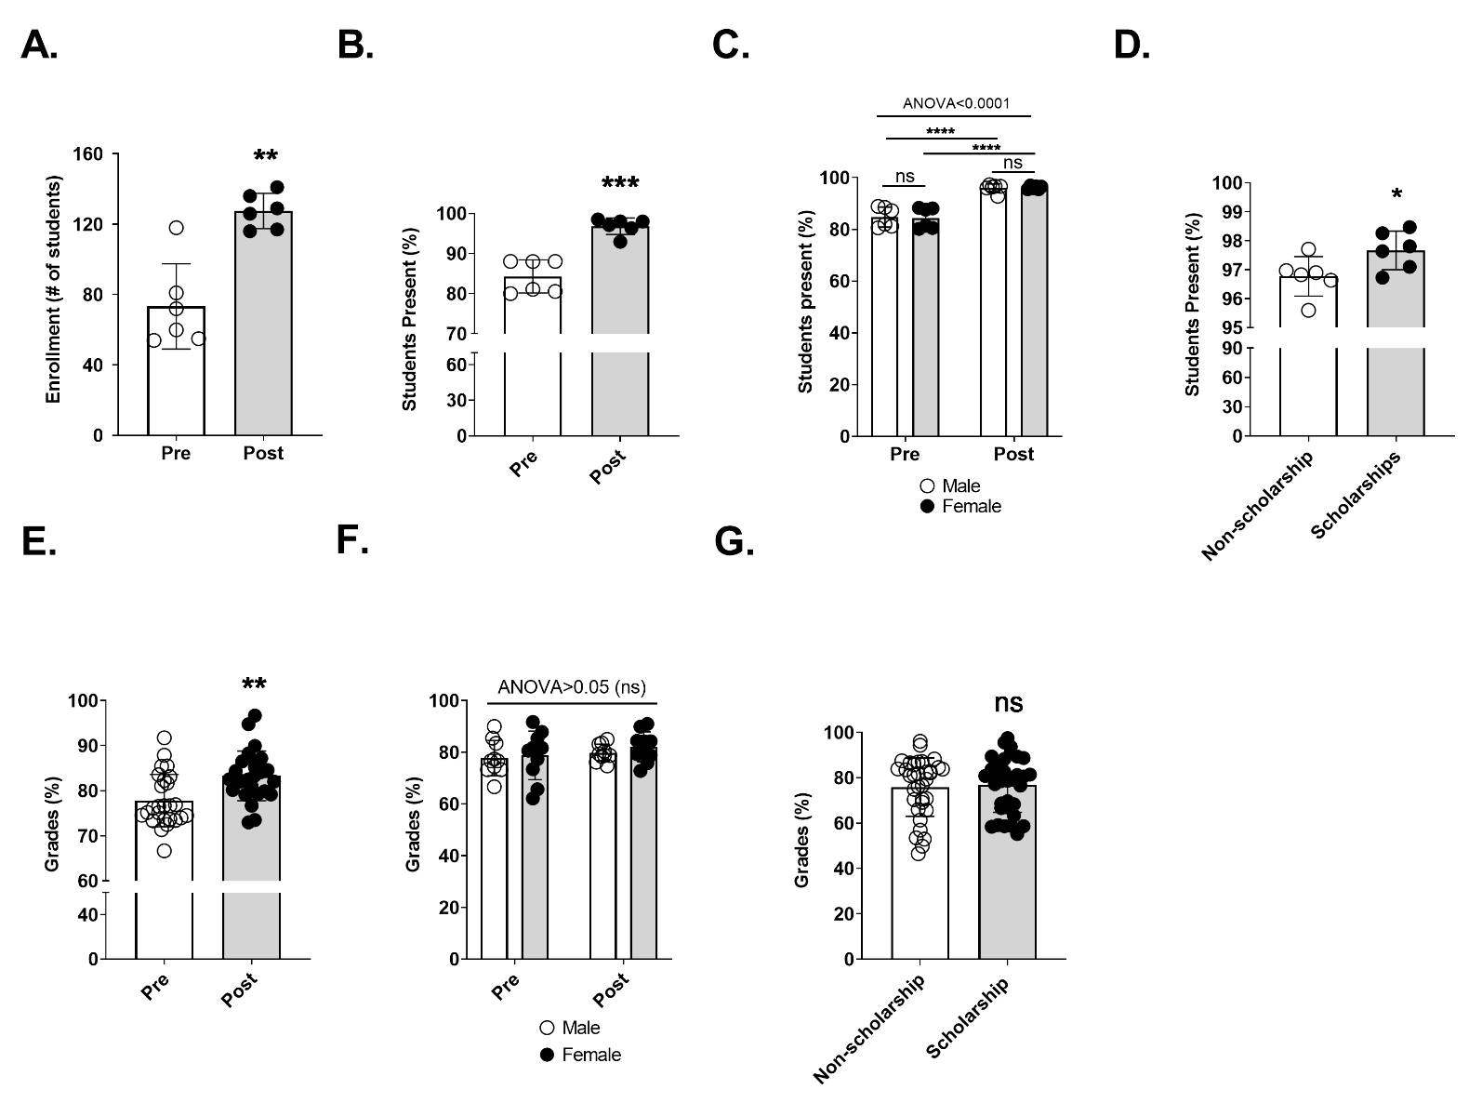

Figure 2. Pupil enrollment, attendance, and grades are positively affected by Kiba programs.

## **Figure 3.**

Figure 3. Utilization of the WASH+ program and its’ impact on health.

## 

## 

## 

## 

## 

## **Table 1.**

**Table 1.** School characteristics pre- and post-intervention.

| **INDICATOR** | **PRE-INTERVENTION (2017)** | **POST-INTERVENTION (2020)** |
| --- | --- | --- |
| **Number of pupils enrolled** | 118 | 151 |
| **Grade levels** | Pre-primary levels 1 & 2  Primary levels 1 – 4 | Pre-primary levels 1 & 2  Primary levels 1 – 6 |
| **Number of classrooms** | 6 | 8 |
| **Pupil:teacher ratio** | ≈20:1 | ≈16:1 |
| **Pupil:bench (3 person) ratio** | 6:1 | 4:1 |
| **Pupil:textbook ratio** | 6:1 | 4:1 |
| **Latrine:person ratio** | ≈1:62 | ≈1:38 |

## Table 2.

**Table 2.** Parents’ perceived impact of programs.

| **Program** | **Total** | **Scholarship**  **N=28 (%)** | **Non Scholarship**  **N=27 (%)** | **Impact** | **Representative Quotes** |
| --- | --- | --- | --- | --- | --- |
| **Overall a** | 44 (80%) | 28 (100%) | 16 (59%) | **Increase in family income** | *“The scholarship is very important because that is one of the burdens that I had and now it is off of my back and so I can take care of the other children with the money I am saving”* (female, age 35, scholarship parent) |
| **Program** | **Total**  **N=44 (%)** | **Scholarship**  **Recipients**  **N=28 (%)** | **No Scholarship**  **N=16 (%)** | **Impact** | **Representative Quotes** |
| **Scholarship Program b** | 4 (9%) | 4 (14%) | - | **Extra income for business investments** | *“The money that I was using to pay for the scholar pupil I am using to employ a person to take care of my livestock and this allowed me to start a motorbike taxi business and I make more income that way”* (male, age 28, scholarship parent) |
| 11 (25%) | 11 (39%) | *-* | **Improvements to scholar’ education** | *“I used to strain to pay school fees and now there is no problem because one of my kids is sponsored. Before the kid was being sent back home due to school fees and now that doesn’t happen anymore”* (female, age 29, scholarship parent) |
| 18 (41%) | 18 (64%) | *-* | **Improvements to children’s education** | *“The income is more stable. The first girl is at high school and I am paying school fees for her and for the other kids and now I can use the school fees I am saving from the sponsorship to pay for those other children and keep the oldest girl in high school”* (male, age 40, scholarship parent) |
| 26 (59%) | 26 (93%) | *-* | **Burden reduction** | *“Before I used to take a lot of care for my children to pay school fees and hospital fees and now that burden is on the program because they are paying for the child. Also, now there is less illness, so I don’t have to stop everything and take the kid to the hospital. There is less concentration on the child, and I can focus on my business and make more income”* (male, age 34, scholarship parent) |
| **Health Program b** | 19 (43%) | 8 (29%) | 11 (69%) | **Reduction in hospital fees** | *“It has helped [with my income] because the water is clean, so the kids don’t fall sick as often, so we are not going to the hospital and paying as many fees. We used to struggle with these fees”* (female, age 60, non-scholarship parent) |
| 13 (30%) | 3 (11%) | 10 (63%) | **Savings on food** | *“Instead of buying meals for the kids, especially for lunch, they are having meals at the school. I have three kids at this school, so I am saving quite a bit on not buying food and I am now able to save that income for other things”* (male, age 45, non-scholarship parent) |
| **Small Business Program b** | 14 (32%) | 8 (29%) | 6 (38%) | **Reduction in school fees to be paid to school** | *“Before [the school] use to ask [the parents] for contributions to fix the school and now they don’t do that anymore because of the small business”* (male, age 35, scholarship parent) |

**a. p-value=0.0002; Odds ratio (95% CI)=1.6875 (1.234,2.307); Tested by Chi-square significance test**

**b. Percent of respondents who indicated the program has an impact on their family income**

## **Figure 4.**

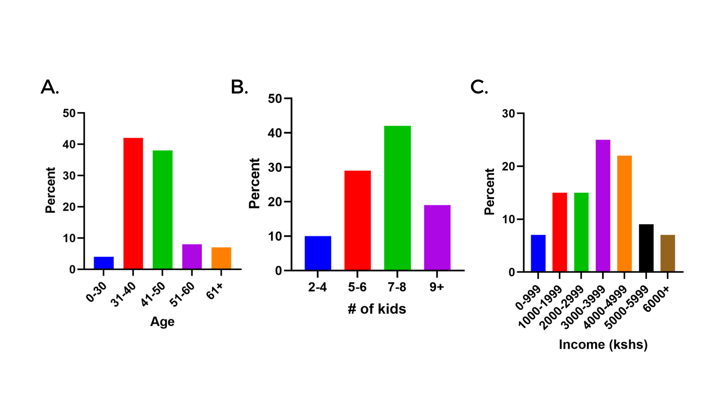

**Figure 4. Demographic data.** Percentage of respondents plotted by (A) age, (B) number of kids, and (C) income (kshs per month).

## **Figure 5.**

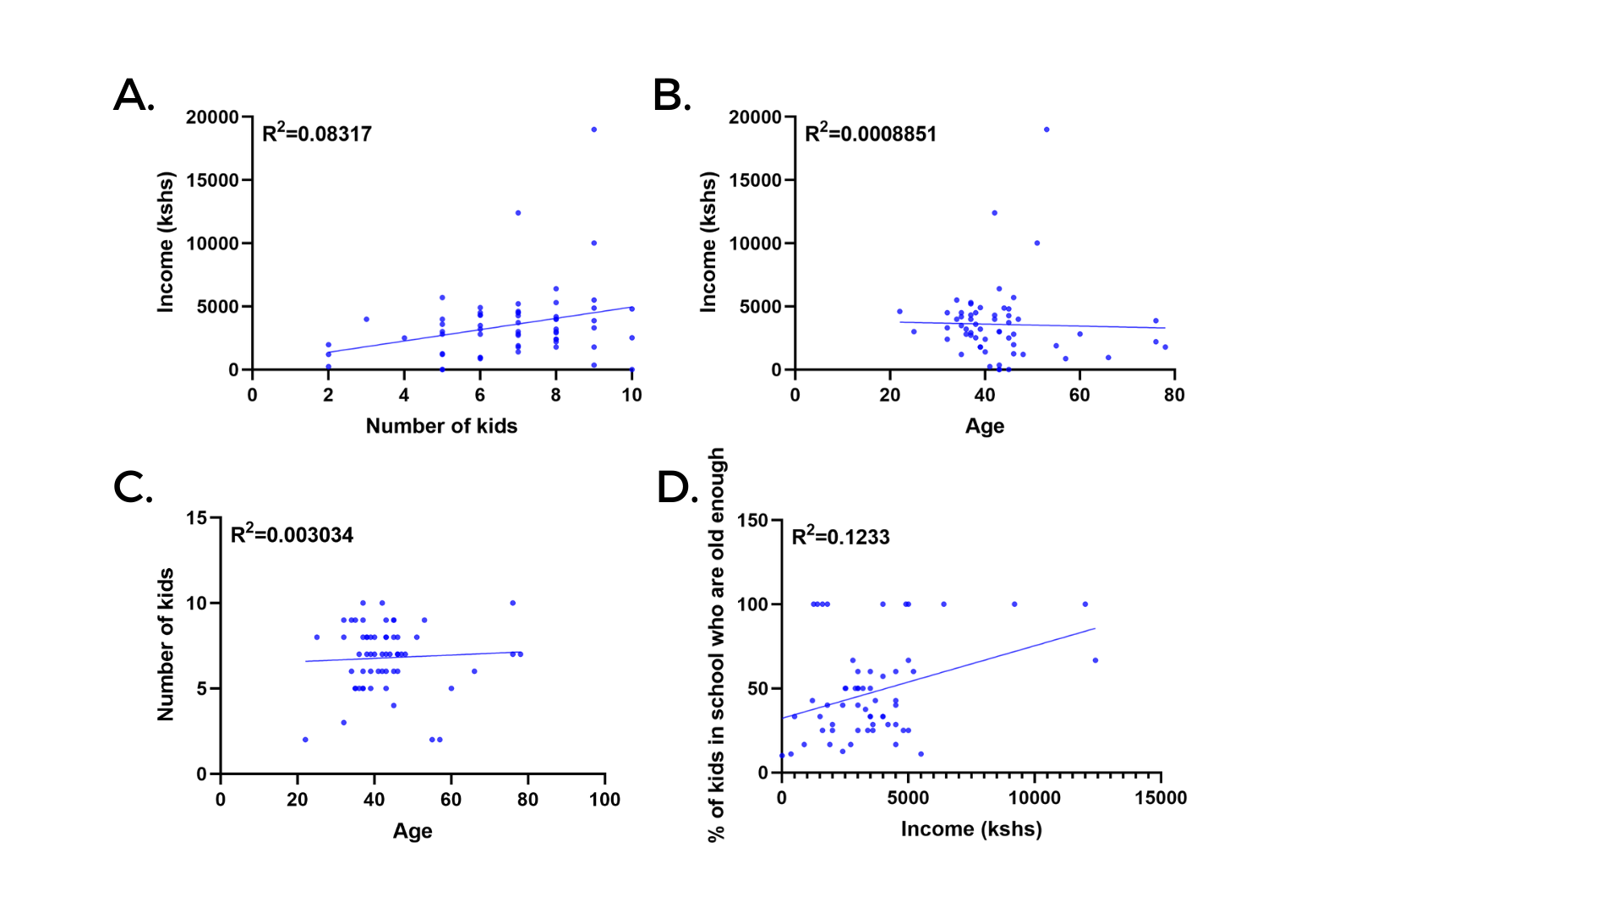

**Figure 5. Correlations.** (A) number of kids and income (kshs per month), (B) age and income (kshs per month), (C) age and a number of kids, and (D) income (kshs per month) and % of kids in school who are old enough (of the total) were plotted against each other to examine the linear relationship. An R2 value was calculated to examine the correlation. *, P<0.05 and **, P<0.01.

## **Chart 3.**

**Chart 3** below depicts the percentage of women who already have a business within the family.

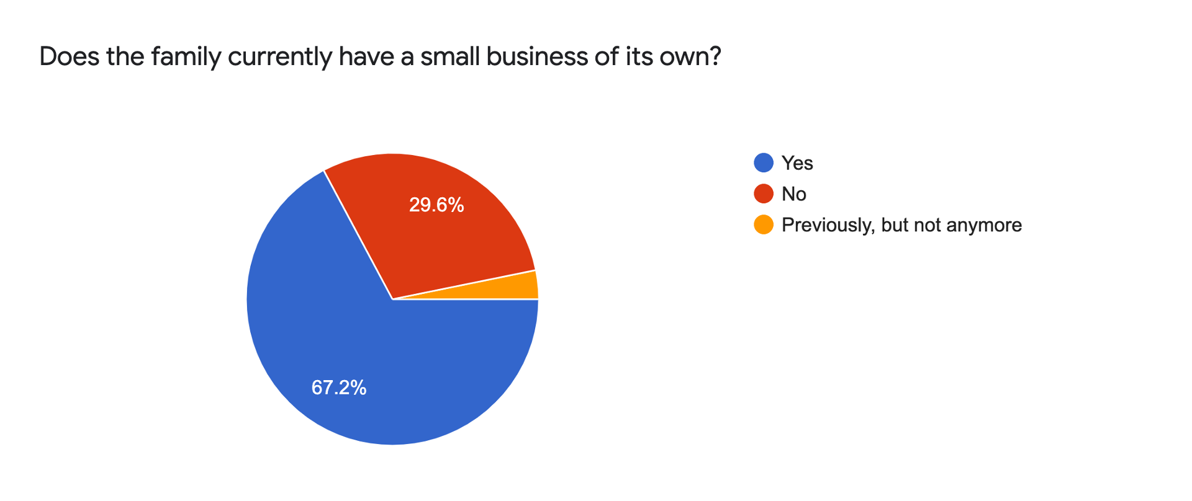

## Table 4.

Although none of these women have a formal educational degree, many of them have marketable skills **Table 4** provides a comprehensive list of these skills. The majority of the women are most skilled at beading, building manyattas, mathematics, or livestock. They also have a variety of skills that allow them to respond diversely to challenges as they are met. Many women do 2-3 businesses at a time to maintain the ability to feed their families and educate their children. However, it is clear that no single applicant has been able to connect their business with larger markets. All applicants sell within their local community and since many of them have similar skills there is often oversaturation of the local markets.

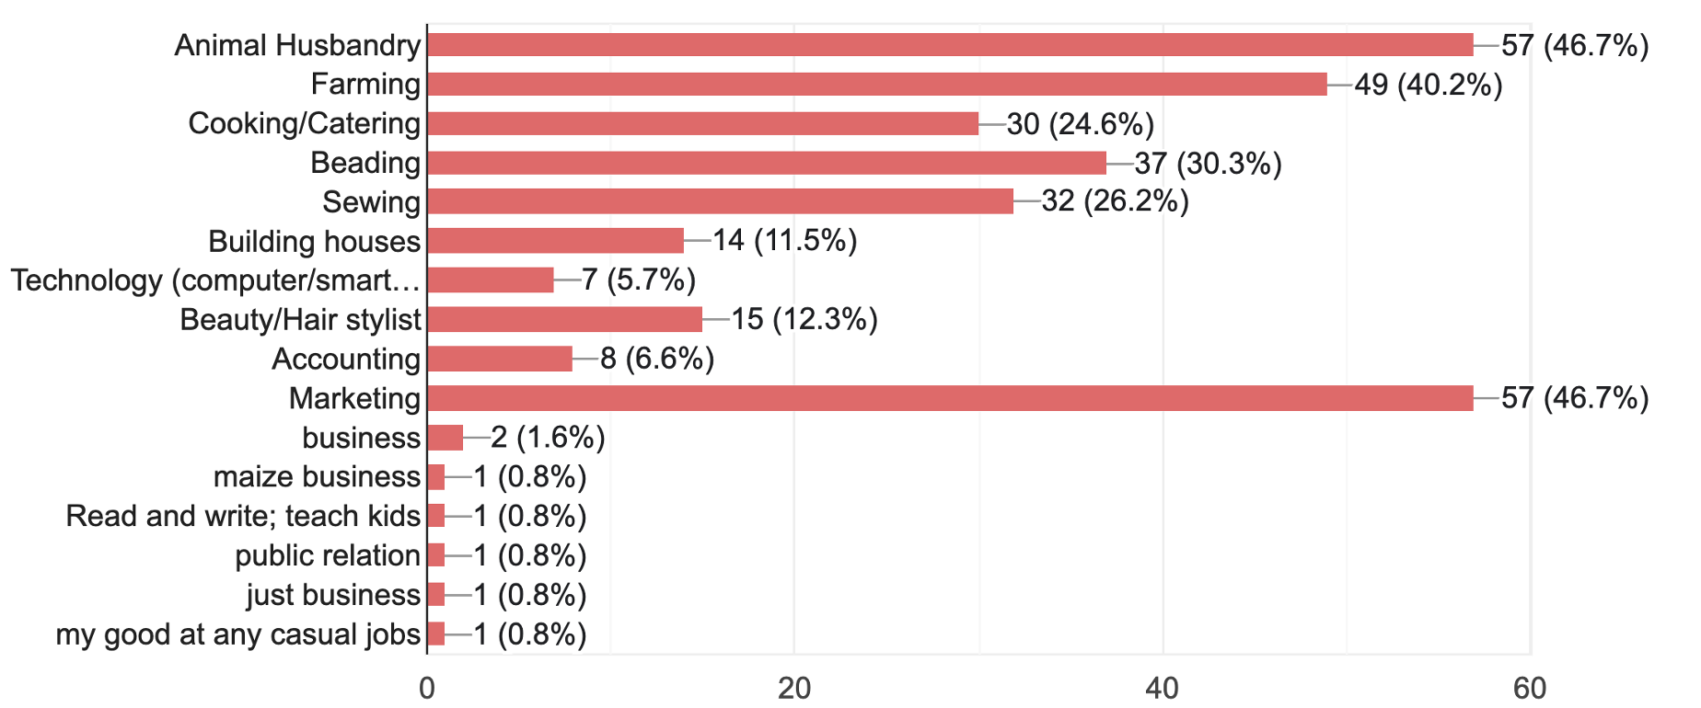

## Table 5.

To get a better understanding of the major issues that these families face and how these women deal with and overcome these issues, we asked the question: “over the past year, what are the major issues that the family has faced? And how have you dealt with and overcome them?”

Responses were organized into 7 themes (**Table 5**): providing for children (44%), starting own business (39%), issues with husband (34%), stressful life situations (22%), husband passing (19%), COVID-19 (12%), and issues with livestock (7%). The first theme, providing for children, mostly dealt with women struggling to clothe, feed, or educate their children. Many women described how starting their own business helped them overcome this struggle. Many women also described having issues with their husbands, due to their husband being sick, being drunkards, or beating them, and additionally, a number of women had husbands that had recently passed and they were left alone to care for the children. Again, it was common to see that women responded to these struggles by starting their own businesses, and some even stood up to their husbands. Not surprisingly, the COVID-19 pandemic was a source of struggle for several families due to the lack of food or money.

| **QUESTION: Over the past year, according to the parents, what are the major issues that the family has faced? And how have you dealt with and overcome them?** | | |
| --- | --- | --- |
| **Theme** | **Number of families (%)** | **Representative quotes** |
| **Providing for children** | 26 (44%) | She had a problem earlier on where she couldn't cloth or feed her children. Now it is better because one child is getting an education and the other jobs I have can now help me feed these children. She has started working because she is dedicated to her children and she would like to see the rest of her children educated. |
| Over the past two years, no one in the house had a job, and paying for school fees and food was very difficult to pay. But now that they have work they are able to provide food and clothes for their children. The education of their children was what motivated them to start working. In order for them to live very well they wanted to have jobs. |
| Her first children didn't go to school and now the rest of the children are going to school so she is very happy about that. It was very hard to feed her children and now because of the small business, she can feed the family and can pay 40% of the school fees to the school. |
| l thought that without education it is very hard to survive and therefore l was somehow hopeless but l take courage and started my business and so far l have seen a big change and development in my family .because my children are eating very well and getting clothes. |
|
| **Starting their own business** | 23 (39%) | It was very hard for her to raise her children alone and without a permanent job. It was really difficult to provide everything alone. But now she is doing these small businesses and so she is able to provide for food, clothes, and education. I am not happy about the poverty and she doesn't like to see her children behaving in a needy way. She started it to help her children. |
| Over the past year, it was very hard for her and her husband to feed the children because they didn't have enough money, and also the livestock are few-they cannot sell all of them. It was very hard for them to live a comfortable life--at least now they are better than they were (not quite a comfortable life, but better). It was very hard after her first business collapsed with the school fees and feeding-when she started the second business and the motorbike business, things improved and she was able to make money to support the family and now they are okay and the children can stay in school. |
| It was so stressful to see her husband arrested and told that he was not to be released early. It was something that she really feared. She was worried that her children would be in trouble but she tried and made sure to open a small business to sustain her children and she decided to sell one goat that was 4,000 kshs. She also started a vegetable business and her family is not eating and one child is studying at school. |
|
|
| **Issues with husband (sick, beating her, drunkard, etc.)** | 20 (34%) | Last year her husband beat her with a big stick in the back. She was worried that she would not be able to do her firewood business again. Her back swelled and she was taken to the hospital. She was worried that she would die and would not see her children again. Brothers to her husband took her to the hospital and she was treated and now she is okay and she is working normally again. |
| Her husband was a drunkard and she called him and asked him not to take alcohol because it will not help the family and it will only destroy them. She called his friends and talked to him until now he is a Christian. This is a major success because most men don't listen to their wives but she is lucky because her husband could hear what she told him and now he is a new person. |
|
| **Stressful life** | 13 (22%) | She was really suffering from stress and she went to the hospital and was diagnosed with diabetes. She realized that she needed to change her lifestyle to reduce her stress to help with her illness. She talks more with her pastor now which helps her to calm down. |
| I married an old man of 60 years and it was so stressful because the only thing that l have been thinking is that he will pass on and he will live me alone with my children, so i decided to cope with the situation because there was no otherwise because in Maasai once you are married whether with any kind of a husband it is done. so l managed the situation and here l am and l am comfortable and l am feeding my kids. |
|
| **Husband passing** | 11 (19%) | When my husband passed away it was hard for me to feed myself and the children because we had no cows, but then I created my own businesses and was able to feed myself and my children. |
| When my husband died, he left me with my children alone and l was so stressed and was asking myself if l will make it alone. it was something that was really giving me sleepless nights .l was asking myself if l will be able to ride the motorbike and feed the children. But l decided to rent the motorbike so that the money that my husband was making, l will also make .and l took the initiative and ask someone if he is interested in doing that and he was. so unto now, l am still receiving 200 ksh from the motorbike though sometimes it consumes the money when it needs some services. |
| **COVID-19** | 7 (12%) | Last year it was very hard for her because of her age and because of COVID- she has seen that old people can be killed by this virus so she was very worried about her life because COVID might come and kill her. She was also worried about getting food because only one of her children was helping to feed her so she was worried about her life so much at that time. At that time it was very hard and she was very hopeless, at that time they came to get food from Kiba and so she became hopeful that she would survive this virus. She is saying that there is nothing that she has done- it is really her child that is helping her get through this time and pass through these issues. |
| Last year she had a shortage of money due to COVID. Life became so stressful and it was hard to get everything. There was a lot of starvation and worries due to COVID. For now, she am happy that COVID has come to an end and we are safe and my job has come back |
|
|
| **Livestock dead/issues with livestock** | 4 (7%) | There was hard life where all our cows died due to a very bad drought and therefore we tried to migrate the to find green pastures but we couldn't find any way so it was so hard for us to withstand the situation where all cows succumbed to death. We have come to know that keeping so many animals is really very bad because sometimes drought kills them all. So l came to keep only 3 cows are manageable and will not easily be killed by the drought. Now henceforth it will be hard for our livestock to die. |