Make to[pology

1. R1 int fa 1/0

en

config t

int

fa 1/0

no switch port

ip address 10.0.0.1 255.255.255.0

no sh

wr

1. R2

en

config t

int fa 1/0

no switch port

ip address 10.0.0.2 255.255.255.0

no sh

wr

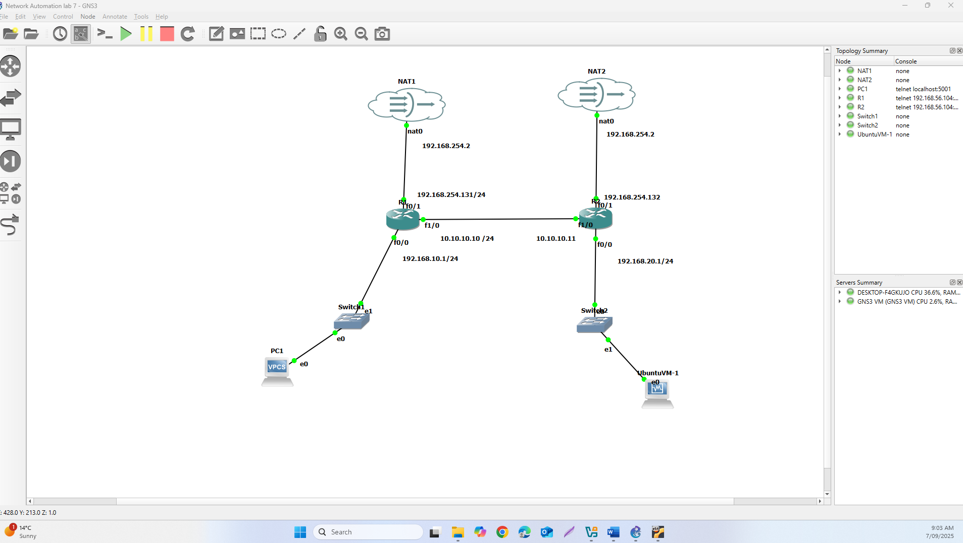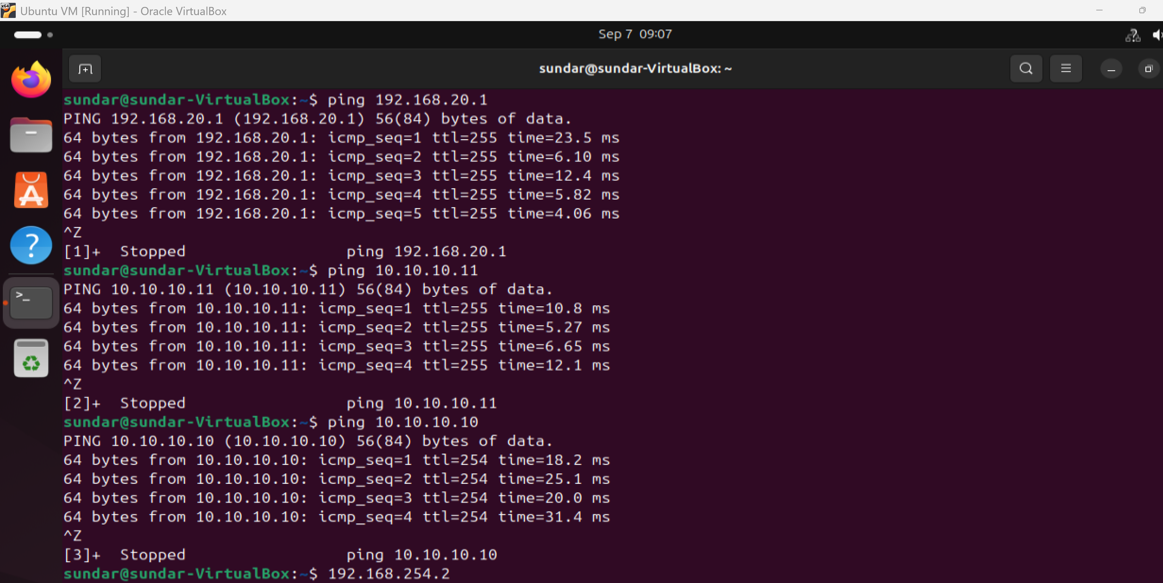

Task 3:

i.

Ansible version:

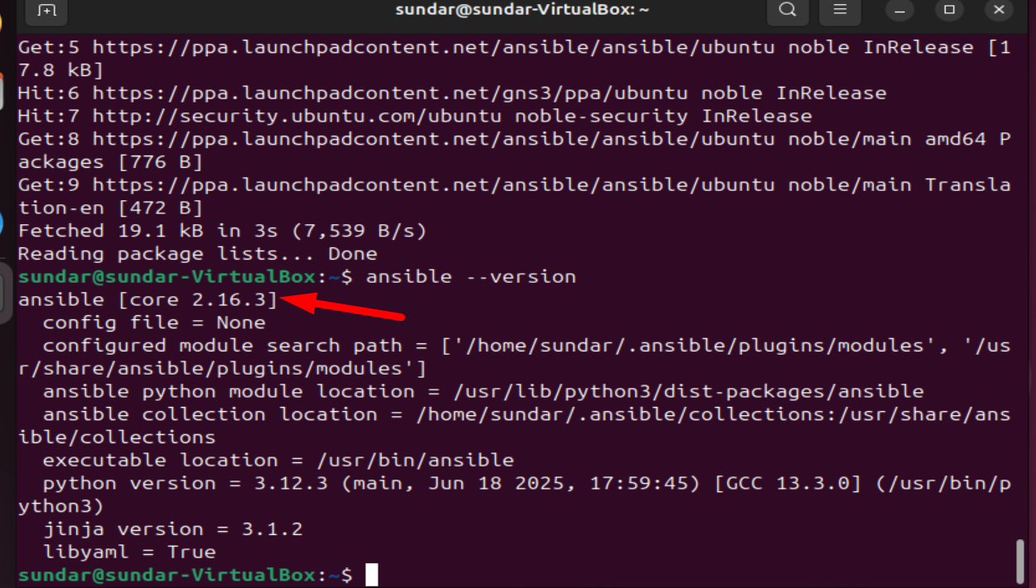

ii

for ssh:

I have used .sh config file:

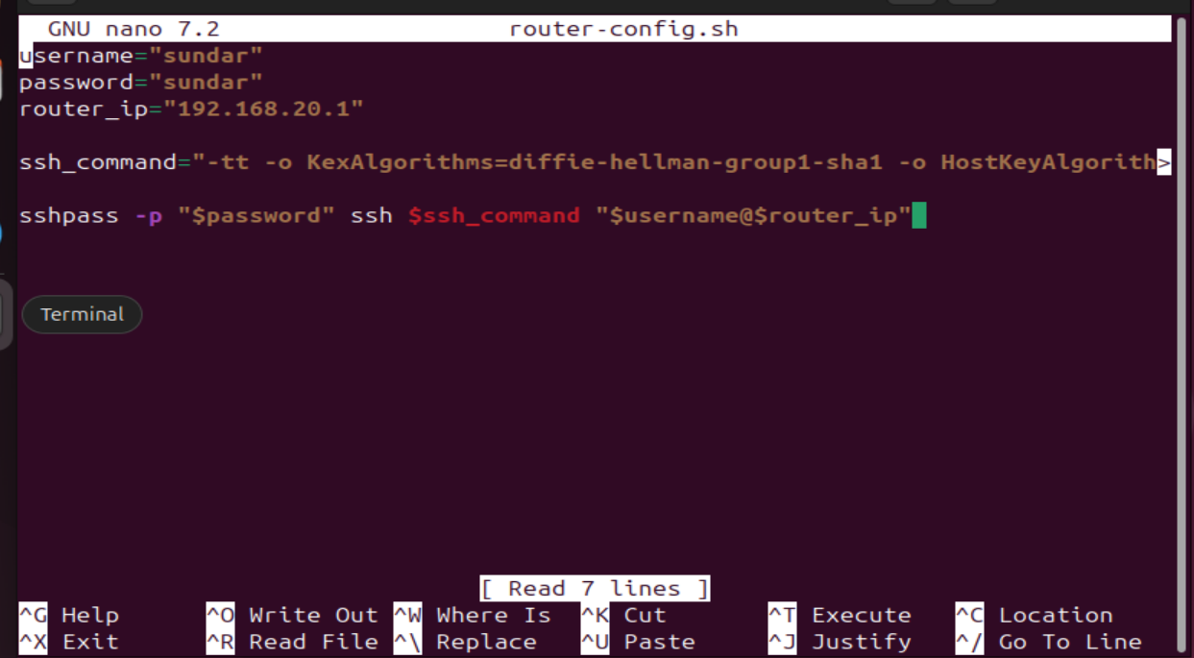

I have ssh using:

Checking sh run from ubuntu machine:

Task 4:

Command to work inside

source ~/ansible-venv/bin/activate

---

pip install ansible

--

Output of task 4:

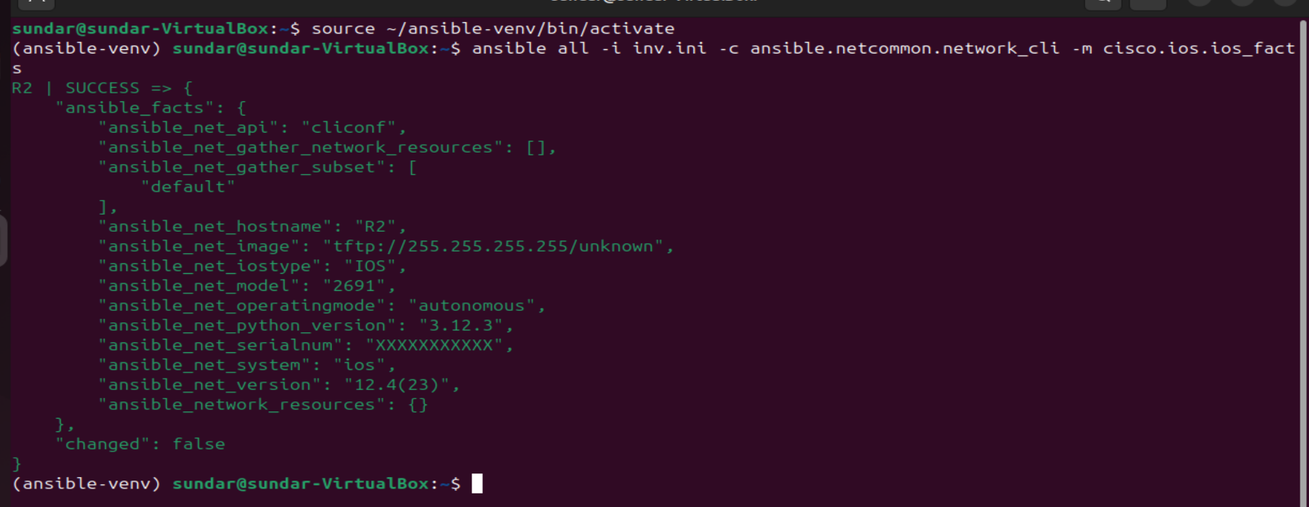

Task 5:

Confirming whether its working or not:

With command:

Task 6:

Created secondd.yml

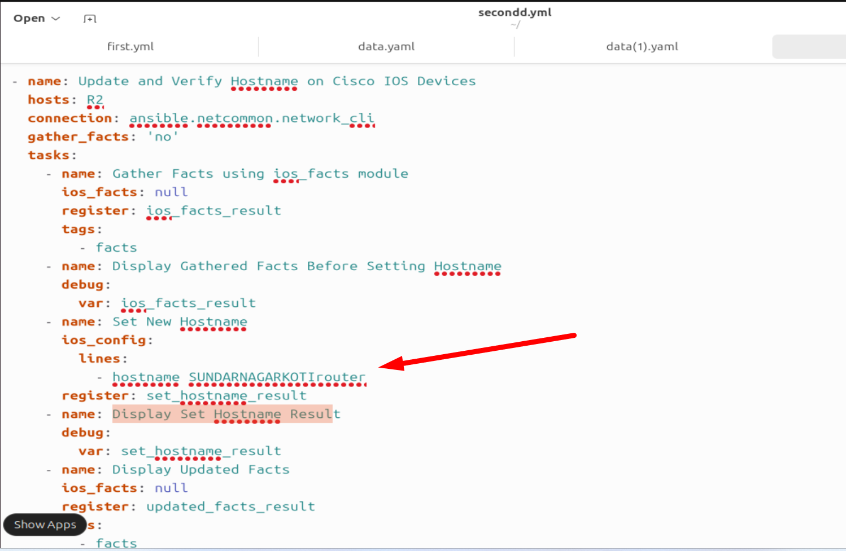

Final result after changing the hostname to sundarnewrouter:

Before:

After changing the hostname:

Verifying through router console:

