JPetStore Performance Test Report

  - Summary
JpetStore (https://petstore.octoperf.com) is a testing web platform that mimic a pet store. It has different kinds of pet products such as Birds, Dogs, Cats, Reptiles and Fish. It offers different species or breeds under each pet product. The web platform enables the performance testers to test different workflows such as navigating different pet products, searching pet products, adding pet species to cart, verifying or updating the cart and completing the order through payment page.
  - Objective
The objective of this test is to measure the performance of the JPetStore web portal. The following metrics are validated and reported from the load test
- Throughput
- Response time
- Total transactions
- Percentiles
- Errors
This test will serve as a baseline numbers for the JPetStore portal. The JPetStore web portal do not have the information about the servers or software versions that limits us to carry out further performance investigation or comparison.
This performance test considers only load test under the assumption that the website is processing a scenario for every 2 seconds. As the capability of the servers that host the JPetStore and the volume of data in the portal are not known, stress test, spike test and volume test are not conducted.
  - Test Configuration
The load test is conducted with 30 users for a duration of 1 hour (with a ramp up duration of 60 seconds).
The workload is distributed among the following identified scenarios
No | Scenario
1 | Buy Fish
2 | Buy Cats
3 | Buy Reptiles
4 | Buy Birds
5 | Buy Dogs
6 | Buy Multiple Pets  (Two pets are considered for this scenario)
7 | Search and Buy
8 | Search and Add to Cart
9 | Login and Logout

    - Workload Model
The test had the following workload model (with the assumption that the pet store process a scenario every 2 seconds)

No | Scenario | No of Users | Pacing | Scenario response time with Think time | Buffer
1 | Buy Fish | 8 | 5 | 53 | 3
2 | Buy Cats | 4 | 4 | 52 | 3
3 | Buy Reptiles | 1 | 2 | 53 | 3
4 | Buy Birds | 2 | 3 | 52 | 3
5 | Buy Dogs | 5 | 4 | 52 | 3
6 | Buy Multiple Pets | 6 | 1 | 56 | 3
7 | Search and Buy | 2 | 2 | 53 | 3
8 | Search and Add to Cart | 1 | 2 | 53 | 3
9 | Login and Logout | 1 | 22 | 33 | 3

    - Test Data
The following are the data used in this test
- 30 Users are created in the JPetStore portal (peruser01 to perfuser30). These users are distributed to all the threads/users and reused in each scenarios
- The Scenarios for buying a specific pet product has data of pet’s product IDs and Item IDs
- The “Multiple Pet Scenario” (orders two pets) contains name of the pet, distinct pet product IDs and distinct pet species IDs
- The “Search & Buy” and “Search & Add to Cart” scenarios contains distinct pet Product IDs, Name of the pet Product and distinct pet Species IDs under the product
- The quantity of the items in the cart will be updated with the randomly generated integer between 1 to 5

  - Test Scope
This section elaborates in-scope and out-of-scope items for this test
    - In-Scope
The scope of the performance test includes the following
- Running a Load test with the JpetStore web portal with a duration of 1 hour
- The workflows contain completing an online order of pets through click or search, adding them to cart and making a payment. Other workflows such as adding an pet species/item to cart (with out buying) and Login/Logout were considered for the test
- The performance of the web portal is analyzed using metrics such as throughput, latency, percentile along with error rate are analyzed with the result

    - Out-of-Scope
The following are the out-of-scope items considered for this test
- functional testing
- The server metrics for the web portal are not collected during the load test as those information are not available
- Stress test, spike test and endurance test is considered out of scope as the capacity of the web instance is unknown

  - Test Result

    - Overall test result
The following table shows the overall result of the load test
Parameters | Value
Total transactions | 32476
Total scenario processed | 1942
Errors | 2 (0.006%)
Throughput (Hits/sec) | 9.13
Average response time | 177.93 ms
Average 99% | 528.27 ms
Average 95% | 306.85 ms
Average 90% | 260.62 ms

The following are the number of Expected and Actual scenarios achieved during the load test. The Actual number of target scenarios achieved in the test is higher than expected due to the 5% buffer provided for errors, network/script overhead and higher latencies resulted from servicing the workload
Scenario No | Scenario | Excepted target processed | Actual target processed
1 | Buy Fish | 472 | 508
2 | Buy Cats | 244 | 259
3 | Buy Reptiles | 62 | 68
4 | Buy Birds | 124 | 132
5 | Buy Dogs | 305 | 323
6 | Buy Multiple Pets | 360 | 382
7 | Search and Buy | 124 | 135
8 | Search and Add to Cart | 62 | 68
9 | Login and Logout | 62 | 67

    - Response time of transactions
The average of Average Response Time (ART) of all the transaction is 177.83 ms. The maximum response time of all the transaction is below 3 seconds (Assumption: 3 secs is considered to be SLA for most UI scenarios for web interactions)
The following are some of the Response times of specific transaction that are common to most of the scenarios
      - Response time of Launch Transactions
The response time of launching the JPetStore web portal took ~180 ms to ~450 ms. The following plot shows launch times for each of the scenarios during the duration of the test

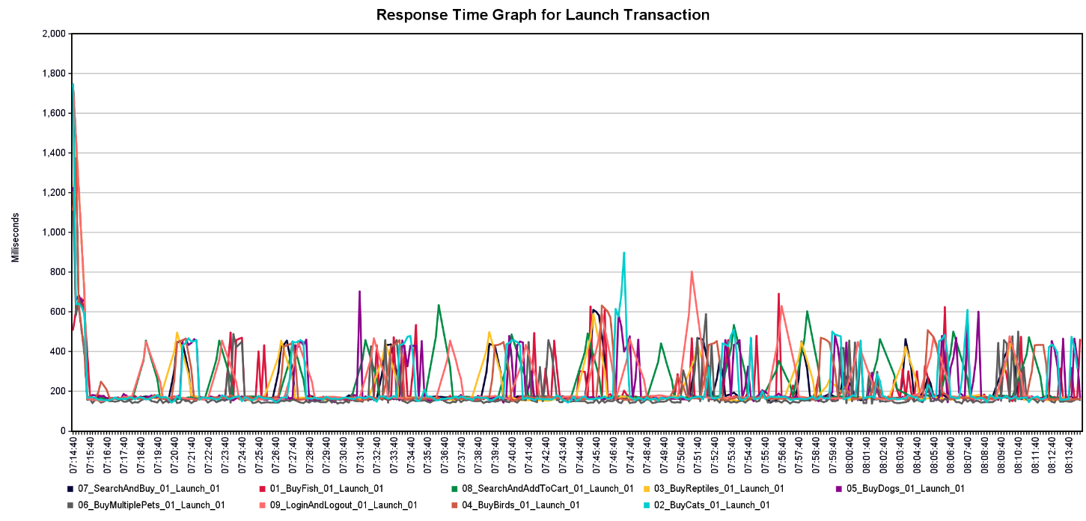
      - Response time of Login Transaction
The response time of login usually stayed under 580 ms with some exception happened toward the end of the load test reaching 630 ms to 800ms.
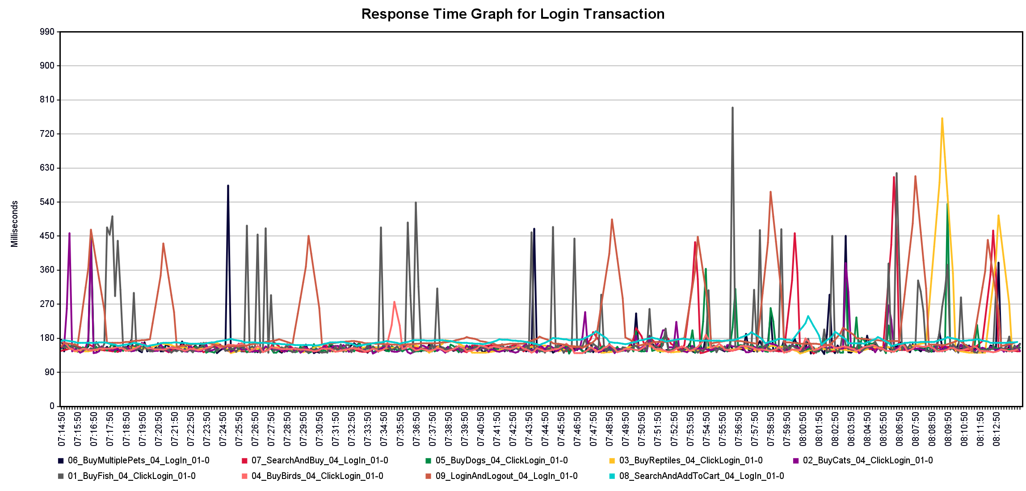
      - Response time of Adding Items to Cart Transaction
The response time of adding item to cart ranges between ~180 ms to ~450 ms with exceptions. The maximum response time of 1.45 ms is seen in Buy Cats scenario during 45 min in to the test.
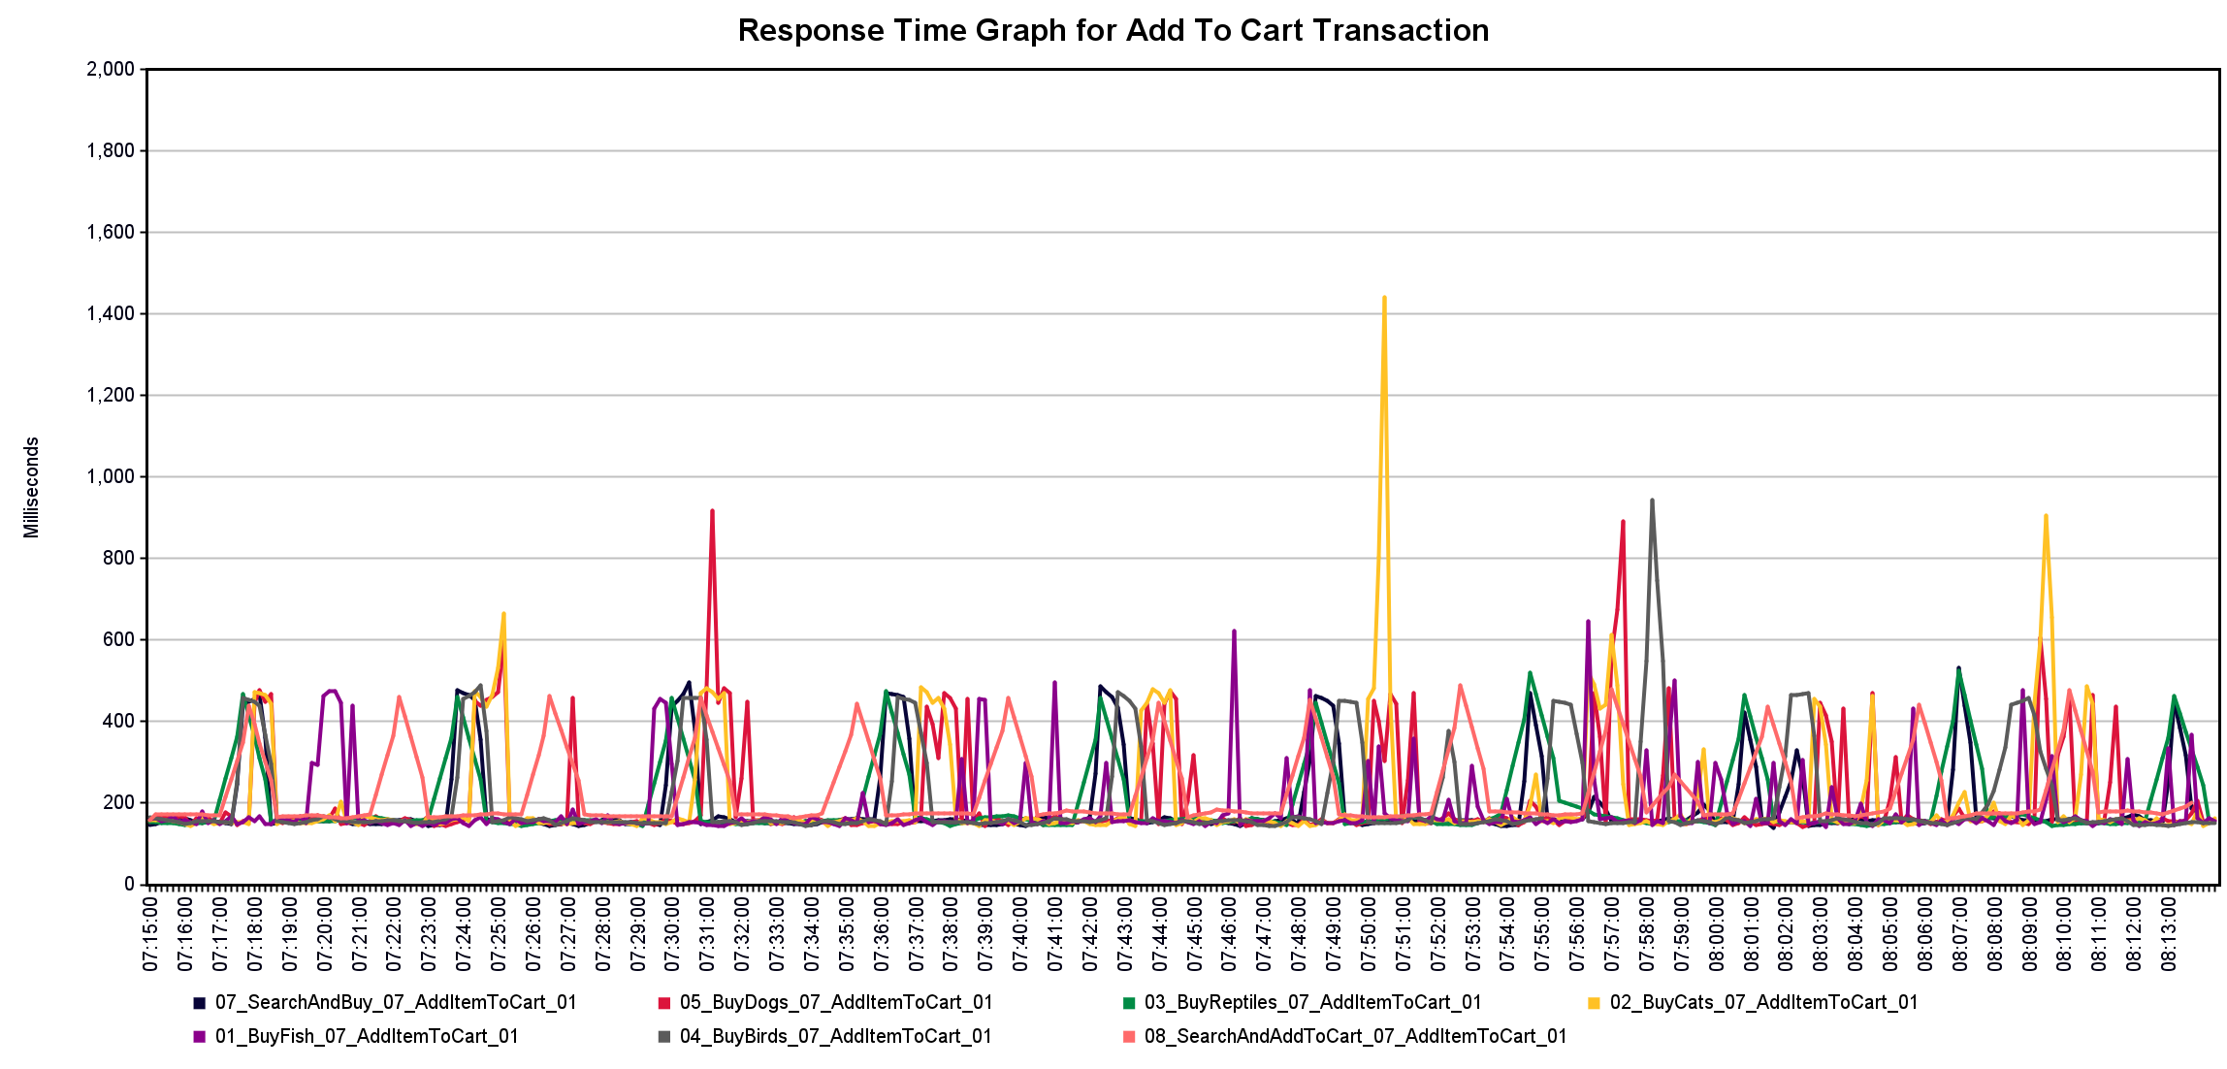
      - Response time of Payment transaction
The response time of payment transaction mostly varied between ~ 180 ms and ~500 ms with the exception heading to a maximum of ~630 ms.
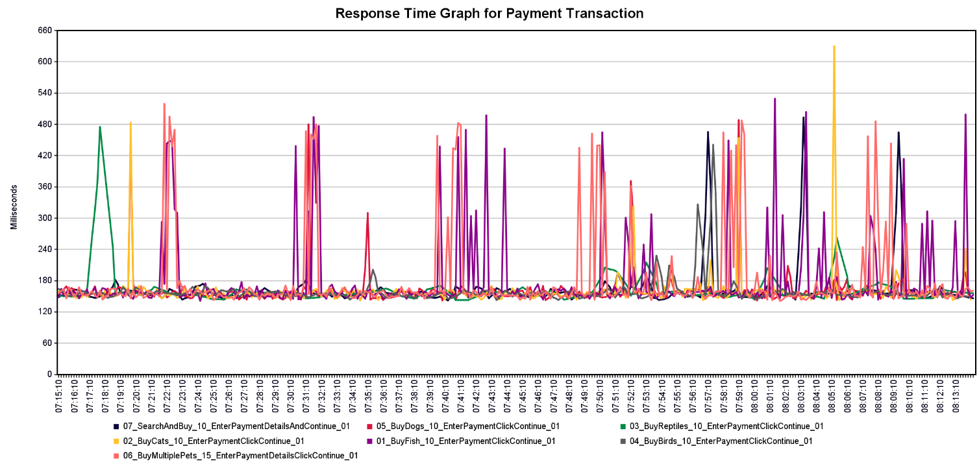

    - Throughput (Hits/sec)
Each scenario contain multiple transactions in the workflow, which hits the server. The average of transaction processed per second is 9.13 (If we consider the response from redirection, the throughput increases to 10.11). The total transaction processed is 32476 during the test. The following plot shows the number of responses/sec received from the web portal
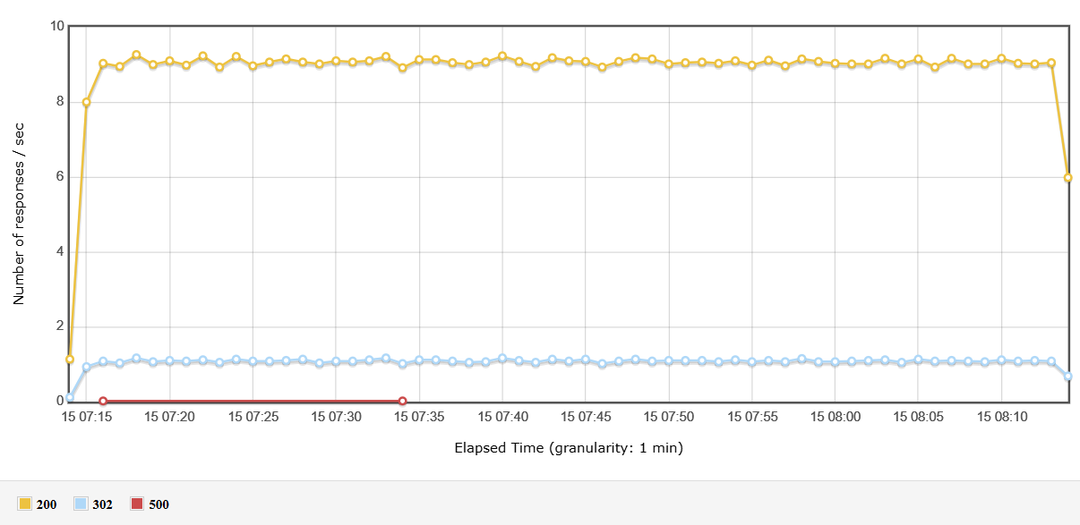
1.5.4 Percentiles
The average 90%, 95% and 99% of the response time were 260.62 ms, 306.85 ms and 528.27 ms.
1.5.5 Errors
There are 2 errors during the duration of the test. Both the errors are due to internal server error in the web portal
The following table shows the errors during the test
Sample | Sample Number | Error Code
01_BuyFish_11_ConfirmOrder_01 | 509 | 500
02_BuyCats_11_ConfirmOrder_01 | 259 | 500

  - Conclusion
The above result shows the performance results are within the assumed SLA of 3 seconds. Although, server metrics are not analyzed, this result servers as a baseline for the JPetStore. The response time of the plot was analyzed and plotted to check any deviation from the expected results.

