JPetStore Performance Test Report

  - Summary
JpetStore (https://petstore.octoperf.com) is a testing web platform that mimic a pet store. It has different kinds of pet products such as Birds, Dogs, Cats, Reptiles and Fish. It offers different species or breeds under each pet product. The web platform enables the performance testers to test different workflows such as navigating different pet products, searching pet products, adding pet species to cart, verifying or updating the cart and completing the order through payment page.
  - Objective
The objective of this test is to measure the performance of the JPetStore web portal. The following metrics are validated and reported from the load test
- Throughput
- Response time
- Total transactions
- Percentiles
- Errors
This test will serve as a baseline numbers for the JPetStore portal. The JPetStore web portal do not have the information about the servers or software versions that limits us to carry out further performance investigation or comparison.
This performance test considers only load test under the assumption that the website is processing a scenario for every 2 seconds. As strength of the servers that host the JPetStore and the volume of data in the portal are not known; stress test, spike test and volume test are not conducted.
  - Test Configuration
The load test is conducted with 30 users for a duration of 1 hour (with a ramp up duration of 60 seconds).
The workload is distributed among the following identified scenarios
No | Scenario
1 | Buy Fish
2 | Buy Cats
3 | Buy Reptiles
4 | Buy Birds
5 | Buy Dogs
6 | Buy Multiple Pets  (Two pets are considered for this scenario)
7 | Search and Buy
8 | Search and Add to Cart
9 | Login and Logout

    - Workload Model
The test had the following workload model (with the assumption that the pet store process a scenario every 2 seconds)

No | Scenario | No of Users | Pacing | Scenario response time with Think time | Buffer
1 | Buy Fish | 8 | 5 | 53 | 3
2 | Buy Cats | 4 | 4 | 52 | 3
3 | Buy Reptiles | 1 | 2 | 53 | 3
4 | Buy Birds | 2 | 3 | 52 | 3
5 | Buy Dogs | 5 | 4 | 52 | 3
6 | Buy Multiple Pets | 6 | 1 | 56 | 3
7 | Search and Buy | 2 | 2 | 53 | 3
8 | Search and Add to Cart | 1 | 2 | 53 | 3
9 | Login and Logout | 1 | 22 | 33 | 3

    - Test Data
The following are the data used in this test
- 30 Users are created in the JPetStore portal (peruser01 to perfuser30). These users are distributed to all the threads/users and reused in each scenarios
- The scenarios for buying a specific pet product has pet product IDs and Item IDs
- The “Multiple Pet Scenario” (orders two pets) contains name of the pet, distinct pet product IDs and distinct pet species IDs
- The “Search & Buy” and “Search & Add to Cart” scenarios contains distinct pet Product IDs, Name of the pet product and distinct pet Species IDs under the product
- The quantity of the items in the cart will be updated with the randomly generated integer between 1 to 5

  - Test Scope
This section elaborates in-scope and out-of-scope items for this test
    - In-Scope
The scope of the performance test includes the following
- Running a Load test on the JpetStore web portal with a duration of 1 hour
- The workflows contain completing an online order of pets through click or search, adding them to cart and making a payment. Other workflows such as adding an pet species/item to cart (with out buying) and Login/Logout were considered for the test
- The performance of the web portal is analyzed using metrics such as throughput, latency, percentile along with error rate are analyzed with the result

    - Out-of-Scope
The following are the out-of-scope items for this test
- functional testing
- The server metrics for the web portal are not collected during the load test, as those information are not available
- Stress test, spike test and endurance test is considered out of scope as the capacity of the web instance is unknown

  - Test Result

    - Overall test result
The following table shows the overall result of the load test
Parameters | Value
Total transactions | 24562
Total scenario processed | 1948
Errors | 0
Average Throughput (Hits/sec) | 15.638
Average response time | 347.47 ms
Average 90% | 359.46 ms

The following are the number of Expected and Actual scenarios achieved during the load test. The Actual number of target scenarios achieved in the test is higher than expected due to the 5% buffer provided for errors, network/script overhead and higher latencies resulted from servicing the workload
Scenario No | Scenario | Excepted target processed | Actual target processed
1 | Buy Fish | 472 | 512
2 | Buy Cats | 244 | 261
3 | Buy Reptiles | 62 | 67
4 | Buy Birds | 124 | 132
5 | Buy Dogs | 305 | 325
6 | Buy Multiple Pets | 360 | 384
7 | Search and Buy | 124 | 133
8 | Search and Add to Cart | 62 | 68
9 | Login and Logout | 62 | 66

    - Response time of transactions
The average of Average Response Time (ART) of all the transaction is 347.47 ms and are below 3 seconds (Assumption: 3 secs is considered to be SLA for most UI scenarios for web interactions). However, some of the transactions have maximum response time greater than 3 seconds (Due to server load, network latency or server capacity limits).
The following are response times of specific transaction that are common to most of the scenarios

      - Response time of Launch Transactions
The average response time of launching the JPetStore web portal took ~957 ms to ~1012 ms. The following plot shows launch times of the web portal for each of the scenarios during the duration of the test
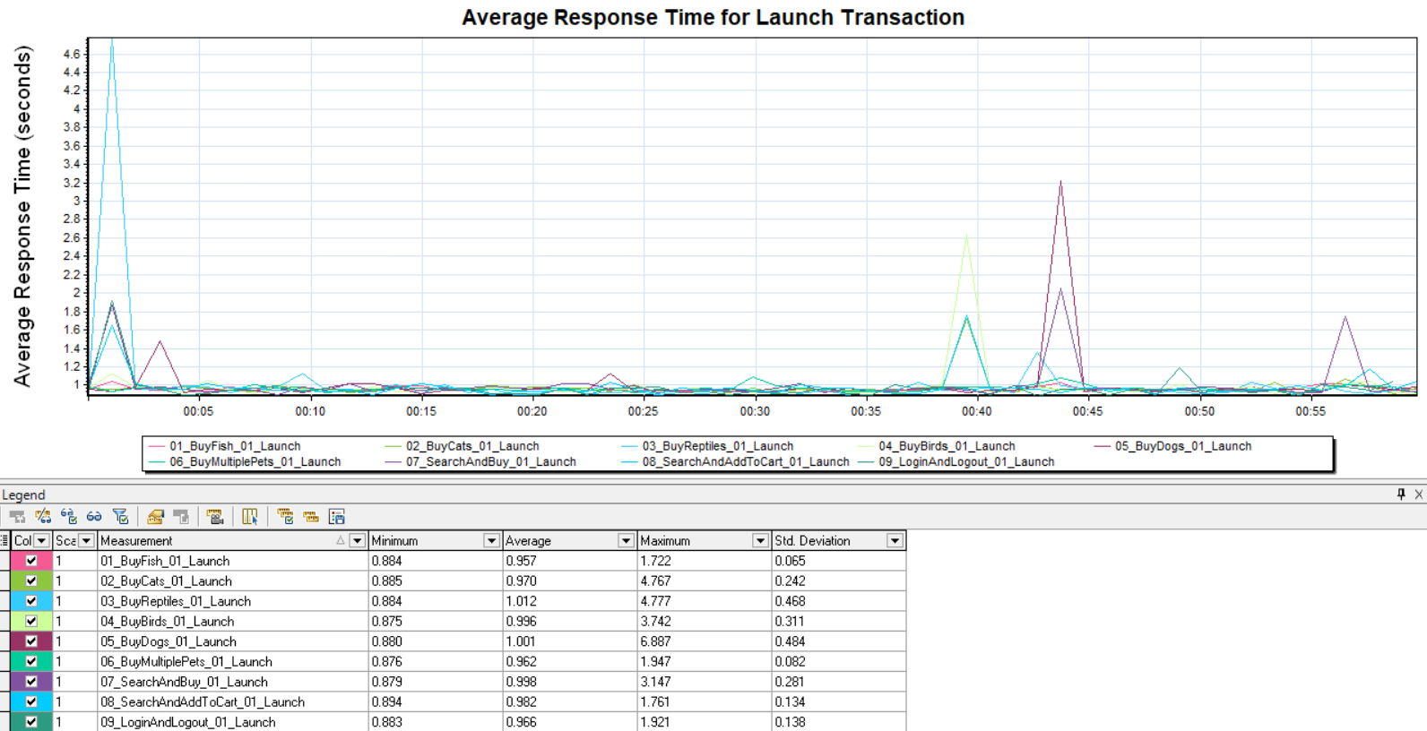

      - Response time of Login Transaction
The response time of login stayed under 484 ms with some exception happened toward the end of the load test reaching 2257 ms for Login & Logout scenario.
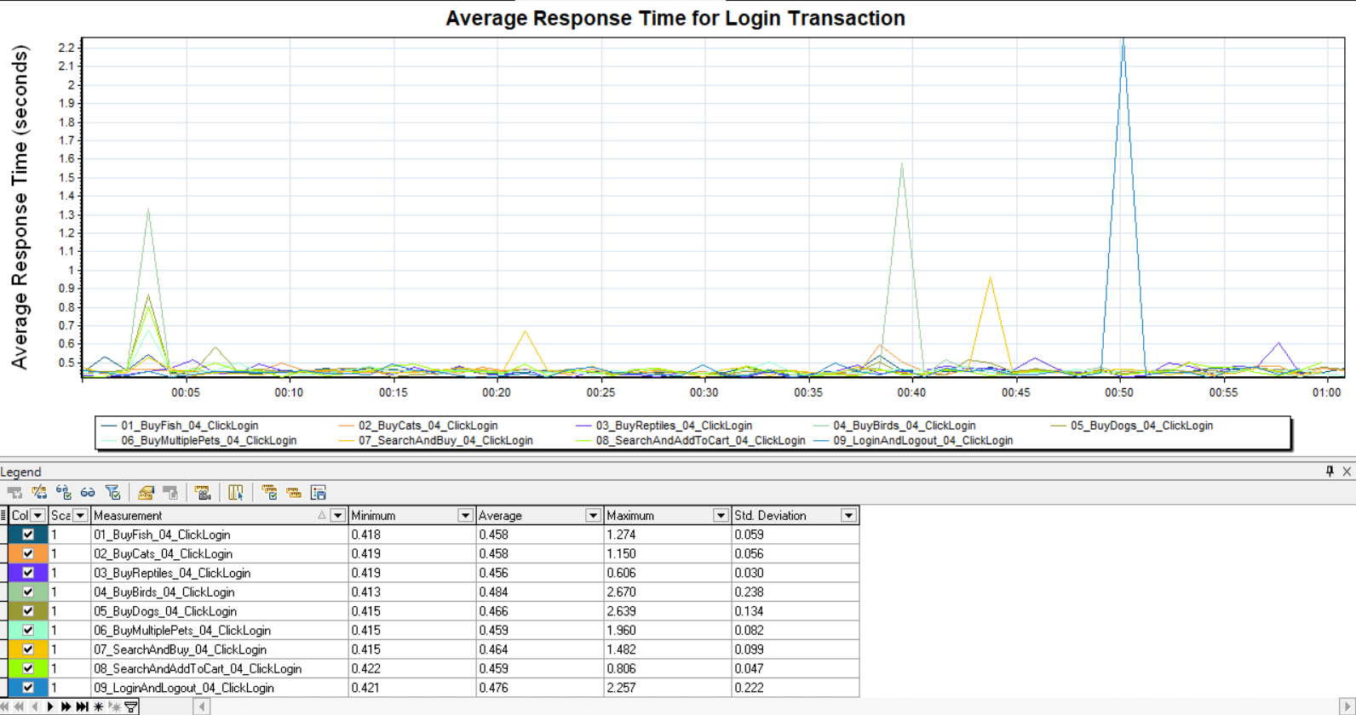
      - Response time of Adding Items to Cart Transaction
The average response time of adding item to cart ranges between ~154 ms to ~161 ms. The maximum response time of 783 ms is seen in Search and Buy scenario.
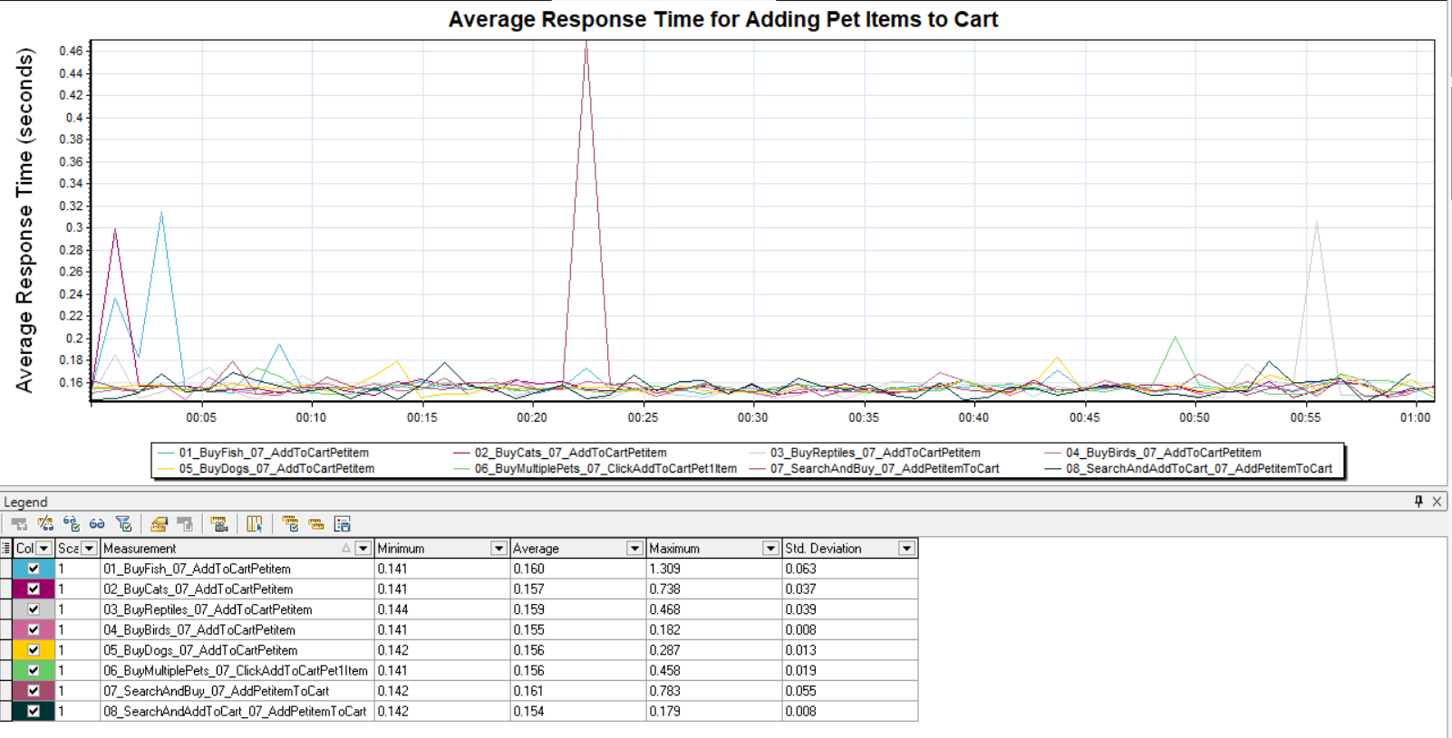
      - Response time of Payment transaction
The average response time of payment transaction varied between 302 ms to 321 ms. The maximum response time was seen in “Buy Cats” and “Buy Birds” scenarios reaching 2522 ms and 2587 ms respectively.
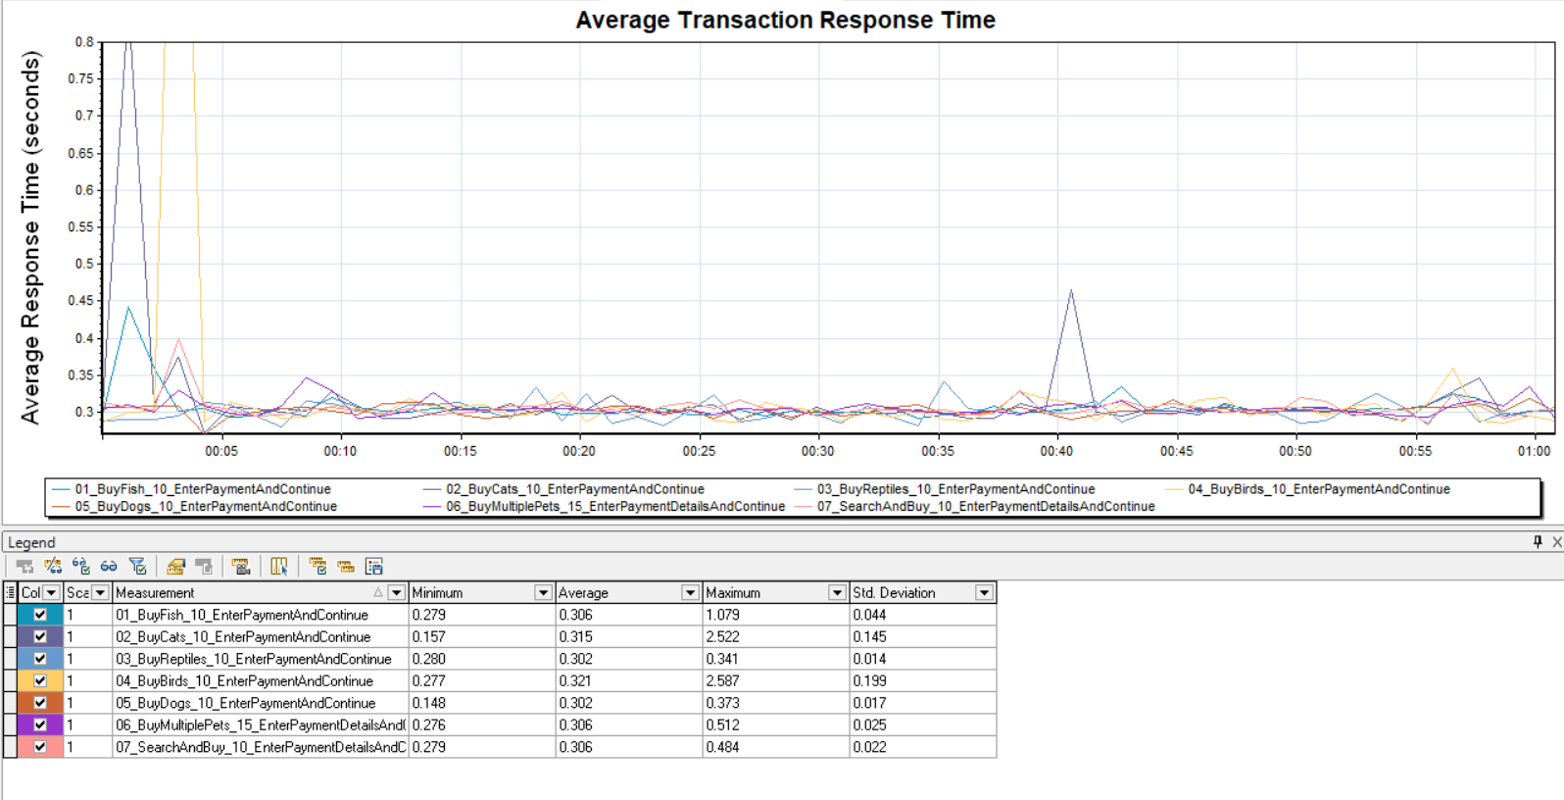

    - Throughput
Each scenario contain multiple transactions in the workflow. The average transaction processed per second is 6.63. The total transaction processed is 24562 during the test. The following plot shows the number of hits/sec received by the web portal
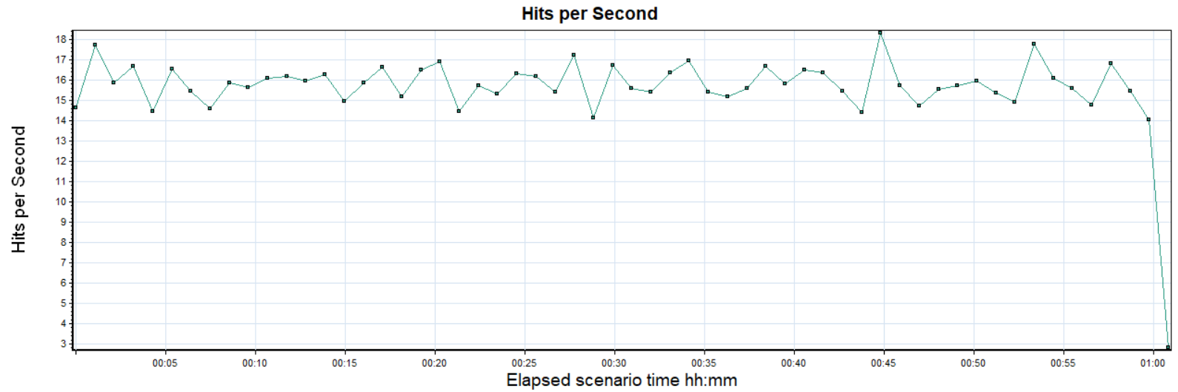
The following graphs shows the total number of transaction processed per second. A transaction will issue multiple request to the server based on the user action. Hence, we are seeing a difference in the total number of Hits/sec and transactions/sec.
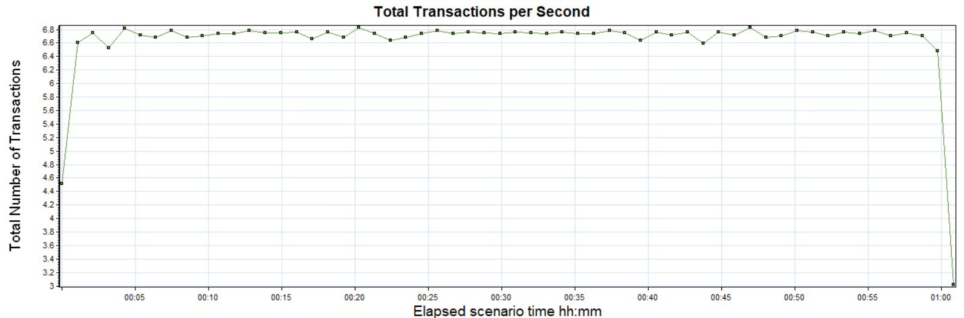
1.5.4 Percentiles
The average 90% of the response time were 359.46 ms.
1.5.5 Errors
There are no errors or failed transactions in the test.
  - Conclusion
The above result shows the performance results are within the assumed SLA of 3 seconds. Although, server metrics are not analyzed, this result servers as a baseline for the JPetStore web portal. The response time of the plot was analyzed and plotted to check any deviation from the expected results.

