**Dashboard:**

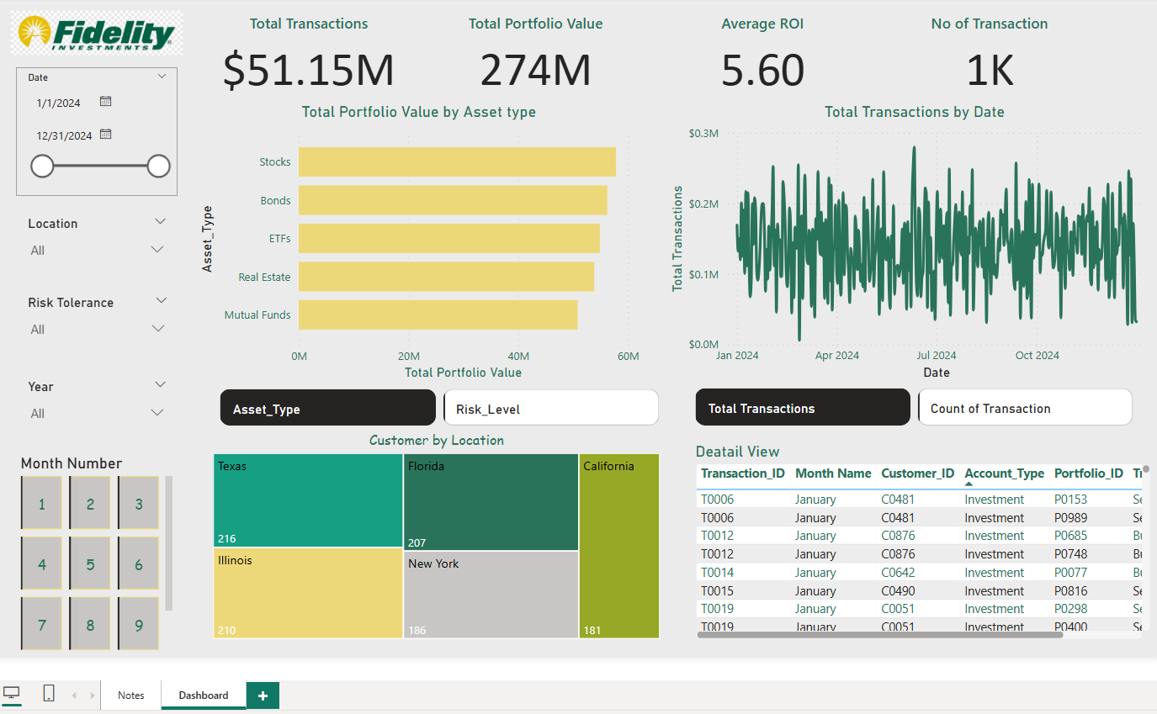

**Approach:**

1. Make sure star schema is achieved in the BI model.
2. Data types and columns are right.
3. Relationship are there between tables.
4. Calendar Table is implemented.
5. Field Parameter for toggling visuals.
6. The key metrics are able to tell the story.
7. Color pallets are right

Question

**1.Embed the Report in Web Portal**

1. Need to publish the report to the Power BI service.
2. From Power Bi Service, nee dto File -->Menu -->Website or Portal get the HTML Code and use html link to embed in the url.
3. User Authentication / Row Level Security

**2.Row Level security can be achieved using Static/ Dynamic RLS in Power BI, following are the step to implement them.**

a. Static RLS :

1.Click on Manage Role.

2.Select the tables we want to filter, and filter for specific [Column] = 'xx'.

3.Roles are then created and managed in Power BI Service to add the ID where users are restricted to specific level of data.

b. Dynamic RLS:

1. We need to have RLS table set for the Dynamic one, we need to have User ID listed, specific filters the users wanted to see and the roles has to be created.
2. The mapping has to joined with the filtering table and should be enabled with USERPRINCIPLNAME().
3. The Azure AD group should be added in Power BI service under the securities.

**3.Optimize data** with a massive amount of rows (optimization techniques and data consumption techniques).

1. 1.Can be achieved through Incremental refresh in Power bI.
2. 2. enabling Fabric capacities.
3. 3. Approach through Hybrid tables enabling direct queries, incremental refresh for single. table.
4. 4. Composite model method.