**Problem Definition:**

The problem is to build an AI-powered diabetes prediction system that uses machine learning algorithms to analyze medical data and predict the likelihood of an individual developing diabetes. The system aims to provide early risk assessment and personalized preventive measures, allowing individuals to take proactive actions to manage their health.



**Design Thinking:**

1. Functionality: Define the scope of the chatbot's abilities, including answering common questions, providing guidance, and directing users to appropriate resources.
2. User Interface: Determine where the chatbot will be integrated (website, app) and design a user-friendly interface for interactions.
3. Natural Language Processing (NLP): Implement NLP techniques to understand and process user input in a conversational manner.
4. Responses: Plan responses that the chatbot will offer, such as accurate answers, suggestions, and assistance.
5. Integration: Decide how the chatbot will be integrated with the website or app.
6. Testing and Improvement: Continuously test and refine the chatbot's performance based on user interactions

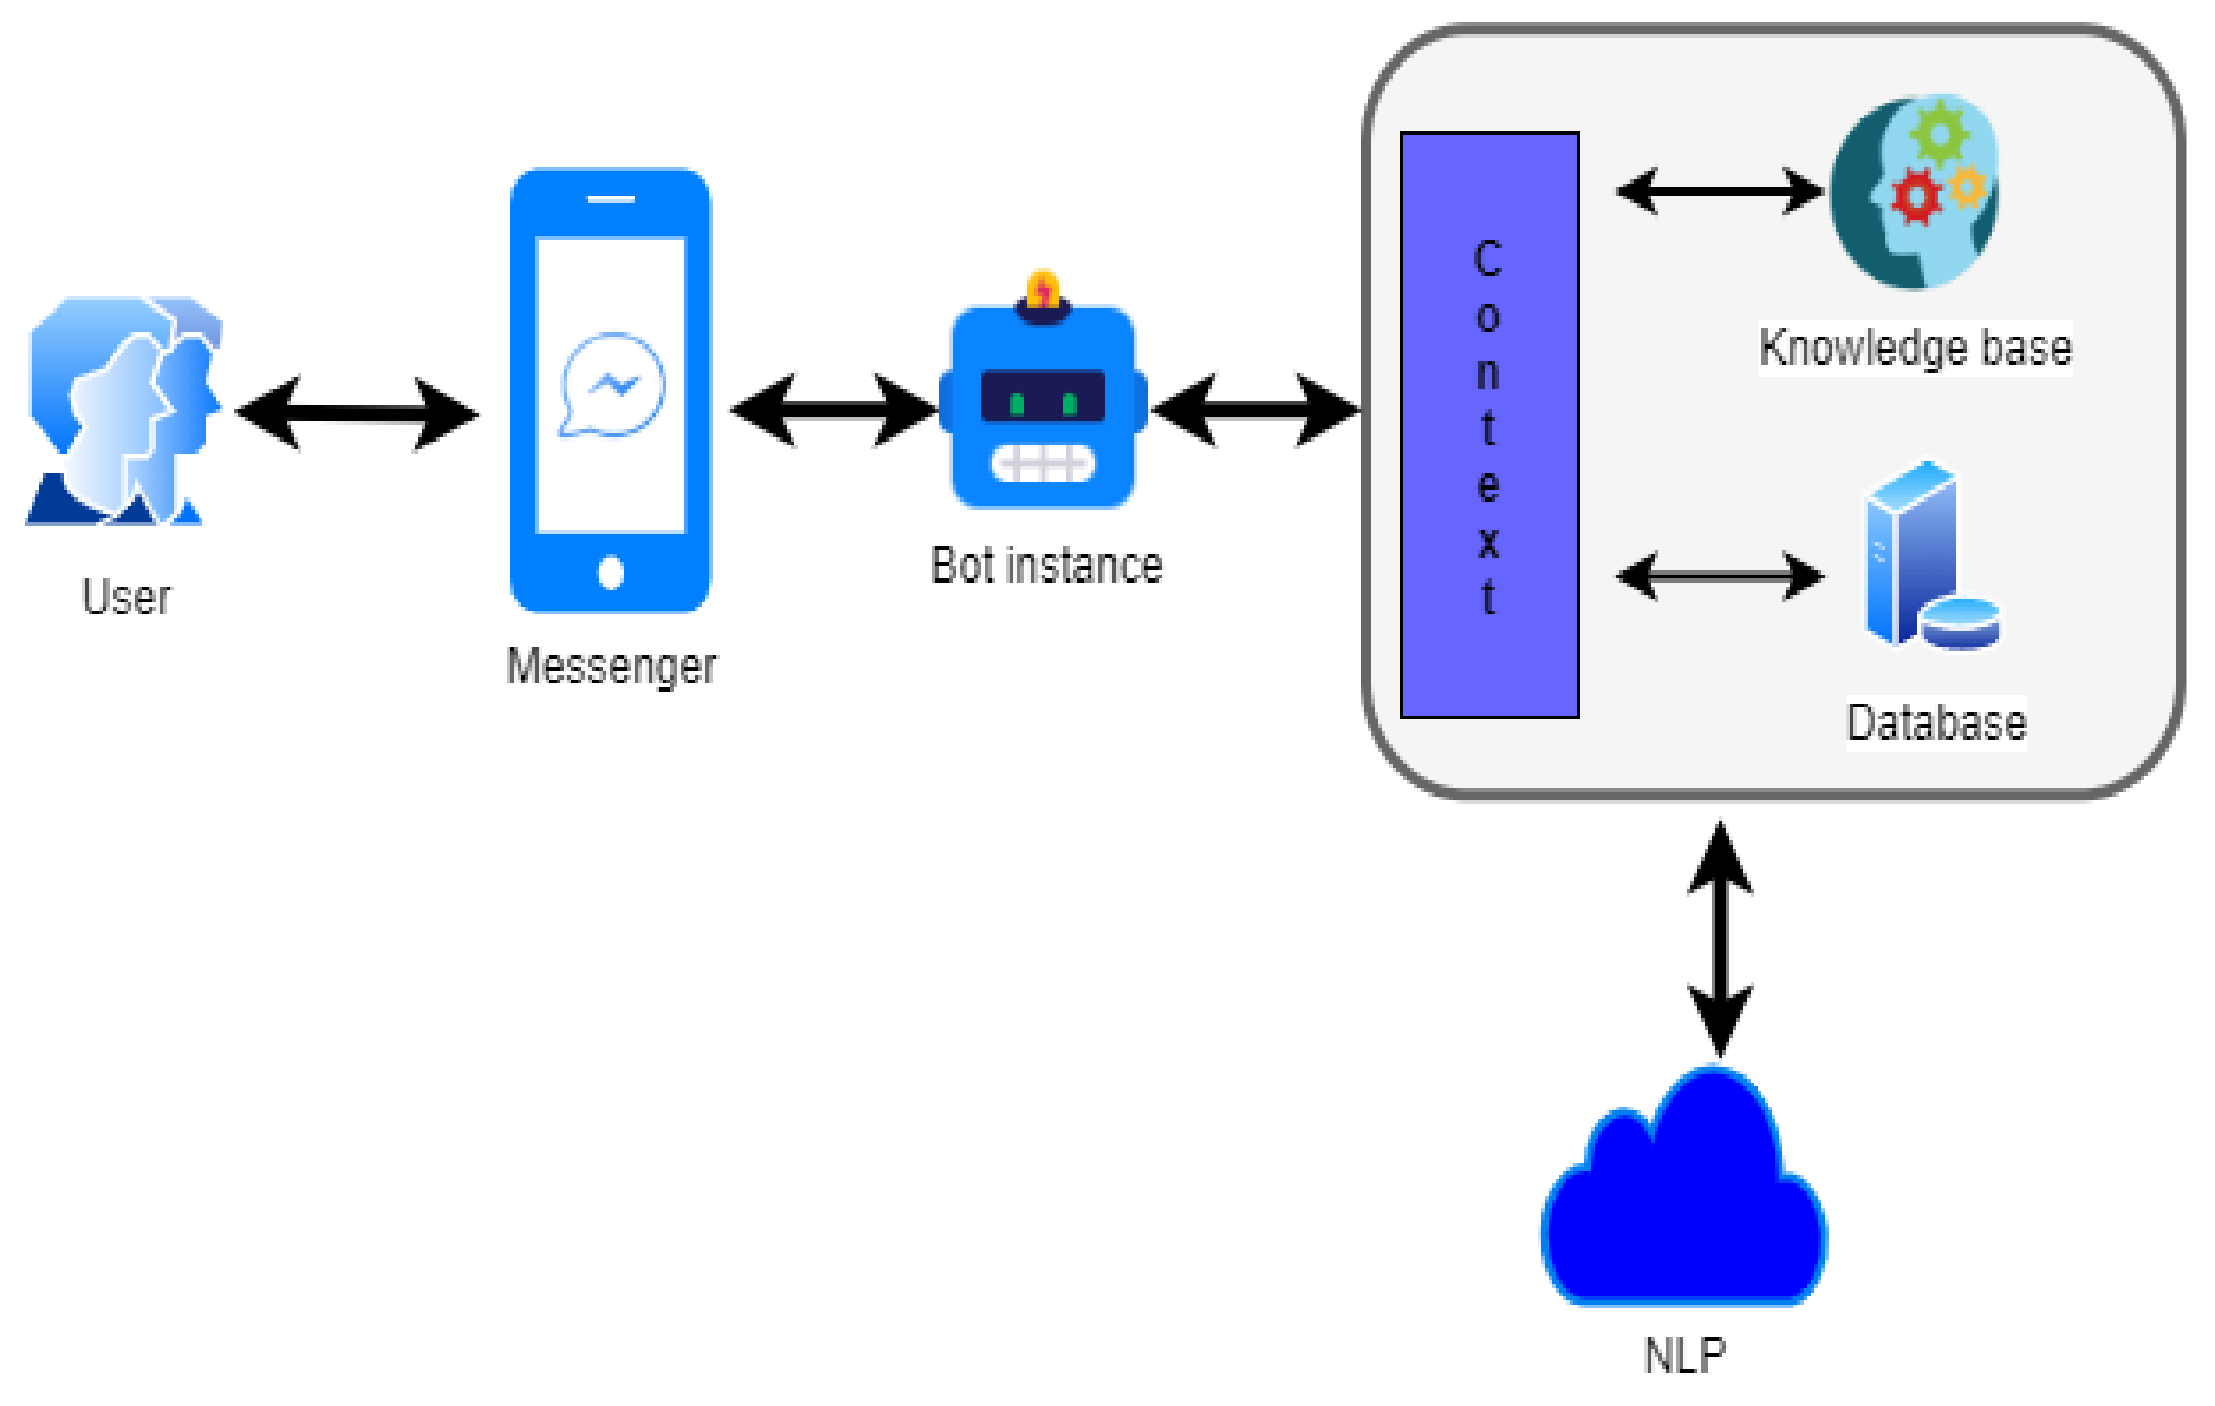

**Innovation in Chatbot:**

1. **Conversational Memory and Context:**

Innovations in chatbots include the ability to maintain context and remember

previous parts of a conversation. This allows chatbots to have more natural and

continuous interactions with users by recalling previous questions and responses.

Conversational memory is how a chatbot can respond to multiple queries in a chat-

like manner. It enables a coherent conversation, and without it, every query would be

treated as an entirely independent input without considering past interactions. The

LLM with and without conversational memory. The blue boxes are user prompts and

in grey are the LLMs responses. Without conversational memory (right), the LLM

cannot respond using knowledge of previous interactions. The memory allows a

Large Language Model (LLM) to remember previous interactions with the user. By

default, LLMs are stateless — meaning each incoming query is processed

independently of other interactions.

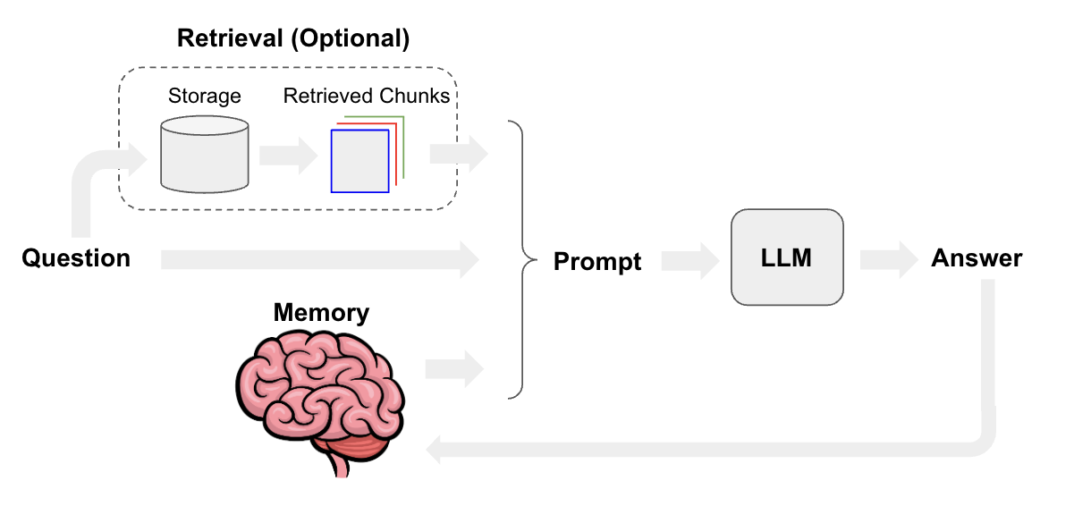

1. **Multimodal Capabilities:**

Chatbots are increasingly incorporating support for multiple modes of

communication, such as text, voice, and images. This enables users to interact with

chatbots using their preferred method, making interactions more flexible and

accessible. Multimodal AI is artificial intelligence that combines multiple types, or

modes, of data to create more accurate determinations, draw insightful conclusions or

make more precise predictions about real-world problems. Multimodal AI systems

train with and use video, audio, speech, images, text and a range of traditional

numerical data sets. Most importantly, multimodal AI means numerous data types are

used in tandem to help AI establish content and better interpret context, something

missing in earlier AI.

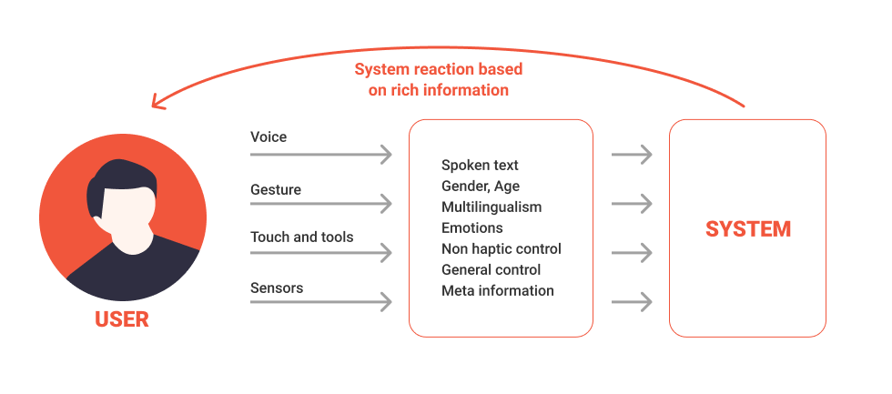

1. **AI-driven Emotion Recognition:**

Innovations in emotion recognition technology enable chatbots to detect and respond

to users' emotions. Chatbots can adjust their tone and responses based on the user's

emotional state, leading to more empathetic and personalized interactions. A

conversational dataset is required to evaluate the performance of a chatbot. Moreover,

the dataset must be labeled with emotional tags to feed the encoder with emotional

input and train the decoder to generate appropriate output. AI-driven chatbots can

detect user sentiments in a conversation, thus triggering the chatbot to comprehend

the user’s emotional state and generate an appropriate response. Facial expression

recognition, or face computing, is a sub-field of image processing. In most common

cases it allows companies to detect the emotions of people passing by their cameras.

It may be used for marketing purposes, in healthcare, robotics — basically, in any

field that requires an in-depth understanding of the human emotional response to

certain activities. Facial recognition technology can be as well applied in many

security cases including access control, authentification, payment verification, as well

as in interviews, or interrogations. Emotion AI in face detection measures the facial

expressions using any optical sensor like a standard web/ smartphone camera,

detecting a human face in real-time, in a pre-recorded video or images. Computer

vision algorithms identify the main points of an individual's face: eyes, the tip of the

nose, eyebrows, corners of the mouth, etc., and track their movement to decode

emotions. By comparing this gathered data to a vast library of template images, facial

expression detection software can determine the person’s feelings based on the

combination of facial expressions. Advanced emotion AI solutions like those

provided by Affectiva or Kairos can measure the following emotion metrics: joy,

sadness, anger, contempt, disgust, fear, and surprise. Additional software features

may include facial identification and verification, age and gender detection, ethnicity

and multi-face detection, and much more. Recognizing emotion from speech has

become the next stage of natural language processing, adding new value to the

human-computer interaction. Voice emotion recognition software enables to process

audio files containing human voice and analyzes not what is said, but how it is said,

by extracting the paralinguistic features and observing changes in tone, loudness,

tempo, voice qualities to interpret these as human emotions, distinguish gender, age,

etc. Voice analysis and emotion detection are already used by major brands in many

industries, including market research, call centers, social robotics, healthcare, and

many more. Voice recognition software works similarly to facial emotion recognition.

The underlying technology uses machine learning algorithms (deep learning with

Python, convolutional neural networks in Keras/ TensorFlow, other deep learning

algorithms) to recognize emotional states from acoustic speech and measure with high

levels of accuracy whether the speaker is happy, sad, surprised, angry or has a neutral

state of mind. Nemesysco developed a technology named Layered Voice Analysis

(LVA) to detect stress and deception in the speech by leveraging above 150

uncontrollable biomarkers to trace the genuine emotion of the speaker regardless of

their language and tone of voice. Insights this technology can provide are invaluable

for customer experience management, forensic science, security and fraud protection

in banking and insurance, and many other industries.

