**Importing and Loading Data from Dataset:**

Loading a dataset into a chatbot typically involves several steps, and the specific method can vary depending on the programming language, chatbot framework, and the format of your dataset (e.g., CSV, JSON, or a custom format). Here's a general outline of the process:

* **Prepare Your Dataset:** Your dataset should be structured and well-organized. It could be a list of intents and responses, and it might also include entity recognition. Each row or entry in the dataset should map user input to the appropriate response.
* **Dataset Format:** Common formats for datasets include CSV, JSON, or custom formats. Ensure that your dataset format is compatible with your chosen chatbot framework.
* **Load the Dataset:** In Python, you can use libraries like pandas to load CSV or JSON files, or you can write custom code to load data from your custom format.

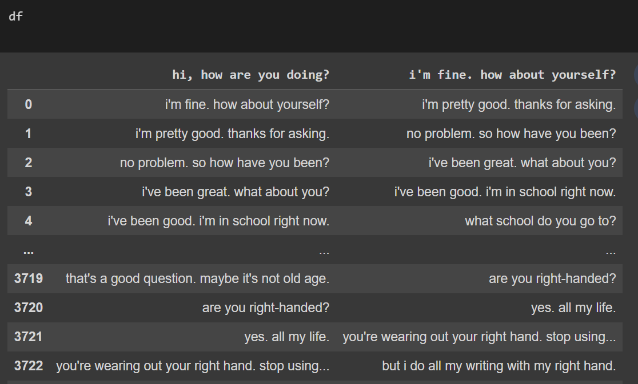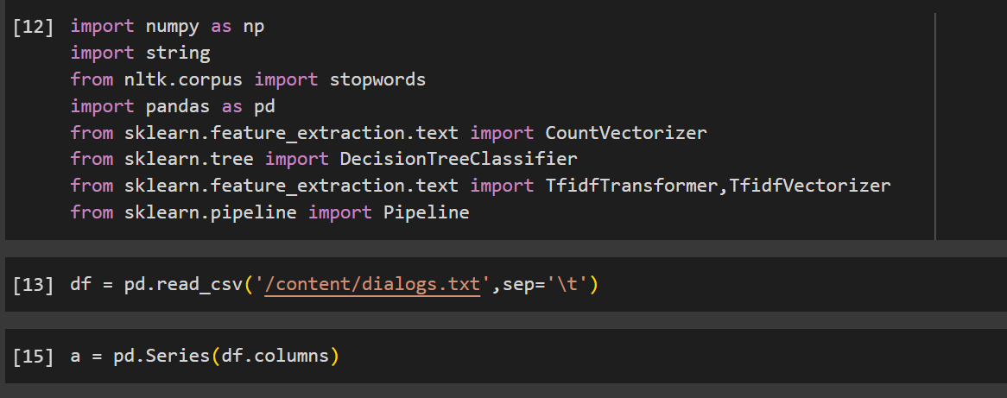

**Preprocessing The Data Set:**

Data preprocessing is a crucial step in building a chatbot, as it ensures that the dataset used for training and natural language understanding (NLU) is clean and properly formatted. Here are common data preprocessing steps in chatbot development:

1. **Data Cleaning:**
   * **Remove Duplicates:** Check for and remove duplicate entries in your dataset. Duplicates can lead to biased training and affect the chatbot's performance.
   * **Handle Missing Values:** Address any missing or null values in your dataset. Missing data can lead to issues during training.
2. **Text Cleaning and Normalization:**
   * **Lowercasing:** Convert all text to lowercase to ensure consistency.
   * **Remove Special Characters:** Remove unnecessary special characters, punctuation, and symbols that don't carry significant meaning for the chatbot.
   * **Tokenization:** Split sentences into individual words or tokens. Tokenization is essential for text analysis.
   * **Stemming and Lemmatization:** Reduce words to their root form to improve the chatbot's ability to understand variations of a word.
3. **Handling Imbalanced Data:**
   * If your dataset has imbalanced classes, you may need to oversample the minority class or under sample the majority class to ensure balanced training.
4. **Remove Stop Words:**
   * Stop words like "a," "an," "the," and other common words don't typically carry much meaning and can be removed from the text.
5. **Entity Recognition:**
   * Identify and mark entities (e.g., names, dates, locations) in your dataset. Many chatbot frameworks allow you to specify and label entities in your training data.
6. **Feature Engineering:**
   * Create additional features if needed. For instance, you might want to extract features like sentiment scores or named entity types to improve the chatbot's understanding of user input.
7. **Intent and Response Mapping:**
   * Ensure that each user input is correctly mapped to the intended intent and associated response.
8. **Dataset Splitting:**
   * Split your dataset into training, validation, and test sets. The training set is used to train the chatbot, the validation set helps tune hyperparameters, and the test set is used to evaluate the chatbot's performance.
9. **Data Format Conversion:**
   * Convert your dataset into a format suitable for your chatbot framework. For example, Rasa uses Markdown-style training data, while other frameworks may have different data format requirements.
10. **Remove Noise:**
    * Remove any irrelevant or noisy data that doesn't contribute to the chatbot's training.
11. **Data Augmentation:**
    * In some cases, you might consider data augmentation techniques to generate additional training examples, especially if your dataset is small.

After preprocessing your data, you can proceed with training your chatbot using the clean and properly formatted dataset. Regularly revisiting and refining your preprocessing steps can help improve your chatbot's performance as you continue to collect and analyze user interactions.

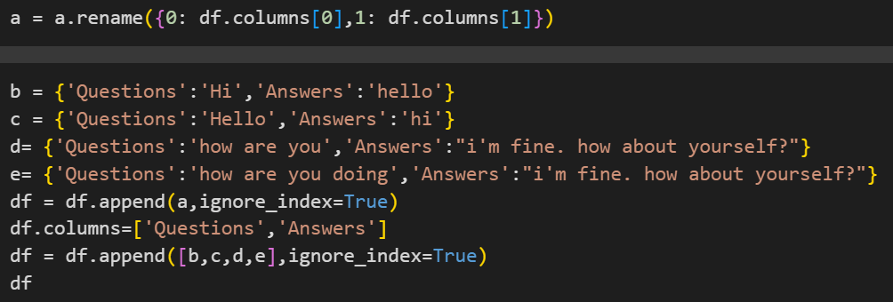

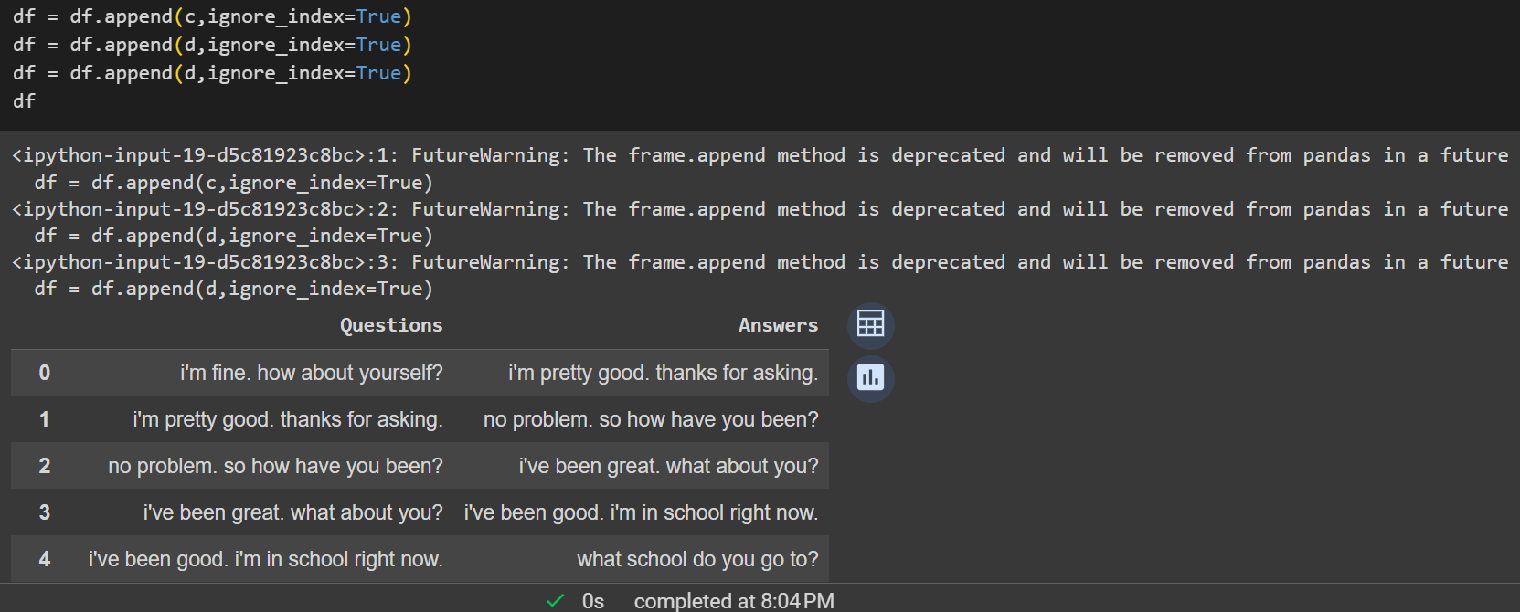

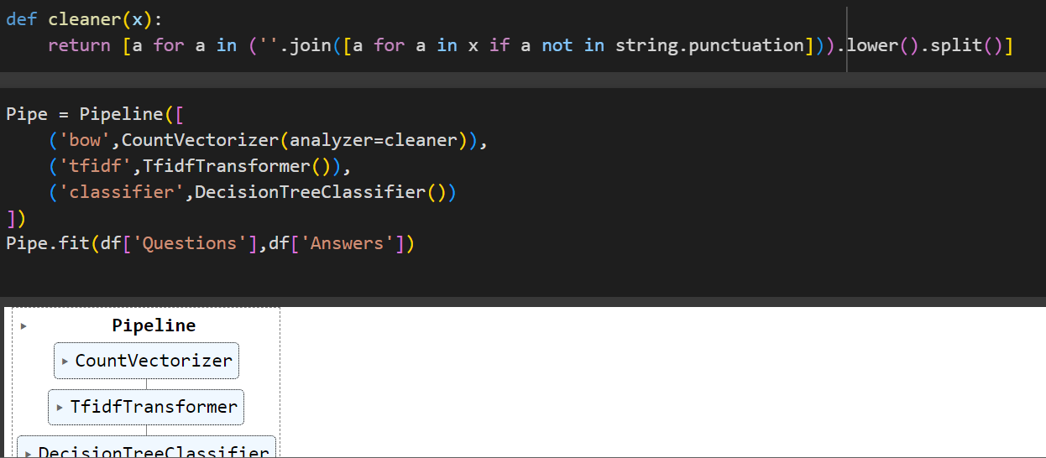

**Dataset link:**

<https://drive.google.com/file/d/1DkFCHWtcQhWEHy7RMcQtCqR9tMB7mMNV/view?usp=share_link>

**Google colab link:**

<https://colab.research.google.com/drive/1q870qTuEL3S9MrvhoF0wMiXY8rjRC8AZ?usp=share_link>