Intelligent Disputes and Claims
An AI-Enabled Operating Model for the Dispute Lifecycle at a Large Card Issuer, with a Vendor Moat Analysis and a Build-Rent-Govern Strategy
Sundaram Thevar
July 2026 · Working draft

Executive Summary
Disputes and claims sit at an awkward intersection: a regulated consumer-protection process with hard statutory clocks, a network-governed adversarial process against merchants, a fraud-loss channel increasingly exploited through first-party misuse, and one of the most emotionally charged moments in the customer relationship. At the scale of a top-five United States issuer, the function processes millions of claims per year across cards, Zelle, ACH, wires, and emerging payment types, each with its own rulebook.
This paper does three things. First, it lays out a reference lifecycle model for disputes and claims and maps, stage by stage, where AI materially changes the economics: intake classification, first-party misuse detection, auto-adjudication under policy-as-code, agentic evidence gathering, representment optimization, and a learning loop that converts case outcomes into a compounding data asset. Second, it surveys the vendor landscape (Quavo, Pega, FIS, Fiserv, ACI, Chargebacks911, and the network-owned utilities Verifi and Ethoca) and analyzes what each moat actually consists of. Third, it argues that for a Chase-scale issuer the right answer is neither pure build nor pure buy but a deliberate hybrid: rent the network utilities and the compliance rule content, buy or retain a case management chassis, and build the AI decisioning layer and the data foundation, because that layer is where loss rates, cost per case, and customer experience are actually determined.
The strategy can be stated in one line, consistent with the framing this paper's companion work on financial crime technology used: build the moat, rent the utilities, govern everything.

1. Why Disputes and Claims, and Why Now
Three forces are converging on the disputes back office.
- Volume is growing faster than headcount can. Datos Insights research cited by Pegasystems put disputed charges in the United States at eleven billion dollars in a single recent year, with a projected forty percent rise by 2026. Industry counts of global chargebacks were roughly 238 million in 2023, with projections in the low three hundreds of millions by 2028. Dispute volume also now spans payment types (wallets, peer-to-peer, BNPL, real-time payments) that legacy dispute systems were never designed for.
- First-party fraud has become a rules problem, not just a loss problem. A substantial share of card-not-present fraud claims are first-party misuse: the cardholder, or someone in the household, made the purchase. The network response has been structural. Visa's Compelling Evidence 3.0 lets merchants shift liability back to the issuer when qualifying prior purchase history exists, gained automatic qualification through Visa Secure in October 2025, and was extended in April 2026 to cover fraud reports that never became disputes. Mastercard is running its parallel First Party Trust program. The practical effect for an issuer is that writing off a claim as fraud without interrogating it now has a direct network cost, not just a loss cost.
- Compliance exposure and unit cost are both concentrated in manual handling. Regulation E timelines (ten business days to investigate or grant provisional credit, forty-five to ninety days to resolve) are strict liability: missing the clock is itself a violation regardless of the claim's merit, and regulator examination materials repeatedly flag late or missing provisional credit as a common finding. Meanwhile the operational cost of manually working a case is widely estimated in the tens of dollars per case; at millions of cases this is a nine-figure operating expense before a single dollar of loss. Those cost figures are industry rules of thumb rather than audited numbers and should be validated against internal data before being used in a business case.
The conclusion is not that disputes should be automated because automation is fashionable. It is that the function has the specific shape AI is good at: high volume, structured decisions governed by explicit rules, rich historical labels (every closed case has a known outcome), and a long tail of judgment cases where a human should stay in the loop.

2. The Regulatory and Network Frame
Any design starts from the constraints, because in this domain the constraints are the product.
Regulation E (Electronic Fund Transfer Act) governs consumer claims on debit, ATM, and electronic transfers, including Zelle. The institution generally has ten business days from notice of error to complete its investigation, or twenty for new accounts; if it cannot, it must post provisional credit within that window, notify the consumer within two business days of the credit, and may then take up to forty-five calendar days, or ninety for point-of-sale, foreign, and new-account transactions. Errors must be corrected within one business day of determination and results reported within three. Reversing provisional credit requires notice and a grace period. Examiners have documented late provisional credit, missing interest on interest-bearing accounts, and misapplied timelines as recurring violations.
Regulation Z governs credit card billing error resolution on a different clock (acknowledgment within thirty days, resolution within two complete billing cycles not exceeding ninety days), with distinct rules on finance charges and adverse reporting during the pendency. Section 75 in the United Kingdom and Regulation C-86 in Canada are the analogues a multi-jurisdiction issuer must also encode.
On the network side, Visa Claims Resolution defines four dispute categories across allocation and collaboration workflows with a thirty-day merchant response window; Mastercard runs its equivalent through Mastercom. Visa consolidated its fraud and dispute monitoring programs into the single VAMP framework in 2025. Compelling Evidence 3.0 formalizes when qualifying evidence, such as two undisputed transactions from the same identity signals between 120 and 365 days prior, blocks or reverses a fraud dispute. The pre-dispute layer, Verifi's Order Insight, RDR, and CDRN on the Visa side and Ethoca's Alerts and Consumer Clarity on the Mastercard side, increasingly resolves cases before a chargeback exists at all.
Two design consequences follow. First, timeline compliance must be a property of the system, not of analyst diligence: every case carries machine-enforced regulatory clocks from the moment of intake. Second, the issuer's dispute system must be a first-class participant in the pre-dispute networks, because the cheapest dispute is the one deflected at the point of customer inquiry.

3. A Reference Lifecycle Model
Figure 1 shows the lifecycle model used throughout this paper. It deliberately mirrors the Detect, Decide, Investigate, Learn structure of the real-time fraud platform work that precedes it, because the two systems should share infrastructure: the same event backbone, the same feature store, the same decision engine pattern, and the same evidentiary ledger.
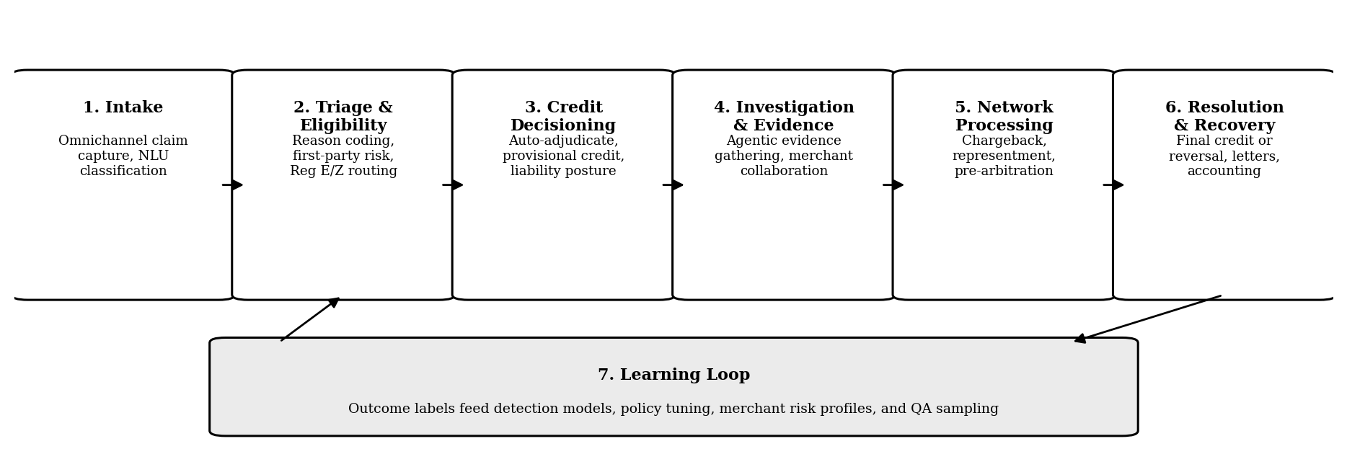
Figure 1. Dispute and claims lifecycle reference model with the learning loop feeding back into triage and detection.
The stages are conventional; what matters is the handoffs. Intake quality determines triage accuracy. Triage determines which regulatory clock applies and whether provisional credit posture is aggressive or conservative. The investigation record determines representment strength. And every closed case, win or lose, is a labeled training example. Institutions that treat these as separate departmental systems forfeit the compounding effect.

4. Where AI Changes the Economics, Stage by Stage
The table below is the opportunity map. Two general principles apply across all rows. First, generative models draft and summarize; deterministic policy decides. Liability decisions, provisional credit, and network filings execute under policy-as-code with model scores as inputs, never as free-form model output. Second, every automated action writes its rationale to an immutable decision ledger, because in a Reg E examination the question is not only whether the outcome was right but whether the institution can reconstruct why.
Lifecycle stage | AI capability | Primary value lever
Intake | Conversational and guided claim capture; NLU classification of claim type and reason code; document and receipt extraction | Fewer misrouted and malformed claims; lower call handle time; cleaner data for everything downstream
Triage and eligibility | First-party misuse scoring using prior purchase history, device, identity, and graph features; duplicate and serial-disputer detection; Reg E versus Reg Z versus network-rule routing | Loss reduction on friendly fraud; regulatory clock started correctly on day one
Credit decisioning | Auto-adjudication of low-risk, low-value claims under policy-as-code with champion and challenger controls; provisional credit decisions with liability posture | Straight-through resolution for a large share of cases; provisional credit issued on time, every time
Investigation and evidence | Agentic evidence gathering across auth logs, 3DS data, Order Insight and Consumer Clarity responses, merchant records, and prior contact history; drafted investigator narratives with human checkpoints | Investigator productivity; higher representment win rates; consistent case files
Network processing | Automated chargeback filing validation against association rules; CE 3.0 evidence evaluation on inbound merchant responses; pre-arbitration recommendation | Fewer invalid filings and fee losses; better recovery outcomes
Resolution and recovery | Generated customer letters with compliance-checked templates; accounting event automation; denial rationale drafting | Cycle time; complaint reduction; audit-ready correspondence
Learning loop | Outcome-labeled cases feed detection models, policy tuning, merchant risk profiles, and QA sampling; drift monitoring | Compounding accuracy; the data asset that becomes the in-house moat

Three capabilities deserve elaboration.

4.1 First-party misuse scoring at triage
This is the highest-leverage model in the stack. The features are exactly the ones CE 3.0 formalized: prior undisputed purchases at the same merchant, device and IP continuity, login and delivery address history, plus household and graph signals the network rules do not capture. An issuer that runs this scoring at intake gains three options a manual shop does not have: challenge the claim conversationally at the point of intake with specific transaction detail (the issuer-side equivalent of Order Insight deflection), route high-risk claims to enhanced investigation before provisional credit hardens into expectation, and select the denial cases it can defend with documented evidence. Graph-based approaches, including the localized graph network work developed for the fraud detection program, transfer directly to serial-disputer and collusion detection.

4.2 Auto-adjudication under policy-as-code
A large fraction of claims are low-value, low-risk, and clear-cut. The design pattern is the same arbitration-ladder decision engine already proven in the fraud platform: tiers as discrete, legally reviewable objects, model scores mapped to policies, champion and challenger slots for policy experiments, and appetite expressed in the objective rather than hand-tuned thresholds. Vendors report meaningful straight-through rates on this class of claim; the honest statement is that the achievable rate at any given institution depends on its claim mix and risk appetite and should be established empirically in a controlled rollout, not asserted from vendor benchmarks.

4.3 Agentic investigation with human checkpoints
Evidence gathering is tool use: query auth and 3DS logs, pull Order Insight and Consumer Clarity responses, retrieve prior contact history, assemble merchant correspondence, and draft an investigator narrative with citations to each artifact. This is the same multi-agent triage and evidence pattern, with human-in-the-loop checkpoints before any customer-affecting or network-facing action, that the agentic financial crime investigation workflow already implements. Disputes are arguably the better first production home for it: outcomes are faster, labels are cleaner, and the regulatory downside of a drafted narrative is lower than in SAR territory.

5. Target Architecture
Figure 2 presents the target architecture as a set of layers annotated with the sourcing decision for each. This section is a design proposal, not a description of any institution's current state.
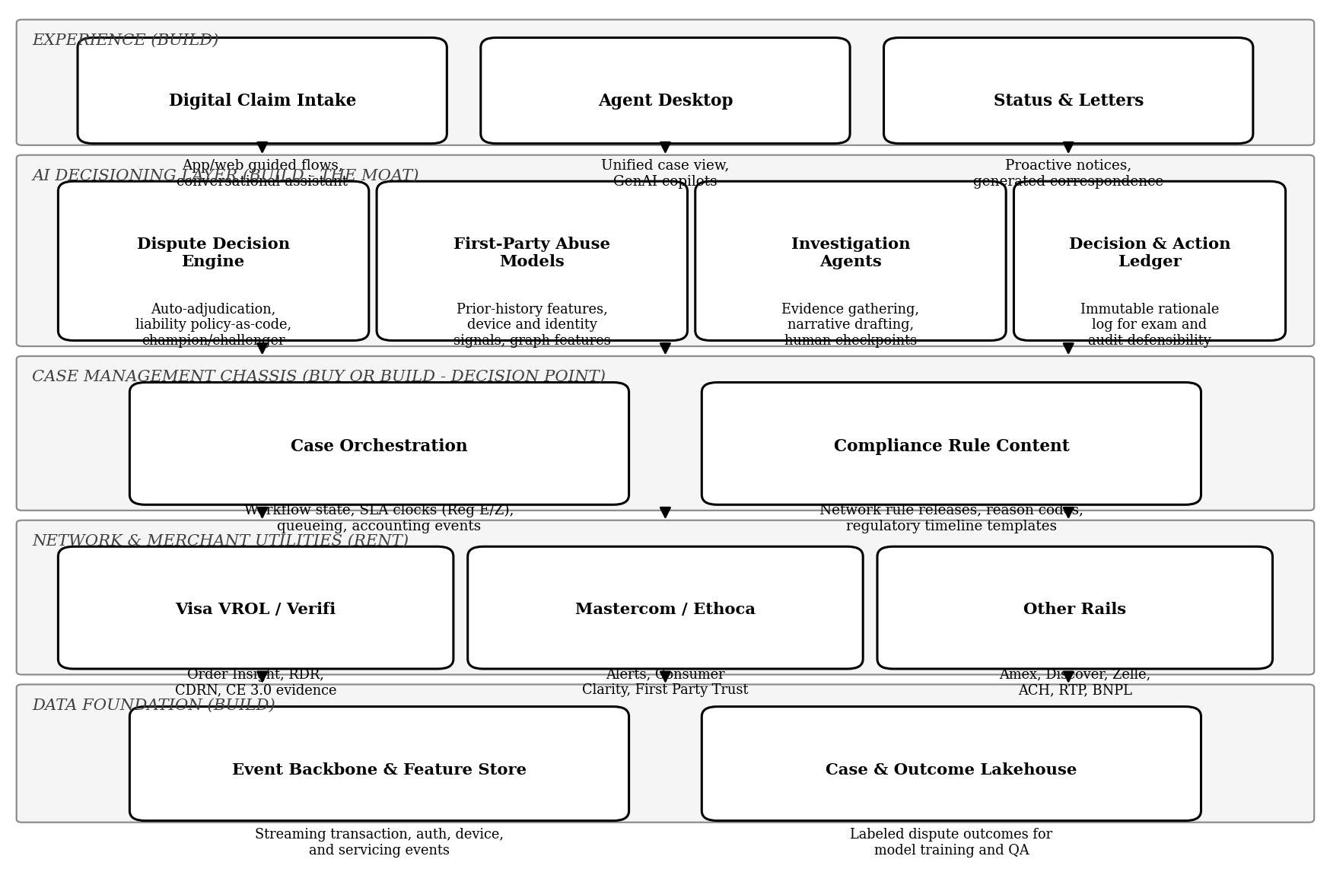
Figure 2. Layered target architecture. Build the decisioning layer and data foundation; rent the network utilities and rule content; treat the case chassis as a discrete decision.
The architectural center of gravity is the AI decisioning layer, deliberately separated from the case management chassis beneath it. The chassis owns workflow state, SLA clocks, accounting events, and network connectivity. The decisioning layer owns everything judgmental: scores, adjudication, evidence agents, and the ledger. The interface between them is a narrow API: the chassis asks for decisions and reports events; the decisioning layer answers and records. This separation is what makes the hybrid strategy workable, because it means the chassis can be a vendor product, an incumbent system, or eventually an in-house build without the bank's differentiating logic being trapped inside any of them.
The data foundation is shared with the fraud platform by design. A dispute is frequently the delayed echo of a detection decision made weeks earlier; joining dispute outcomes back to the original authorization features closes the loop that makes both systems better. Practically, this means dispute events flow on the same streaming backbone, dispute features live in the same feature store, and case outcomes land in a lakehouse where they are joinable to transaction, device, and identity history.

6. Vendor Landscape and Moat Analysis
The issuer-side dispute market divides into purpose-built platforms, BPM-based enterprise suites, processor adjacencies, managed services, and network utilities. The table summarizes; the prose that follows examines what each moat is actually made of.
Vendor | Positioning | Primary moat | Best fit
Quavo (QFD, Aria, DRE) | Purpose-built issuer dispute SaaS with an embedded AI analyst and an optional managed back-office service | Accumulated dispute-domain workflow depth; automation trained on large volumes of historical dispute data; pre-built integrations to cores (Fiserv, FIS, Jack Henry, TSYS) and to Verifi and Ethoca; semiannual releases aligned to association mandates | Institutions that want issuer dispute automation as a product rather than a platform program; strong in mid-market, growing upmarket
Pega Smart Dispute (Agentic Automation edition) | Enterprise dispute and fraud-claim case management on the Pega low-code BPM platform, used for decades by many of the largest global banks | Compliance rule content delivered as a subscription (Reg E, Reg Z, Section 75, Canada C-86, plus network operational rules); deep enterprise entrenchment and switching cost; GenAI agents (coach, knowledge retrieval, call summarization) and Blueprint-based extension to new payment types | Large, complex issuers with many payment types, heavy customization needs, and existing Pega estates
FIS and Fiserv dispute modules | Dispute resolution offered as an adjacency to core processing and issuer processing | Ownership of the transaction system of record; disputes bundled with processing contracts; Fiserv has integrated Ethoca Alerts directly into its Dispute Expert issuer platform | Institutions that want a single throat to choke with their processor; least attractive to banks running in-house processing
ACI Worldwide | Dispute management adjacent to its issuer payments processing stack | Rails adjacency and installed base in issuer processing | Existing ACI processing customers
Chargebacks911 (issuer edition) | Managed dispute services plus software; specialists work network queues on the institution's behalf | Operational expertise as a service; elastic capacity without headcount | Institutions seeking outsourcing or surge capacity rather than technology
Verifi (Visa) and Ethoca (Mastercard) | Network-owned pre-dispute utilities: Order Insight and Consumer Clarity for transaction detail, RDR and Alerts for pre-dispute resolution, CDRN for mediated refunds | The networks themselves. These are two-sided issuer-merchant data networks owned by Visa and Mastercard; they cannot be replicated by any issuer or vendor and must be connected to, not competed with | Every issuer. These are utilities in the rent category by definition

6.1 What the moats are made of
- Accumulated domain data and mandate absorption (Quavo). Quavo's automation is trained on a large corpus of historical dispute cases across its client base, and its semiannual release cycle absorbs association mandate changes so clients do not have to. That is a real moat against smaller entrants, but it is thinner against a top-five issuer, whose own case volume rivals or exceeds a mid-market vendor's entire network and who must track network mandates internally regardless.
- Rulebook-as-subscription and entrenchment (Pega). Pega's strongest asset is arguably not the software but the maintained rule content for Reg E, Reg Z, Section 75, C-86, and network operational rules, delivered on subscription, combined with decades-deep deployments at large global banks that make replacement projects expensive and risky. The switching cost is the moat. The corollary for a bank already running it: the cheapest path to AI-enabled disputes may run through the incumbent's API surface rather than around it.
- Rails adjacency (FIS, Fiserv, ACI). FIS, Fiserv, and ACI hold the system of record and bundle disputes into processing relationships. This moat is strong exactly where the bank is weakest, at small institutions with no engineering capacity, and weak at a money-center bank that runs its own processing and negotiates network access directly.
- Network ownership (Verifi, Ethoca). Verifi and Ethoca are owned by Visa and Mastercard respectively. Their value is the two-sided network of issuers and merchants exchanging order detail and pre-dispute resolutions in real time. This is the one moat in the landscape that is absolute: no issuer build replicates it, and every serious dispute architecture is a consumer of it. Notably, both networks are pushing intelligence into the pre-dispute layer (Order Insight now carries CE 3.0 evidence evaluation; issuers increasingly see merchant evidence before a chargeback is even filed), which shifts value toward whoever makes the best real-time decision with that data. That decision-maker can and should be the bank.

6.2 What no vendor moat covers
Every vendor in the table sees only dispute-domain data. None of them sees the issuer's full authorization stream, device graph, behavioral biometrics, servicing history, and cross-product relationship data. The models that most move loss and cost, first-party misuse scoring and adjudication policy, are precisely the ones that need that full picture. This asymmetry is the strategic basis for the hybrid recommendation: the vendors' moats are real but they surround the chassis and the utilities, not the decisioning.

7. Build, Buy, or Hybrid
For a Chase-scale issuer the pure options both fail. Pure buy caps the institution at the vendor's model quality, forfeits the proprietary data advantage, and leaves the bank renting its own differentiation. Pure build spends scarce engineering capacity recreating undifferentiated workflow plumbing and a rule-content maintenance function that vendors amortize across hundreds of clients, while the network utilities cannot be built at all. The layer-by-layer resolution:
Layer | Recommendation | Rationale
Network and merchant utilities | Rent, always | Verifi, Ethoca, VROL, and Mastercom are network-owned. There is no build option
Compliance rule content | Rent (subscription) | Association rules change on a semiannual mandate cycle; vendors amortize the tracking cost across hundreds of clients
Case management chassis | Buy for speed, or retain incumbent; replatform only with a clear cost case | Workflow, SLA clocks, and accounting events are undifferentiated; the risk of rebuilding them exceeds the value
AI decisioning layer | Build | Adjudication policy, first-party abuse models, and investigation agents encode the bank's own risk appetite and data; this is where losses and cost per case are actually determined
Data foundation and learning loop | Build | Outcome-labeled dispute data joined with transaction, device, and identity signals is proprietary and compounds; no vendor sees the full picture
Customer experience | Build | Intake quality determines everything downstream, and the experience is a brand surface

The honest caveats. First, if the incumbent chassis is deeply embedded, the realistic near-term hybrid is incumbent chassis plus in-house decisioning layer, with replatforming evaluated separately on its own economics. Second, the build recommendation for the decisioning layer assumes the institution already has, as the fraud program does, a decision engine pattern, a feature store, model governance, and agentic tooling to reuse; without those assets the build case weakens materially. Third, vendor AI is improving quickly (Quavo's Aria, Pega's agentic edition), so the differentiation argument must be re-tested annually rather than assumed.

8. Phased Roadmap
- Phase 1 (0 to 6 months). Measure, connect, and pipe the data. Instrument the current state: unit cost per case, straight-through rate, cycle times against Reg E and Reg Z clocks, representment win rates, and first-party misuse share by merchant category and channel. Connect or deepen Verifi and Ethoca participation. Stand up the dispute lakehouse joined to transaction history. This phase produces the baseline every later claim of improvement will be measured against.
- Phase 2 (6 to 15 months). Decisioning layer, first production slices. Deploy first-party misuse scoring at triage in shadow mode, then as a routing input. Launch auto-adjudication for the lowest-risk claim tier under policy-as-code with champion and challenger controls and full ledger logging. Add GenAI drafting for investigator narratives and customer letters with human review.
- Phase 3 (15 to 30 months). Agentic investigation and deflection at intake. Expand auto-adjudication tiers as measured performance allows. Deploy agentic evidence gathering with human checkpoints. Integrate CE 3.0 evidence evaluation into intake conversations for real-time deflection. Extend the model to Zelle, ACH, and emerging payment types where the chassis supports them.
- Phase 4 (30 months and beyond). Chassis strategy from a position of strength. Revisit the chassis question with two years of interface experience and measured vendor dependency. By this point the decisioning layer, the data asset, and the operating metrics exist independently of the chassis, which is exactly what makes the decision reversible in either direction.

9. Risks, Controls, and Governance
- Consumer harm and fair treatment. Auto-adjudication and misuse scoring touch protected consumer rights. Controls: adjudication only ever resolves in the consumer's favor automatically in early phases; denials always carry human review and documented evidence; disparate-impact testing on misuse models; model risk management under the existing governance framework and SR 11-7 style validation.
- Regulatory timeline breach. Machine-enforced clocks with automated escalation; provisional credit posting as a system guarantee with interest handling; correspondence generated from compliance-approved templates with change control.
- Model error and explainability. Generative components are constrained to drafting and summarization; no customer-facing or network-facing action executes without either deterministic policy authorization or human approval; the decision ledger records inputs, policy version, model version, and rationale for every automated action.
- Vendor concentration. The narrow chassis API, the in-house data foundation, and annual re-testing of vendor differentiation keep exit costs bounded in both directions.

10. What This Paper Claims and What It Does Not
The regulatory descriptions, network program mechanics, and vendor characterizations in Sections 2 and 6 are drawn from public sources current as of July 2026 and are cited below. The lifecycle model, the architecture, the moat analysis conclusions, and the hybrid recommendation are the author's design proposals; they are informed by production experience with an adjacent real-time fraud decisioning platform but have not been validated in a production disputes deployment. Volume and cost figures quoted from industry research are directional; any business case should substitute the institution's own measured baseline. No claim in this paper should be read as describing the current systems of JPMorgan Chase or any named institution.

Sources and Notes
- Consumer Compliance Outlook (Federal Reserve), Error Resolution and Liability Limitations Under Regulations E and Z, and the 2025 examiner insights follow-up, for Reg E timelines and common violations.
- Pegasystems press materials and Pega Academy documentation on Smart Dispute Enterprise Edition and Smart Dispute Agentic Automation, including the Datos Insights disputed-charges figures and the compliance rule subscription model.
- Quavo public materials on QFD, Aria, DRE, core and network integrations, and release cadence.
- Visa Compelling Evidence 3.0 documentation and merchant readiness guides; PaymentBrief and Chargebacks911 analyses of the October 2025 auto-qualification via Visa Secure, the April 2026 extension to undisputed fraud reports, and the 2025 VAMP consolidation.
- Verifi and Ethoca product documentation and independent comparisons (Justt, ChargebackHelp, chargeback.io) for pre-dispute network mechanics and coverage.
- Fintechspecs issuer dispute platform comparison for the vendor field; Mastercard newsroom on the Fiserv Dispute Expert and Ethoca Alerts integration.

