APPENDIX
The appendix includes supplementary information, sample outputs, and additional details that support the main report.
SOURCE CODE:
FILE STRUCTURE
SpeakSafe
├── backend
│ ├── pom.xml
│ └── src/main
│ ├── java/com/speaksafe
│ │ ├── SpeakSafeApplication.java
│ │ ├── model
│ │ │ ├── Category.java
│ │ │ ├── Action.java
│ │ │ ├── AnalysisResult.java
│ │ │ └── Report.java
│ │ ├── nlp
│ │ │ ├── TextPreprocessor.java
│ │ │ └── TfIdfVectorizer.java
│ │ ├── ml
│ │ │ ├── Classifier.java
│ │ │ ├── NaiveBayesClassifier.java
│ │ │ ├── SvmClassifier.java
│ │ │ ├── DatasetLoader.java
│ │ │ ├── DetectionPipeline.java
│ │ │ └── ModelEvaluator.java
│ │ ├── service
│ │ │ ├── ToxicityDetector.java
│ │ │ └── ReportRepository.java
│ │ └── controller
│ │ └── DetectionController.java
│ └── resources
│ ├── application.properties
│ ├── schema.sql
│ ├── dataset/speaksafe_dataset.csv
│ └── static (index.html, dashboard.html, style.css)
└── extension
├── manifest.json
├── background.js
├── content.js
├── content.css
├── popup.html
├── popup.js
├── popup.css
└── icons

MODULE 1 – DATA MODELS
Category.java
package com.speaksafe.model;

/** The labels a message can receive. */
public enum Category {
SAFE,
INSULT,
THREAT,
HATE_SPEECH;

/** Reads a label from the dataset, e.g. "hate_speech" or "HATE SPEECH". */
public static Category fromLabel(String label) {
return Category.valueOf(label.trim().toUpperCase().replace(' ', '_'));
}
}

Action.java
package com.speaksafe.model;

/** What the browser extension should do with a message. */
public enum Action {
NONE, // safe message, do nothing
WARN, // show a warning to the user
BLUR // hide the message behind a blur and flag it for moderators
}

AnalysisResult.java
package com.speaksafe.model;

import java.util.Map;

/**
* Output of the detection engine for one message.
*
* @param text the original message
* @param score toxicity score from 0 (safe) to 100 (very toxic)
* @param category SAFE, INSULT, THREAT or HATE_SPEECH
* @param action NONE, WARN or BLUR
* @param probabilities probability of each category (0.0 - 1.0)
* @param model name of the model that produced the result
*/
public record AnalysisResult(String text,
int score,
Category category,
Action action,
Map<Category, Double> probabilities,
String model) {
}

Report.java
package com.speaksafe.model;

/** A flagged or reported message stored in the database. */
public record Report(long id,
String text,
int score,
Category category,
String sourceUrl,
String reportedBy,
String createdAt) {
}

MODULE 2 – PREPROCESSING MODULE
TextPreprocessor.java
package com.speaksafe.nlp;

import opennlp.tools.stemmer.PorterStemmer;
import opennlp.tools.tokenize.SimpleTokenizer;

import java.util.ArrayList;
import java.util.List;
import java.util.Set;

/**
* MODULE: Preprocessing.
* Cleans raw text and turns it into a list of word stems, for example:
* "You are SUCH an 1d10t!!! http://x.com" -> [you, such, idiot]
*/
public class TextPreprocessor {

// Common words that carry no meaning. Words like "you", "not", "all" and "die"
// are kept on purpose because they matter a lot for bullying and threats.
private static final Set<String> STOPWORDS = Set.of(
"a", "an", "the", "is", "am", "are", "was", "were", "be", "been", "being",
"and", "or", "but", "if", "of", "at", "by", "for", "with", "about", "to",
"from", "in", "on", "this", "that", "these", "those", "it", "its", "so",
"as", "do", "does", "did", "have", "has", "had", "just", "very", "can",
"will", "would", "should", "could", "i", "me", "my", "we", "our", "us",
"then", "than", "there", "here", "what", "which", "who", "when", "where",
"how", "too", "also", "such", "some", "any", "into", "up", "out", "over");

private final SimpleTokenizer tokenizer = SimpleTokenizer.INSTANCE;
private final PorterStemmer stemmer = new PorterStemmer();

public List<String> process(String text) {
if (text == null) {
return List.of();
}
String clean = text.toLowerCase();
clean = clean.replaceAll("https?://\\S+|www\\.\\S+", " "); // remove links
clean = clean.replaceAll("@\\w+", " "); // remove @mentions
clean = expandContractions(clean); // you're -> you are
clean = normalizeLeetspeak(clean); // 1d10t -> idiot
clean = clean.replaceAll("(.)\\1{2,}", "$1"); // stuuupid -> stupid
clean = clean.replaceAll("[^a-z\\s]", " "); // remove symbols and digits

List<String> tokens = new ArrayList<>();
for (String token : tokenizer.tokenize(clean)) {
if (token.length() > 1 && !STOPWORDS.contains(token)) {
tokens.add(stemmer.stem(token));
}
}
return tokens;
}

/** Writes short forms out in full, so "I'll" and "you're" become real words instead of "ll" and "re". */
private String expandContractions(String text) {
return text.replace('\u2019', '\'') // curly apostrophe -> straight
.replaceAll("\\bcan't\\b", "can not")
.replaceAll("\\bwon't\\b", "will not")
.replaceAll("n't\\b", " not")
.replaceAll("'re\\b", " are")
.replaceAll("'ll\\b", " will")
.replaceAll("'m\\b", " am")
.replaceAll("'ve\\b", " have")
.replaceAll("'d\\b", " would")
.replaceAll("'s\\b", "");
}

/** Replaces digits and symbols used to hide bad words, but only inside words that contain letters. */
private String normalizeLeetspeak(String text) {
StringBuilder result = new StringBuilder();
for (String word : text.split("\\s+")) {
if (word.matches(".*[a-z].*")) {
word = word.replace('0', 'o').replace('1', 'i').replace('3', 'e')
.replace('4', 'a').replace('5', 's').replace('7', 't')
.replace('@', 'a').replace('$', 's');
}
result.append(word).append(' ');
}
return result.toString();
}
}

MODULE 3 – FEATURE EXTRACTION MODULE (TF-IDF)
TfIdfVectorizer.java
package com.speaksafe.nlp;

import java.util.ArrayList;
import java.util.HashMap;
import java.util.HashSet;
import java.util.List;
import java.util.Map;

/**
* MODULE: Feature Extraction.
* Converts a list of words into numbers using TF-IDF.
* It uses single words ("kill") and word pairs ("kill you") as features.
* Vectors are stored as a map of {feature index -> weight}, because most weights are zero.
*/
public class TfIdfVectorizer {

private final Map<String, Integer> vocabulary = new HashMap<>();
private double[] idf;

/** Learns the vocabulary and IDF weights from the training documents. */
public void fit(List<List<String>> documents) {
Map<String, Integer> documentFrequency = new HashMap<>();
for (List<String> doc : documents) {
for (String term : new HashSet<>(terms(doc))) {
documentFrequency.merge(term, 1, Integer::sum);
}
}
for (String term : documentFrequency.keySet()) {
vocabulary.put(term, vocabulary.size());
}
int n = documents.size();
idf = new double[vocabulary.size()];
for (Map.Entry<String, Integer> entry : vocabulary.entrySet()) {
int df = documentFrequency.get(entry.getKey());
idf[entry.getValue()] = Math.log((1.0 + n) / (1.0 + df)) + 1.0;
}
}

/** Turns one document into a normalized TF-IDF vector. Unknown words are ignored. */
public Map<Integer, Double> transform(List<String> doc) {
Map<Integer, Double> vector = new HashMap<>();
for (String term : terms(doc)) {
Integer index = vocabulary.get(term);
if (index != null) {
vector.merge(index, 1.0, Double::sum); // term frequency
}
}
double length = 0;
for (Map.Entry<Integer, Double> entry : vector.entrySet()) {
double weight = entry.getValue() * idf[entry.getKey()];
entry.setValue(weight);
length += weight * weight;
}
double norm = Math.sqrt(length);
if (norm > 0) {
vector.replaceAll((index, weight) -> weight / norm);
}
return vector;
}

public int size() {
return vocabulary.size();
}

/** Single words plus pairs of neighbouring words. */
private List<String> terms(List<String> words) {
List<String> terms = new ArrayList<>(words);
for (int i = 0; i + 1 < words.size(); i++) {
terms.add(words.get(i) + "_" + words.get(i + 1));
}
return terms;
}
}

MODULE 4 – CLASSIFICATION MODULE
Classifier.java
package com.speaksafe.ml;

import com.speaksafe.model.Category;

import java.util.List;
import java.util.Map;

/** Common interface so the Naive Bayes and SVM models can be swapped and compared. */
public interface Classifier {

/** Learns from TF-IDF vectors and their correct labels. */
void train(List<Map<Integer, Double>> vectors, List<Category> labels, int featureCount);

/** Returns the probability (0.0 - 1.0) of each category for one TF-IDF vector. */
Map<Category, Double> predictProbabilities(Map<Integer, Double> vector);

String name();
}

NaiveBayesClassifier.java
package com.speaksafe.ml;

import com.speaksafe.model.Category;

import java.util.EnumMap;
import java.util.List;
import java.util.Map;

/**
* MODULE: Classification (model 1 of 2).
* Multinomial Naive Bayes: learns how often each word appears in each category,
* then picks the category that best explains the words of a new message.
*/
public class NaiveBayesClassifier implements Classifier {

private static final double SMOOTHING = 0.1; // stops unseen words from giving zero probability

private final Category[] categories = Category.values();
private double[] logPrior; // log P(category)
private double[][] logLikelihood; // log P(word | category)

@Override
public void train(List<Map<Integer, Double>> vectors, List<Category> labels, int featureCount) {
int k = categories.length;
double[] docsPerClass = new double[k];
double[][] wordWeight = new double[k][featureCount];
double[] totalWeight = new double[k];

for (int i = 0; i < vectors.size(); i++) {
int c = labels.get(i).ordinal();
docsPerClass[c]++;
for (Map.Entry<Integer, Double> entry : vectors.get(i).entrySet()) {
wordWeight[c][entry.getKey()] += entry.getValue();
totalWeight[c] += entry.getValue();
}
}

logPrior = new double[k];
logLikelihood = new double[k][featureCount];
for (int c = 0; c < k; c++) {
logPrior[c] = Math.log(docsPerClass[c] / vectors.size());
double denominator = totalWeight[c] + SMOOTHING * featureCount;
for (int f = 0; f < featureCount; f++) {
logLikelihood[c][f] = Math.log((wordWeight[c][f] + SMOOTHING) / denominator);
}
}
}

@Override
public Map<Category, Double> predictProbabilities(Map<Integer, Double> vector) {
double[] logScores = new double[categories.length];
for (int c = 0; c < categories.length; c++) {
logScores[c] = logPrior[c];
for (Map.Entry<Integer, Double> entry : vector.entrySet()) {
logScores[c] += entry.getValue() * logLikelihood[c][entry.getKey()];
}
}
return toProbabilities(logScores);
}

/** Softmax: converts log scores into probabilities that add up to 1. */
private Map<Category, Double> toProbabilities(double[] logScores) {
double max = Double.NEGATIVE_INFINITY;
for (double s : logScores) max = Math.max(max, s);
double sum = 0;
double[] exp = new double[logScores.length];
for (int c = 0; c < logScores.length; c++) {
exp[c] = Math.exp(logScores[c] - max);
sum += exp[c];
}
Map<Category, Double> probabilities = new EnumMap<>(Category.class);
for (int c = 0; c < categories.length; c++) {
probabilities.put(categories[c], exp[c] / sum);
}
return probabilities;
}

@Override
public String name() {
return "Naive Bayes";
}
}

SvmClassifier.java
package com.speaksafe.ml;

import com.speaksafe.model.Category;

import java.util.ArrayList;
import java.util.Collections;
import java.util.EnumMap;
import java.util.List;
import java.util.Map;
import java.util.Random;

/**
* MODULE: Classification (model 2 of 2).
* Linear Support Vector Machine (SVM), "one-vs-rest":
* one straight-line separator is trained per category (e.g. THREAT vs everything else).
* Training uses stochastic gradient descent on the hinge loss.
*/
public class SvmClassifier implements Classifier {

private static final int EPOCHS = 30;
private static final double LEARNING_RATE = 0.1;
private static final double REGULARIZATION = 0.0001;

private final Category[] categories = Category.values();
private double[][] weights; // one weight per feature, per category
private double[] bias;

@Override
public void train(List<Map<Integer, Double>> vectors, List<Category> labels, int featureCount) {
weights = new double[categories.length][featureCount];
bias = new double[categories.length];

List<Integer> order = new ArrayList<>();
for (int i = 0; i < vectors.size(); i++) order.add(i);
Random random = new Random(42); // fixed seed -> same result every run

for (int epoch = 0; epoch < EPOCHS; epoch++) {
Collections.shuffle(order, random);
for (int i : order) {
Map<Integer, Double> x = vectors.get(i);
for (int c = 0; c < categories.length; c++) {
double y = labels.get(i).ordinal() == c ? 1.0 : -1.0;
double margin = y * score(c, x);
shrinkWeights(c, x);
if (margin < 1) { // wrong or not confident enough -> move the line
for (Map.Entry<Integer, Double> e : x.entrySet()) {
weights[c][e.getKey()] += LEARNING_RATE * y * e.getValue();
}
bias[c] += LEARNING_RATE * y;
}
}
}
}
}

/** L2 regularization, applied only to the features present in this example (keeps training fast). */
private void shrinkWeights(int c, Map<Integer, Double> x) {
for (int f : x.keySet()) {
weights[c][f] *= (1 - LEARNING_RATE * REGULARIZATION);
}
}

private double score(int c, Map<Integer, Double> x) {
double s = bias[c];
for (Map.Entry<Integer, Double> e : x.entrySet()) {
s += weights[c][e.getKey()] * e.getValue();
}
return s;
}

@Override
public Map<Category, Double> predictProbabilities(Map<Integer, Double> vector) {
// An SVM gives distances, not probabilities. We squash each distance into 0..1 with a sigmoid.
double[] p = new double[categories.length];
double sum = 0;
for (int c = 0; c < categories.length; c++) {
p[c] = 1.0 / (1.0 + Math.exp(-3.0 * score(c, vector)));
sum += p[c];
}
// If no category is confident (total below 1), the message is unlike anything toxic
// the model has seen, so the left-over probability goes to SAFE.
int safe = Category.SAFE.ordinal();
if (sum < 1.0) {
p[safe] += 1.0 - sum;
sum = 1.0;
}
Map<Category, Double> probabilities = new EnumMap<>(Category.class);
for (int c = 0; c < categories.length; c++) {
probabilities.put(categories[c], p[c] / sum);
}
return probabilities;
}

@Override
public String name() {
return "Linear SVM";
}
}

MODULE 5 – TRAINING AND EVALUATION
DatasetLoader.java
package com.speaksafe.ml;

import com.speaksafe.model.Category;

import java.io.BufferedReader;
import java.io.IOException;
import java.io.InputStream;
import java.io.InputStreamReader;
import java.io.UncheckedIOException;
import java.nio.charset.StandardCharsets;
import java.util.ArrayList;
import java.util.List;

/**
* Loads the labelled dataset (CSV file with the columns: label,text).
* Example line: insult,"you are such a loser"
*/
public class DatasetLoader {

public static final String DEFAULT_DATASET = "/dataset/speaksafe_dataset.csv";

/** One labelled example. */
public record Sample(String text, Category label) { }

public static List<Sample> load(String resourcePath) {
List<Sample> samples = new ArrayList<>();
InputStream in = DatasetLoader.class.getResourceAsStream(resourcePath);
if (in == null) {
throw new IllegalStateException("Dataset not found: " + resourcePath);
}
try (BufferedReader reader = new BufferedReader(new InputStreamReader(in, StandardCharsets.UTF_8))) {
String line = reader.readLine(); // skip header
while ((line = reader.readLine()) != null) {
if (line.isBlank()) continue;
int comma = line.indexOf(',');
String label = line.substring(0, comma);
String text = line.substring(comma + 1).trim();
if (text.startsWith("\"") && text.endsWith("\"")) {
text = text.substring(1, text.length() - 1).replace("\"\"", "\"");
}
samples.add(new Sample(text, Category.fromLabel(label)));
}
} catch (IOException e) {
throw new UncheckedIOException(e);
}
return samples;
}
}

DetectionPipeline.java
package com.speaksafe.ml;

import com.speaksafe.model.Category;
import com.speaksafe.nlp.TextPreprocessor;
import com.speaksafe.nlp.TfIdfVectorizer;

import java.util.ArrayList;
import java.util.EnumMap;
import java.util.List;
import java.util.Map;

/**
* Connects the modules in order:
* raw text -> Preprocessing -> Feature Extraction (TF-IDF) -> Classification -> probabilities
*/
public class DetectionPipeline {

private final TextPreprocessor preprocessor = new TextPreprocessor();
private final TfIdfVectorizer vectorizer = new TfIdfVectorizer();
private final Classifier classifier;

public DetectionPipeline(Classifier classifier) {
this.classifier = classifier;
}

public void train(List<DatasetLoader.Sample> samples) {
List<List<String>> documents = new ArrayList<>();
List<Category> labels = new ArrayList<>();
for (DatasetLoader.Sample sample : samples) {
documents.add(preprocessor.process(sample.text()));
labels.add(sample.label());
}
vectorizer.fit(documents);

List<Map<Integer, Double>> vectors = new ArrayList<>();
for (List<String> doc : documents) {
vectors.add(vectorizer.transform(doc));
}
classifier.train(vectors, labels, vectorizer.size());
}

public Map<Category, Double> predict(String text) {
Map<Integer, Double> vector = vectorizer.transform(preprocessor.process(text));
if (vector.isEmpty()) {
// No known words (e.g. "ok", emojis, a new language): treat as safe.
Map<Category, Double> safe = new EnumMap<>(Category.class);
for (Category c : Category.values()) safe.put(c, c == Category.SAFE ? 1.0 : 0.0);
return safe;
}
return classifier.predictProbabilities(vector);
}

/** The category with the highest probability. */
public Category predictCategory(String text) {
Map<Category, Double> probabilities = predict(text);
Category best = Category.SAFE;
for (Map.Entry<Category, Double> e : probabilities.entrySet()) {
if (e.getValue() > probabilities.get(best)) best = e.getKey();
}
return best;
}

public String modelName() {
return classifier.name();
}
}

ModelEvaluator.java
package com.speaksafe.ml;

import com.speaksafe.model.Category;

import java.util.ArrayList;
import java.util.Collections;
import java.util.EnumMap;
import java.util.List;
import java.util.Map;
import java.util.Random;
import java.util.function.Supplier;

/**
* Evaluation: splits the dataset into 80% training and 20% testing data,
* trains a model, and measures accuracy, precision, recall, F1-score and speed.
*/
public class ModelEvaluator {

/** Scores for one category. */
public record ClassMetrics(double precision, double recall, double f1, int support) { }

/** Full result for one model. */
public record EvaluationResult(String model,
int trainSize,
int testSize,
double accuracy,
double macroPrecision,
double macroRecall,
double macroF1,
double avgMillisPerMessage,
Map<Category, ClassMetrics> perCategory,
int[][] confusionMatrix) { }

public static EvaluationResult evaluate(Supplier<Classifier> modelFactory, List<DatasetLoader.Sample> data) {
List<DatasetLoader.Sample> train = new ArrayList<>();
List<DatasetLoader.Sample> test = new ArrayList<>();
splitStratified(data, train, test);

DetectionPipeline pipeline = new DetectionPipeline(modelFactory.get());
pipeline.train(train);

int k = Category.values().length;
int[][] confusion = new int[k][k]; // rows = actual, columns = predicted
long start = System.nanoTime();
for (DatasetLoader.Sample sample : test) {
Category predicted = pipeline.predictCategory(sample.text());
confusion[sample.label().ordinal()][predicted.ordinal()]++;
}
double avgMillis = (System.nanoTime() - start) / 1_000_000.0 / test.size();

int correct = 0;
double sumP = 0, sumR = 0, sumF = 0;
Map<Category, ClassMetrics> perCategory = new EnumMap<>(Category.class);
for (Category c : Category.values()) {
int i = c.ordinal();
int truePositive = confusion[i][i];
int predictedAsC = 0, actuallyC = 0;
for (int j = 0; j < k; j++) {
predictedAsC += confusion[j][i];
actuallyC += confusion[i][j];
}
correct += truePositive;
double precision = predictedAsC == 0 ? 0 : (double) truePositive / predictedAsC;
double recall = actuallyC == 0 ? 0 : (double) truePositive / actuallyC;
double f1 = precision + recall == 0 ? 0 : 2 * precision * recall / (precision + recall);
perCategory.put(c, new ClassMetrics(precision, recall, f1, actuallyC));
sumP += precision;
sumR += recall;
sumF += f1;
}
return new EvaluationResult(pipeline.modelName(), train.size(), test.size(),
(double) correct / test.size(), sumP / k, sumR / k, sumF / k,
avgMillis, perCategory, confusion);
}

/** Puts 80% of every category into training and 20% into testing, the same way every run. */
private static void splitStratified(List<DatasetLoader.Sample> data,
List<DatasetLoader.Sample> train,
List<DatasetLoader.Sample> test) {
Random random = new Random(7);
for (Category c : Category.values()) {
List<DatasetLoader.Sample> group = new ArrayList<>();
for (DatasetLoader.Sample s : data) {
if (s.label() == c) group.add(s);
}
Collections.shuffle(group, random);
int cut = (int) Math.round(group.size() * 0.8);
train.addAll(group.subList(0, cut));
test.addAll(group.subList(cut, group.size()));
}
}

/** Runs both models and prints a comparison table (used with --evaluate). */
public static void printComparison() {
List<DatasetLoader.Sample> data = DatasetLoader.load(DatasetLoader.DEFAULT_DATASET);
System.out.println("\n================ SpeakSafe Model Evaluation ================");
System.out.println("Dataset size: " + data.size() + " messages (80% train / 20% test)\n");

List<EvaluationResult> results = List.of(
evaluate(NaiveBayesClassifier::new, data),
evaluate(SvmClassifier::new, data));

System.out.printf("%-14s %9s %10s %8s %9s %12s%n",
"Model", "Accuracy", "Precision", "Recall", "F1-score", "ms/message");
for (EvaluationResult r : results) {
System.out.printf("%-14s %8.1f%% %9.1f%% %7.1f%% %8.1f%% %12.3f%n", r.model(),
r.accuracy() * 100, r.macroPrecision() * 100, r.macroRecall() * 100,
r.macroF1() * 100, r.avgMillisPerMessage());
}

for (EvaluationResult r : results) {
System.out.println("\n--- " + r.model() + ": per category ---");
System.out.printf("%-12s %10s %8s %9s %8s%n", "Category", "Precision", "Recall", "F1-score", "Support");
for (Map.Entry<Category, ClassMetrics> e : r.perCategory().entrySet()) {
ClassMetrics m = e.getValue();
System.out.printf("%-12s %9.1f%% %7.1f%% %8.1f%% %8d%n", e.getKey(),
m.precision() * 100, m.recall() * 100, m.f1() * 100, m.support());
}
System.out.println("Confusion matrix (rows = actual, columns = predicted):");
System.out.printf("%-12s", "");
for (Category c : Category.values()) System.out.printf("%12s", c);
System.out.println();
for (Category actual : Category.values()) {
System.out.printf("%-12s", actual);
for (Category predicted : Category.values()) {
System.out.printf("%12d", r.confusionMatrix()[actual.ordinal()][predicted.ordinal()]);
}
System.out.println();
}
}
System.out.println("============================================================\n");
}
}

MODULE 6 – CATEGORIZATION, SCORING AND ACTION MODULE
ToxicityDetector.java
package com.speaksafe.service;

import com.speaksafe.ml.DatasetLoader;
import com.speaksafe.ml.DetectionPipeline;
import com.speaksafe.ml.ModelEvaluator;
import com.speaksafe.ml.NaiveBayesClassifier;
import com.speaksafe.ml.SvmClassifier;
import com.speaksafe.model.Action;
import com.speaksafe.model.AnalysisResult;
import com.speaksafe.model.Category;
import org.springframework.beans.factory.annotation.Value;
import org.springframework.stereotype.Service;

import java.util.List;
import java.util.Map;

/**
* MODULE: Categorization + Scoring.
* Trains the chosen model when the app starts, then for every message:
* 1. gets category probabilities from the model
* 2. computes a toxicity score from 0 to 100
* 3. picks the category label and the action (NONE / WARN / BLUR)
*/
@Service
public class ToxicityDetector {

private final DetectionPipeline pipeline;
private final List<DatasetLoader.Sample> dataset;
private final int warnThreshold;
private final int blurThreshold;

public ToxicityDetector(@Value("${speaksafe.model:svm}") String modelName,
@Value("${speaksafe.warn-threshold:50}") int warnThreshold,
@Value("${speaksafe.blur-threshold:70}") int blurThreshold) {
this.warnThreshold = warnThreshold;
this.blurThreshold = blurThreshold;
this.dataset = DatasetLoader.load(DatasetLoader.DEFAULT_DATASET);
this.pipeline = new DetectionPipeline(
modelName.equalsIgnoreCase("naive-bayes") ? new NaiveBayesClassifier() : new SvmClassifier());
pipeline.train(dataset);
System.out.println("SpeakSafe: trained " + pipeline.modelName() + " on " + dataset.size() + " messages");
}

public AnalysisResult analyze(String text) {
Map<Category, Double> probabilities = pipeline.predict(text);

// Toxicity score = how sure the model is that the message is NOT safe.
int score = (int) Math.round((1.0 - probabilities.get(Category.SAFE)) * 100);

// Below the warning threshold the message is SAFE.
// Otherwise it gets the most likely toxic category (insult, threat or hate speech).
Category category = Category.SAFE;
if (score >= warnThreshold) {
double best = -1;
for (Map.Entry<Category, Double> e : probabilities.entrySet()) {
if (e.getKey() != Category.SAFE && e.getValue() > best) {
best = e.getValue();
category = e.getKey();
}
}
}

return new AnalysisResult(text, score, category, decideAction(category, score),
probabilities, pipeline.modelName());
}

/** MODULE: Action. Decides what the browser extension should do. */
private Action decideAction(Category category, int score) {
if (category == Category.SAFE) return Action.NONE;
if (score >= blurThreshold) return Action.BLUR;
return Action.WARN;
}

/** Evaluates both models on the dataset (for the results page). */
public List<ModelEvaluator.EvaluationResult> evaluateModels() {
return List.of(
ModelEvaluator.evaluate(NaiveBayesClassifier::new, dataset),
ModelEvaluator.evaluate(SvmClassifier::new, dataset));
}
}

MODULE 7 – DATABASE MODULE
schema.sql
CREATE TABLE IF NOT EXISTS flagged_messages (
id INTEGER PRIMARY KEY AUTOINCREMENT,
text TEXT NOT NULL,
score INTEGER NOT NULL,
category TEXT NOT NULL,
source_url TEXT,
reported_by TEXT NOT NULL, -- AUTO (flagged by the system) or USER (reported by a person)
created_at TEXT NOT NULL
);
CREATE UNIQUE INDEX IF NOT EXISTS idx_unique_flag
ON flagged_messages (text, source_url, reported_by);

ReportRepository.java
package com.speaksafe.service;

import com.speaksafe.model.Category;
import com.speaksafe.model.Report;
import org.springframework.jdbc.core.JdbcTemplate;
import org.springframework.stereotype.Repository;

import java.time.LocalDateTime;
import java.time.format.DateTimeFormatter;
import java.util.LinkedHashMap;
import java.util.List;
import java.util.Map;

/**
* MODULE: Database.
* Saves flagged / reported messages in SQLite so moderators can review them.
*/
@Repository
public class ReportRepository {

private static final DateTimeFormatter TIME = DateTimeFormatter.ofPattern("yyyy-MM-dd HH:mm:ss");

private final JdbcTemplate jdbc;

public ReportRepository(JdbcTemplate jdbc) {
this.jdbc = jdbc;
}

/** Saves a message. The same message from the same page is stored only once. */
public void save(String text, int score, Category category, String sourceUrl, String reportedBy) {
jdbc.update("INSERT OR IGNORE INTO flagged_messages "
+ "(text, score, category, source_url, reported_by, created_at) VALUES (?, ?, ?, ?, ?, ?)",
text, score, category.name(), sourceUrl == null ? "" : sourceUrl, reportedBy,
LocalDateTime.now().format(TIME));
}

public List<Report> findAll() {
return jdbc.query("SELECT * FROM flagged_messages ORDER BY id DESC LIMIT 500",
(rs, row) -> new Report(
rs.getLong("id"),
rs.getString("text"),
rs.getInt("score"),
Category.valueOf(rs.getString("category")),
rs.getString("source_url"),
rs.getString("reported_by"),
rs.getString("created_at")));
}

public void delete(long id) {
jdbc.update("DELETE FROM flagged_messages WHERE id = ?", id);
}

/** Number of stored messages per category, e.g. {INSULT=4, THREAT=1, ...}. */
public Map<String, Integer> countByCategory() {
Map<String, Integer> counts = new LinkedHashMap<>();
for (Category c : Category.values()) counts.put(c.name(), 0);
jdbc.query("SELECT category, COUNT(*) AS total FROM flagged_messages GROUP BY category",
rs -> { counts.put(rs.getString("category"), rs.getInt("total")); });
return counts;
}
}

MODULE 8 – INPUT MODULE (REST API)
DetectionController.java
package com.speaksafe.controller;

import com.speaksafe.ml.ModelEvaluator;
import com.speaksafe.model.Action;
import com.speaksafe.model.AnalysisResult;
import com.speaksafe.model.Report;
import com.speaksafe.service.ReportRepository;
import com.speaksafe.service.ToxicityDetector;
import org.springframework.http.ResponseEntity;
import org.springframework.web.bind.annotation.CrossOrigin;
import org.springframework.web.bind.annotation.DeleteMapping;
import org.springframework.web.bind.annotation.GetMapping;
import org.springframework.web.bind.annotation.PathVariable;
import org.springframework.web.bind.annotation.PostMapping;
import org.springframework.web.bind.annotation.RequestBody;
import org.springframework.web.bind.annotation.RequestMapping;
import org.springframework.web.bind.annotation.RestController;

import java.util.ArrayList;
import java.util.List;
import java.util.Map;

/**
* MODULE: Input (REST API).
* The browser extension and the web page send messages here.
*/
@RestController
@RequestMapping("/api")
@CrossOrigin
public class DetectionController {

private static final int MAX_LENGTH = 5000;
private static final int MAX_BATCH = 50;

private final ToxicityDetector detector;
private final ReportRepository reports;

public DetectionController(ToxicityDetector detector, ReportRepository reports) {
this.detector = detector;
this.reports = reports;
}

/** Request bodies. autoFlag = save the message automatically if it gets blurred. */
public record AnalyzeRequest(String text, String sourceUrl, boolean autoFlag) { }
public record BatchRequest(List<String> texts, String sourceUrl, boolean autoFlag) { }
public record ReportRequest(String text, String sourceUrl) { }

@GetMapping("/health")
public Map<String, String> health() {
return Map.of("status", "UP");
}

/** Analyze one message. */
@PostMapping("/analyze")
public ResponseEntity<AnalysisResult> analyze(@RequestBody AnalyzeRequest request) {
if (request.text() == null || request.text().isBlank()) {
return ResponseEntity.badRequest().build();
}
return ResponseEntity.ok(analyzeAndFlag(request.text(), request.sourceUrl(), request.autoFlag()));
}

/** Analyze many messages at once (used when the extension scans a page). */
@PostMapping("/analyze/batch")
public ResponseEntity<List<AnalysisResult>> analyzeBatch(@RequestBody BatchRequest request) {
if (request.texts() == null || request.texts().size() > MAX_BATCH) {
return ResponseEntity.badRequest().build();
}
List<AnalysisResult> results = new ArrayList<>();
for (String text : request.texts()) {
results.add(analyzeAndFlag(text == null ? "" : text, request.sourceUrl(), request.autoFlag()));
}
return ResponseEntity.ok(results);
}

/** A person reports a message to the moderators. */
@PostMapping("/report")
public ResponseEntity<AnalysisResult> report(@RequestBody ReportRequest request) {
if (request.text() == null || request.text().isBlank()) {
return ResponseEntity.badRequest().build();
}
String text = limit(request.text());
AnalysisResult result = detector.analyze(text);
reports.save(text, result.score(), result.category(), request.sourceUrl(), "USER");
return ResponseEntity.ok(result);
}

@GetMapping("/reports")
public List<Report> listReports() {
return reports.findAll();
}

@DeleteMapping("/reports/{id}")
public void deleteReport(@PathVariable long id) {
reports.delete(id);
}

@GetMapping("/stats")
public Map<String, Integer> stats() {
return reports.countByCategory();
}

/** Accuracy, precision, recall and F1 for Naive Bayes vs SVM. */
@GetMapping("/evaluate")
public List<ModelEvaluator.EvaluationResult> evaluate() {
return detector.evaluateModels();
}

private AnalysisResult analyzeAndFlag(String text, String sourceUrl, boolean autoFlag) {
text = limit(text);
AnalysisResult result = detector.analyze(text);
if (autoFlag && result.action() == Action.BLUR) {
reports.save(text, result.score(), result.category(), sourceUrl, "AUTO");
}
return result;
}

private String limit(String text) {
return text.length() > MAX_LENGTH ? text.substring(0, MAX_LENGTH) : text;
}
}

MODULE 9 – MAIN APPLICATION
SpeakSafeApplication.java
package com.speaksafe;

import com.speaksafe.ml.ModelEvaluator;
import org.springframework.boot.SpringApplication;
import org.springframework.boot.autoconfigure.SpringBootApplication;

/**
* Entry point of SpeakSafe.
*
* java -jar speaksafe.jar -> starts the REST API on http://localhost:8080
* java -jar speaksafe.jar --evaluate -> trains both models and prints accuracy, precision, recall, F1
*/
@SpringBootApplication
public class SpeakSafeApplication {

public static void main(String[] args) {
for (String arg : args) {
if (arg.equals("--evaluate")) {
ModelEvaluator.printComparison();
return;
}
}
SpringApplication.run(SpeakSafeApplication.class, args);
}
}

application.properties
# ---------- Server ----------
server.port=8080

# ---------- Database (SQLite file created next to where you run the app) ----------
spring.datasource.url=jdbc:sqlite:speaksafe.db
spring.datasource.driver-class-name=org.sqlite.JDBC
spring.datasource.hikari.maximum-pool-size=1
spring.sql.init.mode=always

# ---------- SpeakSafe settings ----------
# Which model scores messages: naive-bayes or svm
speaksafe.model=svm
# Score (0-100) at which the user is warned
speaksafe.warn-threshold=50
# Score (0-100) at which a message is blurred and flagged
speaksafe.blur-threshold=70

MODULE 10 – BROWSER EXTENSION
manifest.json
{
"manifest_version": 3,
"name": "SpeakSafe - Cyberbullying & Hate Speech Detector",
"version": "1.0.0",
"description": "Warns you before you send hurtful messages and blurs cyberbullying and hate speech on web pages.",
"permissions": ["storage"],
"host_permissions": ["http://localhost:8080/*"],
"background": {
"service_worker": "background.js"
},
"content_scripts": [
{
"matches": ["<all_urls>"],
"js": ["content.js"],
"css": ["content.css"],
"run_at": "document_idle"
}
],
"action": {
"default_title": "SpeakSafe",
"default_popup": "popup.html",
"default_icon": { "16": "icons/icon16.png", "48": "icons/icon48.png", "128": "icons/icon128.png" }
},
"icons": { "16": "icons/icon16.png", "48": "icons/icon48.png", "128": "icons/icon128.png" }
}

background.js
// SpeakSafe background service worker.
// Content scripts cannot call the Java backend directly (web pages block it),
// so they send messages here and this script talks to the backend.

const SERVER = 'http://localhost:8080';

const DEFAULT_SETTINGS = {
enabled: true, // master on/off switch
warnTyping: true, // warn the user while typing
scanPage: true, // blur toxic messages on the page
autoFlag: true // save blurred messages for moderators
};

chrome.runtime.onInstalled.addListener(async () => {
const saved = await chrome.storage.sync.get(DEFAULT_SETTINGS);
await chrome.storage.sync.set(saved);
await chrome.storage.local.set({ checked: 0, blurred: 0, warned: 0, reported: 0 });
});

async function callServer(path, body) {
const response = await fetch(SERVER + path, {
method: body ? 'POST' : 'GET',
headers: { 'Content-Type': 'application/json' },
body: body ? JSON.stringify(body) : undefined
});
if (!response.ok) throw new Error('Server error ' + response.status);
return response.json();
}

async function addToCounter(name, amount) {
if (!amount) return;
const counters = await chrome.storage.local.get({ [name]: 0 });
await chrome.storage.local.set({ [name]: counters[name] + amount });
}

async function handle(message, sender) {
switch (message.type) {
case 'health':
return callServer('/api/health');

case 'analyze': {
const result = await callServer('/api/analyze', { text: message.text, sourceUrl: message.url, autoFlag: false });
await addToCounter('checked', 1);
if (result.action !== 'NONE') await addToCounter('warned', 1);
return result;
}

case 'analyzeBatch': {
const results = await callServer('/api/analyze/batch',
{ texts: message.texts, sourceUrl: message.url, autoFlag: message.autoFlag });
const blurred = results.filter(r => r.action === 'BLUR').length;
await addToCounter('checked', results.length);
await addToCounter('blurred', blurred);
// Show how many messages were hidden on this page as a red number on the icon.
if (sender.tab && blurred > 0) {
chrome.action.setBadgeBackgroundColor({ tabId: sender.tab.id, color: '#dc2626' });
chrome.action.setBadgeText({ tabId: sender.tab.id, text: String(message.pageBlurredTotal + blurred) });
}
return results;
}

case 'report': {
const result = await callServer('/api/report', { text: message.text, sourceUrl: message.url });
await addToCounter('reported', 1);
return result;
}
}
throw new Error('Unknown message type: ' + message.type);
}

chrome.runtime.onMessage.addListener((message, sender, sendResponse) => {
handle(message, sender)
.then(data => sendResponse({ ok: true, data }))
.catch(error => sendResponse({ ok: false, error: error.message }));
return true; // tells Chrome we will answer asynchronously
});

content.js
// SpeakSafe content script: runs inside every web page.
// 1. Warns the user while they type a hurtful message.
// 2. Scans the messages on the page and blurs toxic ones.

(() => {
const BATCH_SIZE = 25;
const MIN_LENGTH = 3;
const MAX_LENGTH = 600;
const LABELS = { INSULT: 'Insult', THREAT: 'Threat', HATE_SPEECH: 'Hate speech', SAFE: 'Safe' };

let settings = { enabled: true, warnTyping: true, scanPage: true, autoFlag: true };
let blurredOnPage = 0;
const checkedText = new WeakMap(); // element -> text we already analyzed

// Don't scan SpeakSafe's own dashboard, otherwise it would blur the reports.
if (location.host === 'localhost:8080') return;

// Sends a request to background.js and returns the backend's answer (or null if the backend is offline).
function ask(message) {
return new Promise(resolve => {
try {
chrome.runtime.sendMessage(message, response => {
resolve(response && response.ok ? response.data : null);
});
} catch (e) {
resolve(null); // extension was reloaded; ignore
}
});
}

// ---------------------------------------------------------------
// PART 1: warn while typing
// ---------------------------------------------------------------
let bubble = null;
let typingTimer = null;

function isTextBox(el) {
if (!el || !el.tagName) return false;
if (el.tagName === 'TEXTAREA') return true;
if (el.tagName === 'INPUT') return ['text', 'search', ''].includes((el.getAttribute('type') || '').toLowerCase());
return el.isContentEditable;
}

function textOf(el) {
return (el.value !== undefined ? el.value : el.innerText || '').trim();
}

function hideBubble() {
if (bubble) bubble.remove();
bubble = null;
}

function showBubble(target, result) {
hideBubble();
bubble = document.createElement('div');
bubble.className = 'speaksafe-bubble ' + (result.action === 'BLUR' ? 'block' : 'warn');
bubble.textContent = (result.action === 'BLUR' ? '⛔ ' : '⚠️ ')
+ 'SpeakSafe: this message looks like ' + LABELS[result.category].toLowerCase()
+ ' (toxicity ' + result.score + '/100). Please think before you send it.';
document.body.appendChild(bubble);
const box = target.getBoundingClientRect();
bubble.style.left = (window.scrollX + box.left) + 'px';
// Show the bubble below the text box, or above it if there is no room below (e.g. chat apps).
const fitsBelow = box.bottom + 6 + bubble.offsetHeight <= window.innerHeight;
const top = fitsBelow ? box.bottom + 6 : box.top - 6 - bubble.offsetHeight;
bubble.style.top = (window.scrollY + top) + 'px';
}

document.addEventListener('input', event => {
const target = event.target.closest ? event.target.closest('textarea, input, [contenteditable]') : null;
if (!settings.enabled || !settings.warnTyping || !isTextBox(target)) return;
clearTimeout(typingTimer);
typingTimer = setTimeout(async () => { // wait until the user pauses typing
const text = textOf(target);
if (text.length < MIN_LENGTH) { hideBubble(); return; }
const result = await ask({ type: 'analyze', text: text.slice(0, 2000), url: location.href });
if (result && result.action !== 'NONE' && textOf(target) === text) showBubble(target, result);
else hideBubble();
}, 700);
}, true);

document.addEventListener('focusout', () => setTimeout(hideBubble, 200), true);

// ---------------------------------------------------------------
// PART 2: scan the page and blur toxic messages
// ---------------------------------------------------------------
const SKIP = 'script, style, noscript, textarea, input, select, code, pre, [contenteditable], .speaksafe-label, .speaksafe-bubble';

// Finds the smallest "block" element (paragraph, list item, comment div, ...) around a piece of text.
function blockOf(node) {
let el = node.parentElement;
while (el && el !== document.body && getComputedStyle(el).display.startsWith('inline')) {
el = el.parentElement;
}
return el;
}

function findMessages() {
const blocks = new Set();
const walker = document.createTreeWalker(document.body, NodeFilter.SHOW_TEXT);
let node;
while ((node = walker.nextNode()) && blocks.size < 300) {
if (node.nodeValue.trim().length < MIN_LENGTH || node.parentElement.closest(SKIP)) continue;
const block = blockOf(node);
if (!block || block === document.body || block.closest(SKIP + ', .speaksafe-blurred')) continue;
blocks.add(block);
}
const messages = [];
for (const block of blocks) {
// Use only the innermost blocks, so a comment and its container are not both blurred.
if ([...blocks].some(other => other !== block && block.contains(other))) continue;
if (block.querySelector('.speaksafe-blurred, .speaksafe-label')) continue;
const text = (block.innerText || '').trim().replace(/\s+/g, ' ');
if (text.length < MIN_LENGTH || text.length > MAX_LENGTH) continue;
if (checkedText.get(block) === text) continue; // already checked, nothing changed
checkedText.set(block, text);
messages.push({ block, text });
}
return messages;
}

function blur(block, result) {
if (block.classList.contains('speaksafe-blurred')) return;
block.classList.add('speaksafe-blurred');

const label = document.createElement('span');
label.className = 'speaksafe-label';
label.textContent = '🛡️ Hidden by SpeakSafe: ' + LABELS[result.category] + ' (' + result.score + '/100)';

const show = document.createElement('button');
show.textContent = 'Show';
show.onclick = () => {
const hidden = block.classList.toggle('speaksafe-blurred');
show.textContent = hidden ? 'Show' : 'Hide';
};

const report = document.createElement('button');
report.textContent = 'Report';
report.onclick = async () => {
report.textContent = 'Reporting…';
const ok = await ask({ type: 'report', text: result.text, url: location.href });
report.textContent = ok ? 'Reported ✓' : 'Server offline';
report.disabled = true;
};

label.append(show, report);
block.parentNode.insertBefore(label, block);
}

function warn(block, result) {
block.classList.add('speaksafe-warned');
block.title = 'SpeakSafe: possible ' + LABELS[result.category].toLowerCase() + ' (' + result.score + '/100)';
}

let scanning = false;
async function scanPage() {
if (!settings.enabled || !settings.scanPage || scanning) return;
scanning = true;
try {
const messages = findMessages();
for (let i = 0; i < messages.length; i += BATCH_SIZE) {
const batch = messages.slice(i, i + BATCH_SIZE);
const results = await ask({
type: 'analyzeBatch',
texts: batch.map(m => m.text),
url: location.href,
autoFlag: settings.autoFlag,
pageBlurredTotal: blurredOnPage
});
if (!results) return; // backend offline
results.forEach((result, j) => {
if (result.action === 'BLUR') { blur(batch[j].block, result); blurredOnPage++; }
else if (result.action === 'WARN') warn(batch[j].block, result);
});
}
} finally {
scanning = false;
}
}

// Re-scan when the page changes (new chat messages, new comments, infinite scroll...).
let scanTimer = null;
const observer = new MutationObserver(mutations => {
const ours = mutations.every(m => [...m.addedNodes].every(n =>
n.classList && (n.classList.contains('speaksafe-label') || n.classList.contains('speaksafe-bubble'))));
if (ours) return;
clearTimeout(scanTimer);
scanTimer = setTimeout(scanPage, 1000);
});

// ---------------------------------------------------------------
// Settings (changed from the popup)
// ---------------------------------------------------------------
chrome.storage.sync.get(settings, saved => {
settings = saved;
scanPage();
observer.observe(document.body, { childList: true, subtree: true, characterData: true });
});

chrome.storage.onChanged.addListener((changes, area) => {
if (area !== 'sync') return;
for (const key in changes) settings[key] = changes[key].newValue;
if (!settings.enabled || !settings.warnTyping) hideBubble();
if (settings.enabled && settings.scanPage) scanPage();
});
})();

content.css
/* Toxic message hidden behind a blur */
.speaksafe-blurred {
filter: blur(6px) !important;
user-select: none !important;
transition: filter .2s;
}
/* Message that may be hurtful (warning only) */
.speaksafe-warned {
text-decoration: underline wavy #d97706 !important;
text-decoration-skip-ink: none !important;
}
/* Small label shown above a blurred message */
.speaksafe-label {
all: initial;
display: inline-flex !important;
align-items: center;
gap: 6px;
margin: 2px 0;
padding: 3px 8px;
border-radius: 6px;
background: #fde8e8;
color: #991b1b;
font: 600 12px/1.4 "Segoe UI", system-ui, sans-serif;
}
.speaksafe-label button {
all: initial;
cursor: pointer;
padding: 1px 6px;
border-radius: 4px;
background: #fff;
color: #991b1b;
border: 1px solid #f5b5b5;
font: 600 11px/1.4 "Segoe UI", system-ui, sans-serif;
}
/* Warning bubble shown under a text box while typing */
.speaksafe-bubble {
all: initial;
position: absolute;
z-index: 2147483647;
max-width: 340px;
padding: 8px 12px;
border-radius: 8px;
box-shadow: 0 4px 14px rgba(0, 0, 0, .18);
font: 13px/1.4 "Segoe UI", system-ui, sans-serif;
color: #fff;
}
.speaksafe-bubble.warn { background: #d97706; }
.speaksafe-bubble.block { background: #dc2626; }

popup.html
<!DOCTYPE html>
<html lang="en">
<head>
<meta charset="UTF-8">
<link rel="stylesheet" href="popup.css">
</head>
<body>
<header>
<img src="icons/icon48.png" alt="">
<div>
<h1>SpeakSafe</h1>
<div id="status" class="status">Checking server…</div>
</div>
</header>

<section>
<label class="toggle"><input type="checkbox" id="enabled"> Protection on</label>
<label class="toggle"><input type="checkbox" id="warnTyping"> Warn me while I type</label>
<label class="toggle"><input type="checkbox" id="scanPage"> Blur toxic messages on pages</label>
<label class="toggle"><input type="checkbox" id="autoFlag"> Auto-flag blurred messages to moderators</label>
</section>

<section class="counters">
<div><b id="checked">0</b>checked</div>
<div><b id="blurred">0</b>blurred</div>
<div><b id="warned">0</b>warnings</div>
<div><b id="reported">0</b>reported</div>
</section>

<section>
<textarea id="testText" placeholder="Test a message here…"></textarea>
<button id="testBtn">Check</button>
<div id="testResult" class="result"></div>
</section>

<footer>
<a href="http://localhost:8080/dashboard.html" target="_blank">Open moderator dashboard →</a>
</footer>
<script src="popup.js"></script>
</body>
</html>

popup.js
// SpeakSafe popup: settings switches, counters, server status and a quick test box.

const SETTINGS = ['enabled', 'warnTyping', 'scanPage', 'autoFlag'];
const COUNTERS = ['checked', 'blurred', 'warned', 'reported'];

function ask(message) {
return new Promise(resolve => chrome.runtime.sendMessage(message, response =>
resolve(response && response.ok ? response.data : null)));
}

async function loadSettings() {
const saved = await chrome.storage.sync.get({ enabled: true, warnTyping: true, scanPage: true, autoFlag: true });
for (const key of SETTINGS) {
const box = document.getElementById(key);
box.checked = saved[key];
box.addEventListener('change', () => chrome.storage.sync.set({ [key]: box.checked }));
}
}

async function loadCounters() {
const counts = await chrome.storage.local.get({ checked: 0, blurred: 0, warned: 0, reported: 0 });
for (const key of COUNTERS) document.getElementById(key).textContent = counts[key];
}

async function checkServer() {
const status = document.getElementById('status');
const health = await ask({ type: 'health' });
status.textContent = health ? 'Server online' : 'Server offline – start the Java backend';
status.className = 'status ' + (health ? 'online' : 'offline');
}

async function testMessage() {
const text = document.getElementById('testText').value.trim();
const output = document.getElementById('testResult');
if (!text) return;
const result = await ask({ type: 'analyze', text: text, url: 'popup' });
if (!result) {
output.textContent = 'Server offline';
output.className = 'result';
return;
}
output.textContent = result.category.replace('_', ' ') + ' – toxicity ' + result.score + '/100';
output.className = 'result ' + result.category;
loadCounters();
}

document.getElementById('testBtn').addEventListener('click', testMessage);
loadSettings();
loadCounters();
checkServer();

MODULE 11 – WEB INTERFACE (MESSAGE CHECKER AND MODERATOR DASHBOARD)
index.html
<!DOCTYPE html>
<html lang="en">
<head>
<meta charset="UTF-8">
<meta name="viewport" content="width=device-width, initial-scale=1">
<title>SpeakSafe - Message Checker</title>
<link rel="stylesheet" href="style.css">
</head>
<body>
<header>
<h1>🛡️ SpeakSafe</h1>
<nav>
<a href="index.html" class="active">Check a Message</a>
<a href="dashboard.html">Moderator Dashboard</a>
</nav>
</header>
<main>
<section class="card">
<h2>Type or paste a message</h2>
<textarea id="message" placeholder="e.g. you are such a loser"></textarea>
<div class="examples">
<span class="muted">Try:</span>
<button type="button">thanks for helping me with the homework</button>
<button type="button">nobody likes you, loser</button>
<button type="button">I will beat you up after school</button>
<button type="button">refugees should go back where they came from</button>
</div>
<button id="analyzeBtn">Analyze</button>
<button id="reportBtn" class="secondary" disabled>Report to moderator</button>
</section>

<section class="card" id="resultCard" hidden>
<h2>Result</h2>
<div class="score-row">
<div class="score" id="score">0</div>
<div class="bar"><div id="bar"></div></div>
<span class="badge" id="category">SAFE</span>
</div>
<p id="advice"></p>
<table>
<thead><tr><th>Category</th><th>Probability</th></tr></thead>
<tbody id="probabilities"></tbody>
</table>
<p class="muted" id="model"></p>
</section>
</main>

<script>
const messageBox = document.getElementById('message');
const reportBtn = document.getElementById('reportBtn');

const ADVICE = {
NONE: 'This message looks safe.',
WARN: '⚠️ This message may be hurtful. Consider rewording it.',
BLUR: '⛔ This message is harmful. The extension would blur it and flag it for moderators.'
};
const COLORS = { SAFE: '#1f9d55', INSULT: '#d97706', THREAT: '#dc2626', HATE_SPEECH: '#7c3aed' };

async function analyze() {
const text = messageBox.value.trim();
if (!text) return;
const response = await fetch('/api/analyze', {
method: 'POST',
headers: { 'Content-Type': 'application/json' },
body: JSON.stringify({ text: text, sourceUrl: 'web-form', autoFlag: false })
});
showResult(await response.json());
reportBtn.disabled = false;
}

function showResult(result) {
document.getElementById('resultCard').hidden = false;
document.getElementById('score').textContent = result.score;
const bar = document.getElementById('bar');
bar.style.width = result.score + '%';
bar.style.background = COLORS[result.category];
const badge = document.getElementById('category');
badge.textContent = result.category.replace('_', ' ');
badge.className = 'badge ' + result.category;
document.getElementById('advice').textContent = ADVICE[result.action];
document.getElementById('model').textContent = 'Model: ' + result.model;

const rows = document.getElementById('probabilities');
rows.innerHTML = '';
for (const [category, p] of Object.entries(result.probabilities)) {
const tr = document.createElement('tr');
tr.innerHTML = '<td></td><td>' + (p * 100).toFixed(1) + '%</td>';
tr.firstChild.textContent = category.replace('_', ' ');
rows.appendChild(tr);
}
}

async function report() {
await fetch('/api/report', {
method: 'POST',
headers: { 'Content-Type': 'application/json' },
body: JSON.stringify({ text: messageBox.value.trim(), sourceUrl: 'web-form' })
});
reportBtn.disabled = true;
reportBtn.textContent = 'Reported ✓';
setTimeout(() => { reportBtn.textContent = 'Report to moderator'; }, 2000);
}

document.getElementById('analyzeBtn').addEventListener('click', analyze);
reportBtn.addEventListener('click', report);
messageBox.addEventListener('input', () => { reportBtn.disabled = true; });
document.querySelectorAll('.examples button').forEach(button =>
button.addEventListener('click', () => { messageBox.value = button.textContent; analyze(); }));
</script>
</body>
</html>

dashboard.html
<!DOCTYPE html>
<html lang="en">
<head>
<meta charset="UTF-8">
<meta name="viewport" content="width=device-width, initial-scale=1">
<title>SpeakSafe - Moderator Dashboard</title>
<link rel="stylesheet" href="style.css">
</head>
<body>
<header>
<h1>🛡️ SpeakSafe</h1>
<nav>
<a href="index.html">Check a Message</a>
<a href="dashboard.html" class="active">Moderator Dashboard</a>
</nav>
</header>
<main>
<section class="card">
<h2>Flagged messages by category</h2>
<div class="stats" id="stats"></div>
</section>

<section class="card">
<h2>Flagged &amp; reported messages</h2>
<button class="secondary" id="refreshBtn">Refresh</button>
<div class="table-wrap">
<table>
<thead><tr><th>Time</th><th>Message</th><th>Score</th><th>Category</th><th>Source</th><th>By</th><th></th></tr></thead>
<tbody id="reports"></tbody>
</table>
</div>
<p class="muted" id="empty" hidden>No flagged messages yet.</p>
</section>

<section class="card">
<h2>Model evaluation (Naive Bayes vs SVM)</h2>
<p class="muted">80% of the dataset is used for training and 20% for testing.</p>
<button class="secondary" id="evalBtn">Run evaluation</button>
<div class="table-wrap">
<table>
<thead><tr><th>Model</th><th>Accuracy</th><th>Precision</th><th>Recall</th><th>F1-score</th><th>ms / message</th></tr></thead>
<tbody id="evaluation"></tbody>
</table>
</div>
</section>
</main>

<script>
const COLORS = { SAFE: '#1f9d55', INSULT: '#d97706', THREAT: '#dc2626', HATE_SPEECH: '#7c3aed' };
const pct = x => (x * 100).toFixed(1) + '%';

// Builds a table cell with plain text (never HTML), so stored messages cannot inject code.
function cell(text) {
const td = document.createElement('td');
td.textContent = text;
return td;
}

async function loadStats() {
const stats = await (await fetch('/api/stats')).json();
const box = document.getElementById('stats');
box.innerHTML = '';
for (const [category, count] of Object.entries(stats)) {
if (category === 'SAFE') continue;
const div = document.createElement('div');
div.className = 'stat';
div.style.background = COLORS[category];
div.innerHTML = '<b>' + count + '</b>' + category.replace('_', ' ');
box.appendChild(div);
}
}

async function loadReports() {
const reports = await (await fetch('/api/reports')).json();
const body = document.getElementById('reports');
body.innerHTML = '';
document.getElementById('empty').hidden = reports.length > 0;
for (const r of reports) {
const tr = document.createElement('tr');
tr.append(cell(r.createdAt), cell(r.text), cell(r.score));
const categoryCell = document.createElement('td');
categoryCell.innerHTML = '<span class="badge ' + r.category + '"></span>';
categoryCell.firstChild.textContent = r.category.replace('_', ' ');
tr.append(categoryCell, cell(r.sourceUrl), cell(r.reportedBy));
const actionCell = document.createElement('td');
const del = document.createElement('button');
del.className = 'danger';
del.textContent = 'Dismiss';
del.onclick = async () => { await fetch('/api/reports/' + r.id, { method: 'DELETE' }); refresh(); };
actionCell.appendChild(del);
tr.appendChild(actionCell);
body.appendChild(tr);
}
}

async function runEvaluation() {
const body = document.getElementById('evaluation');
body.innerHTML = '<tr><td colspan="6">Running…</td></tr>';
const results = await (await fetch('/api/evaluate')).json();
body.innerHTML = '';
for (const r of results) {
const tr = document.createElement('tr');
tr.append(cell(r.model), cell(pct(r.accuracy)), cell(pct(r.macroPrecision)),
cell(pct(r.macroRecall)), cell(pct(r.macroF1)), cell(r.avgMillisPerMessage.toFixed(3)));
body.appendChild(tr);
}
}

function refresh() { loadStats(); loadReports(); }

document.getElementById('refreshBtn').addEventListener('click', refresh);
document.getElementById('evalBtn').addEventListener('click', runEvaluation);
refresh();
</script>
</body>
</html>

SAMPLE OUTPUT
Model evaluation (java -jar speaksafe.jar --evaluate)

================ SpeakSafe Model Evaluation ================
Dataset size: 1160 messages (80% train / 20% test)

Model Accuracy Precision Recall F1-score ms/message
Naive Bayes 98.7% 98.9% 97.3% 98.1% 0.096
Linear SVM 95.7% 97.7% 91.5% 94.3% 0.038

--- Naive Bayes: per category ---
Category Precision Recall F1-score Support
SAFE 98.6% 100.0% 99.3% 144
INSULT 97.0% 100.0% 98.5% 32
THREAT 100.0% 92.9% 96.3% 28
HATE_SPEECH 100.0% 96.4% 98.2% 28
Confusion matrix (rows = actual, columns = predicted):
SAFE INSULT THREAT HATE_SPEECH
SAFE 144 0 0 0
INSULT 0 32 0 0
THREAT 1 1 26 0
HATE_SPEECH 1 0 0 27

--- Linear SVM: per category ---
Category Precision Recall F1-score Support
SAFE 94.1% 100.0% 97.0% 144
INSULT 96.6% 87.5% 91.8% 32
THREAT 100.0% 82.1% 90.2% 28
HATE_SPEECH 100.0% 96.4% 98.2% 28
Confusion matrix (rows = actual, columns = predicted):
SAFE INSULT THREAT HATE_SPEECH
SAFE 144 0 0 0
INSULT 4 28 0 0
THREAT 4 1 23 0
HATE_SPEECH 1 0 0 27
============================================================

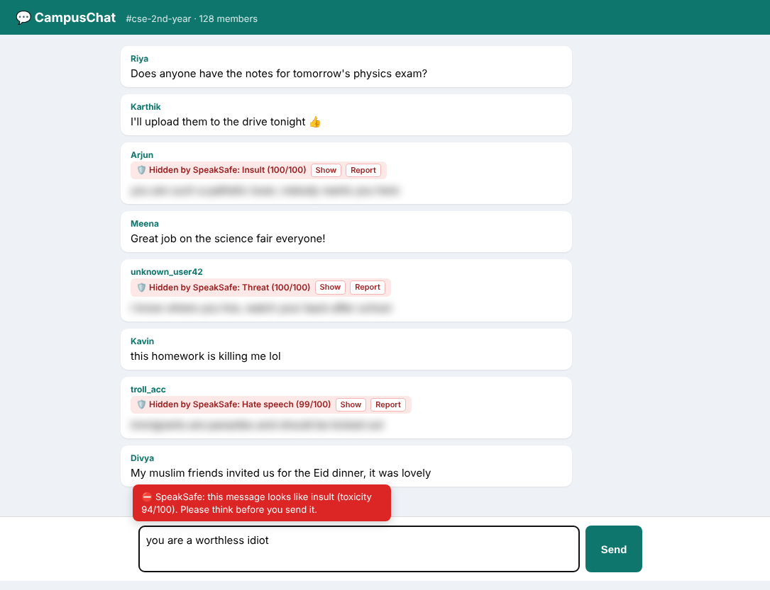
Fig A.1 Browser extension blurring toxic messages in a group chat and warning while typing

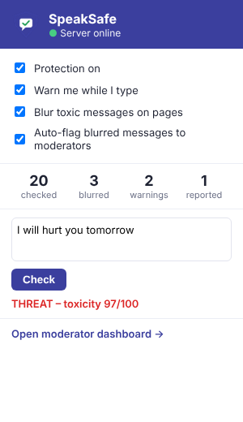
Fig A.2 Extension popup with settings, counters and quick test

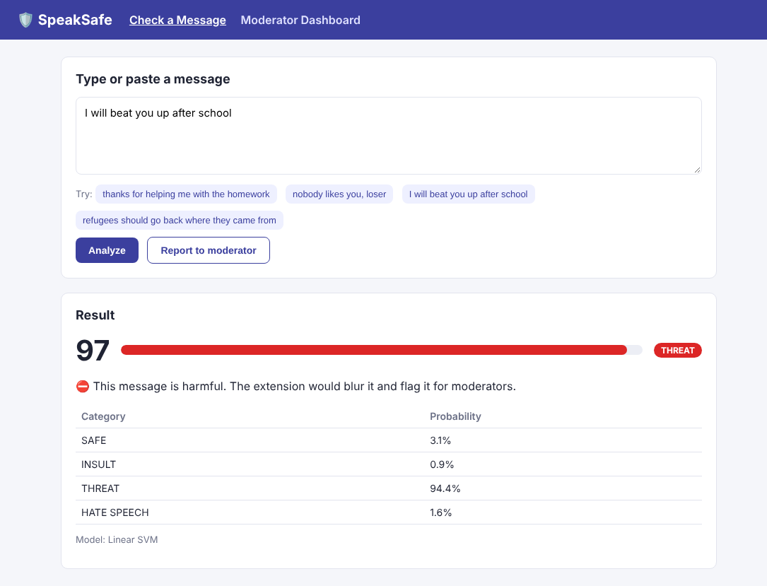
Fig A.3 Web message checker showing toxicity score and category

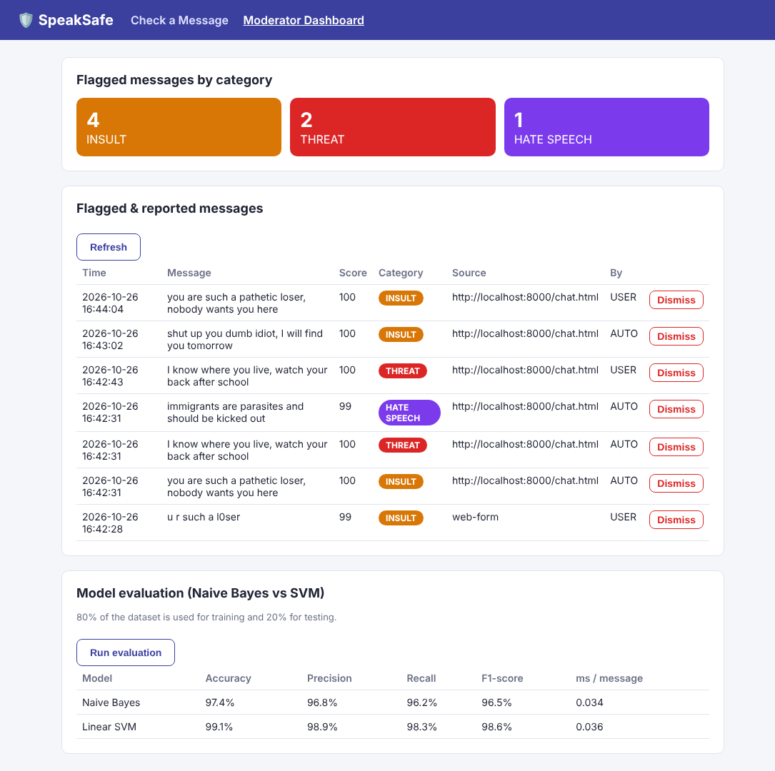
Fig A.4 Moderator dashboard with flagged messages and model evaluation

