**Problem Statement**: Determine the factors of a number (i.e., all positive integer values that evenly divide into a number) and then return the pth element of the list, sorted ascending. If there is no pth element, return 0.

**Example**; n = 20 p = 3 The factors of 20 in ascending order are {1, 2, 4, 5, 10, 20}. Using 1-based indexing, if p = 3, then 4 is returned. If p > 6, 0 would be returned.

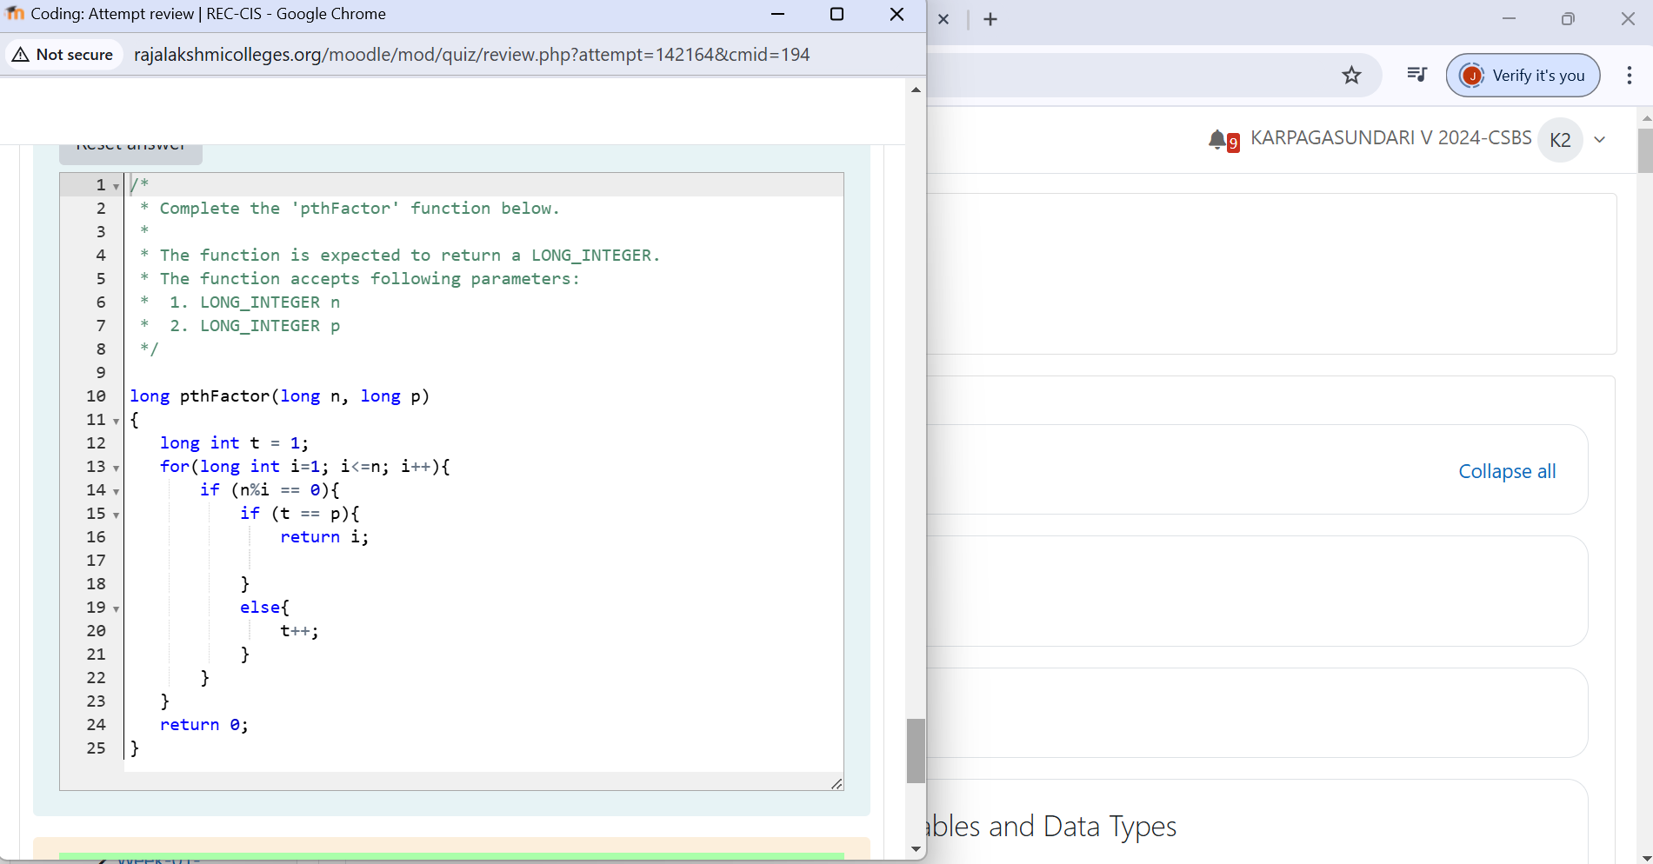

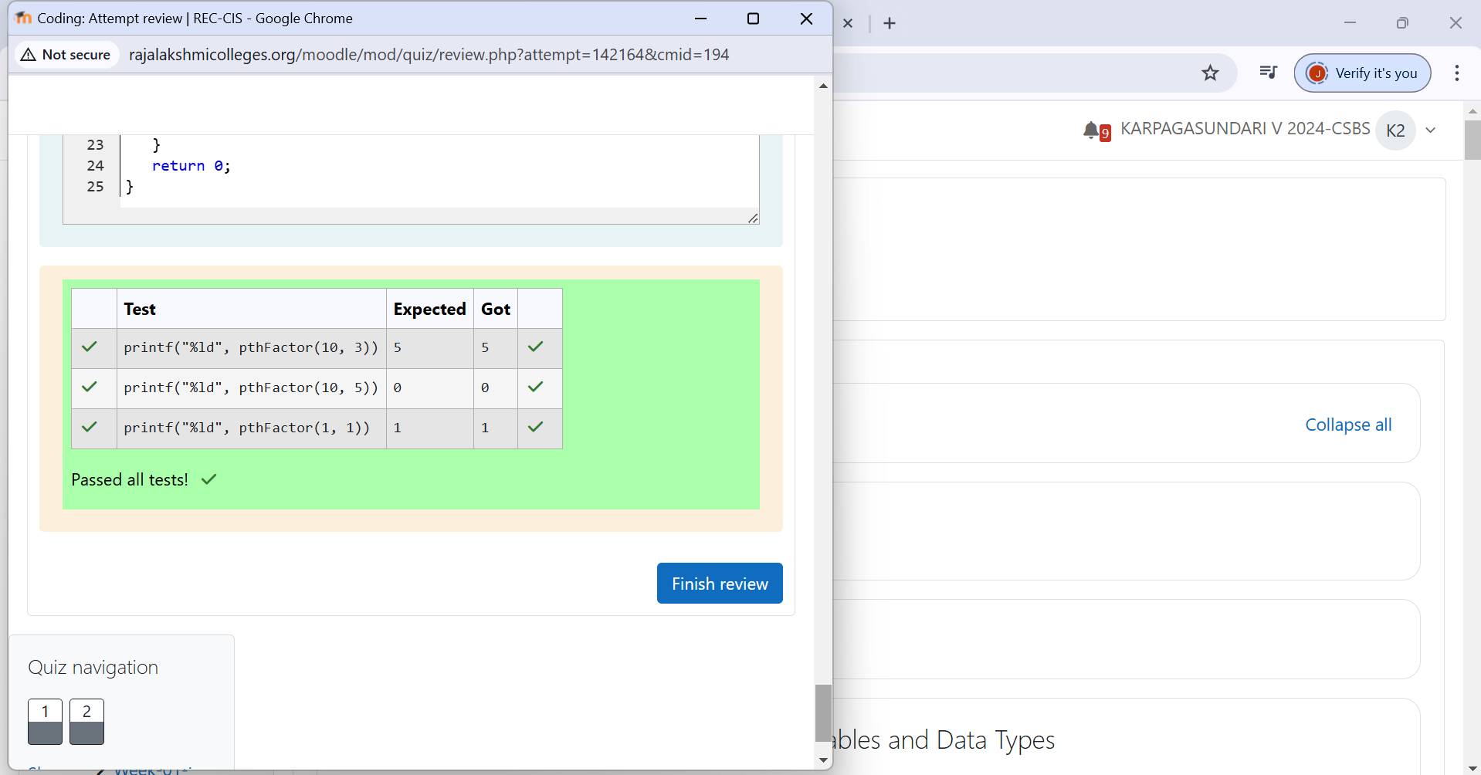

**Problem Statement**: A binary number is a combination of 1s and 0s. Its nth least significant digit is the nth digit starting from the right starting with 1. Given a decimal number, convert it to binary and determine the value of the the 4th least significant digit.

**Example number**; = 23 • Convert the decimal number 23 to binary number: 2310 = 24 + 22 + 21 + 20 = (10111)2. • The value of the 4th index from the right in the binary representation is 0.

