Step 1: Install visual studio. (go to https://visualstudio.microsoft.com/downloads/ and select community version(free version))

Step 2: Select the package ‘Desktop development with c++’ while installing visual studio.

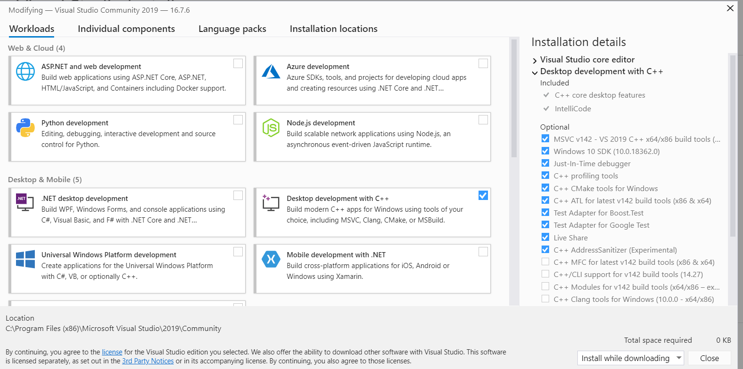

Step 3: Download Cmake (<https://cmake.org/download/>) . Select the platform based on your system (linux, windows, mac). I downloaded the [cmake-3.19.0-rc1-win64-x64.msi](https://github.com/Kitware/CMake/releases/download/v3.19.0-rc1/cmake-3.19.0-rc1-win64-x64.msi) .

Step 4: run the cmake and add CMake executable path to the Enviroment Variables:.

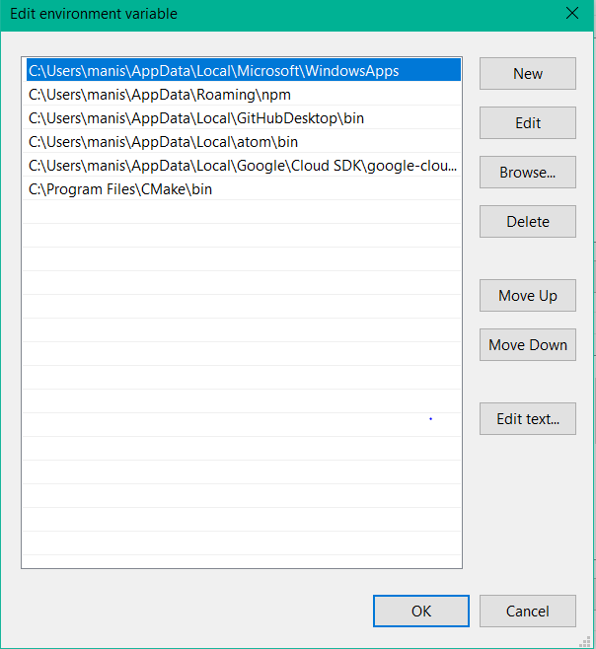

Step 5: install pycharm for running the python code

Step 6: Import the packages cmake, numpy, cv2, face_recognition, json, base64, dlib, requests, datetime, time.

Note: first install cmake and then try to install dlib (pip install dlib) . Try to install 19.18.0 version.