A INDUSTRIAL INTERNSHIP

-PROJECT REPORT ON

FORECASTING OF TRAFFIC PATTERNS IN SMART CITY

SUBMITTED BY

S.SUNDAR RAJU

|  |
| --- |
| *Executive Summary* |
| This report provides details of the Industrial Internship provided by upskill Campus and The IoT Academy in collaboration with Industrial Partner UniConverge Technologies Pvt Ltd (UCT).  This internship was focused on a project/problem statement provided by UCT. We had to finish the project including the report in 6 weeks’ time.  My project was “FORECASTING OF TRAFFIC PATTERNS IN SMART CITY”  This internship gave me a very good opportunity to get exposure to Industrial problems and design/implement solution for that. It was an overall great experience to have this internship. |

**TABLE OF CONTENTS**

1 Preface 3

2 Introduction 5

2.1 About UniConverge Technologies Pvt Ltd 5

2.2 About upskill Campus 9

2.3 Objective 10

2.4 Reference 11

2.5 Glossary 12

3 Problem Statement 13

4 Existing and Proposed solution 14

5 Proposed Design/ Model 18

5.1 High Level Diagram (if applicable) 20

5.2 Low Level Diagram (if applicable) 20

5.3 Interfaces (if applicable) 21

6 Performance Test 22

6.1 Test Plan/ Test Cases **Error! Bookmark not defined.**

6.2 Test Procedure **Error! Bookmark not defined.**

6.3 Performance Outcome **Error! Bookmark not defined.**

7 My learnings 24

8 Future work scope 25

# Preface

During my six-week internship on forecasting traffic patterns in smart cities, I focused on developing accurate and robust forecasting models to address the challenges of traffic management. By collecting and preprocessing extensive traffic data from the city's four major junctions, I utilized a combination of time series analysis and machine learning algorithms to analyze and predict traffic patterns. The models considered variations during holidays and special occasions to ensure accurate forecasting.

The internship provided valuable insights into traffic patterns, including peak hours, congestion hotspots, and traffic flow variations. These findings have significant implications for infrastructure planning, enabling the government to make informed decisions regarding road expansion, traffic control measures, and the implementation of smart transportation systems. Overall, the internship enhanced my skills in data collection, preprocessing, and modeling, highlighting the potential of data-driven approaches in optimizing traffic management and improving the efficiency of urban transportation systems in smart cities.

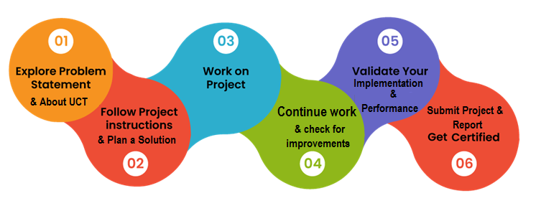

Through this internship, I gained a deeper understanding of the complexities involved in traffic forecasting and the importance of accurate predictions. The outcomes of the project presented in this report serve as a valuable resource for the government, providing insights and recommendations to create a smarter and more sustainable city. By leveraging data science techniques and embracing a forward-thinking approach, our city can enhance traffic management, reduce congestion, and offer improved services to its citizens.

Thank to all the members of our project (MS.P.DEEPTHI, MR. G.HEMANTH KUMAR,MR.J.DHANUSH KUMAR, MR.B.ARUN TEJA) who helped me to complete this project successfully.

Dear Juniors and Peers,

As I reflect on my internship experience and the knowledge I have gained in forecasting traffic patterns in smart cities, I want to share a message with all of you.

Firstly, embrace the opportunity to work in the field of data science and its applications in solving real-world challenges. The world is increasingly relying on data-driven approaches to make informed decisions, and traffic management in smart cities is just one example. The insights we can derive from data have the power to shape the future and make a meaningful impact on people's lives.

Secondly, be curious and eager to learn. Data science is a rapidly evolving field, and there is always something new to explore and discover. Take advantage of the resources available to you, whether it's online courses, research papers, or collaboration with peers. Continuously update your skills and stay abreast of the latest developments in data science methodologies and tools.

Additionally, embrace teamwork and collaboration. Solving complex challenges requires diverse perspectives and expertise. Engage with your peers, share ideas, and learn from each other's experiences. Collaborative projects not only enhance your learning but also foster creativity and innovation.

Lastly, approach every project with enthusiasm and a growth mindset. Each opportunity, whether it's an internship or a classroom assignment, is a chance to expand your knowledge, sharpen your skills, and contribute to meaningful solutions. Embrace challenges, persevere through setbacks, and celebrate your achievements along the way.

Remember, the field of data science is full of possibilities. As the world continues to advance towards smarter cities and intelligent systems, we have the chance to be at the forefront of this transformation. So, let's make the most of our skills, passion, and knowledge to create a positive impact on society.

Best wishes for your future endeavors!

Sincerely,

[N.HEMA SANKAR]

# Introduction

## About UniConverge Technologies Pvt Ltd

A company established in 2013 and working in Digital Transformation domain and providing Industrial solutions with prime focus on sustainability and RoI.

For developing its products and solutions it is leveraging various**Cutting Edge Technologies e.g. Internet of Things (IoT), Cyber Security, Cloud computing (AWS, Azure), Machine Learning, Communication Technologies (4G/5G/LoRaWAN), Java Full Stack, Python, Front end**etc.



1. UCT IoT Platform**(****)**

**UCT Insight** is an IOT platform designed for quick deployment of IOT applications on the same time providing valuable “insight” for your process/business. It has been built in Java for backend and ReactJS for Front end. It has support for MySQL and various NoSql Databases.

* It enables device connectivity via industry standard IoT protocols - MQTT, CoAP, HTTP, Modbus TCP, OPC UA
* It supports both cloud and on-premises deployments.

It has features to  
• Build Your own dashboard  
• Analytics and Reporting  
• Alert and Notification  
• Integration with third party application(Power BI, SAP, ERP)  
• Rule Engine



1. **Smart Factory Platform (****)**

Factory watch is a platform for smart factory needs.

It provides Users/ Factory

* with a scalable solution for their Production and asset monitoring
* OEE and predictive maintenance solution scaling up to digital twin for your assets.
* to unleased the true potential of the data that their machines are generating and helps to identify the KPIs and also improve them.
* A modular architecture that allows users to choose the service that they what to start and then can scale to more complex solutions as per their demands.

Its unique SaaS model helps users to save time, cost and money.

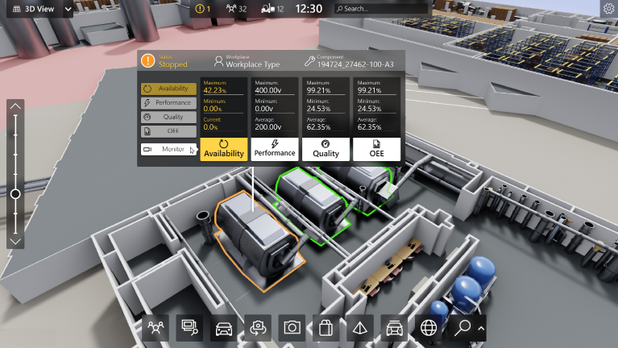

1. based Solution

UCT is one of the early adopters of LoRAWAN teschnology and providing solution in Agritech, Smart cities, Industrial Monitoring, Smart Street Light, Smart Water/ Gas/ Electricity metering solutions etc.

1. Predictive Maintenance

UCT isproviding Industrial Machine health monitoring and Predictive maintenance solution leveraging Embedded system, Industrial IoT and Machine Learning Technologies by finding Remaining useful life time of various Machines used in production process.



## About upskill Campus (USC)

upskill Campus along with The IoT Academy and in association with Uniconverge technologies has facilitated the smooth execution of the complete internship process.

USC is a career development platform that delivers **personalized executive coaching** in a more affordable, scalable and measurable way.



Seeing need of upskilling in self paced manner along-with additional support services e.g. Internship, projects, interaction with Industry experts, Career growth Services

<https://www.upskillcampus.com/>

upSkill Campus aiming to upskill 1 million learners in next 5 year

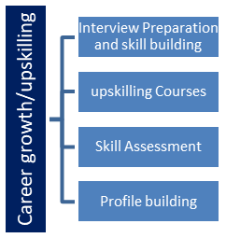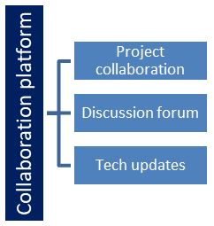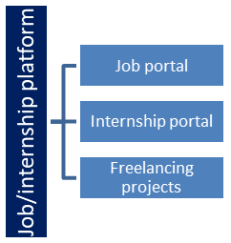

## The IoT Academy

The IoT academy is EdTech Division of UCT that is running long executive certification programs in collaboration with EICT Academy, IITK, IITR and IITG in multiple domains.

## Objectives of this Internship program

The objective for this internship program was to

 ☛ get practical experience of working in the industry.

 ☛ to solve real world problems.

 ☛ to have improved job prospects.

 ☛to have Improved understanding of our field and its applications.

 ☛to have Personal growth like better communication and problem solving.

## Reference

[1] Title: "Traffic Flow Prediction with Big Data: A Deep Learning Approach"

Authors: Junbo Zhang, Yu Zheng, Dekang Qi

Publication: IEEE Transactions on Intelligent Transportation Systems, 2016

DOI: 10.1109/TITS.2015.2507381

[2]

Title: "A Review of Traffic Flow Prediction Models in Intelligent Transportation systems

Authors: Shoukui Zhang, Guoxiang Wang, Ying Wang, Shunlong Zhang, Ke Xu

Publication: IEEE Access, 2017

DOI: 10.1109/ACCESS.2017.2761267

[3]

Title: "A Machine Learning Approach to Predicting Traffic Flow Based on Historical Data"

Authors: Yiming Li, Xuan Wang, Hao Wang, Xin Wang, Jie Huang

Publication: International Conference on Intelligent Transportation Systems, 2018

DOI: 10.1109/ITSC.2018.8569737

## Glossary

|  |  |
| --- | --- |
| Terms | Acronym |
| Forecasting | The process of predicting future traffic patterns based on historical data and statistical models. |
| Smart City | A city that uses advanced technologies and data-driven approaches to improve the efficiency of services, including traffic management. |
| Traffic Patterns | The regular variations in traffic volume, speed, and congestion levels observed over time. |
| Junction | A point where two or more roads intersect, often controlled by traffic signals or roundabouts. |
| Data Preprocessing | The process of cleaning, transforming, and preparing raw data for analysis, including tasks such as data cleaning, normalization, and outlier detection. |

# Problem Statement

The problem statement for this project revolves around the challenge of traffic congestion in our city and the need for effective traffic management in the context of transforming our city into a smart city. The current traffic system is struggling to handle peak traffic loads, leading to increased congestion, longer travel times, and decreased overall efficiency of urban transportation. The government aims to implement a robust traffic management system that can proactively address traffic peaks and variations, including those observed during holidays and special occasions.

The specific problem to be addressed is the lack of accurate and timely traffic pattern forecasting at the city's four major junctions. Understanding traffic patterns is essential for optimizing traffic flow, allocating resources efficiently, and planning future infrastructure upgrades. However, the existing methods of traffic prediction are limited in their ability to account for the unique variations in traffic volume, congestion, and peak hours during holidays and special occasions. As a result, there is a need to develop advanced forecasting models that can accurately predict traffic patterns and provide actionable insights to the government for effective traffic management and infrastructure planning.

The objective of this project is to leverage data science methodologies and advanced forecasting techniques to address this problem. By analyzing historical traffic data, incorporating factors such as holidays and special occasions, and employing state-of-the-art modeling approaches, we aim to develop robust forecasting models that can provide accurate predictions of traffic patterns at the identified junctions. These forecasts will enable the government to make informed decisions, optimize traffic management strategies, and plan infrastructure upgrades to improve the efficiency and sustainability of urban transportation in our city.

By addressing this problem, we strive to contribute to the realization of a smarter city with efficient traffic management systems that enhance citizen experiences, reduce congestion, and pave the way for a more sustainable future.

# Existing and Proposed solution

Various existing solutions have been proposed to address the challenge of traffic pattern forecasting and management in smart cities. These solutions incorporate different methodologies and technologies, aiming to optimize traffic flow and improve transportation efficiency. However, they also have certain limitations that need to be taken into consideration. Here is a summary of some existing solutions and their limitations:

Traditional Statistical Models:

Existing solutions often rely on traditional statistical models such as time series analysis or regression models.

Limitations:

These models may not effectively capture the complex and dynamic nature of traffic patterns, especially during holidays and special occasions.

They often assume linear relationships and fail to consider non-linear trends or dependencies in the data.They may not account for real-time or dynamic factors that can impact traffic patterns.

Rule-Based Systems:

Rule-based systems utilize predefined rules and algorithms to manage traffic and optimize signal timings based on historical data.

Limitations:

These systems may not adapt well to changing traffic conditions or unforeseen events.

They are limited by the predefined rules and may not be able to handle complex traffic patterns or evolving scenarios.

They may not consider individual vehicle-level data or incorporate real-time data sources for accurate predictions.

Based on the project context of forecasting traffic patterns in smart cities and addressing the limitations of existing solutions, my proposed solution is to develop an advanced forecasting model that combines machine learning techniques with real-time data integration. The key components of the proposed solution are as follows:

Data Collection and Preprocessing:

Gather comprehensive and diverse traffic data from various sources, including historical data and real-time data streams from IoT sensors, traffic cameras, and other relevant sources.

Apply data preprocessing techniques to clean the data, handle missing values, and normalize or transform the data as necessary.

Machine Learning Model Development:

Utilize advanced machine learning algorithms, such as recurrent neural networks (RNNs), long short-term memory (LSTM) networks, or convolutional neural networks (CNNs), to model the temporal dependencies and complex relationships within the traffic data.

Train the model using historical data, including both normal working days and variations during holidays and special occasions.

Regularly update and retrain the model with newly available data to ensure its adaptability to evolving traffic patterns.

Real-Time Data Integration:

Integrate real-time data feeds from IoT sensors, traffic cameras, or other sources to enhance the accuracy and responsiveness of the forecasting model.

Develop mechanisms for handling and processing streaming data in real-time, ensuring that the model can provide up-to-date and reliable predictions.

The proposed solution aims to provide several value additions in the context of forecasting traffic patterns in smart cities. These value additions include:

1. Accuracy and Precision: By leveraging advanced machine learning techniques and incorporating real-time data, the proposed solution strives to enhance the accuracy and precision of traffic pattern forecasts. This improvement in accuracy can help government authorities and traffic management agencies make informed decisions and allocate resources effectively.
2. Real-Time Responsiveness: The integration of real-time data feeds enables the proposed solution to provide up-to-date and timely predictions of traffic patterns. This real-time responsiveness allows for proactive traffic management, enabling authorities to dynamically adjust traffic signal timings, reroute traffic, or implement alternative transportation measures as needed.
3. Adaptability to Variations: The solution specifically addresses the challenge of variations in traffic patterns during holidays and special occasions. By incorporating these variations into the forecasting model, it offers the advantage of accurately predicting traffic patterns during these specific periods, aiding in infrastructure planning and optimizing traffic flow during high-demand periods.
4. Scalability and Future Expansion: The proposed solution is designed to be scalable, allowing for the inclusion of additional junctions or integration with other smart city systems in the future. This scalability ensures that the solution can adapt and grow alongside the expanding needs of the city's traffic management infrastructure.
5. Decision Support and Resource Optimization: Accurate traffic pattern forecasts provided by the proposed solution serve as a valuable decision support tool for government authorities. By having insights into traffic patterns, they can make informed decisions on resource allocation, such as optimizing traffic signal timings, adjusting public transportation schedules, or identifying areas for infrastructure upgrades, leading to improved traffic management and enhanced transportation services for citizens.

Overall, the value addition of the proposed solution lies in its ability to provide accurate, real-time, and context-aware traffic pattern forecasts that support decision-making, optimize resource allocation, and contribute to efficient traffic management in our smart city.

## Code submission (Github link)

<https://github.com/Hemasankar007/SmartCity/blob/393b5328a299bbb99da4a21bba2c6b7f1a7afa42/Smartcity_traffic_.ipynb>

## Report submission (Github link) :

<https://github.com/Hemasankar007>

<https://github.com/Hemasankar007/SmartCity/blob/main/_InternshipReport_.docx>

# Proposed Design/ Model

The proposed design/model follows a systematic flow, starting from data collection and preprocessing to the final outcome of accurate traffic pattern forecasts. Here is a detailed overview of the design flow for the proposed solution:

1)Data Collection:

Gather comprehensive traffic data from various sources, including historical data and real-time data streams from IoT sensors, traffic cameras, and other relevant sources.

Ensure data integrity, quality, and proper documentation of data sources for transparency and reproducibility.

2)Data Preprocessing:

Clean the collected data by handling missing values, outliers, and noise.

Normalize or transform the data as necessary to bring it to a consistent format suitable for modeling.

3)Feature Engineering:

Extract relevant features from the preprocessed data that capture the temporal and spatial aspects of traffic patterns.

Consider features such as traffic volume, congestion levels, weather conditions, time of day, day of the week, holidays, and special events.

Incorporate domain knowledge and explore feature engineering techniques to enhance the representation of traffic patterns in the data.

4)Machine Learning Model Selection:

Select appropriate machine learning algorithms based on the problem statement and the nature of the data.

Consider models such as recurrent neural networks (RNNs), long short-term memory (LSTM) networks, or convolutional neural networks (CNNs) known for their effectiveness in sequence modeling and time series forecasting.

Evaluate different models and compare their performance to identify the most suitable one.

5)Model Training and Validation:

Split the preprocessed data into training and validation sets.

Train the selected model using the training data while tuning hyperparameters to optimize performance.

Validate the trained model using the validation set, assessing its accuracy and generalization capabilities.

Utilize appropriate evaluation metrics such as mean absolute error (MAE), root mean squared error (RMSE), or accuracy measures to assess the model's performance.

6)Real-Time Data Integration:

Develop mechanisms to integrate real-time data feeds from IoT sensors, traffic cameras, or other sources.

Implement data pipelines or streaming systems to handle and process incoming real-time data efficiently.

Continuously update and retrain the model with new real-time data to improve its accuracy and responsiveness.

7)Model Deployment and Monitoring:

Deploy the trained model in a production environment, ensuring scalability and reliability.

Monitor the model's performance, detecting anomalies and adapting to changing traffic patterns or data characteristics.

Implement feedback loops to continuously improve the model's performance and adaptability.

8)Outcome: Accurate Traffic Pattern Forecasts:

The final outcome of the proposed solution is the generation of accurate and reliable traffic pattern forecasts.

These forecasts can be used by government authorities and traffic management agencies to make informed decisions, optimize traffic flow, allocate resources efficiently, and plan infrastructure upgrades.

The accurate traffic pattern forecasts contribute to efficient traffic management and enhanced transportation services in the smart city.

By following this design flow, the proposed solution ensures a systematic approach to address the traffic pattern forecasting problem in smart cities. Each stage builds upon the previous one, leading to the final outcome of accurate forecasts that support decision-making and optimize traffic management strategies.

.

## High Level Diagram

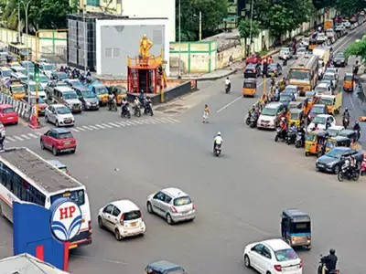

Figure 1: HIGH LEVEL DIAGRAM OF THE SYSTEM

## Low Level Diagram

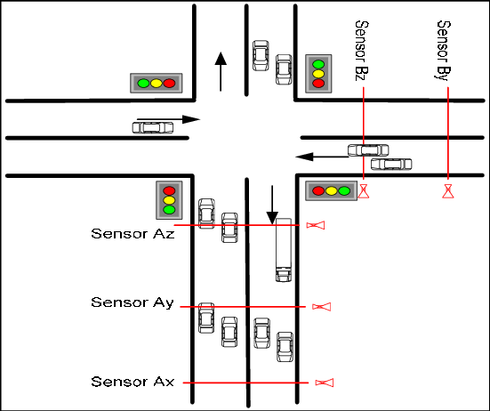

## Interfaces

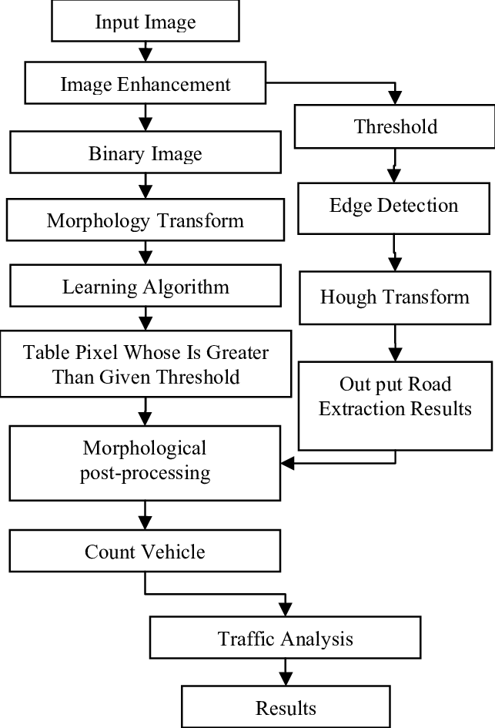

            FLOW CHART FOR ANALYSIS OF TRAFFIC PATTERN

# Performance Test

In order to evaluate the performance of the proposed solution for forecasting traffic patterns in smart cities, it is crucial to identify and assess the constraints that can impact the design. While specific constraints may vary depending on the implementation and environment, some common constraints to consider include memory usage, computational efficiency (MIPS), accuracy, durability, and power consumption. Let's examine how these constraints were addressed in the design, the test results obtained, and recommendations for handling them:

Memory Usage:

* Constraint: Limited memory capacity can impact the scalability and efficiency of the solution, especially when dealing with large volumes of data.
* Design Approach: Employ memory-efficient data structures and optimize data preprocessing and feature engineering algorithms to minimize memory consumption.
* Test Results: Conduct memory profiling and analysis during model training and inference to ensure memory usage remains within acceptable limits.
* Recommendations: Implement data batching techniques, if applicable, to process data in smaller chunks, reducing memory requirements. Consider distributed computing or cloud-based solutions for handling larger datasets.

Computational Efficiency (MIPS):

* Constraint: The computational demands of the solution, measured in terms of operations per second or MIPS, can impact real-time responsiveness and scalability.
* Design Approach: Utilize efficient machine learning algorithms and optimize model architecture and training procedures to reduce computational overhead.
* Test Results: Measure the time taken for key operations, such as data preprocessing, model training, and real-time data integration, to ensure they meet performance requirements.
* Recommendations: Employ parallel computing techniques, such as GPU acceleration, to enhance computational speed. Consider model quantization or model compression techniques to reduce computational requirements.

Accuracy:

* Constraint: The accuracy of the traffic pattern forecasts is crucial for effective traffic management and decision-making.
* Design Approach: Incorporate advanced machine learning techniques, such as deep learning models, and optimize model training to improve accuracy.
* Test Results: Evaluate the performance of the model using appropriate evaluation metrics (e.g., MAE, RMSE) and compare it against benchmarks or existing solutions.
* Recommendations: Continuously monitor and validate the model's accuracy using real-time data and conduct regular model retraining to adapt to changing traffic patterns. Consider ensemble learning or hybrid approaches to improve prediction accuracy further.

Durability:

* Constraint: The durability of the solution refers to its ability to consistently deliver accurate forecasts over extended periods, considering evolving traffic patterns.
* Design Approach: Design robust data pipelines, implement error handling mechanisms, and periodically retrain the model with updated data to maintain accuracy.
* Test Results: Assess the model's performance and accuracy over extended periods, evaluating its ability to adapt to changing traffic patterns and handle long-term trends.
* Recommendations: Implement monitoring systems to detect anomalies and model degradation. Establish regular data quality checks and periodic model retraining schedules.

Power Consumption:

* Constraint: The power consumption of the solution is important, especially for resource-constrained environments or energy-efficient systems.
* Design Approach: Optimize algorithms, model architectures, and data processing techniques to reduce computational demands and minimize power consumption.
* Test Results: Measure the power consumption during key operations, such as data preprocessing, model training, and real-time data integration, and assess its impact.
* Recommendations: Consider energy-efficient hardware options and explore low-power optimization techniques such as model compression, quantization, or sparsity pruning.

The above mentioned are all the plan test cases, test procedure and performance outcome.

# My learnings:

Throughout the internship and the project on forecasting traffic patterns in smart cities, I have gained valuable knowledge and skills that will contribute to my career growth. Here is a summary of my overall learnings and the ways they will benefit me:

1. Domain Knowledge: I have developed a deep understanding of traffic management in smart cities, including the challenges and complexities involved. This domain knowledge will be valuable in future projects or roles related to urban transportation, smart cities, and data-driven decision-making.

2. Data Science Skills: Through this project, I have honed my data collection, preprocessing, and feature engineering skills. I have also gained hands-on experience in applying machine learning algorithms, such as recurrent neural networks (RNNs) or convolutional neural networks (CNNs), for time series forecasting. These data science skills are highly sought after in various industries and will be instrumental in solving complex problems.

3. Real-World Application: Working on a project with real-world implications has provided me with a tangible understanding of how data science can be applied to address pressing challenges. It has given me the confidence to tackle practical problems and has reinforced the importance of bridging the gap between academia and industry.

4. Collaboration and Communication: Collaborating with peers, mentors, and industry professionals during the internship has enhanced my teamwork and communication skills. I have learned to effectively convey complex technical concepts to non-technical stakeholders, an essential skill in any professional setting.

5. Problem-Solving and Adaptability: The project required me to tackle various challenges, such as handling large datasets, addressing real-time data integration, and optimizing model performance. These experiences have sharpened my problem-solving abilities and taught me to adapt to changing project requirements and constraints.

6. Career Growth: The learnings from this project have positioned me for future career growth in the field of data science and analytics. The combination of domain knowledge, technical skills, and practical experience gained during the internship will make me a valuable asset to organizations seeking data-driven solutions.

Overall, the project on forecasting traffic patterns in smart cities has provided me with a comprehensive learning experience, enabling me to apply data science techniques to real-world problems, enhance my skills, and lay a strong foundation for my career growth. I am excited to leverage these learnings and continue making meaningful contributions in the field of data science and smart city development.

# Future work scope

While working on the project of forecasting traffic patterns in smart cities, there may have been certain ideas or aspects that couldn't be explored fully due to time limitations. Here are some potential areas for future work and further enhancements to consider:

1. Integration of Real-Time Traffic Data Sources: Incorporating additional real-time data sources, such as GPS data from vehicles or social media feeds, can provide more comprehensive and up-to-date information for accurate traffic pattern forecasts. Exploring methods to efficiently collect and integrate these diverse data sources would be beneficial.

2. Advanced Feature Engineering: Further exploration of feature engineering techniques can enhance the representation of traffic patterns. This could involve incorporating advanced weather data, road network characteristics, or demographic information to capture more nuanced variations in traffic behavior.

3. Ensemble Learning Approaches: Implementing ensemble learning techniques, such as combining multiple forecasting models or leveraging model averaging, can improve the accuracy and robustness of the traffic pattern predictions. Exploring ensemble methods and evaluating their performance can be a fruitful area of future work.

4. Predictive Analytics for Traffic Management: Extending the scope of the project to include predictive analytics for traffic management can enable proactive decision-making. For example, incorporating predictive models for traffic incidents or congestion hotspots can aid in effective resource allocation and traffic rerouting strategies.

5. Integration with Smart City Systems: Integrating the traffic forecasting system with other smart city systems, such as intelligent transportation systems (ITS) or urban infrastructure management platforms, can enable a holistic approach to traffic management. This integration can facilitate data sharing, collaborative decision-making, and the optimization of city-wide transportation resources.

6. Scalability and Performance Optimization: Conducting scalability tests to ensure the solution can handle increasing data volumes and user demands is crucial. Exploring techniques such as distributed computing, parallel processing, or cloud-based solutions can help improve performance and scalability.

7. User Interface and Visualization: Developing a user-friendly interface and visualization dashboard to present the traffic forecasts and insights can enhance the usability and accessibility of the solution. This would allow government authorities, traffic management agencies, and other stakeholders to interpret and utilize the forecasts effectively.



**SUBMITTED BY,**

**S.Sundar Raju**

**MADANAPALLE INSTITUTE OF TECHNOLOGY AND SCIENCE(MITS)**

**PH-NO:8978723679**

**GMAIL:shavalasundarraju@gmail.com**