Project Report: MegaStore Database System
Project Introduction
This project involved the design and development of a professional relational database for MegaStore, an e-commerce platform. The system is built to efficiently manage large volumes of data, including products, customers, and financial transactions.
Database Structure (Tables)
I designed a normalized database schema consisting of 5 core tables:
- Users: Stores customer information and account details.
- Products: Manages names, descriptions, pricing, and inventory levels.
- Categories: Organizes products into logical groups (e.g., Electronics, Fashion).
- Orders: Records customer purchases and order history.
- Payments: Tracks transaction status and payment methods.
- 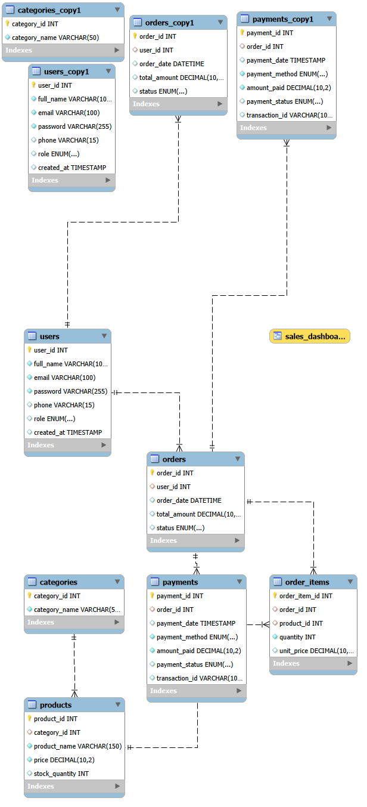
Key Features & Achievements
Based on the project requirements, I successfully implemented the following:
- Large Scale Data Handling: Successfully managed and stored 1,500+ product records and 850+ customer orders.
- Automation with Stored Procedures: Instead of manual entry, I developed SQL Stored Procedures to automate the generation of thousands of rows of testing data.
- Business Intelligence Queries: Created advanced SQL scripts to generate real-time reports, such as:
- Monthly Revenue Tracking: Calculating total sales per month.
- Inventory Alerts: Identifying products with low stock (below 10 units).
- Customer Insights: Finding the top-spending customers for loyalty rewards.
- Data Integrity & Cleaning: Implemented scripts to find and remove duplicate records and ensured data safety using Foreign Key constraints.
Technical Tools

Database Engine: MySQL

Management Tool: MySQL Workbench

