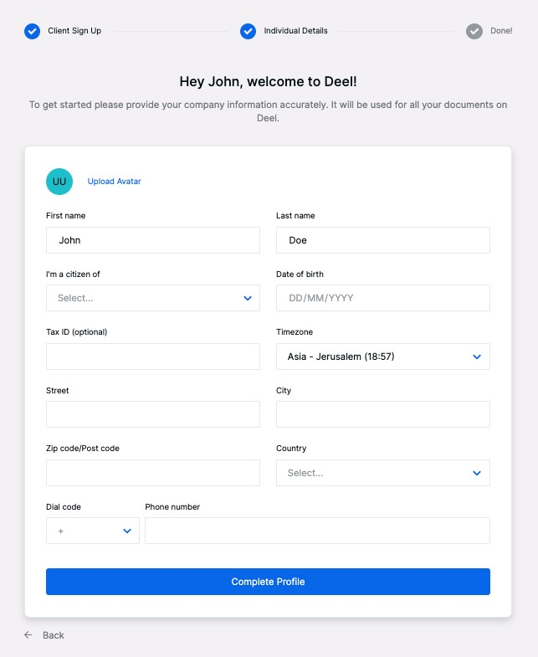

# Test Plan

1. **3 different fields** of your choice in the page above with all relevant edge cases.

* First Name
* Last Name
* Date of Birth

1. **Positive and negative test Cases:**  
      
   -Verify the Maximum Character Limit for the First name and Last name Text box.  
   -Verify the Minimum Character Limit for the First Name and Last name Text box.  
   -Check first and last name text field are accepting the number.   
   -Verify that the able to enter only the specific value in text box.  
   -Verify that cursor blink or not when click on the text box.  
   -Verify that the text field by entering the decimal value.   
   -Verify alphabets are accepted in upper and lower case both.  
   -Verify that the space button working in text box.  
   -Check system behavior when text fields are empty.  
   -Check system behavior when Date-of-Birth is the present date.  
   -Check system behavior when Date-of-Birth is the future date.  
   -Verify that space button working in text box.

# Automation

Please specify how you are going to ***automate*** the test plan in terms of:

1. **Tools**   
   Test Runner   
   Selenium WebDriver  
   Eclipse  
   Selenium IDE  
   Selenium Grid
2. Process

Security Testing

Review of Requirements

Writing Test Cases

Integration Testing

Unit Testing

Cross Browser Testing

Performance Testing

System Testing

Regression Testing

Updating test Cases

1. **Stages**

* Analyze Requirement
* Plan the Tests
* Design the Tests
* Execute tests and Report Defects
* Run Re-Tests and Regression Tests
* Run Release Tests

**4. Reports**

* Defining the scope of automation
* Selecting an automation testing tool
* Planning, Designing and development
* Executing test cases and build your test reports

**If we automate the application by using Automation test framework then Test runner allow to run functional test and export the result.**

# Test Types

I will recommend performing End2end test - running on weekends with heavy data;  
Benefits:

* Expand test coverage
* Ensure the correctness of the Application
* Detect Bugs

**System risks can be avoided by performing the following**

* Verifying the system flow
* Increasing test coverage areas
* Detecting issues associated with the subsystem

# Test Automation

Write a test to create a "Fixed Rate" contract using the best practices.

import org.openqa.selenium.By;

import org.openqa.selenium.WebDriver;

import org.openqa.selenium.WebElement;

import org.openqa.selenium.chrome.ChromeDriver;

import com.sun.org.apache.bcel.internal.generic.Select;

public class ContractDetails {

public static void main(String[] args) {

System.setProperty("webdriver.chrome.driver","C:\\Users\\HP\\Pictures//chromedriver.exe");

WebDriver driver=new ChromeDriver();

driver.get("https://app.letsdeel.com/login");//open the Web URL

driver.findElement(By.name("email")).sendKeys("fewifib273@ehstock.com");//

driver.findElement(By.name("password")).sendKeys("Iqra1515_15");

driver.findElement(By.className("button mt-10 w-100")).click();

driver.findElement(By.className("sidebar-option-p")).click();

driver.findElement(By.xpath("M83.581 70.537a5.814 5.814 0 100-11.628 5.814 5.814 0 000 11.628z")).click();//click on fixed rate

driver.findElement(By.name("name")).sendKeys("test account");

driver.findElement(By.className("deel-ui__textarea-component__textarea")).sendKeys("This is scope");

// Create object of the Select class

Select jobtitle = new Select(driver.findElement(By.name("jobTitle"));

// Select the option with value "1"

jobtitle.selectByValue("1");

// Create object of the Select class for 2nd drop-down

Select senior = new Select(driver.findElement(By.className("deel-ui__select__single-value css-1uccc91-singleValue"));

// Select the option with value "1"

jobtitle.selectByValue("1");

driver.findElement(By.className("deel-ui__textarea-component__textarea"));

WebElement element = driver.findElement(By.className("deel-ui__calendar-input-container__input_content_value"));

String elementval = element.getAttribute("Today-1 - Dec 27, 2021");

// Create object of the Select class for 2nd drop-down

Select currency = new Select(driver.findElement(By.className("deel-ui__select__value-container deel-ui__select__value-container--has-value css-1hwfws3"));

// Select the option with value "40"

jobtitle.selectByValue("40");

driver.findElement(By.name("rate")).sendKeys("1000pound");

// Create object of the Select class for 2nd drop-down

Select payementfrequency = new Select(driver.findElement(By.className("deel-ui__select__control css-yk16xz-control"));

// Select the option with value "1"

payementfrequency.selectByValue("1");

//click on the Next button

driver.findElement(By.className("button mt-9 submit-payments-details heap-create-contract-fixed-payment-details-next w-100")).click();

// writting additional clause

driver.findElement(By.className("counter footer-right")).sendKeys("Where is the contractor's tax residence?\": United States / Colorado");

}

}

