Beginning: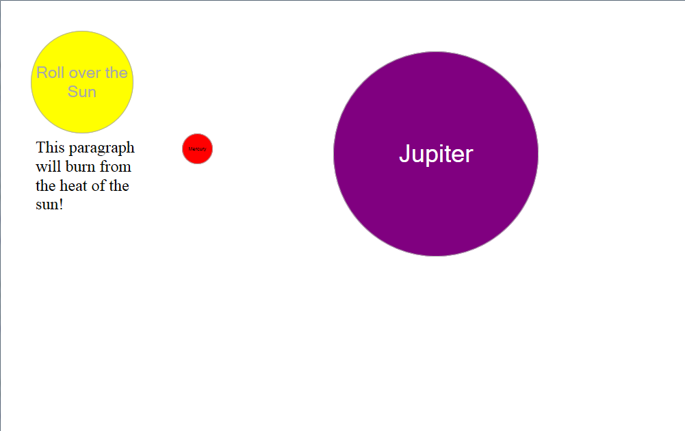

Roll over the sun:

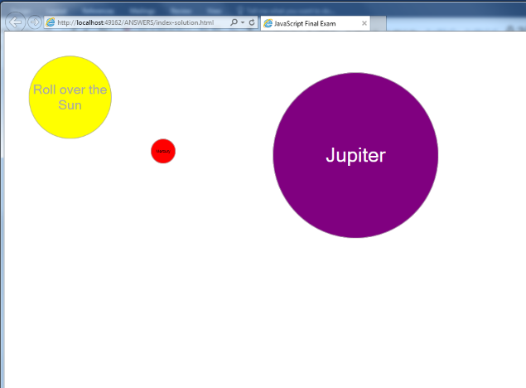

Click Mercury:

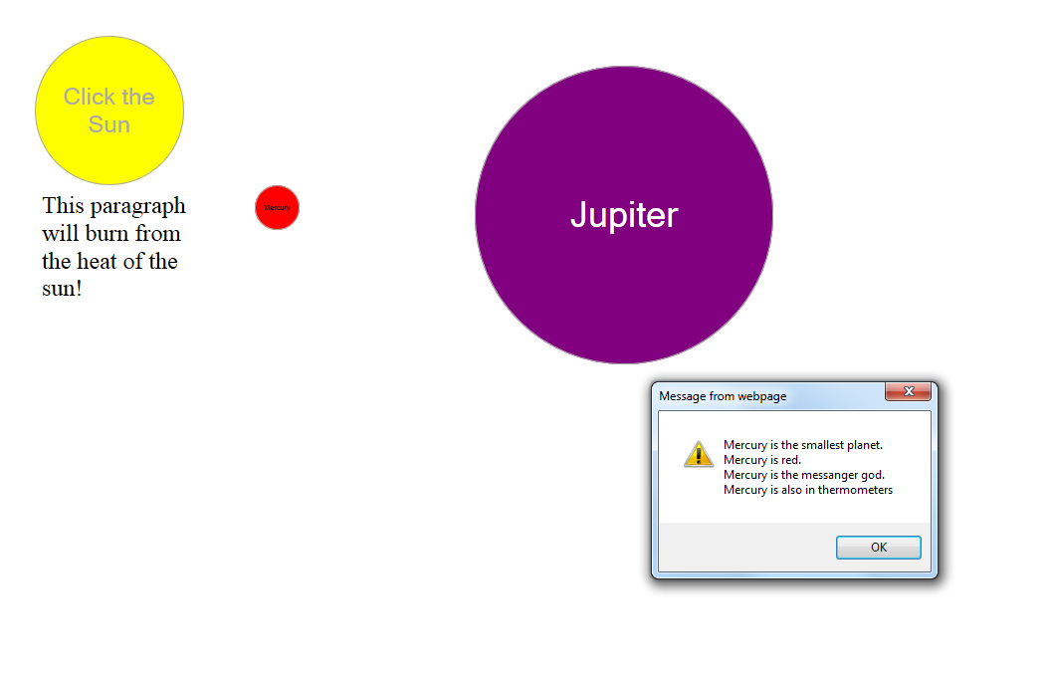

Click Jupiter:

­­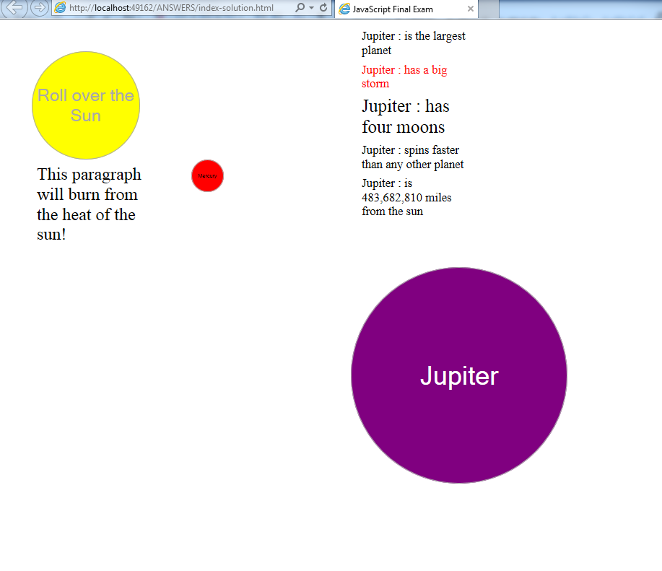

Try to format the planets and the messages just as above. As well, don’t forget the extra credit on the sun and Jupiter.