Contact: Erin Edholm  National Wind, LLC  Phone: (612 ) 746-6646  Fax: (888) 867-0688  eedholm@nationalwind.com | 3033 Excelsior Blvd.  Suite 525  Minneapolis, MN 55416  www.nationalwind.com | 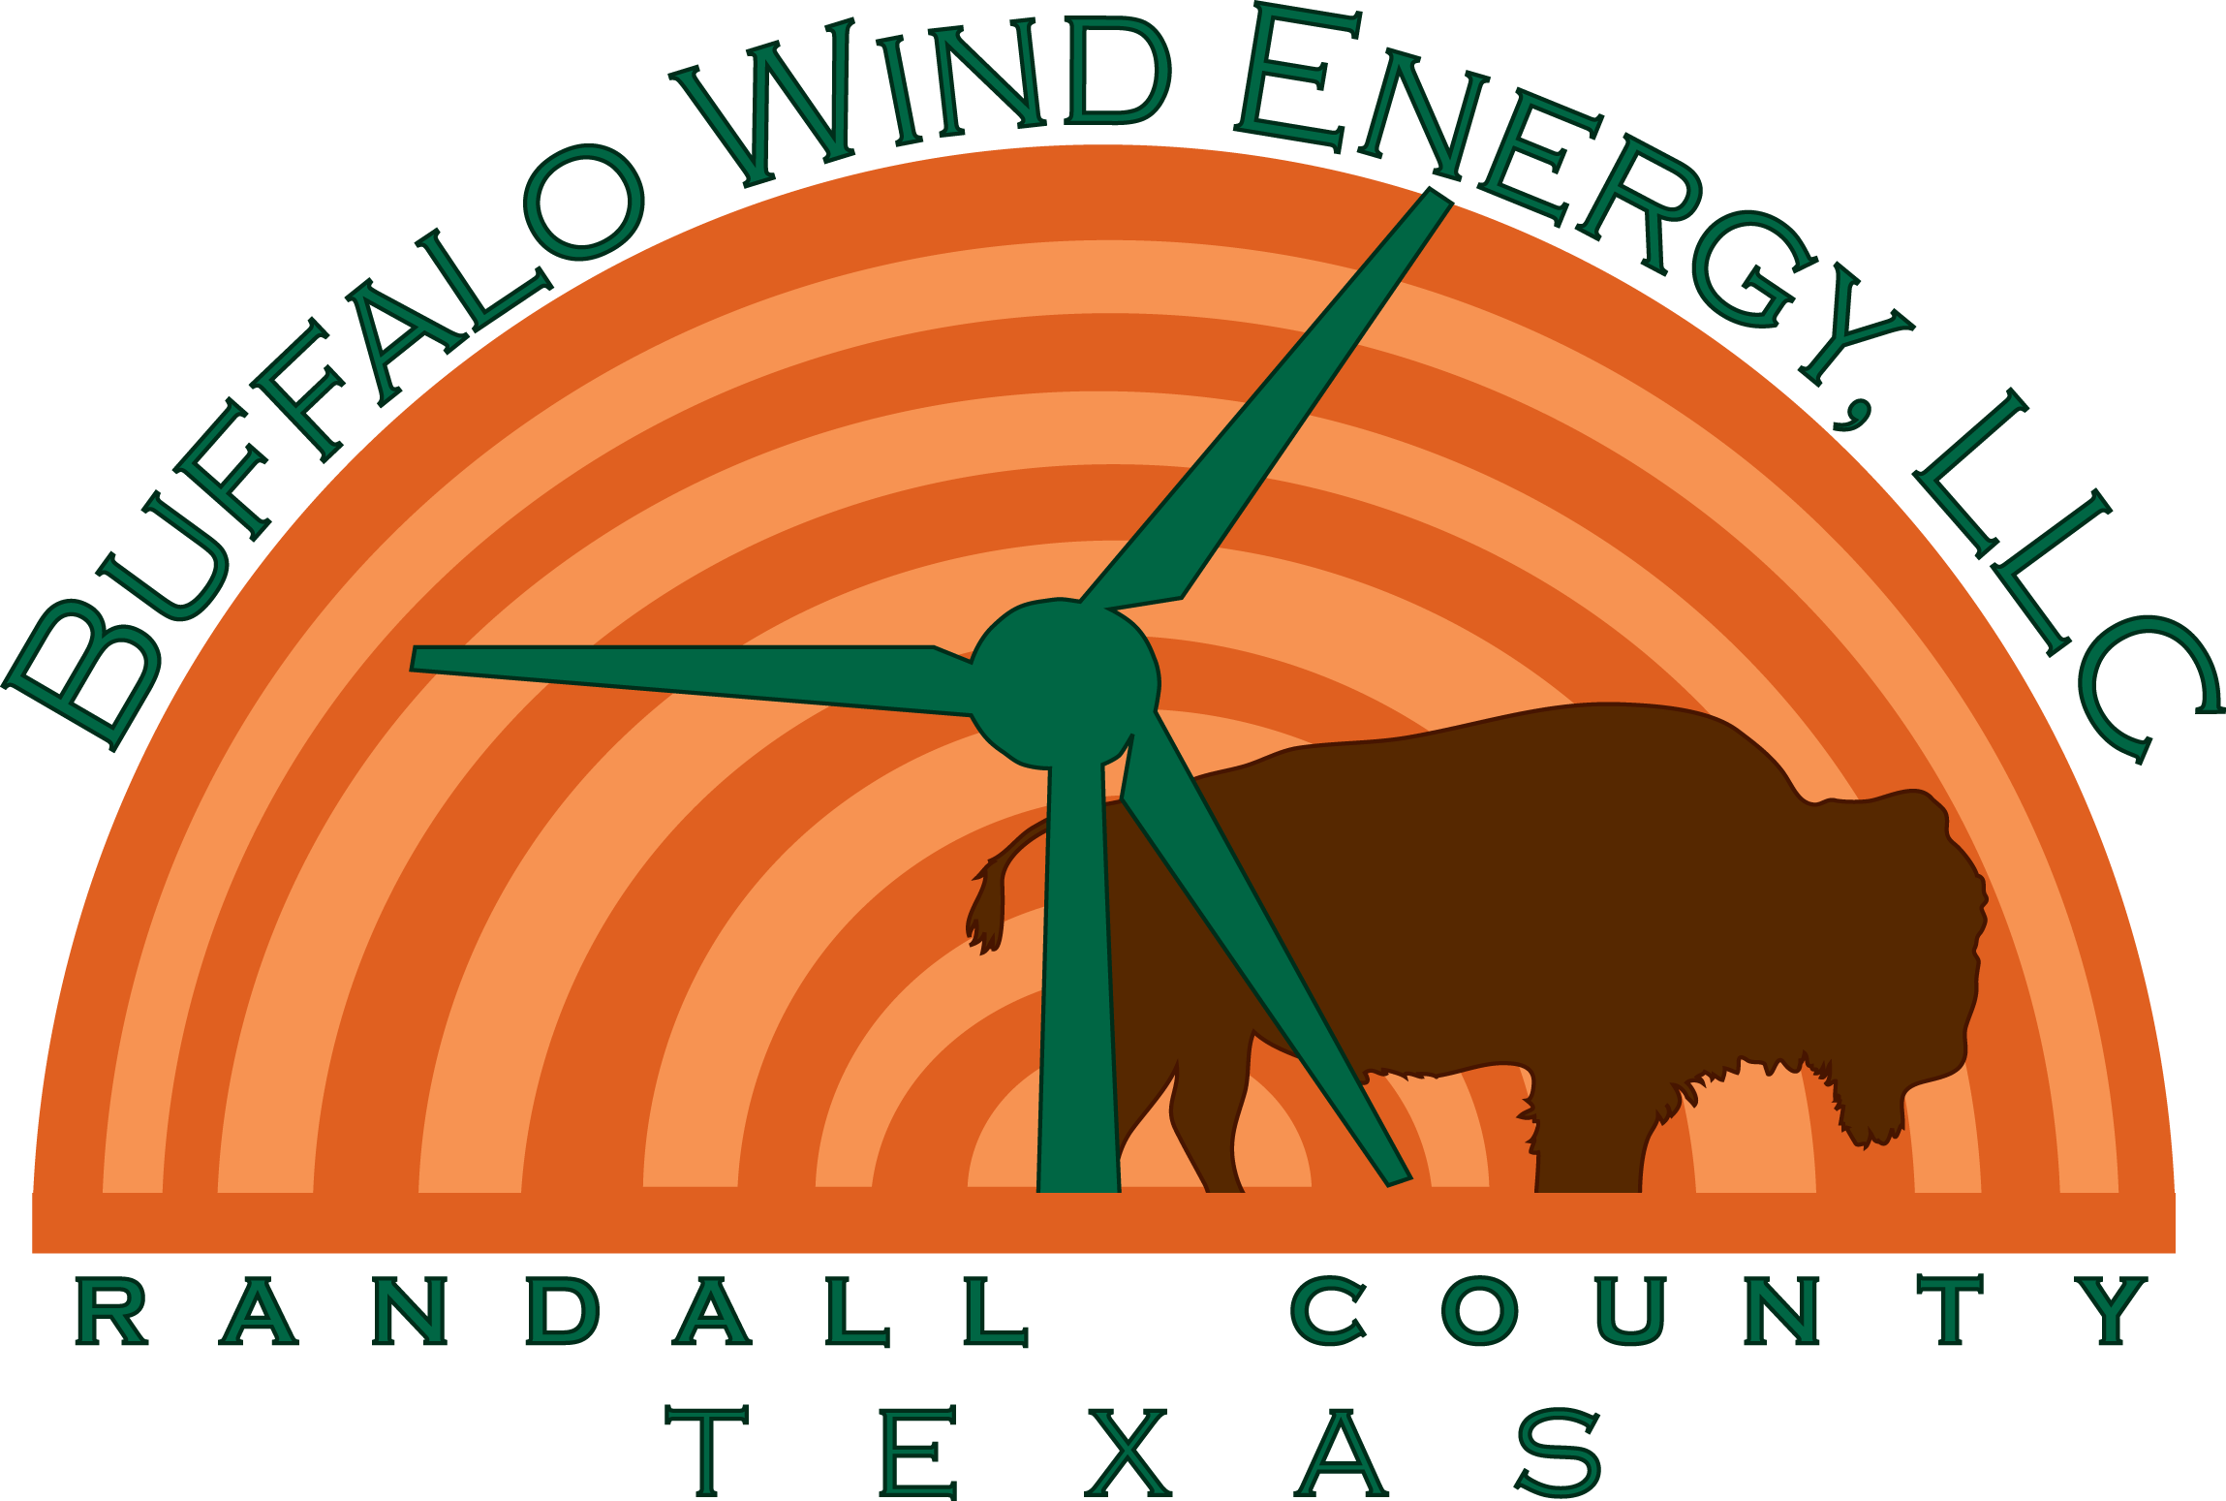

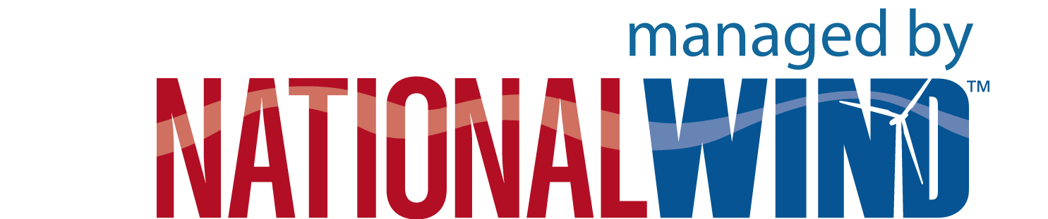
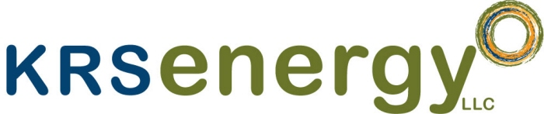
Press Release

Buffalo Wind Energy Announces Development of Utility-Scale Community Wind Project near Amarillo, Texas

Randall County, TX, April 29th, 2010: Managing member, National Wind of Minneapolis, MN, and KRS Energy of Centennial, Colorado, announce the launch of Buffalo Wind Energy, LLC, a utility-scale, community wind project located in west central Randall County (the “Buffalo Wind Project”). The Buffalo Wind Project plans to develop up to 300 megawatts of wind energy.
Buffalo Wind Energy currently has 14,500 acres under lease between the towns of Amarillo and Umbarger along with the direct participation of 12 area families. The 12 families appointed four individuals to represent the development as the project’s Board of Advisors. The Buffalo Wind Project Board of Advisors is made up of David Christian, Randy Darnell, Todd Vincent, and Casey Fox.
“Every Texas landowner or rancher knows that the wind blows all the time here,” says Vincent. “The community members and neighbors I’ve worked with on this project are thrilled that they now have a useful outlet for the wind. Although Texas has more installed wind projects than any other state, it has little community wind development. I like that community wind allows for a local advisory board structure; I feel more involved in the process. The local advisory board allows the community to have a collective voice at the table, a voice that really matters.”
Throughout the last year, the Board of Advisors, along with local attorney, James Wester, has worked in tandem with National Wind and KRS Energy to structure the project and build local interest and participation in the Buffalo Wind Project.
“This is National Wind’s first Texas wind project and we are excited to work with KRS Energy to introduce landowners to our community wind model,” says Travis Moen, Project Developer for National Wind, LLC. “Studies show that community wind projects increase local economic impacts up to five times more than that of non community-based projects. Also, this is a very interesting project because of its unique transmission access that provides potential to sell power into the ERCOT market and the Southern Power Pool (SPP).”
“We’ve made definite headway on Buffalo Wind Energy and the support from the local landowners is encouraging,” adds John Kellogg of KRS Energy. “We look forward to working with the community and cultivating relationships to further the project’s progress. Projects like these help rural Texas communities reinvent themselves, adding permanent jobs, local tax base and a steady stream of income to local landowners. They help provide support during these more challenging economic times.”
“Community wind projects operate under a business model that allows both landowners who receive turbines and even those who don’t, the opportunity to share in project revenues,” says Randy Darnell. “This provides greater profit distribution throughout the local community. It’s about keeping project proceeds local.”
# # #
About Buffalo Wind Energy: Buffalo Wind Energy, LLC is a community-based wind development company located in Randall County, Texas. Our company’s objective is to develop up to 300 MW of wind turbine-based renewable energy. Our development commitment is to produce wind energy projects that are sustainable, generational and environmentally responsible. Our financial commitment is to ensure that the financial benefits are shared with our local stockholders, area land owners and the surrounding community. Visit our website at www.buffalowindenergy.com.

About National Wind: National Wind, LLC is the leader in developing utility-scale (50 megawatts or larger) community wind energy projects. We form powerful community wind energy partnerships with property owners, ensuring that the project’s economic benefits are shared with the surrounding community. National Wind and its subsidiary, Wind Energy Developers, LLC, have participated in developing 14 wind energy projects and currently have over 4,000 megawatts in active development. National Wind projects are located in Minnesota, Iowa, North Dakota, South Dakota, Montana, Colorado, Texas and Ohio. The company has an additional 1,500 megawatts of wind energy in advanced feasibility study stages and is continually exploring expansion opportunities in other states. Please visit http://www.nationalwind.com for more information.
About KRS Energy: KRS Energy, LLC, is a wind energy development company based in Centennial, Colorado. It is owned and operated by developers, John Kellogg and Paul Seby. KRS’s principals have over 40 years of combined experience in developing energy and industrial projects.

