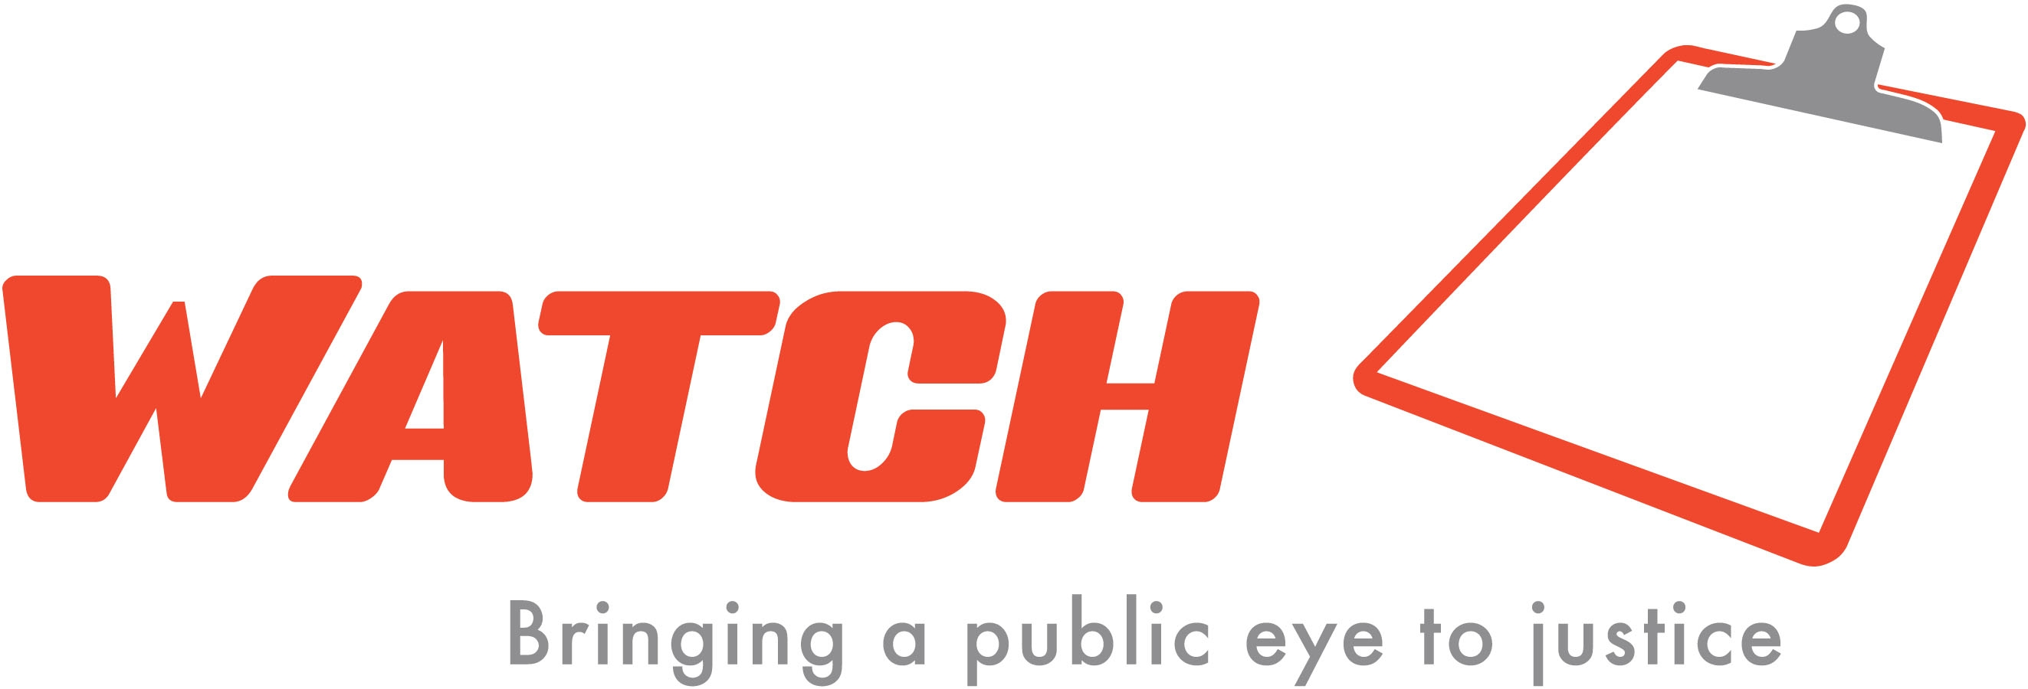
Please check position applying for:
Volunteer ¨
Intern ¨

Date ____/_____/_______

Volunteer/Intern Application
WATCH is committed to work force diversity and does not discriminate against qualified persons on the basis of race, color, religion, sex, national origin, age, disability, veteran status or other factors identified and protected by federal, state or local legislation. WATCH Is An Equal Opportunity Employer. Fill out completely. Please be honest and accurate.

Last Name First Name Middle Name

Address City State Zip Code

Telephone Number Cell Fax Birthday ___/____/_____

Preferred Method of Contact

Email

Ethnicity:
___African ___African-American/Black ___Asian/Pacific Islander ___Caucasian
___Hispanic/Latino ___Native American ___Middle Eastern/Arab ___Other

How did you hear about this position? ________________________________________________________________________

How soon will you be available to volunteer? ____________
Number of hours/month you are able to volunteer? ______

How do you hope this opportunity will benefit you? _____________________________________________________________________

Brief Educational History

Brief Employment History

Brief Volunteer History

List any academic courses/subjects relating to the position for which you are applying. These include technical skills, training certificates or licenses, or other volunteer activities and positions or activities held in professional societies, civic, community and school organizations, etc.
______________________________________________________________________________________________________________________________________________________________________________________________________________________________________
Please indicate other skills, foreign language, data entry, organizational management, software capabilities, etc.
Compensation & Confidentiality

Will you be receiving compensation for volunteering (i.e. work-study funds, school credits, class requirements fulfilled)?
___Yes ___No

WATCH publishes a newsletter and occasionally its articles may include volunteers’ names and information about their work as
court monitors. Do we have your permission to release such information? ___Yes ___No

Criminal History
In order to ensure that WATCH volunteers have no conflict of interest and/or are assigned properly to watch various court proceedings, we ask that you provide information about any contact you have had with the criminal or civil justice systems. An active criminal charge disqualifies one from a volunteer/intern position, however prior criminal conviction or charges are decided on a case-by-case basis. This information is confidential.

Do you currently have any type of criminal charge, including traffic offenses, pending against you? ___Yes ___No

If yes, please describe the charges: _________________________________________________________________________

What county? ________________

Are you currently on probation for any type of criminal charge, under a stay of imposition, or under a “CWOP”—continued
without dismissal? __Yes ___No

If yes, please describe the charges: _________________________________________________________________________

What county? ________________

Aside from what you have already noted, have you ever had any type of criminal charge filed against you? ___Yes ___No

If yes, please describe the charges: _________________________________________________________________________

What county? _______________ What happened in this case? ____________________________________________________

Are you currently a victim or witness in a pending criminal case? ___Yes ___No

If yes, what county? ____________

Are you currently or have you ever been involved in any civil matter including an order for protection, harassment order,
a divorce, child custody dispute, or civil lawsuit? ___Yes ___No

If yes, what kind of action: ________________________________________________________________________________

What county? _________________

What is the current status of this matter? _____________________________________________________________________

Professional References
Besides a thorough check of applicant’s criminal history, WATCH performs a reference check on all applicants.

1. _______________________________________________________________________________________
Name Company Title Telephone Number

2.________________________________________________________________________________________
Name Company Title Telephone Number

3.________________________________________________________________________________________
Name Company Title Telephone Number

The Mission of WATCH is to make the justice system more effective and responsive in handling cases of violence, particularly against women and children, and to create a more educated and informed public.

Emergency Contact Information

Name____________________________________________________________________Relationship____________________________

Phone___________________________________________________________________Place of Work___________________________

Address________________________________________________________________________________________________________

Please mail the completed application to:
WATCH, attn: Mandy Iverson, Volunteer Coordinator
608 Second Avenue South, NorthStar East, Suite 465, Minneapolis, Minnesota 55402
Or email to: miverson@watchmn.org

