
Experiment :- 1.2

Student Name : Aditya Sivam Kashyap UID : 23BCC70036
Branch : CSE (Cloud Computing) Section/Group : 23BCC-1 (A)
Semester : 6th Date of Performance : 10/01/2025
Subject Name : Building & Release Management Subject Code : 23CSH-395
1. Aim/Overview of the practical:
To perform branch creation and management using GitHub for organized code development.
2. Task to be done:
Create and manage branches in a git repository and synchronize them with a GitHub remote repository to practice collaborative version control.
3. Steps for Experiment/practical:
- Open the local Git repository and link it to a remote GitHub repository using the command git remote add origin <repo-URL>.
- Create a new branch in the local repository using git branch <branch-name> and switch to it using git checkout <branch-name> or git switch <branch-name>.
- Make the necessary changes in the newly created branch, stage the updated files using git add, and commit the changes with an appropriate commit message.
- Push the branch to the remote GitHub repository using git push -u origin <branch-name> and confirm that the branch has been successfully uploaded.
- Merge the branch into the main branch either by creating a Pull Request on GitHub or by using the git merge <branch-name> command locally, and resolve any merge conflicts if they occur.
4. Learning outcomes:
To I have learned to understand efficient branching strategies in version control, create, switch, and manage branches in Git and GitHub, collaborate effectively with others, and perform merging and conflict resolution efficiently.
5. Result:
This program has been successfully executed.
6. Output:
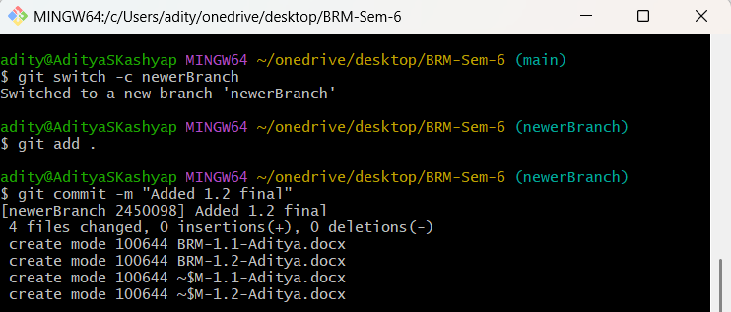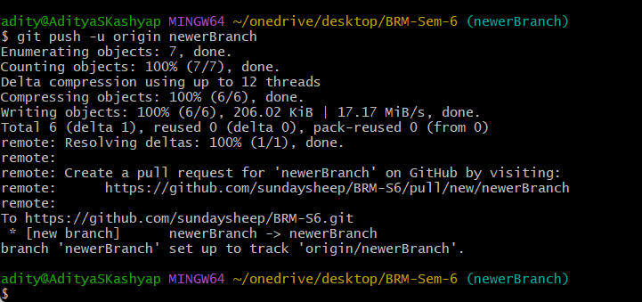
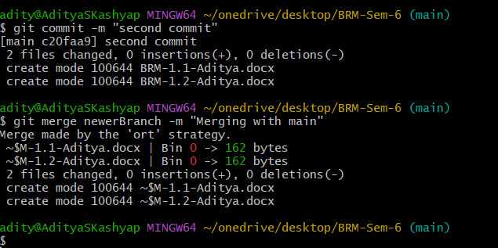

Evaluation Grid (To be created as per the SOP and Assessment guidelines by the faculty):

Sr. No. | Parameters | Marks Obtained | Maximum Marks
1.
2.
3.

7. Viva Questions:
- What is Git and why is it used in software development?
- What is the difference between a local repository and a remote repository?
- How do you configure Git for the first time after installation?
- What is the difference between git add and git commit?
- How can you check the status of your Git repository?

