
Experiment :- 1.1

Student Name : Aditya Sivam Kashyap UID : 23BCC70036
Branch : CSE (Cloud Computing) Section/Group : 23BCC-1 (A)
Semester : 6th Date of Performance : 10/01/2025
Subject Name : Building & Release Management Subject Code : 23CSH-395
1. Aim/Overview of the practical:
To perform the installation of Git and creation of a local repository for initiating version control.
2. Task to be done:
Install Git on your system and create a local repository to initiate version control.
3. Steps for Experiment/practical:
- Download and install Git from the official website: https://git-scm.com . After installation, configure the global username and email address using git config.
- Open a terminal or command prompt and navigate to the project directory that needs to be placed under version control.
- Initialize a new local Git repository in the selected directory using the git init command.
- Add the required project files to the staging area using git add <filename> or git add .
- Commit the staged files using git commit -m "Initial commit".
- Verify the repository status and commit history using git status and git log.
4. Learning outcomes:
To install Git and manage a repository for consistent version control. I have learned to install and configure Git, initialize a local repository, stage and commit files, and understand the basic principles of version control for collaborative software development.
5. Result:
This program has been successfully executed.
6. Output:
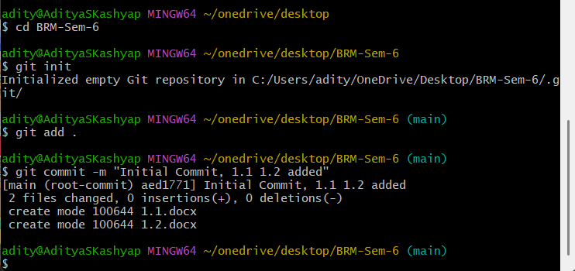
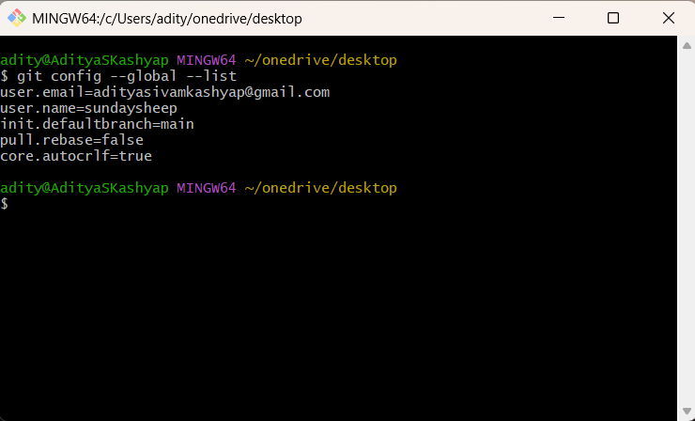
Evaluation Grid (To be created as per the SOP and Assessment guidelines by the faculty):

Sr. No. | Parameters | Marks Obtained | Maximum Marks
1.
2.
3.

7. Viva Questions:
- What is Git and why is it used in software development?
- What is the difference between a local repository and a remote repository?
- How do you configure Git for the first time after installation?
- What is the difference between git add and git commit?
- How can you check the status of your Git repository?
Web Links:
• Official Git Documentation
• TutorialsPoint – Git Tutorial

