Experiment :-. 1.3
Student Name : Aditya Sivam Kashyap UID: 23BCC70036
Branch : CSE (Cloud Computing) Section/Group: 23BCC-1 (A)
Semester : 6th Date of Performance: 19/01/2026
Subject Name : Building & Release Management Subject Code : 23CSH-395

- Aim/Overview of the practical:
The main objective of this practical is to create and understand the working of Pull Requests (PRs) in GitHub
for team-based and collaborative development.
- Task to be done:
Create and manage branches in a git repository and synchronize them with a GitHub remote repository to practice collaborative version control.


- Steps for Experiment/practical:

- Open the local Git repository and link it to a remote GitHub repository using the command git remote add origin <repo-URL>.
- Create a new branch in the local repository using git branch <branch-name> and switch to it using git checkout <branch-name> or git switch <branch-name>.
- Make the necessary changes in the newly created branch, stage the updated files using git add, and commit the changes with an appropriate commit message.
- Push the branch to the remote GitHub repository using git push -u origin <branch-name> and confirm that the branch has been successfully uploaded.
- Merge the branch into the main branch either by creating a Pull Request on GitHub or by using the git merge <branch-name> command locally, and resolve any merge conflicts if they occur.

- Learning outcomes:
- Collaborative Development Understanding: Learns how pull requests support teamwork in software development.
- Branch Handling in Git: Gains practice in creating and managing branches properly.
- Working with Remote Repositories: Understands how to push code to GitHub successfully.
- Pull Request Process: Learns how to raise, review, and merge pull requests confidently.
- Merge Conflict Handling: Gets exposure to resolving conflicts during merges.
- Real-Time Practical Experience: Gains hands-on experience with a standard industry collaboration
workflow.
- Result: This program has been successfully executed.

- Output:

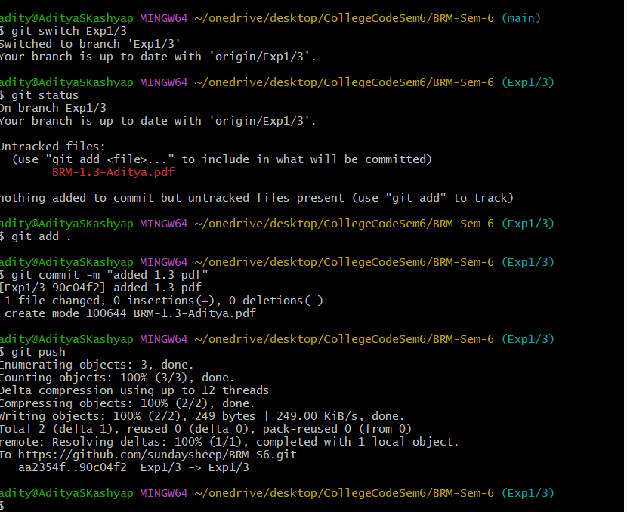
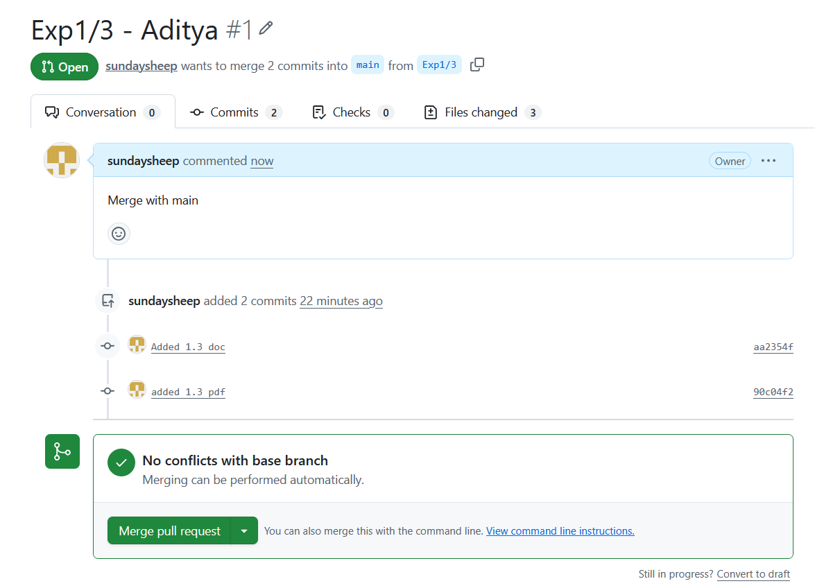
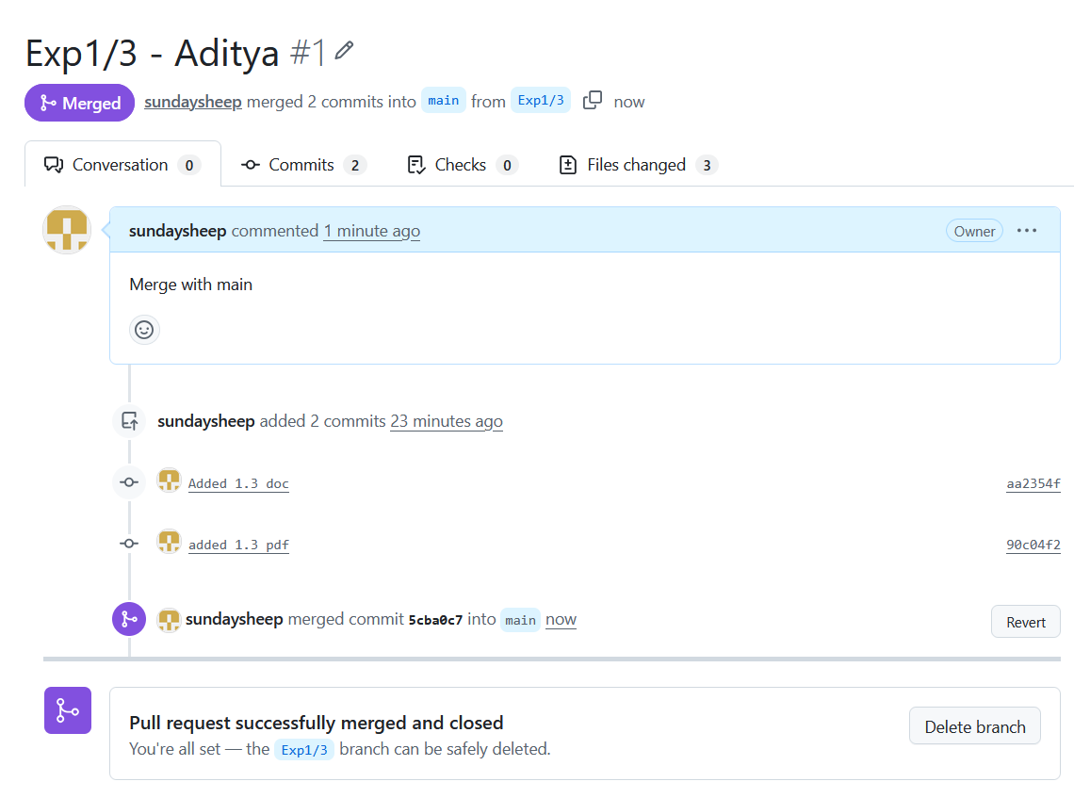

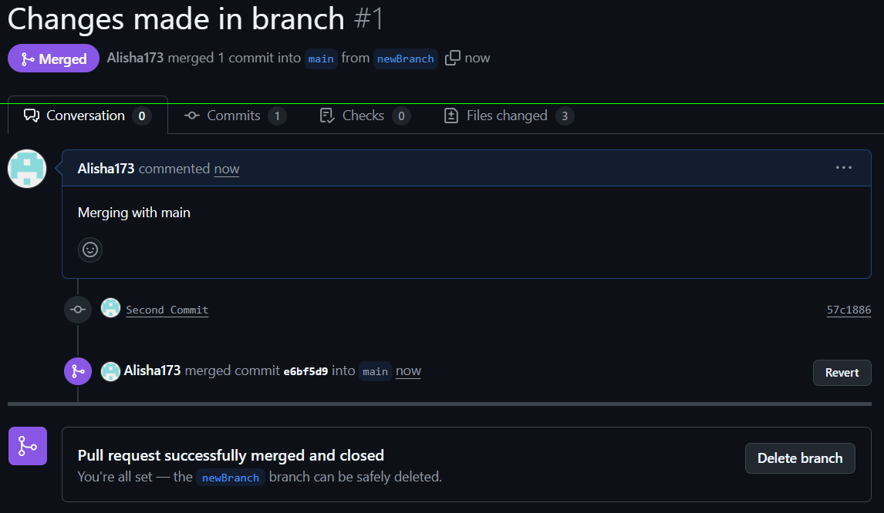

Evaluation Grid (To be created as per the SOP and Assessment guidelines by the faculty):

Sr. No. | Parameters | Marks Obtained | Maximum Marks
1.
2.
3.

- Viva Questions
  - What is What is a branch in Git, and why is it used?
  - How do you create and switch between branches locally?
  - How do you push a branch to a remote GitHub repository?
  - What is a Pull Request (PR) in GitHub, and why is it important?
  - How do you resolve conflicts during branch merging?
Web Links:
  - Official Git Documentation
  - TutorialsPoint – Git Tutorial

