Experiment :-. 1.2
Student Name : Aditya Sivam Kashyap UID: 23BCC70036
Branch : CSE (Cloud Computing) Section/Group: 23BCC-1 (A)
Semester : 6th Date of Performance: 10/01/2025
Subject Name : Building & Release Management Subject Code : 23CSH-395

- Aim/Overview of the practical:
To perform branch creation and management using GitHub for organized code development.

- Task to be done:
Create and manage branches in a git repository and synchronize them with a GitHub remote repository to practice collaborative version control.


- Steps for Experiment/practical:

- Open the local Git repository and link it to a remote GitHub repository using the command git remote add origin <repo-URL>.
- Create a new branch in the local repository using git branch <branch-name> and switch to it using git checkout <branch-name> or git switch <branch-name>.
- Make the necessary changes in the newly created branch, stage the updated files using git add, and commit the changes with an appropriate commit message.
- Push the branch to the remote GitHub repository using git push -u origin <branch-name> and confirm that the branch has been successfully uploaded.
- Merge the branch into the main branch either by creating a Pull Request on GitHub or by using the git merge <branch-name> command locally, and resolve any merge conflicts if they occur.

- Learning outcomes:
To I have learned to understand efficient branching strategies in version control, create, switch, and
manage branches in Git and GitHub, collaborate effectively with others, and perform merging and
conflict resolution efficiently.

- Result: This program has been successfully executed.

- Output:
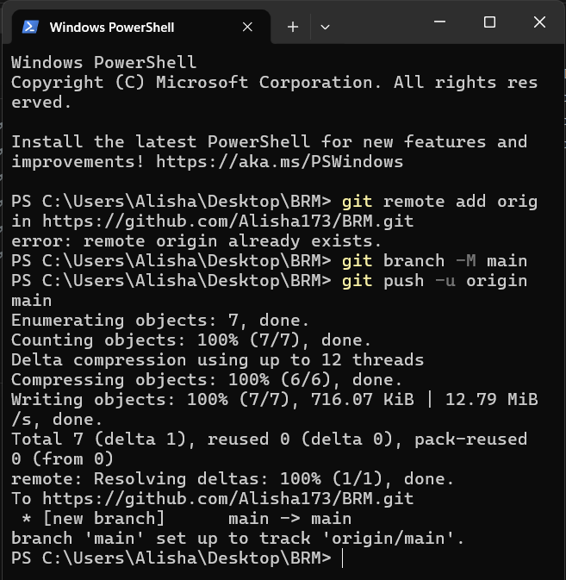

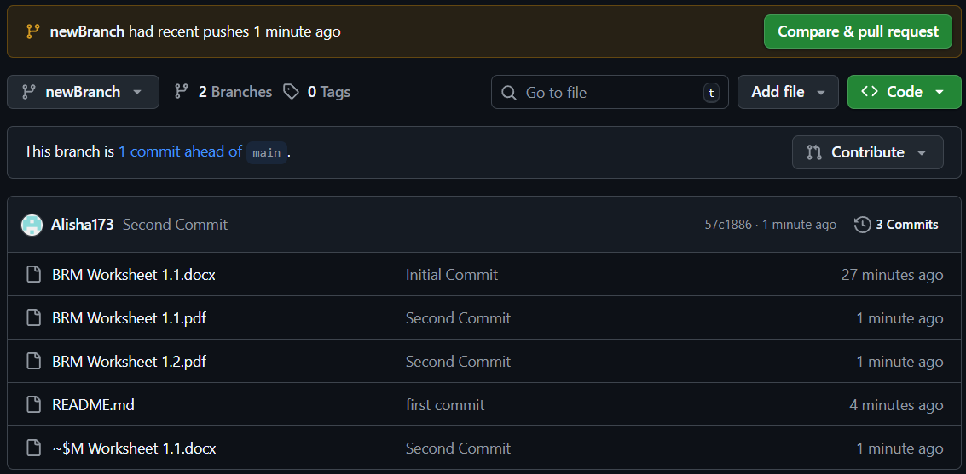

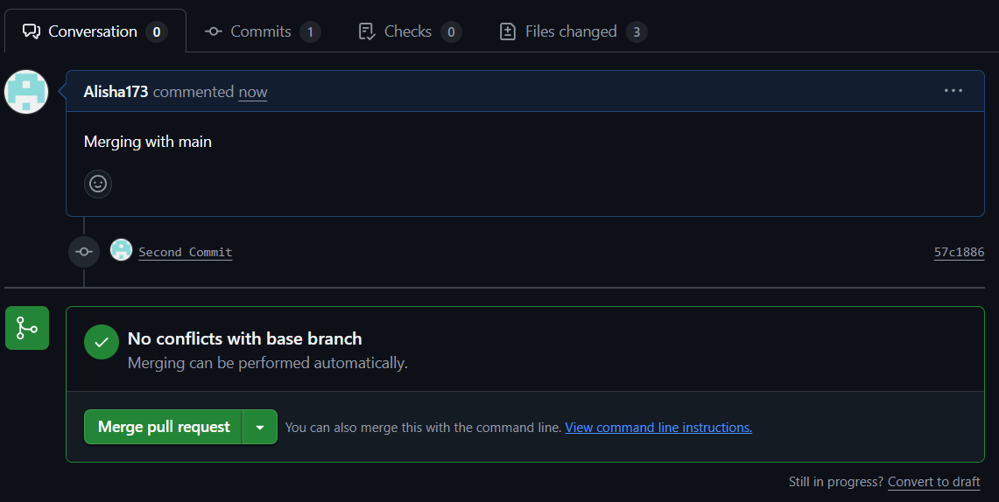

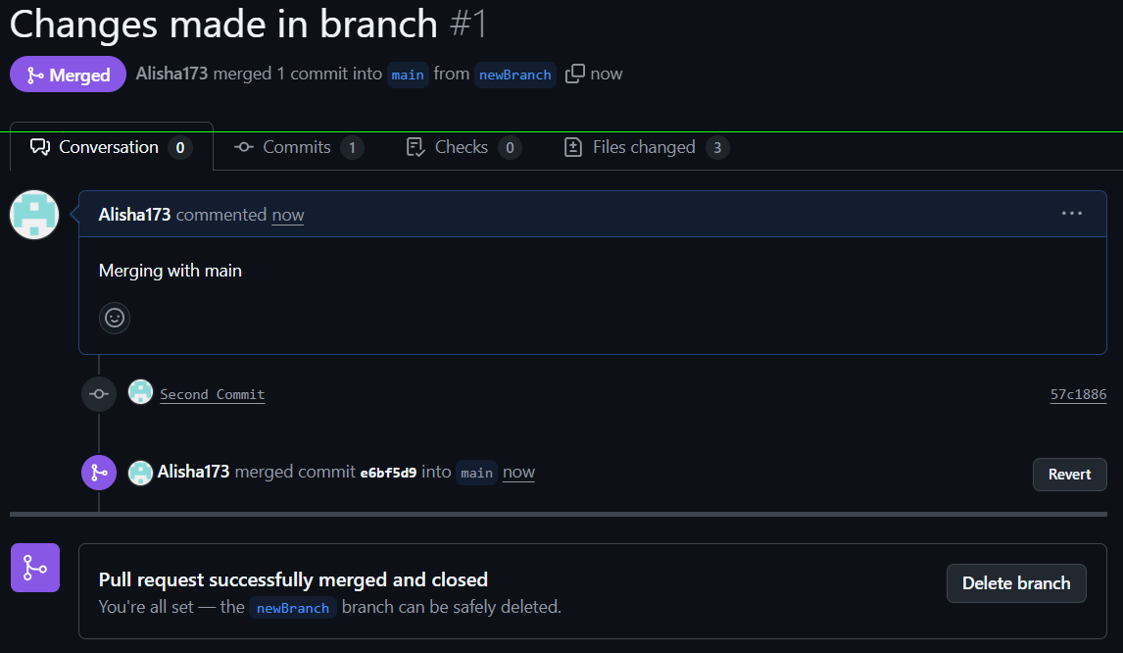

Evaluation Grid (To be created as per the SOP and Assessment guidelines by the faculty):

Sr. No. | Parameters | Marks Obtained | Maximum Marks
1.
2.
3.

- Viva Questions
  - What is What is a branch in Git, and why is it used?
  - How do you create and switch between branches locally?
  - How do you push a branch to a remote GitHub repository?
  - What is a Pull Request (PR) in GitHub, and why is it important?
  - How do you resolve conflicts during branch merging?
Web Links:
  - Official Git Documentation
  - TutorialsPoint – Git Tutorial

