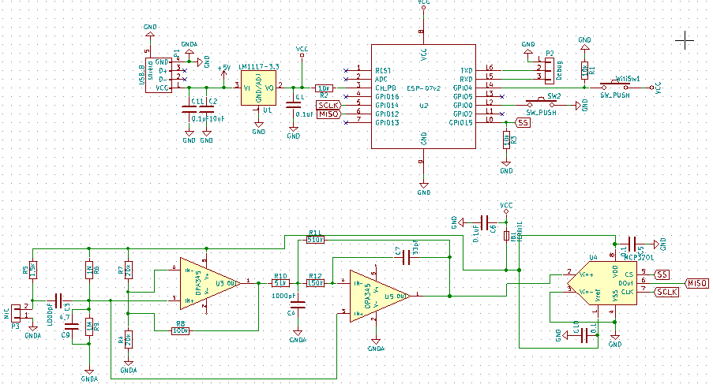
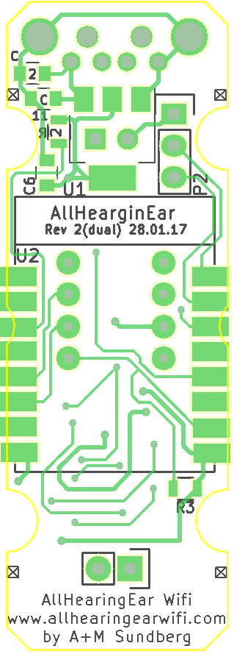  C1 – 0.1uF  C2 - 10uF  C3 - 1nF  C4 - 1nF  C5 – 0.1uF  C6 – 0.1uF  C7 - 33pF  C8 – X  C9 – 4.7uF  C10 – 0.1uF  C11 – 0.1uF | 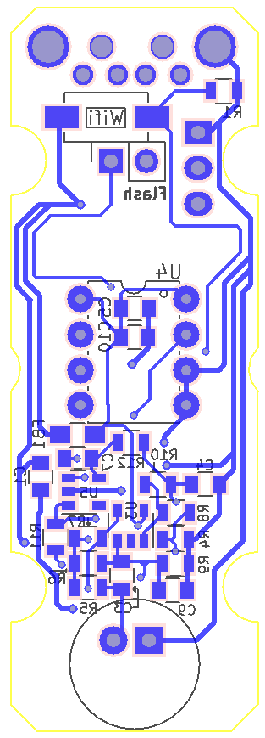  R1 - 10k  R2 - 10k  R3 - 10k  R4 - 20k  R5 – 1.5k  R6 - 1M  R7 - 20k  R8 - 100k  R9 - 1M  R10 – 51k  R11 – 510k  R12 – 150k

