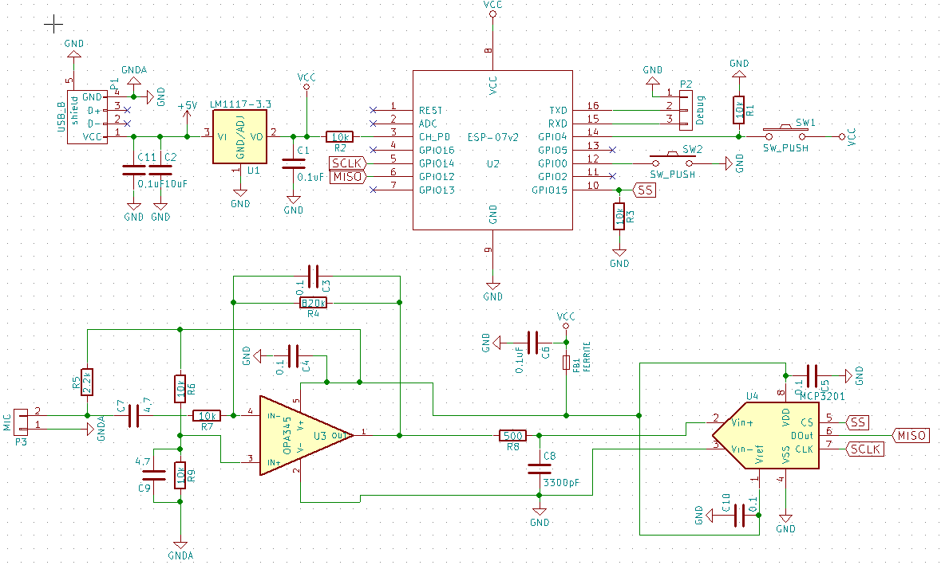
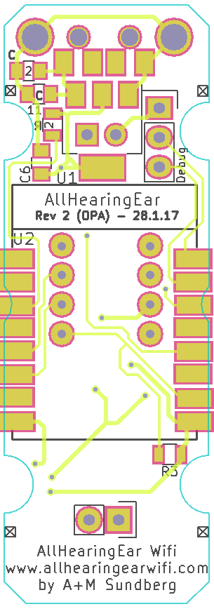  C1 0.1  C2 10  C3 0.1  C4 0.1  C5 0.1  C6 0.1  C7 4.7  C8 3300pf / 3.3nF  C9 4.7  C10 0.1 | 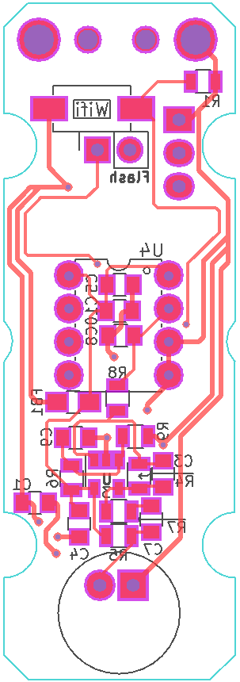  R1 - 10k  R2 - 10k  R3 – 10k  R4 – 820k  R5 – 2.2k  R6 – 10k  R7 – 10k  R8 – 500  R9 - 10k

