Test/Diagnostics Logger Machine

Test source

Atmega328p, 8mhz int osc, BOD 1.8v
Gert Sanders Optiboot 32pin (Based on Optiboot 6.2)
115200 serial speed – looping serial message (40 char) every 50ms.

2.2V source
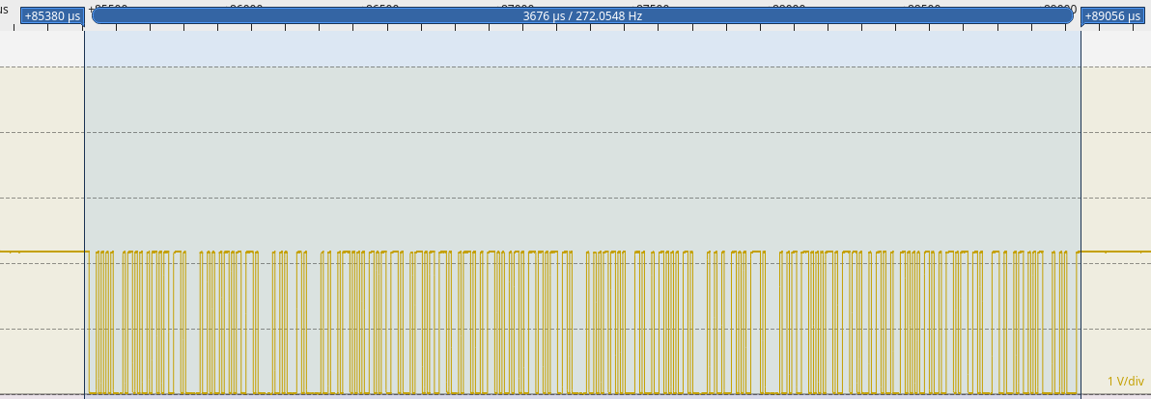
3.3V source
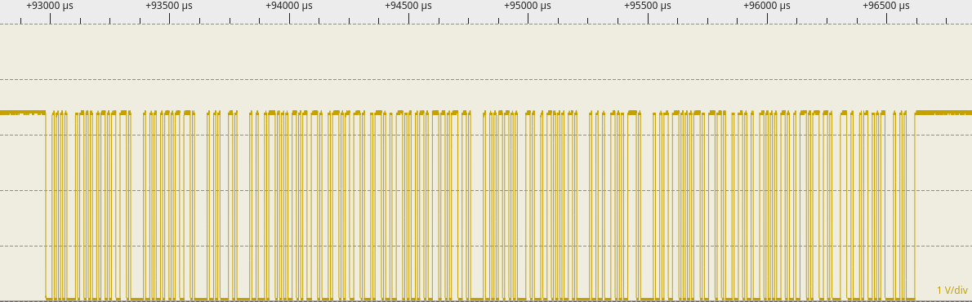
5v source
