Purpose

The purpose of this project was to create a distributed storage file system consisting of one or more workstations, a directory server, a print server and an optional authentication server. The file server stores and accesses file through the standard system commands such as create, delete, open, read, etc…. The print server simulates the printing of files, a print queue and allows for rudimentary manipulation of the print queue. The optional authentication server issues and renews tickets to allow the workstation user access to the file and print servers.
These individual servers are all implemented as distinct Java virtual machines that use the Java Remote Method Invocation for communication amongst themselves.

Architecture

The distributed storage file system has 3 virtual machines that are always present and an optional virtual machine that provides for authentication services if they are desired.

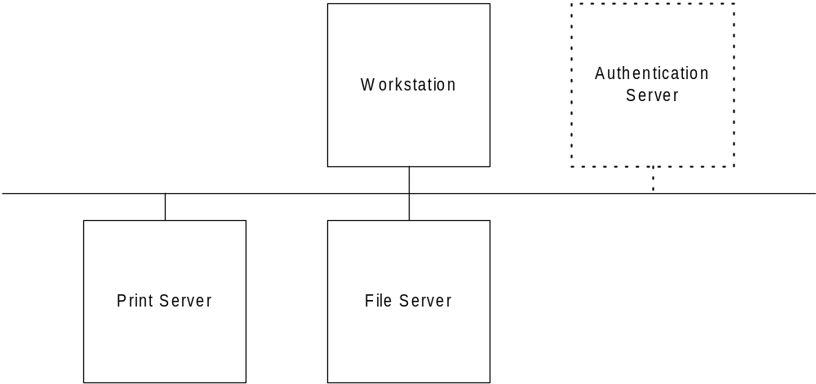

Figure 1 – Distributed File System Architecture

The workstation provides the users only interface into the system. Before any commands may be issued the user must first login to the workstation providing both and valid user id and the appropriate password for that id. There is a command line option for the workstation that tells it whether or not to use an authentication server.
If the workstation is started up without an authentication server then it will do the verification of the user id and password and will also issue any necessary ticket for performing a command. It should be noted that there would be no permissions checking done if there is no authentication server, instead the workstation will create the tickets as they are needed for a particular command. By implementing the architecture in this manner it was possible to simplify the design of the file and print servers.
If, on the other hand, the workstation knows that there is an authentication server then it will pass on the user id and password to that server for validation. The authentication server will check the permissions that are contained within the password file to determine what tickets that user should be allowed to have. The workstation stores all of the tickets for a user and is also responsible for timing them out and renewing them as necessary.

Grammar

The permissions that are assigned to a user are contained within a bit string stored in the password file. The structure of the permissions is as follows:

permissions := x₁x₂x₃x₄
x₁ := 1/0 – allow user to manipulate print queue (delete jobs)
x₂ := 1/0 – allow user to print files
x₃ := 1/0 – allow user to manipulate directories (make, rename, etc…)
x₄ := 1/0 – allow user to manipulate files (make, rename, delete, etc…)

Rather than using an existing command set (UNIX, MS-DOS etc…) a new grammar was generated which would allow the servers to be easily ported from one operating system to another. The allowable commands are as follows:

File Server Commands
Functions:

dir
description: list files and directories
permissions required: any
returns:
successful: a listing of files and directories
unsuccessful: none

cd <path>
description: change the current directory. The current directory will be stored on the workstation and passed to the server as necessary.
permissions required: any
returns:
successful: none
unsuccessful: message for invalid path

path
description: show the current path. The current path will be stored on the workstation.
permissions required: any
returns:
successful: the current path
unsuccessful: none

mkdir <directory name>
description: make a directory with specified name
permissions required: x₃ == 1 (Directory ticket)
returns:
successful: none
unsuccessful: error message for directory already existing
error message for invalid permissions

deldir <directory name>
description: delete an empty directory
permissions required: x₃ == 1 (Directory ticket)
returns:
successful: none
unsuccessful: error message for directory not existing
error message for directory name actually belonging to a file
error message for invalid permissions
error message for non-empty directory

deltree <directory name>
description: delete a (possibly) non-empty directory. Note that this will require permissions for both directory and file manipulation.
permissions required: x₃ == 1 (Directory ticket)
x₄ == 1 (File ticket)
returns:
success: none
unsuccessful: error message for directory not existing
error message for directory name actually belonging to a file
error message for invalid permissions

ren <old filename> <new filename>
description: rename a file or directory.
permissions required: x₃ == 1 (for directory – Directory ticket)
x₄ == 1 (for file – File ticket)
returns:
successful: none
unsuccessful: error message for invalid old filename
error message for new filename already existing
error message for invalid permissions

copy <old filename> <new filename>
description: make a copy of a file or directory.
permissions required: x₃ == 1 (for directory – Directory ticket)
x₄ == 1 (for file – File ticket)
returns:
successful: none
unsuccessful: error message for invalid old filename
error message for new filename already existing
error message for invalid permissions

create <filename>
description: creates an empty file with the given name
permissions required: x₄ == 1 (File ticket)
returns:
successful: none
unsuccessful: error message for filename already existing
error message for invalid permissions

delete <filename>
description: deletes a file with the given name
permissions required: x₄ == 1 (File ticket)
returns:
successful: none
unsuccessful: error message for filename not existing
error message for invalid permissions
error message for filename corresponding to directory

display <filename>
description: displays a file with the given name
permissions required: x₄ == 1 (File ticket)
returns:
successful: displays file to the screen
unsuccessful: error message for filename not existing
error message for invalid permissions
error message for filename corresponding to directory

Print Server Commands
Functions:

print <filename>
description: prints a file with the given name. User must have file permission as well as print permission. The file will be buffered to the workstation before it is sent to the printer server, so two methods will be called for this operation, each requiring a separate ticket.
permissions required: x₂ == 1 (File ticket – to ‘get’ the file)
x₄ == 1 (Print ticket – to ‘print’ the file)
returns:
successful: the file will be displayed in the screen of the print server
unsuccessful: error message for filename not existing
error message for invalid permissions
error message for filename corresponding to directory

prg
description: will show the filenames of the files currently in the print queue
permissions required: x₁ == 1 (Manipulate Print ticket)
returns:
successful: the print queue will be displayed
unsuccessful: error message for invalid permissions

prcancel <file name>
description: cancels printing of a file in the print queue
permissions required: x₁ == 1 (Manipulate Print ticket)
returns:
successful: message indicating print job was canceled
unsuccessful: error message for invalid permissions
error message for filename not in queue

Workstation

The workstation contains the interface to the other servers. All commands are entered at the workstation command line and then routed to the appropriate server. There are two primary functions that are only present at the workstation – login and logout. The login function is not a command but instead indicates that the user must first enter their user name and password into the login dialog (figure 2) that will pass that information on to the authentication server for verification (if present).

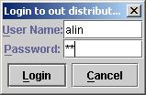

Figure 2 – login dialog

login
description: allows a user to login at the workstation console. Will prompt for a user ID and a password, both of which must appear in the password file. When there is no AS any user may login and perform any operation, when there is an AS there must be a valid Login ticket returned from the AS for that user.
permissions required: any
returns:
successful: a welcome message and system prompt
unsuccessful: an error message and return to login screen

logout
description: ends a user session and returns to login prompt. This operation should always succeed.
permissions required: any
returns:
successful: an exit message and return to login screen
unsuccessful: none

There are a couple of enhancements added to the workstation to make it more user friendly. These are:

- Command history
- Screen capture
- Clear screen

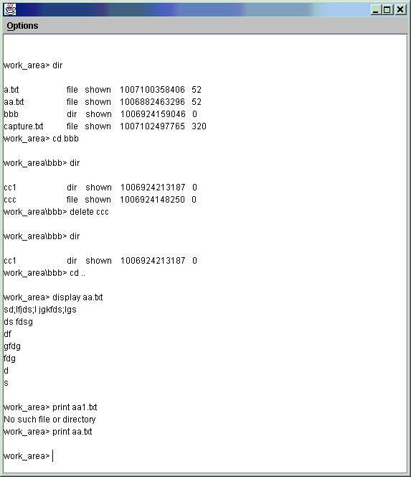
Figure 3 – Workstation Interface

Internally the workstation is implemented as three threads – the main thread, the swing thread which serves the AWT queue and the automatic renewer thread which handles the renewing of the tickets. When the program starts up the automatic renewer thread is created by the main thread, which uses the AWT queue and the “invokeLater” function to communicate with the automatic renewer thread. The swing thread communicates with the main thread through a producer-consumer mechanism with buffer-size 1. The automatic renewer thread sleeps in the background until:

- the login ticket is almost expired, in which case it will renew the ticket, set its wake-up clock and go back to sleep.
or
- the auto-logout (figure 4) logs out the current user, in which case it will go back to sleep until a login operation succeeds.

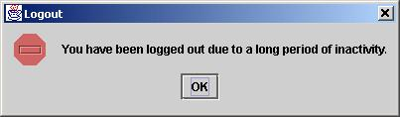
Figure 4 – Auto-logout dialog
When the workstation is started up it locates a RMI REGISTRY service and gets the list of objects recorded there and looks for the entries for the file server, print server, and authentication server. This list is of the format "//host/FileServer/" which allows for the locating of the various servers on different computers. For future efforts it would be possible to include a menu item in the workstation to allow the user to choose the servers on the particular computers that they wished to access.

V. File Server

The file server is the interface into the host computer file system. It is primarily responsible for translating the workstation grammar into the host’s native operating system grammar and sending those results back to the workstation for display to the user. In addition to the commands that are related to the workstation grammar the file server also offers an "initialWD" method that tells the workstation what directory on the server that remote users should start out in, and its "cd" method blocks any attempt by users to change to a directory that is outside of the directory tree rooted at that initial directory. If the workstation presents an expired ticket or a ticket that does not indicate that the user has the correct permissions to access a given file or directory, an exception is thrown and an informative error message is provided to the workstation. Similarly, all file and directory accesses are checked to make sure that the target file exists and is an object of the correct type. Finally, the file server uses a synchronized list to keep track of which files are currently being accessed and blocks any server threads from accessing files which are currently being accessed by other threads. This prevents one user from deleting a file while another user is in the middle of copying it, for instance.

The current working directory is maintained within the workstation, therefore most commands are patterned after the form:

command(ticket, current directory, filename(s))

One result of this design choice is that the server does not understand absolute pathnames: All file and directory names are taken as relative to the current directory. However, the user can still get to any directory that he or she wishes to. Complex directory commands like:

cd ../washington/.././lincoln/../jefferson

are understood and will be executed as long as they do not take the user to a directory outside of the directory tree rooted at "initialWD".

VI. Print Server

The print server allows the users to print files, show the print queue and modify the print queue by deleting jobs. In order to print a file users must have print access indicated in their print server tickets and they must have print queue access to be able to examine the print queue and modify it. Jobs are "printed" by displaying 10 lines to the screen at a time, with a delay of 5 seconds between each 10-line "page" of output. This makes for a very slow virtual printer, but this also allows the opportunity for the user to use the "prcancel" command to remove jobs before they are printed.

The print server is multi-threaded, with one thread handling requests and another thread running in the background and waking up every 5 seconds to print the next 10 lines of whatever print job is at the head of the queue. The "print" command actually takes the entire file to be printed as a String argument, so the file server must fetch the contents of the file from the file server with the "display" command and then pass that String as a parameter to the "print" command. Once a job is in the print queue, it is indexed only by name, so if a user wants to remove one of several print jobs that all have the same file name, the user always ends up removing the first file.

VII. Authentication Server

The authentication server is implemented to use three tickets. A login ticket which controls access to the workstation, a file server ticket which controls access to the file server, and a print ticket which controls access to the print server. All tickets contain the following information:

- user id
- issue time
- expire time

In addition, the file and print server tickets also contain a permissions field that indicates what individual permissions that ticket allows on that server. The user id, user password, and permissions are stored in a password file of the format:

<userid>:<password>:<permissions>

userid := plaintext string – a-z|A-Z|0-9
password := plaintext string – a-z|A-Z|0-9
permissions := x₁x₂x₃x₄
x₁ := 1/0 – allow user to manipulate print queue (delete jobs)
x₂ := 1/0 – allow user to print files
x₃ := 1/0 – allow user to manipulate directories (make, rename etc…)
x₄ := 1/0 – allow user to manipulate files (make, rename, delete, etc…)

Given a username and password, the "login" method checks the password file and creates a new login ticket for that user. Given a valid login ticket, the "renewLogin", "getFSTicket", and "getPSTicket" methods return a new login ticket, file server ticket, or print server ticket, respectively. The workstation takes responsibility for automatically renewing a user's login ticket as long as the user has not been idle for too long and has not logged out. The file and print server tickets are created by looking at the password file entry for the given user and checking their listed file, directory, print, and print-queue access permissions there.

The password file is read when the system starts up and stored as a PasswordFile object. This means that the authentication server must be restarted to apply changes from the password file, but the payoff is that password lookups are very fast and that the PasswordFile class can be reused by the workstation for the simple no-authentication-server version of this system. A possible future enhancement could allow for a super-user class of user that could force a reload of the password file.

